**MAGNETISM: FORCE AND FIELD**

## **Exercises**

**Section 26.2 Magnetic Force and Field**

**15. Interpret** This problem is about the magnetic force exerted on a moving electron.

**Develop**The magnetic force on a charge *q* moving with velocity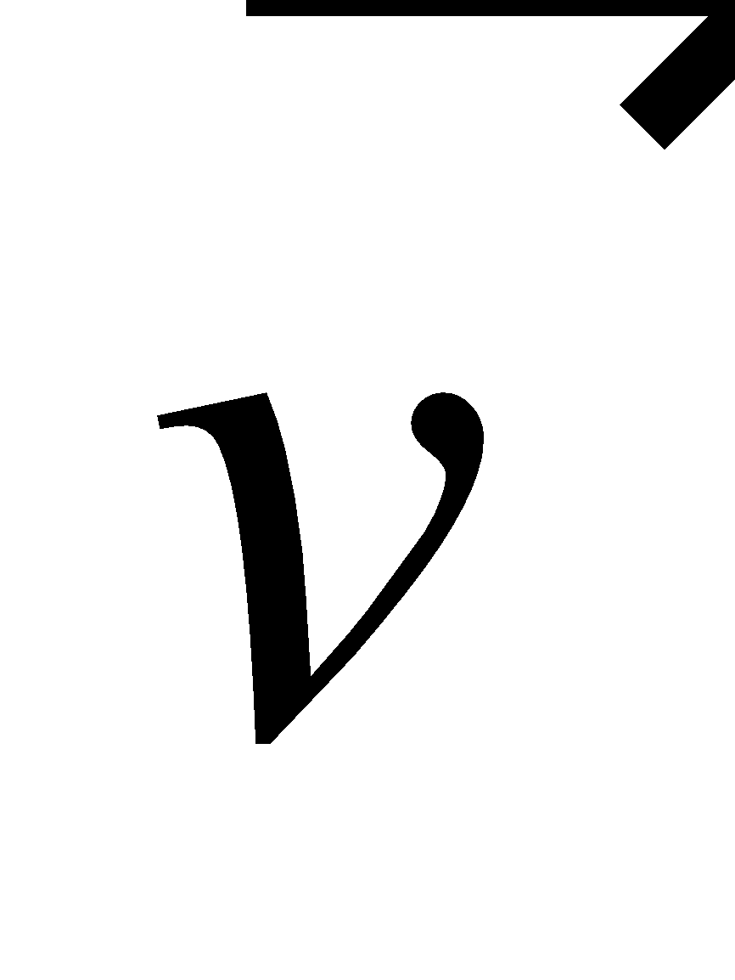is given by Equation 26.1: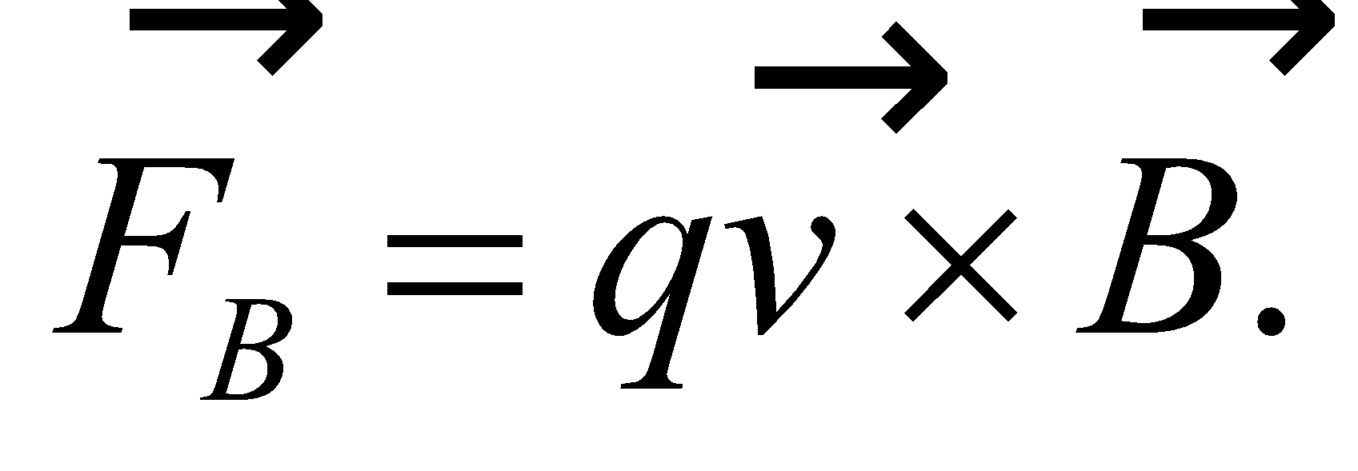The magnitude of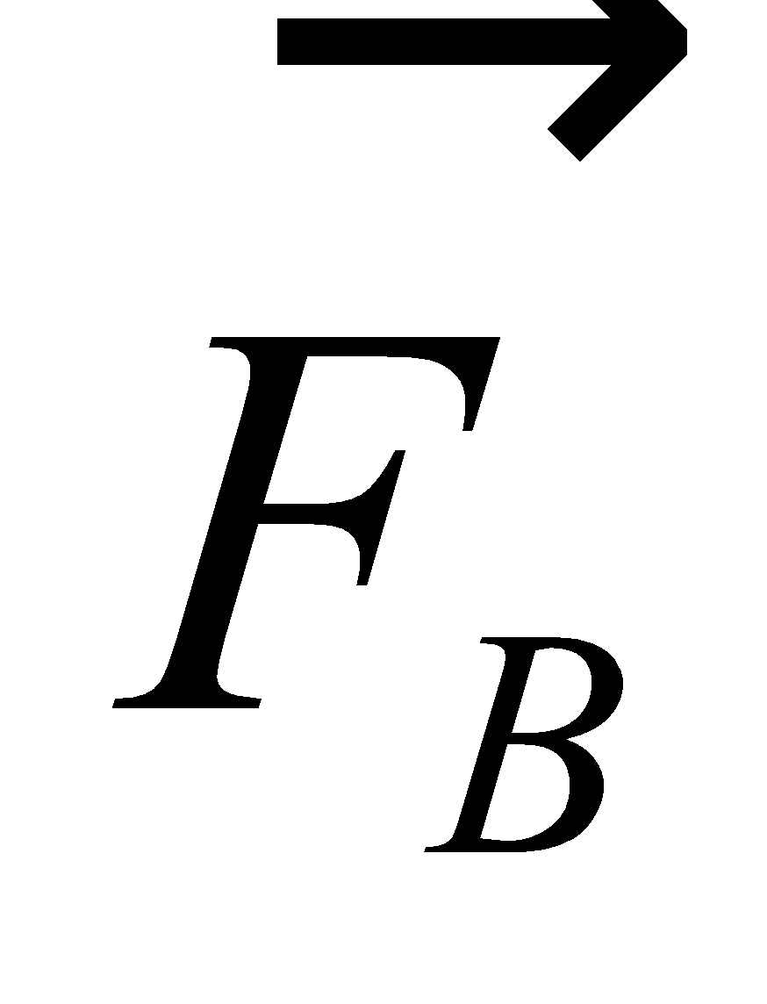is

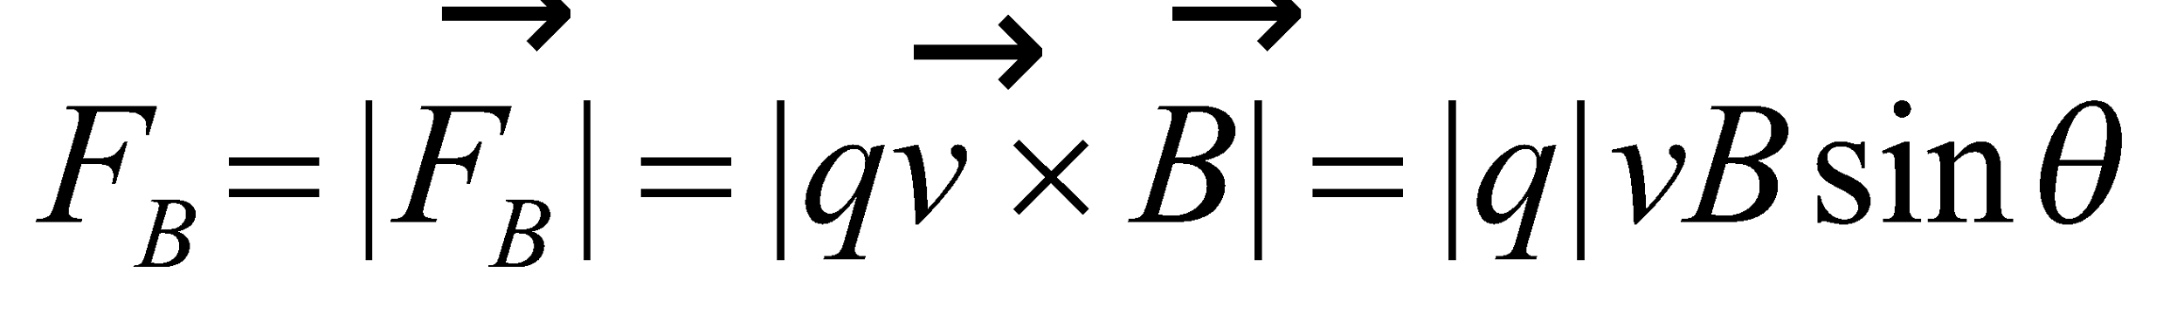

**Evaluate (a)** The magnetic field is a minimum when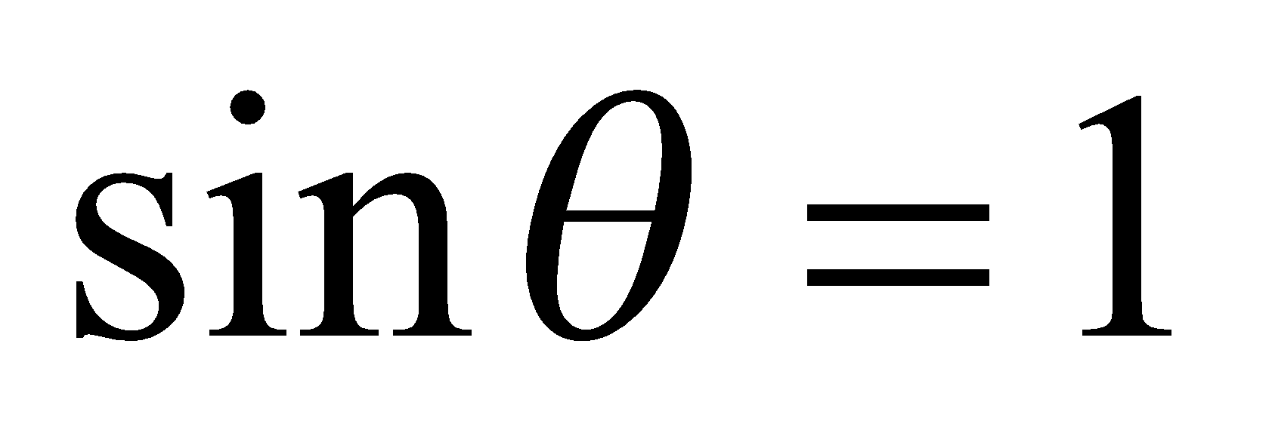(the magnetic field perpendicular to the velocity). Thus,

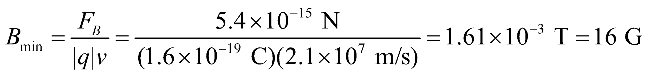

**(b)** For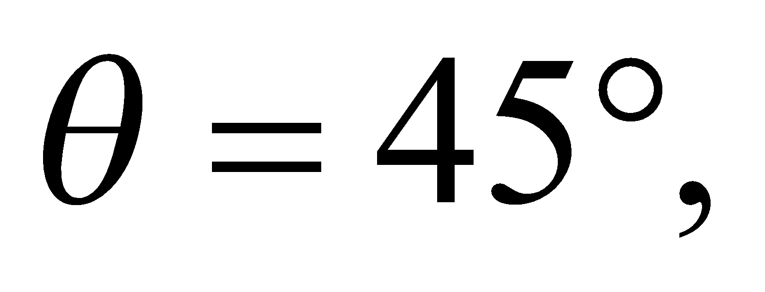the magnetic field is

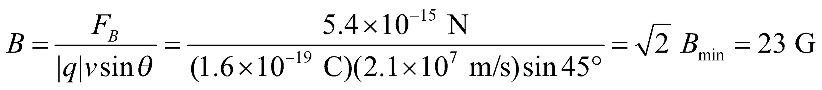

**Assess** The magnetic force on the electron is very tiny. The magnetic field required to produce this force can be compared to the Earth’s magnetic field, which is about 1 G.

**16.** **Interpret** This problem involves force on an electron that moves through a magnetic field. From Newton’s second law we can relate this force to the acceleration experienced by the electron.

**Develop** The magnetic force on a moving charge is given by Equation 26.1, which in scalar form is

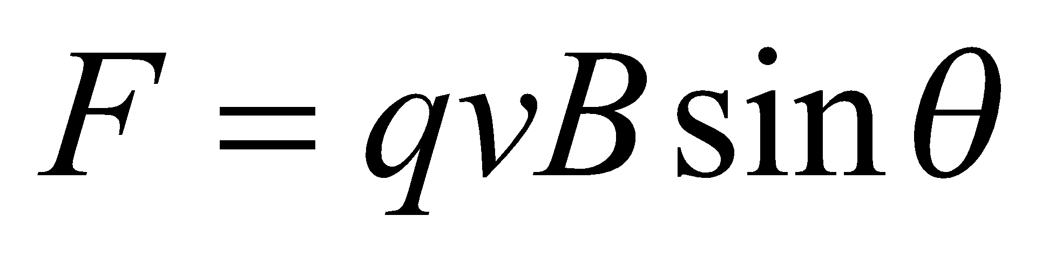

Using Newton’s second law (for constant mass, Equation 4.3, *F* = *ma*) we can solve for the speed *v*. From the vector form of Equation 26.1, we see that the force is perpendicular to the velocity of the particle. Therefore, this force does no work on the particle (see Equation 6.11), so from the work-energy theorem (Equation 6.14), we know that the particle’s kinetic energy does not change.

**Evaluate** (a) Solving for the velocity gives

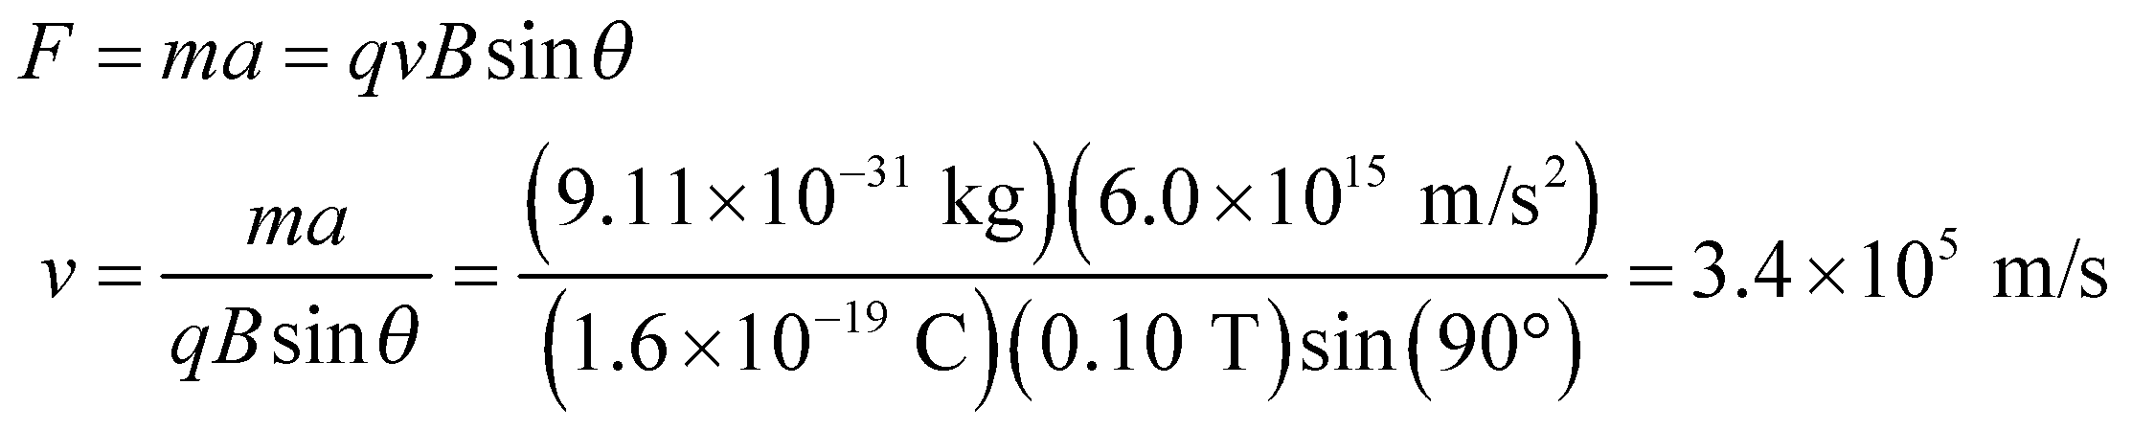

(b) Because the particle’s kinetic energy does not change, its speed does not change.

**Assess** The magnetic force does cause the particles velocity to change, but not its speed. In other words, only the direction of the particle’s velocity changes, but the magnitude of the velocity (i.e., its speed) does not change.

**17. Interpret** In this problem we are asked to find the magnetic force on a proton moving at various angles with respect to a magnetic field.

**Develop** The magnetic force on a charge *q* moving with velocity  is given by Equation 26.1: 

The magnitude of  is

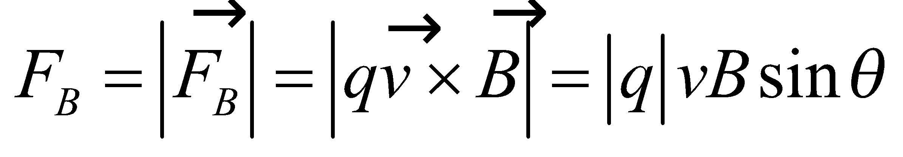

The charge of the proton is 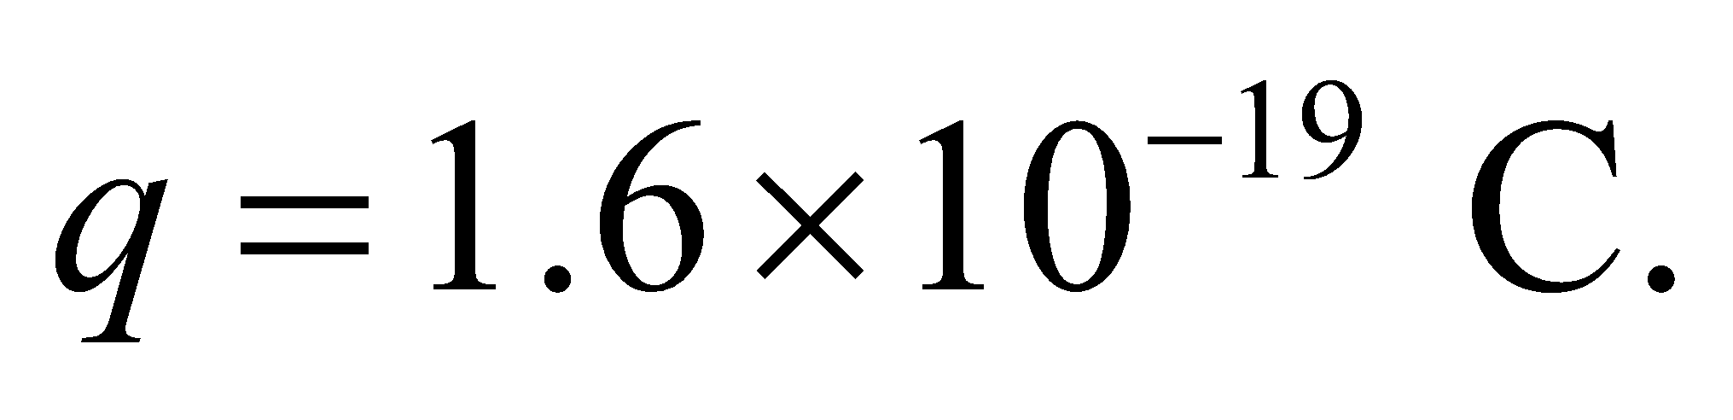

**Evaluate** **(a)** When 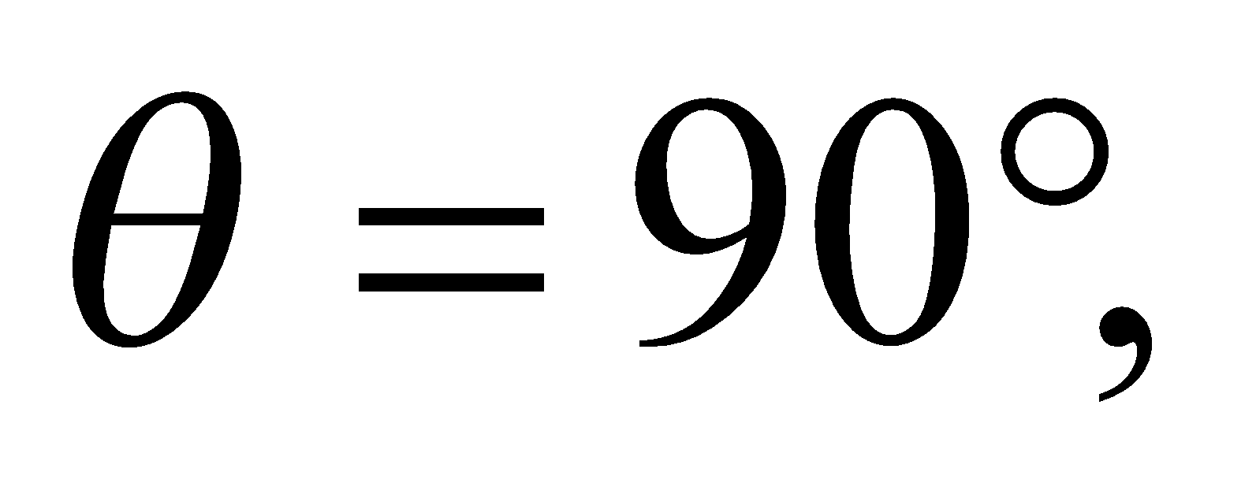 the magnitude of the magnetic force is



**(b)** When 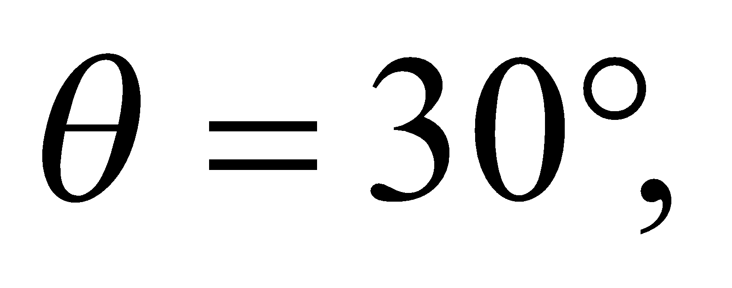 the force is



**(c)** When 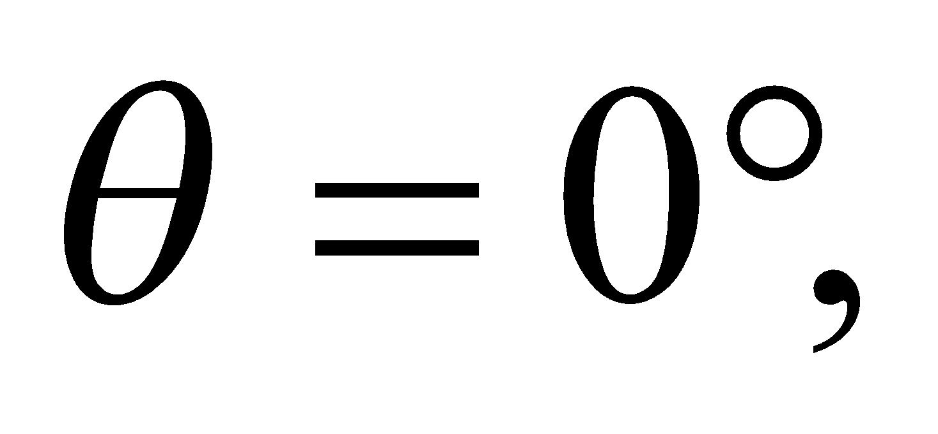 the force is 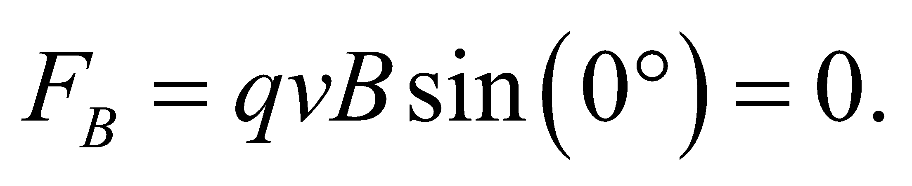

**Assess** The magnetic force is a maximum 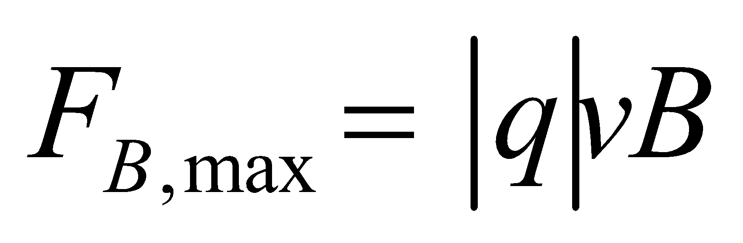 when 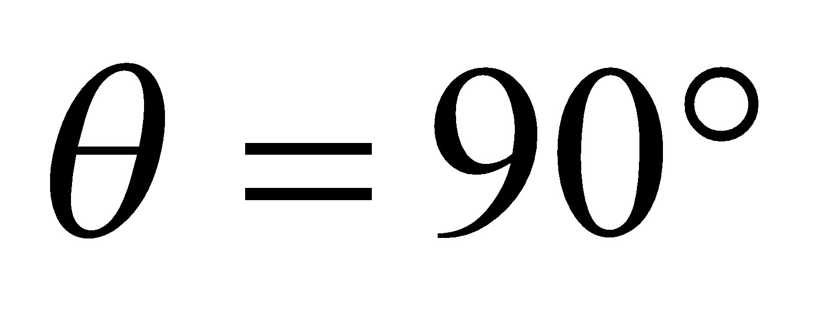 and a minimum 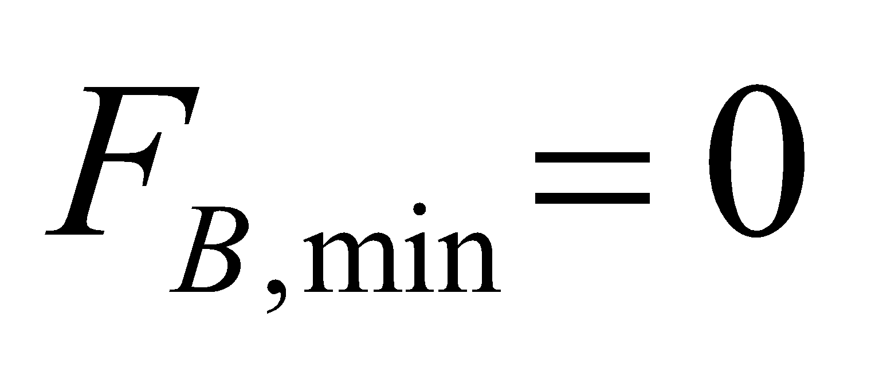 when 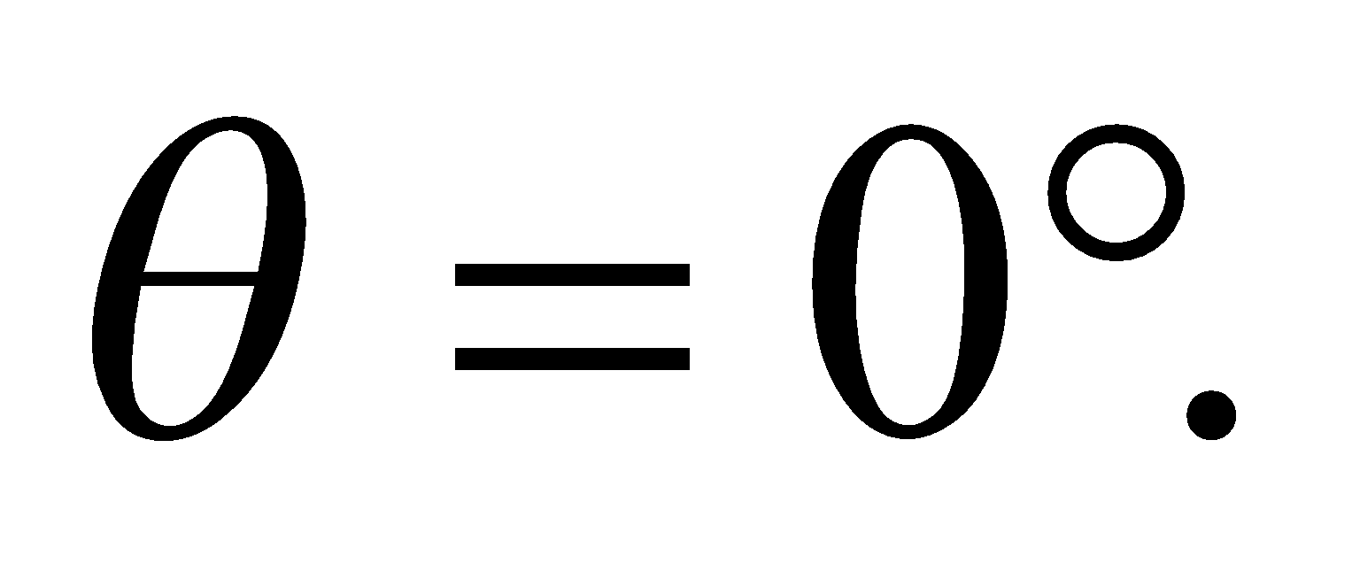

**18.** **Interpret** We're asked to calculate the maximum magnetic force on an electron moving in the Earth's magnetic field at the surface. We then compare that to the gravitational force on the same electron.

**Develop**We're given the electron's kinetic energy, which we can equate to a velocity by

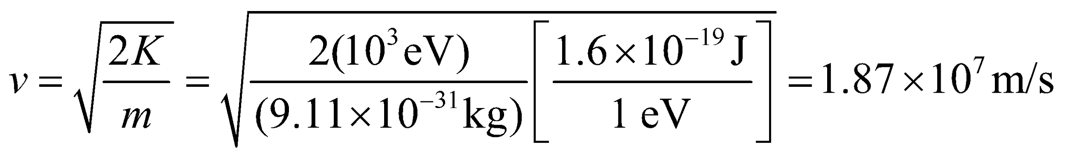

The maximum magnetic force occurs when the velocity is perpendicular to the Earth's magnetic field: 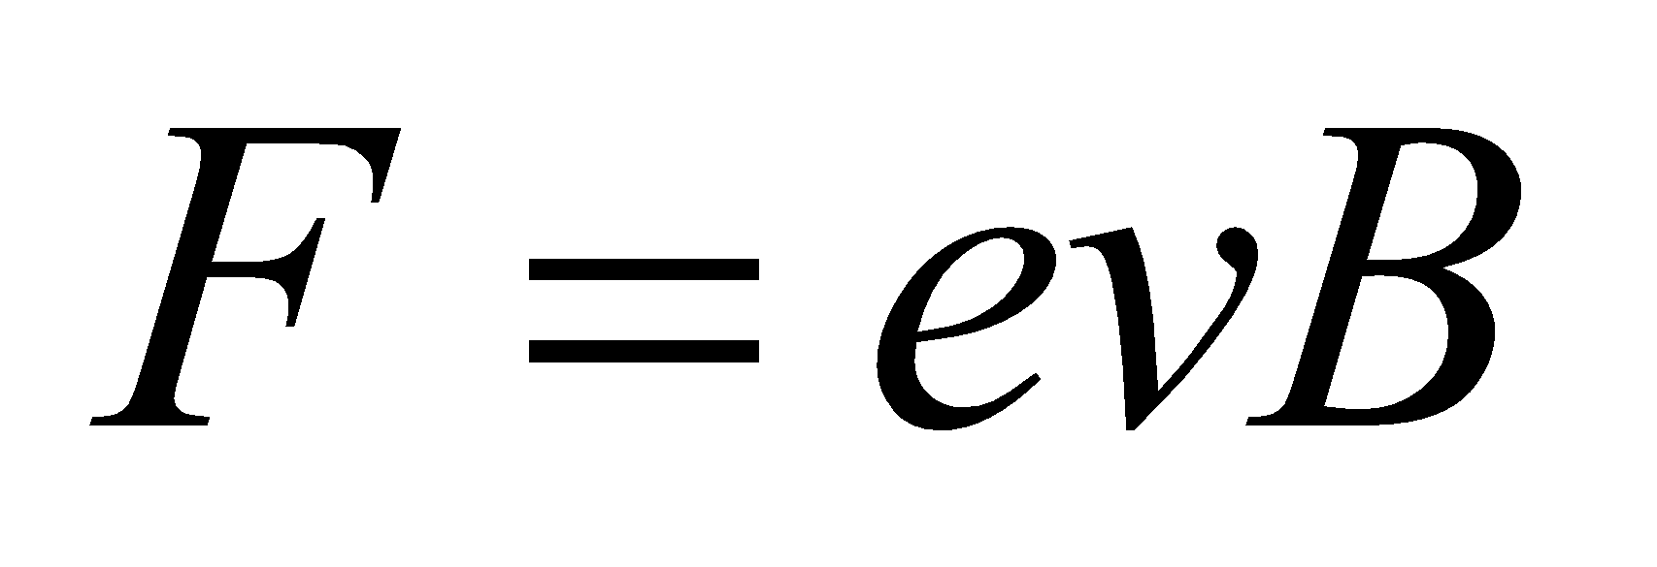 from Equation 26.1 with 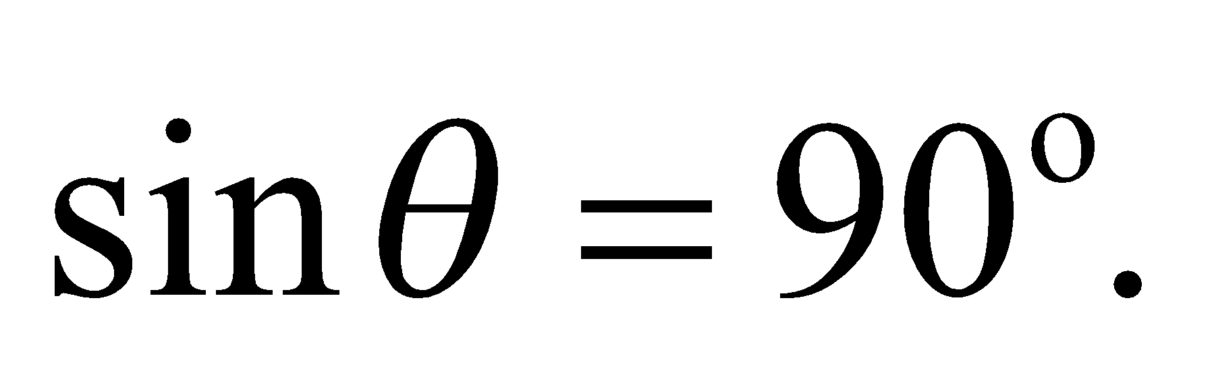

**Evaluate**The maximum magnetic force on the electron is then



By comparison, the weight of an electron at the Earth's surface is



**Assess** The gravitational force is 1013 times smaller than the magnetic force. This has partly to do with the electron moving near the speed of light, but even so, gravity is very weak in comparison to both electric and magnetic forces.

**19. Interpret** This problem is about the speed of a given charge if it is to pass through the velocity selector undeflected. A velocity selector contains an electric and a magnetic field that are perpendicular to each other (see Figure 26.5).

**Develop**In the presence of both electric and magnetic fields, the force on a moving charge is (see Equation 26.2):

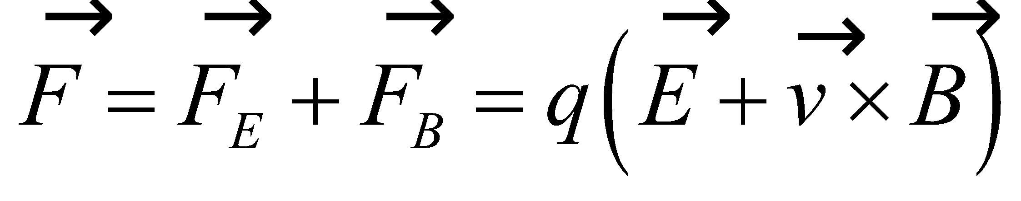

Because 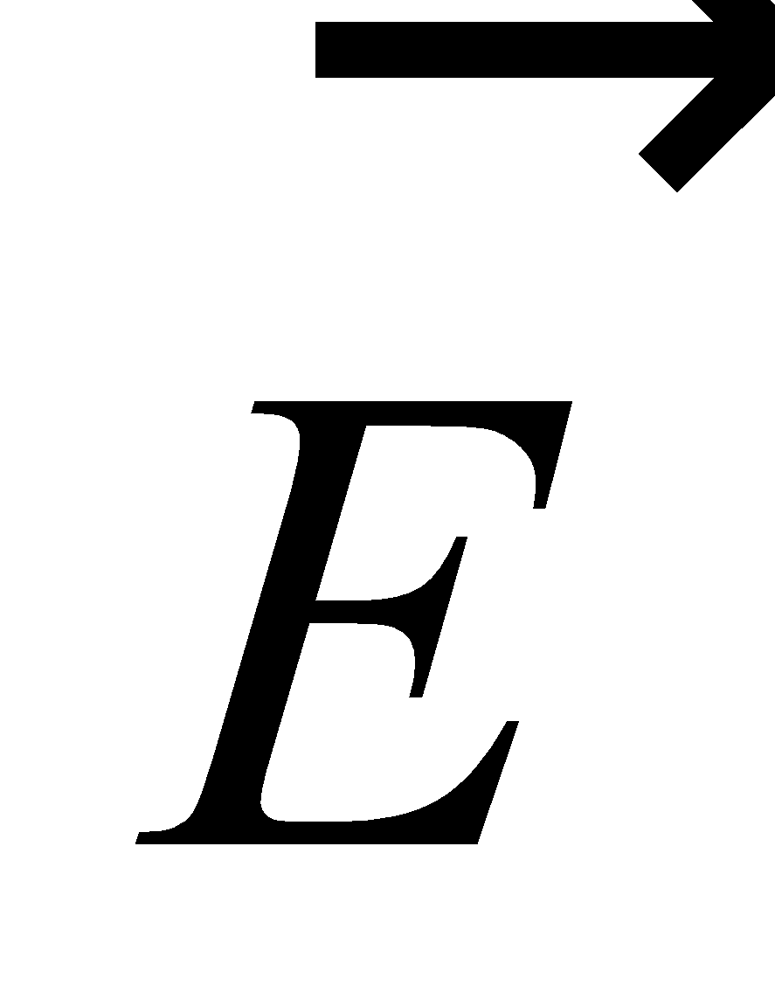 is perpendicular to 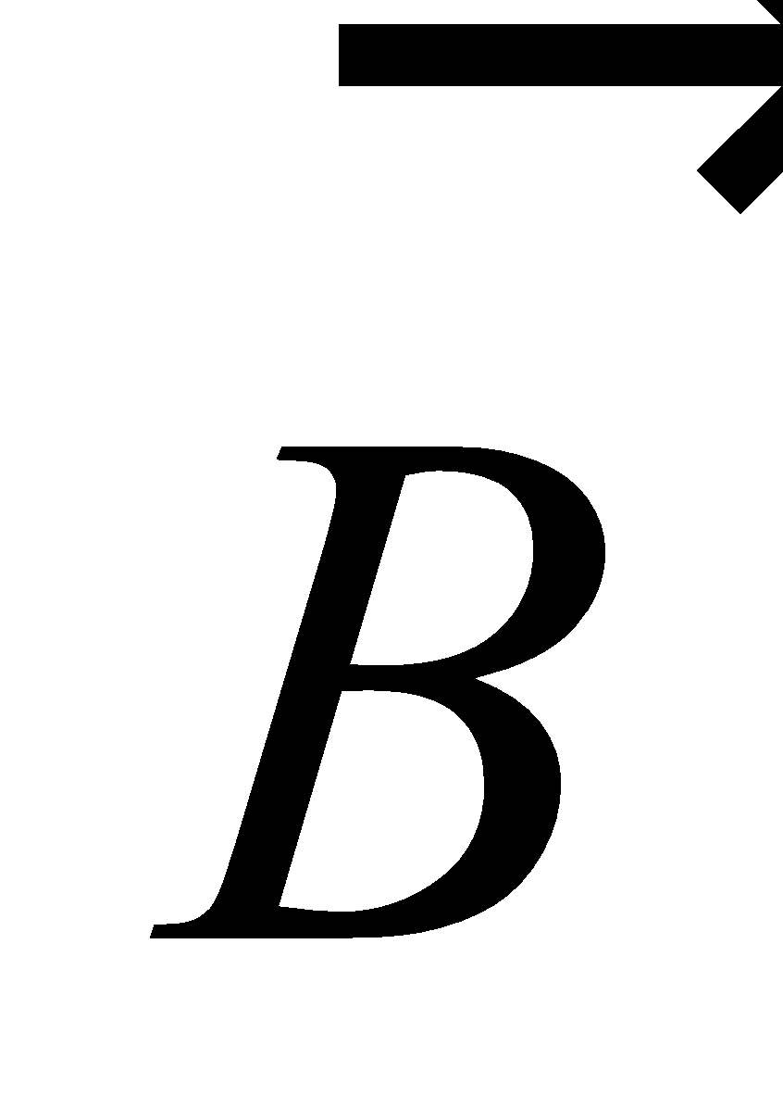, as shown in Figure 26.5, the forces due to each field on a charged particle are antiparallel. Thus, we can use the scalar for of Equation 26.2,

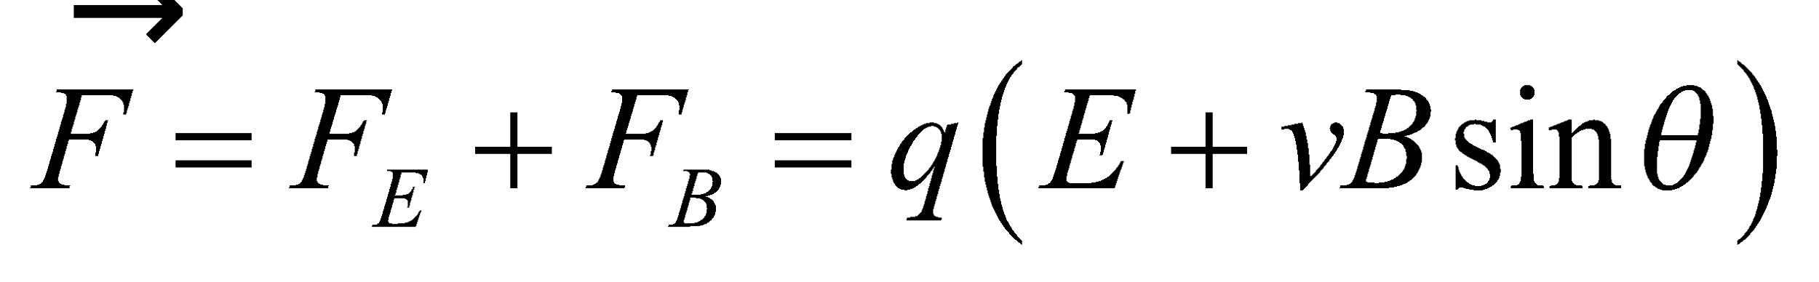

so the condition for a charged particle to pass undeflected through the velocity selector is that the net force on it is zero, or 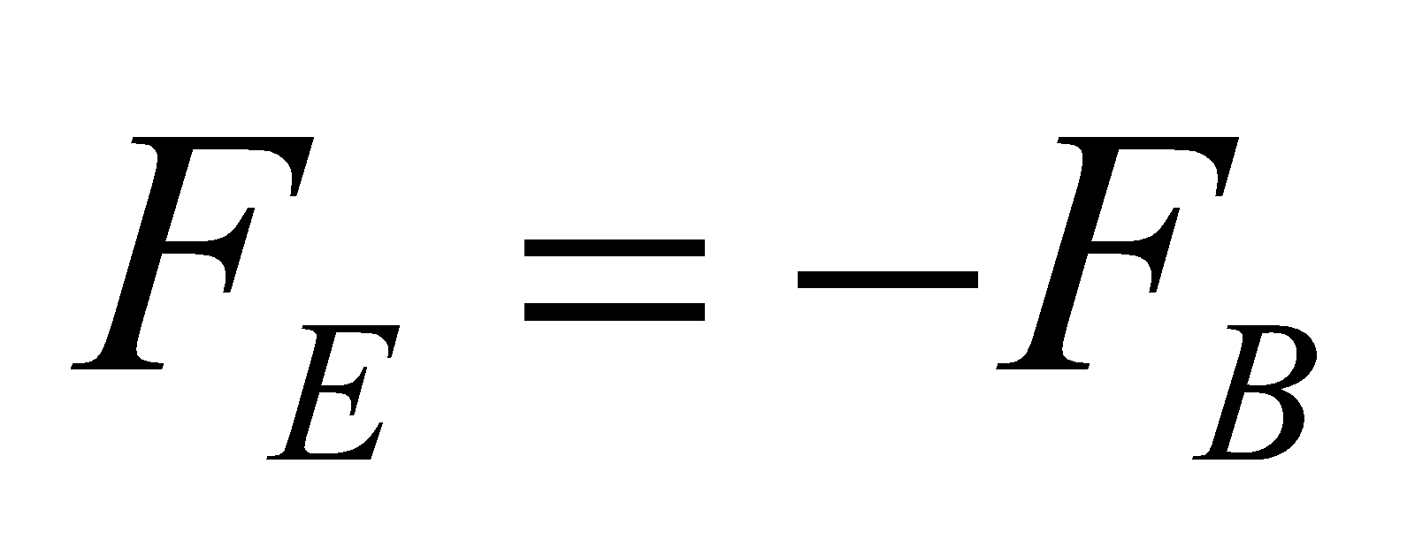.

**Evaluate** Substituting the values given in the problem statement, we obtain

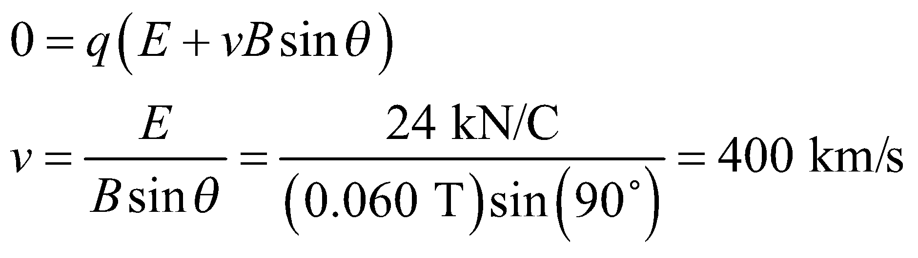

**Assess** Only particles with this speed would pass undeflected through the mutually perpendicular fields; at any other speed, particles would be deflected. Note also that the particle velocity must be perpendicular to the magnetic field for this result to hold.

**Section 26.3 Charged Particles in Magnetic Fields**

**20.** **Interpret** This problem involves finding the radius of orbit of a proton moving perpendicular to a magnetic field.

**Develop** Apply Equation 26.3, *r* = *vm*/(*eB*) to find the radius *r*.

**Evaluate** Inserting the given quantities gives

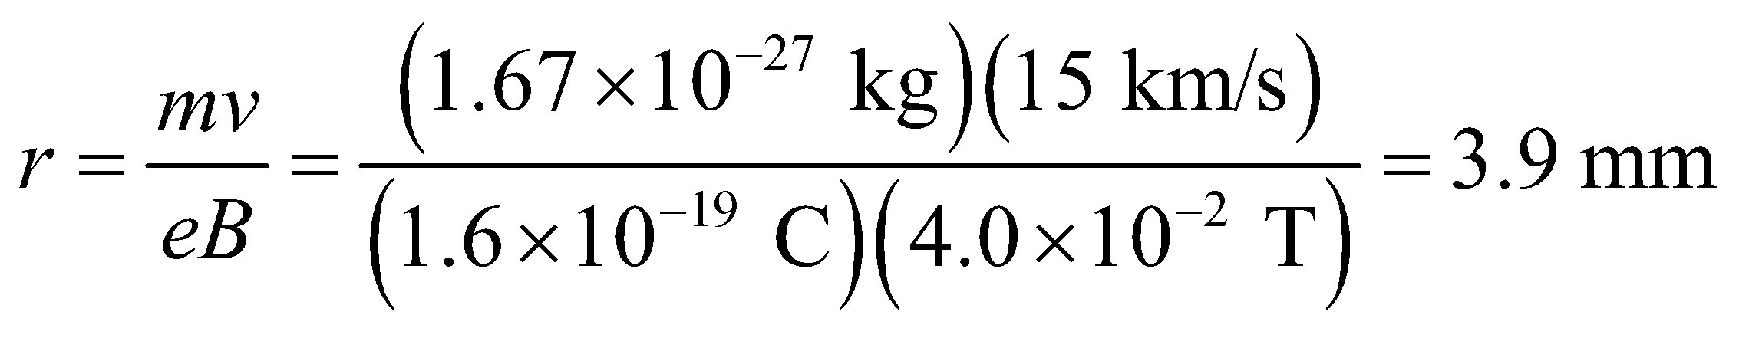

**Assess** To verify that the units of this expression are correct, note that a tesla can be expressed as

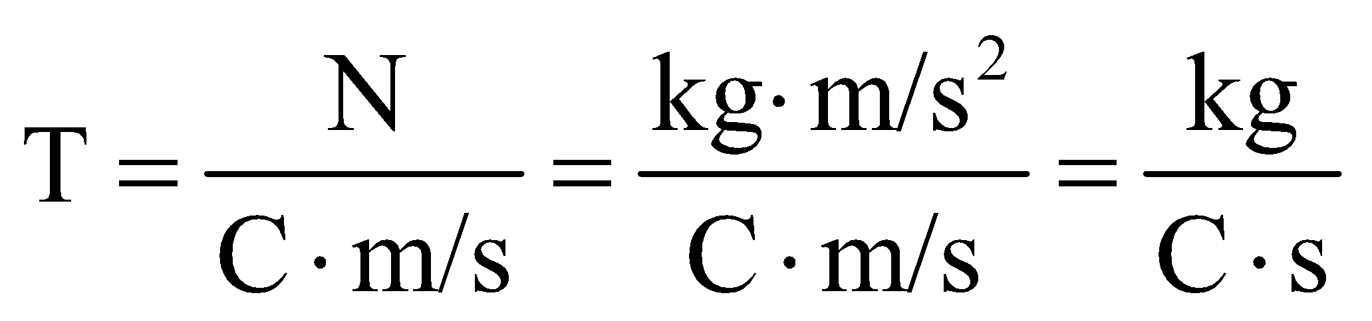

Using kg/(C·s) instead of T in Equation 26.3 gives units of distance, as expected.

**21. Interpret** This problem is about an electron undergoing circular motion in a uniform magnetic field. We want to know its period, or the time it takes to complete one revolution.

**Develop** Using Equation 26.3, the radius of the circular motion is 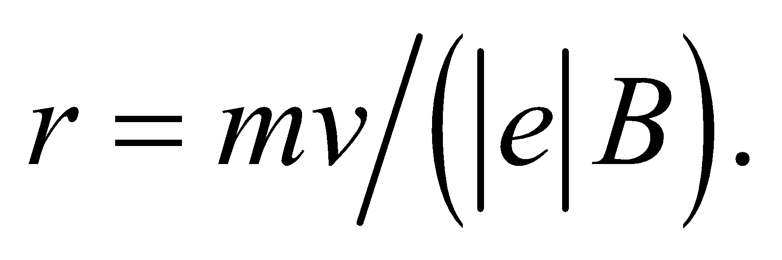 Therefore, the period of the motion is

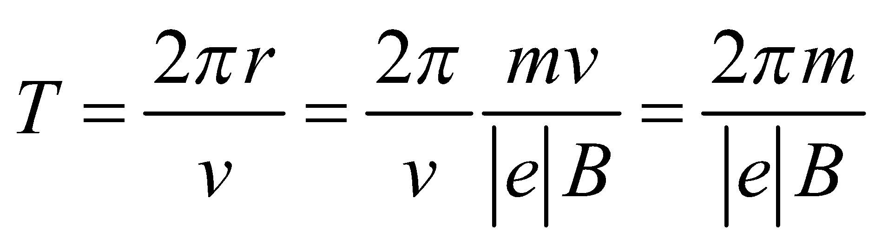

**Evaluate** Substituting the values given in the problem statement, we find the period to be

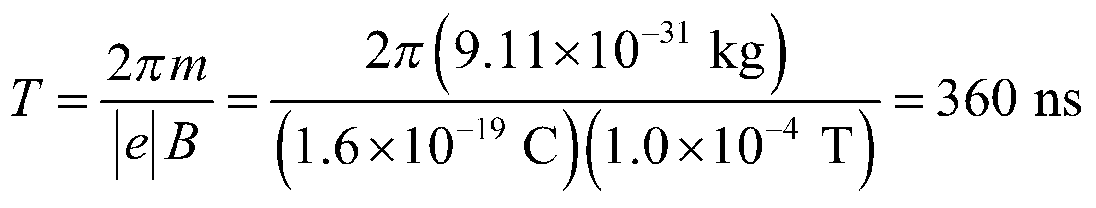

to two significant figures.

**Assess** The period is independent of the electron’s speed and orbital radius. However, it is inversely proportional to the magnetic field strength.

**22.** **Interpret** We are to find the magnetic field strength given the frequency of the radiation emitted by electrons in the field. We can assume that the electrons are moving in a circular path in the field, as for a cyclotron.

**Develop** Apply Equation 26.4 (*f* = *qB*/(2*πm*) for cyclotron motion, and solve for B.

**Evaluate** The magnetic field has a strength of

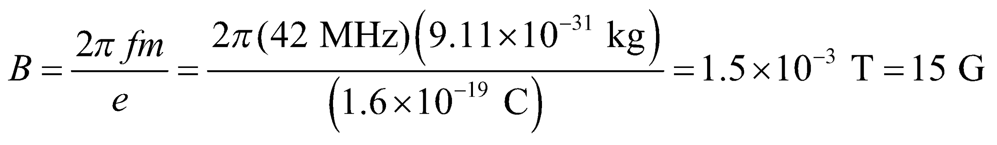

**Assess** This is not a very strong field. The Earth’s magnetic field is 1 G, and a typical refrigerator magnet produces a magnetic field of about 100 G.

**23.** **Interpret** This problem involves finding the magnetic field strength required for the given frequency of electrons moving in a circular path through the field. In addition, given the maximum radius of the electron path, we are to find the maximum electron energy (i.e., kinetic energy).

**Develop** For part (a), apply Equation 26.4, which gives the frequency of motion as a function of magnetic field. For part (b), use Equation 26.3, *r* = *mv*/(*qB*) to find the kinetic energy *K* = *mv*2/2 that corresponds to *r* = 2.5 mm.

**Evaluate**  **(a)** A cyclotron frequency of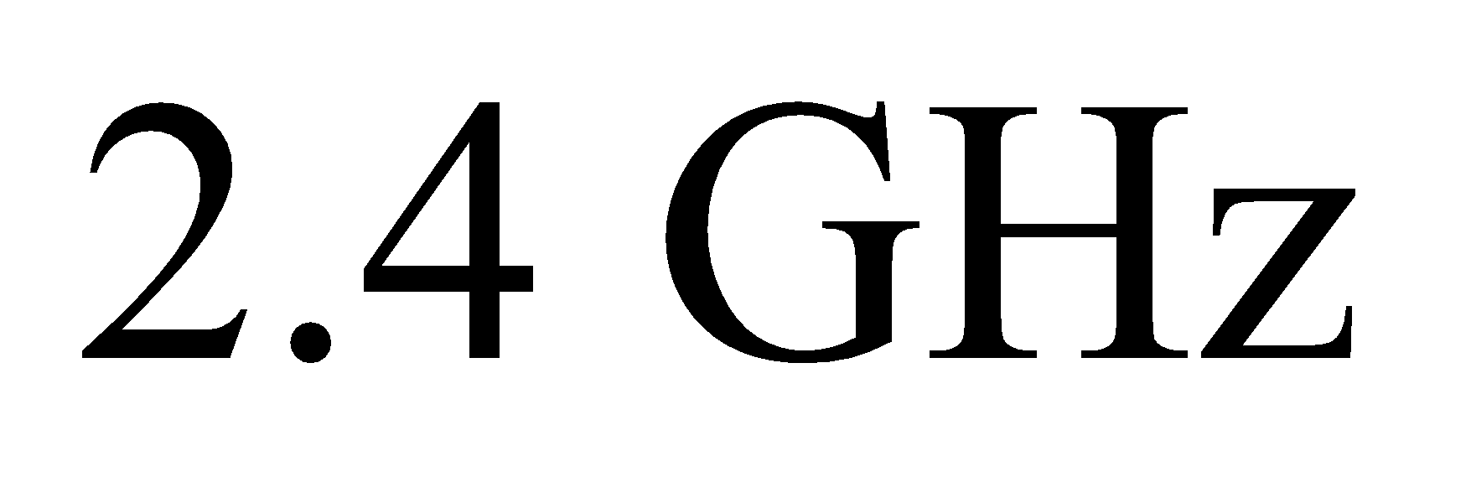for electrons implies a magnetic field strength of

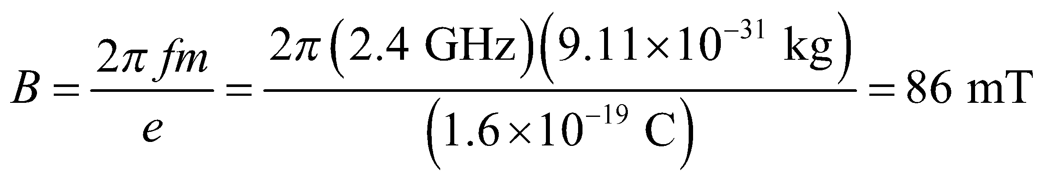

(**b**) Solving Equation 26.3 for v and inserting this into the expression for kinetic energy gives



**Assess** The electron’s kinetic energy could also be expressed in terms of the cyclotron frequency directly, 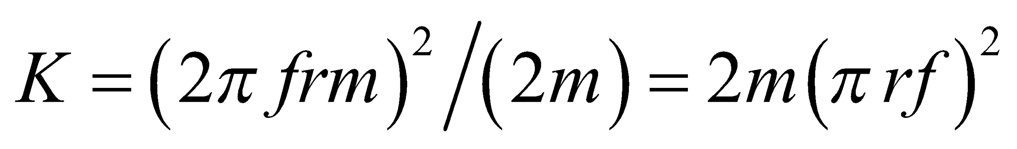, with the same result.

**24.** **Interpret** This problem is about two protons undergoing circular motion and colliding head-on.

**Develop**In an elastic head-on collision between particles of equal mass, the particles exchange velocities: 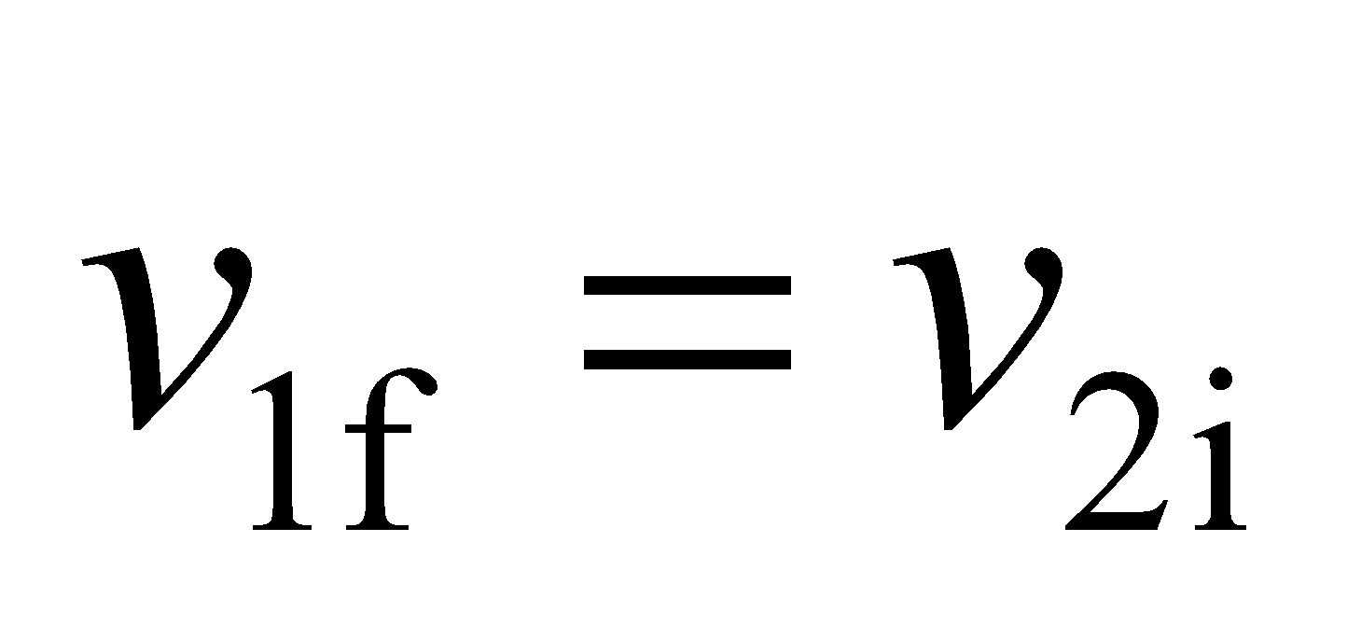 and 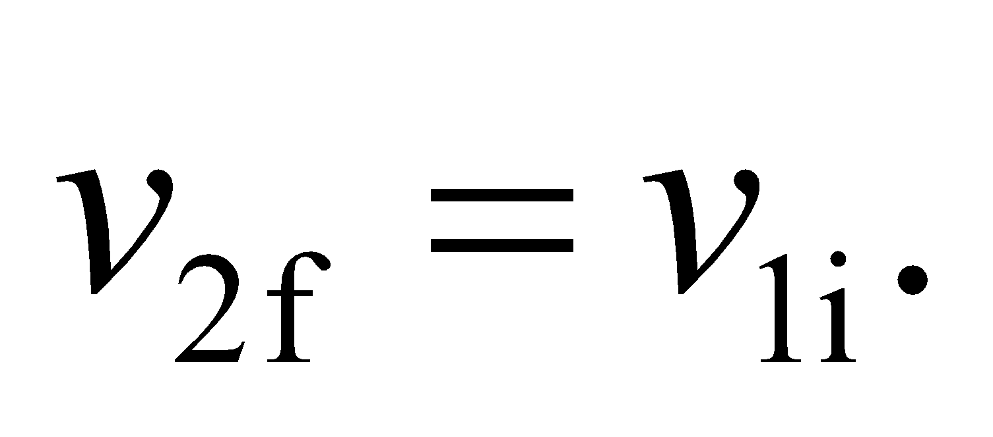 The uniform magnetic field is perpendicular to both their velocities, so the magnetic force 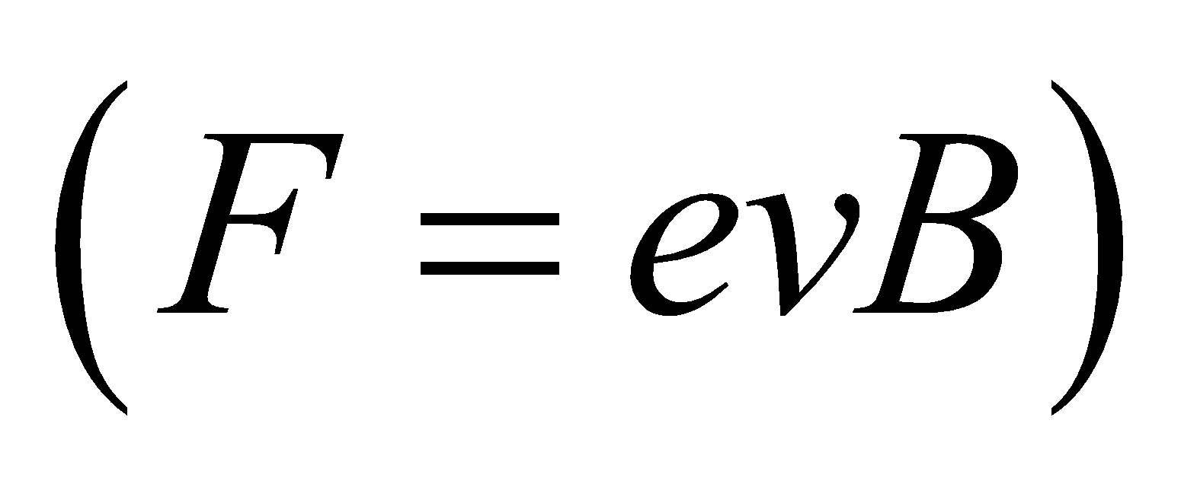 will induce circular motion with radius given in Equation 26.3: 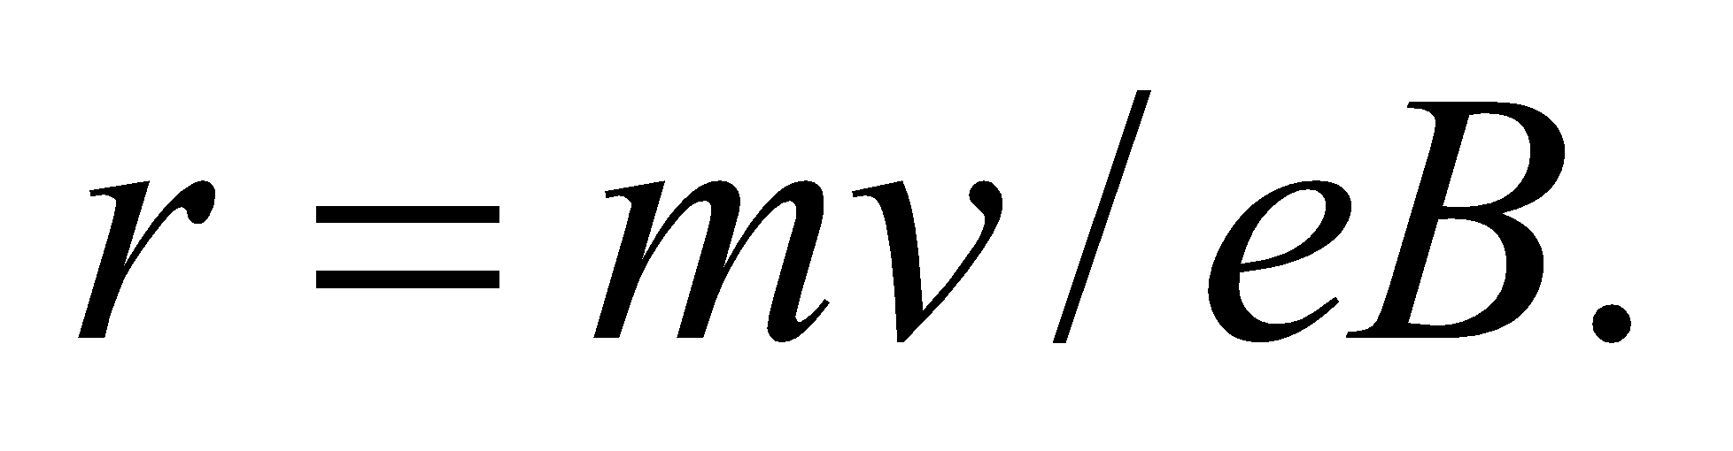 See the figure below, where the magnetic field points out of the page.



In the figure, we have arbitrarily given the second proton a greater post-collision speed 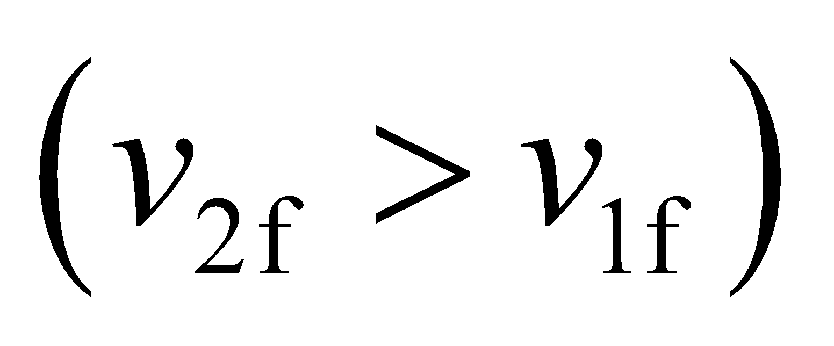, which means 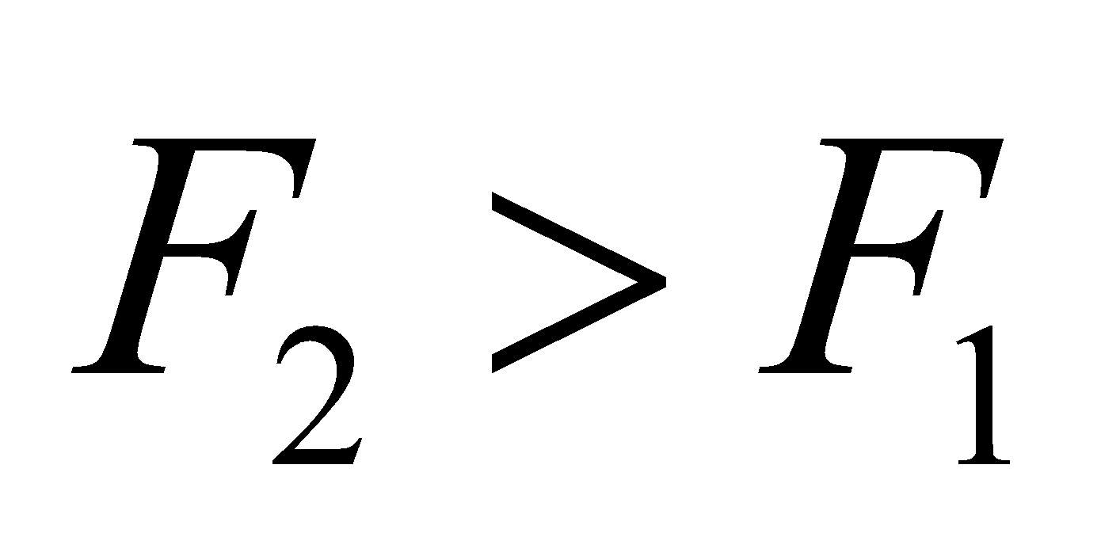 and 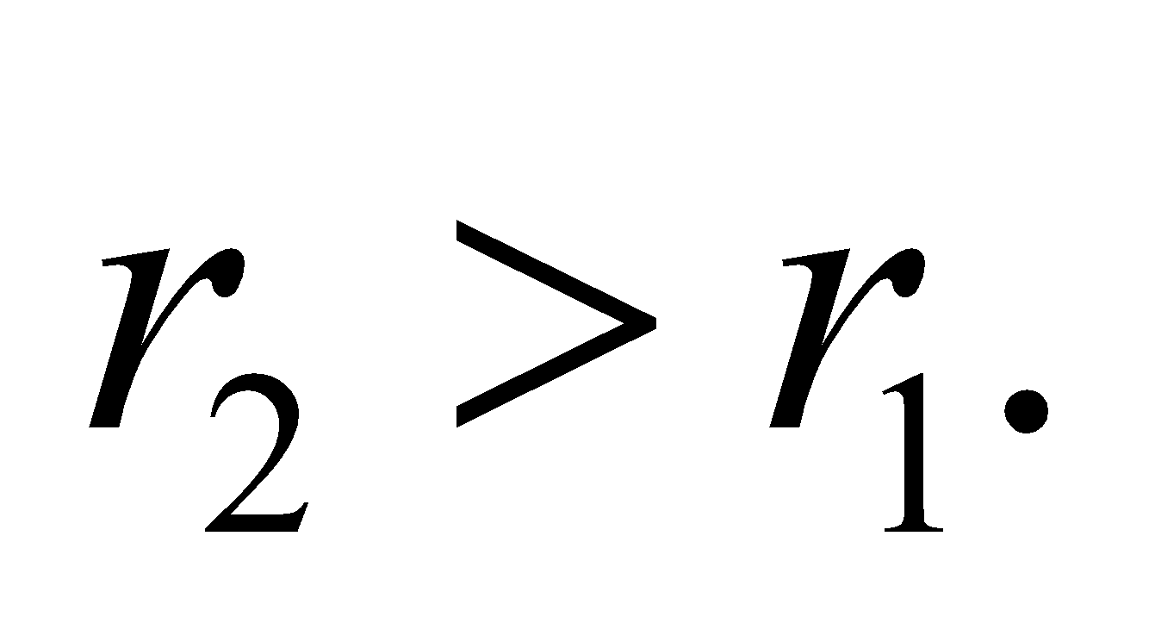 However, from Equation 26.4, we know that the time it takes for each proton to complete its circle is independent of velocity. The two protons will return to the collision point at the same time after one period: 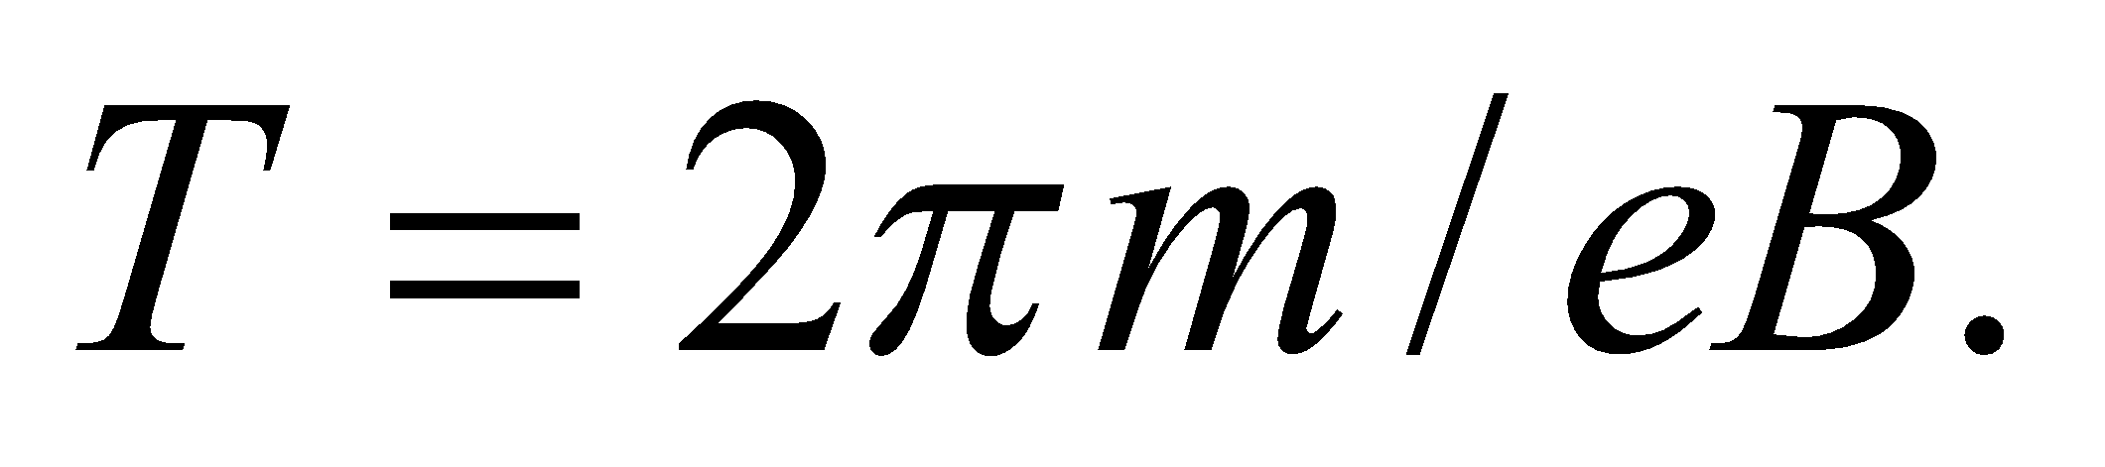

**Evaluate**The protons will collide again after

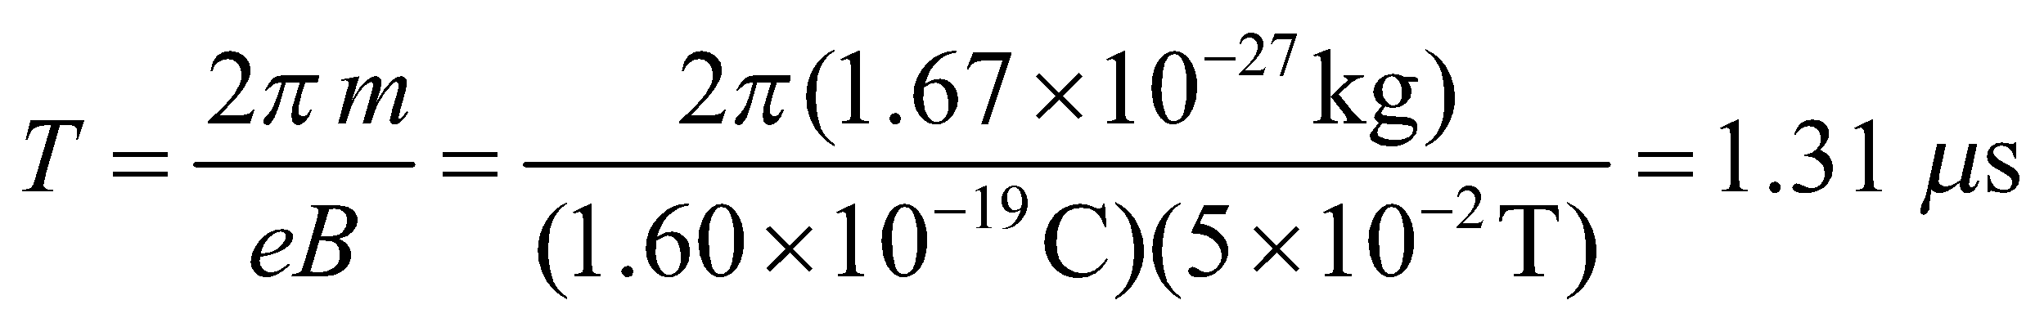

**Assess** In solving the problem, we have ignored Coulomb repulsion between the two protons.

**Section 26.4 The Magnetic Force on a Current**

**25.** **Interpret** This problem involves finding the force on a wire that is perpendicular to the given magnetic field and that carries the given current.

**Develop** Apply Equation 26.5

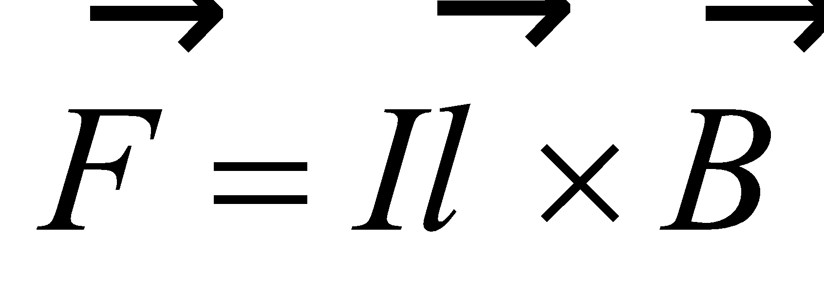

which, in scalar form, is *F* = *IlB*sin*θ*.

**Evaluate** Inserting the given quantities into the expression above gives



**Assess** The direction of this force is given by the right-hand rule, crossing the current 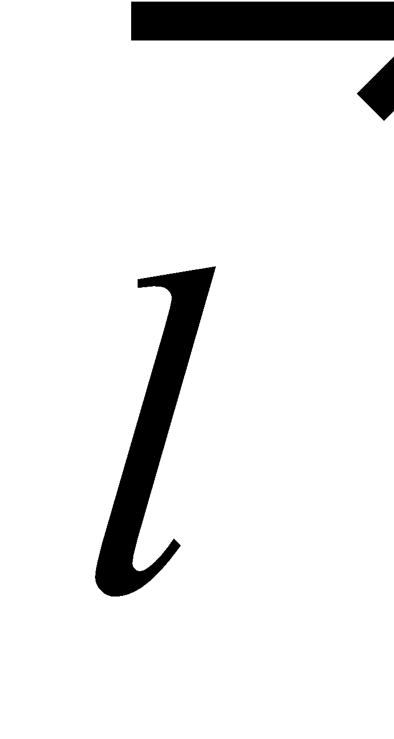 into the magnetic field .

**26. Interpret** In this problem we are asked about the magnetic field strength given the force per unit length exerted on a wire in the field. We are also to find the maximum force this wire can experience in this magnetic field if we were to reorient the wire in the field.

**Develop** Equation 26.5 gives the magnetic force on a straight current-carrying wire in a uniform magnetic field,

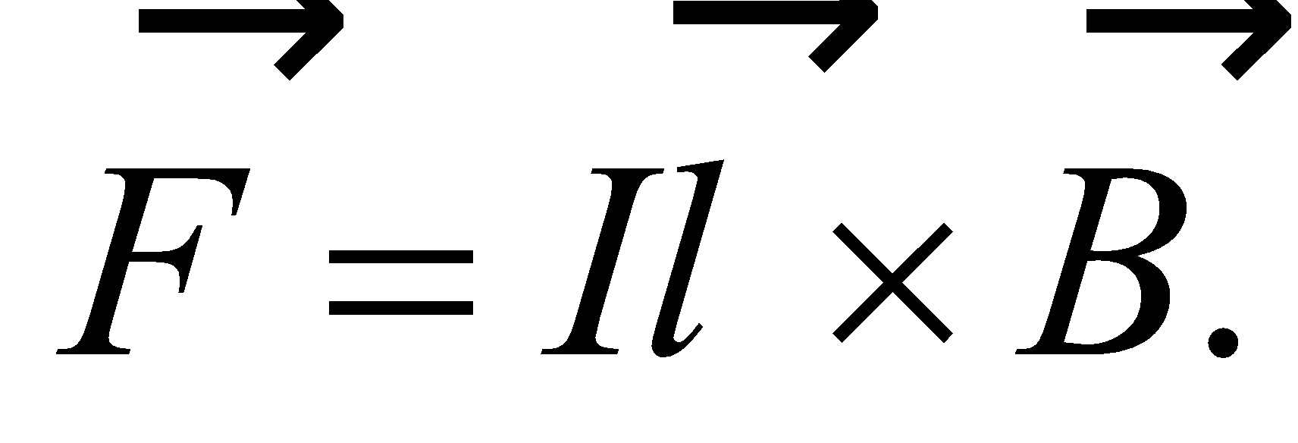 The magnitude of the force is 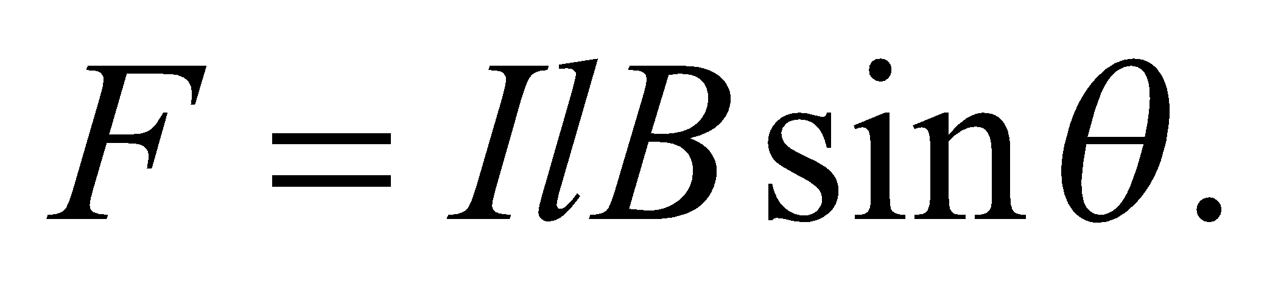

**Evaluate** **(a)** From the magnitude of the force per unit length, 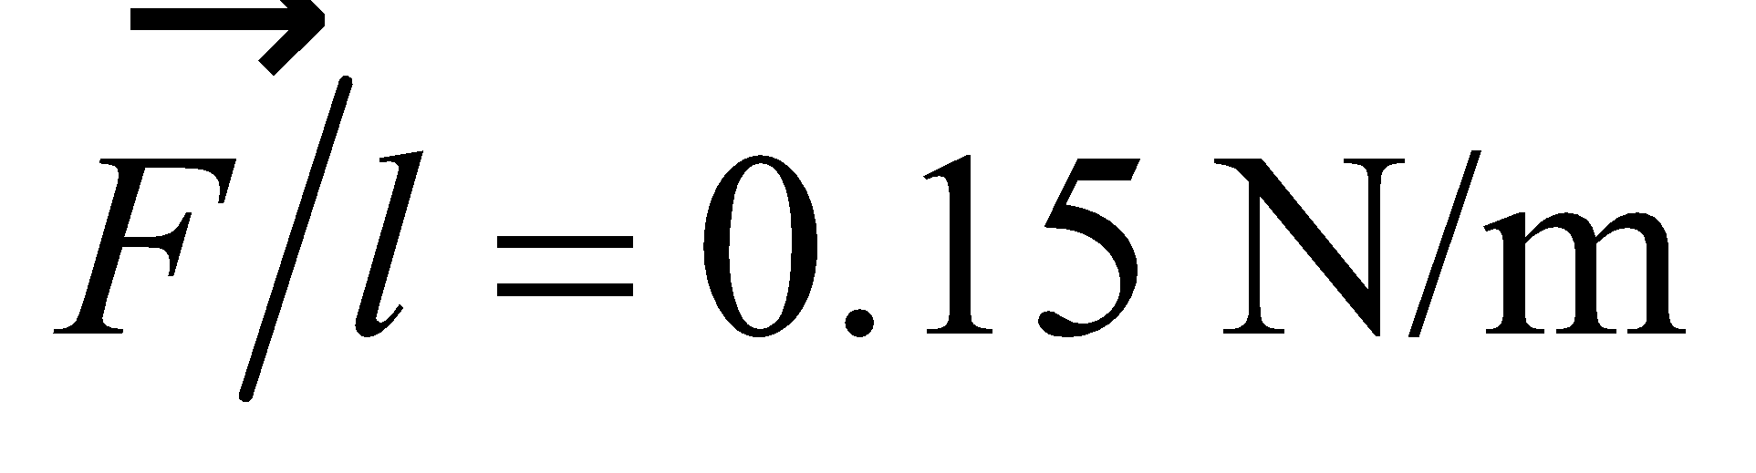 and the given data, we find the magnetic field strength to be

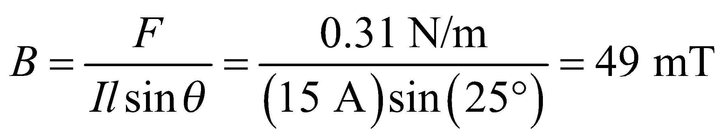

**(b)** By placing the wire perpendicular to the field (sin*θ* = 1), a maximum force per unit length of

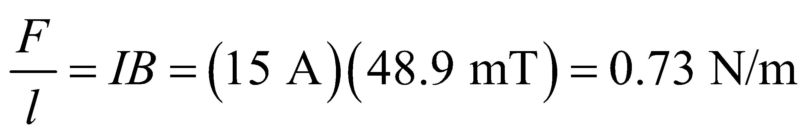

could be attained.

**Assess**From the definition of cross product between two vectors, we see that the magnetic force 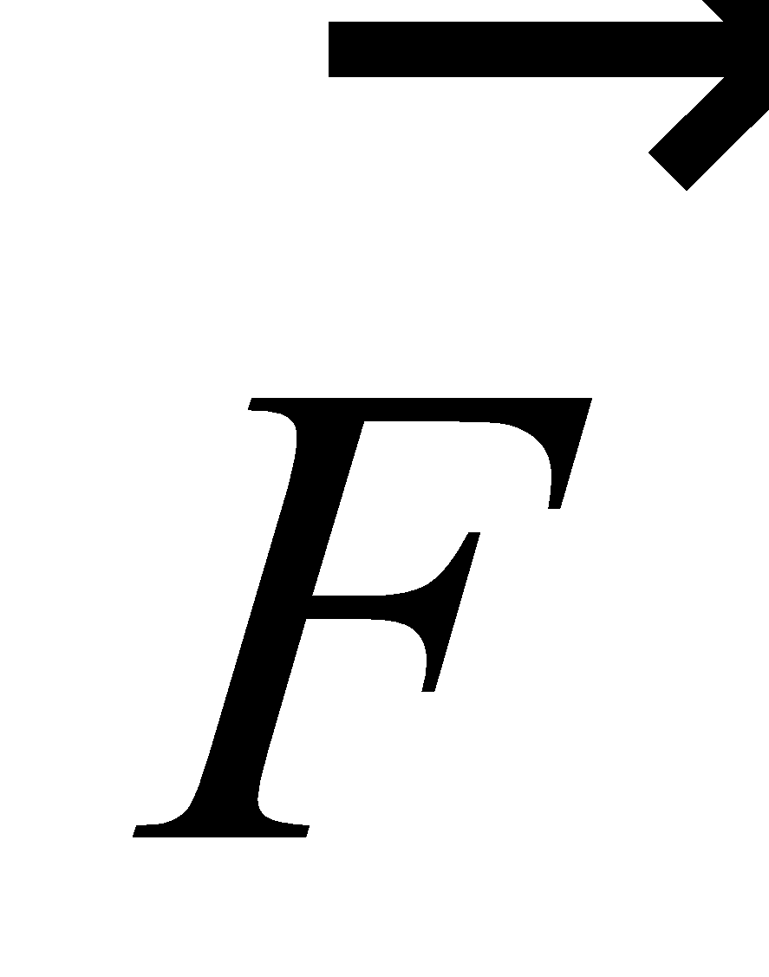 is perpendicular to both the current direction  and the magnetic field 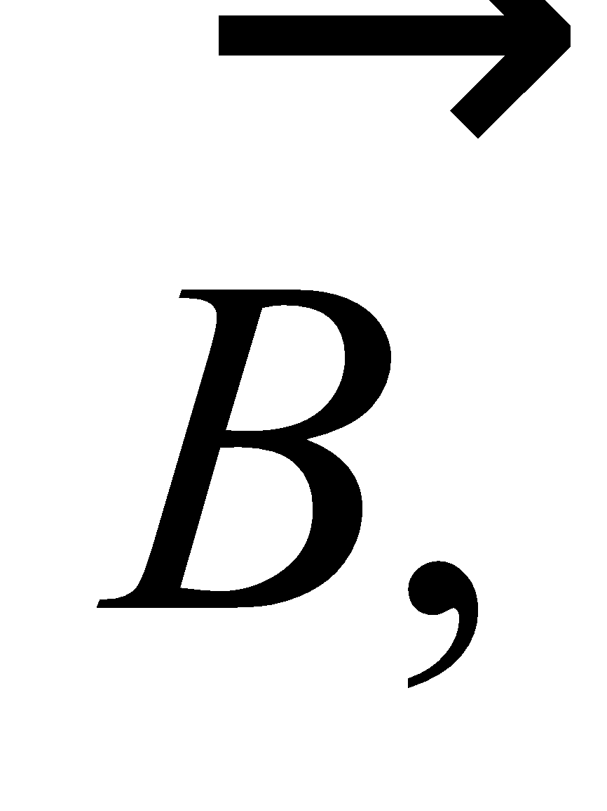 and the magnitude of  is a maximum   
when 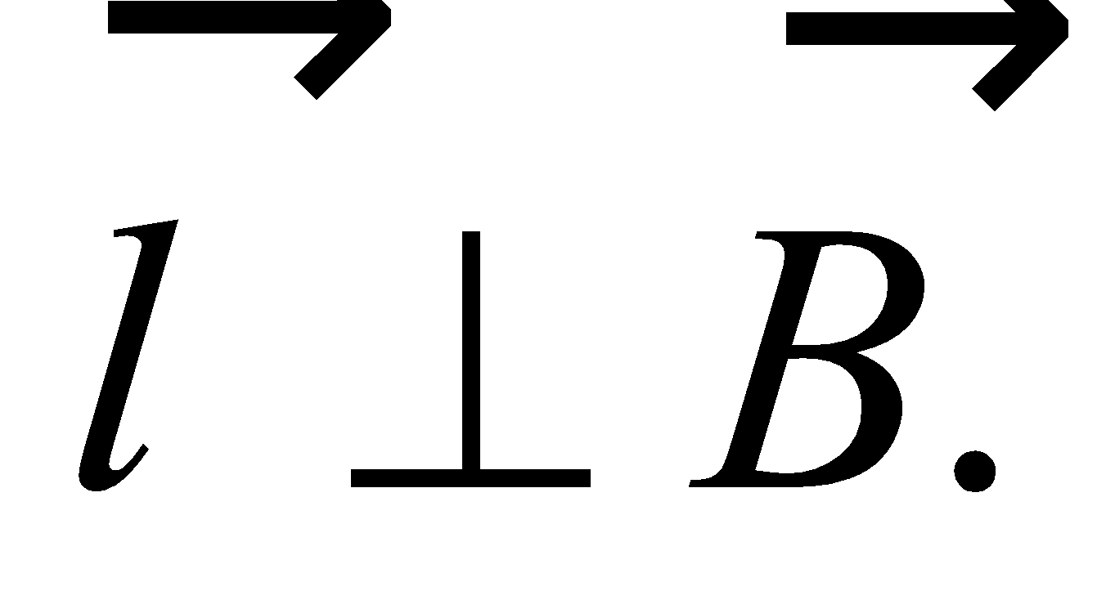

**27.** **Interpret** You need to show that a bar carrying current will need to be securely fastened inside high magnetic field experiment.

**Develop**You can use Equation 26.5 to find the magnitude of the magnetic force on the conducting bar: 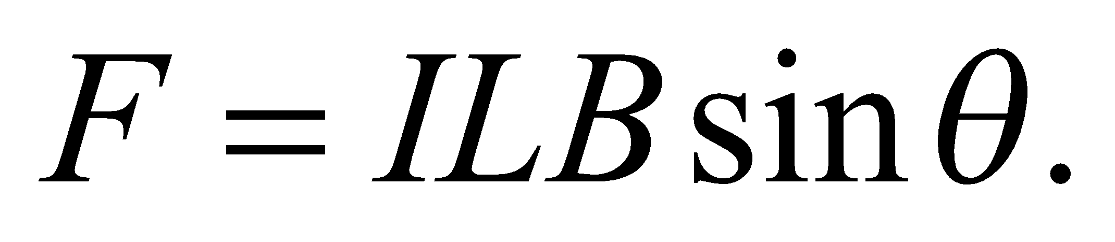

**Evaluate**Putting in the given values,

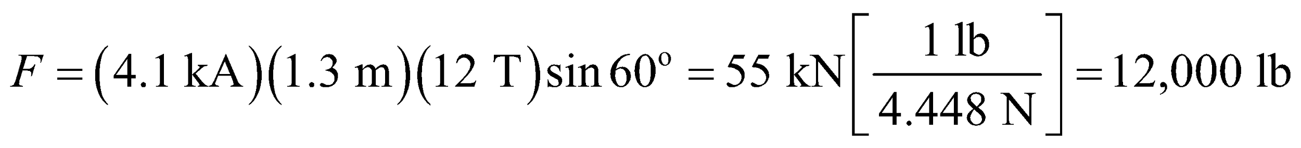

Yes, you were right to suggest clamping down the bar.

**Assess** The force will point in the direction perpendicular to the plane defined by the field and bar. With high magnetic fields such as this, it's very important to remove or secure all metal objects.

**28. Interpret** Two forces are involved in this problem: the magnetic force and the gravitational force. We want to find the magnetic field strength such that the two forces are equal in magnitude.

**Develop** The magnetic force is given by the scalar form of Equation 26.5 with *θ* = 90°, and the force due to gravity is *F* = *mg*. A magnetic force equal in magnitude to the weight of the wire requires that

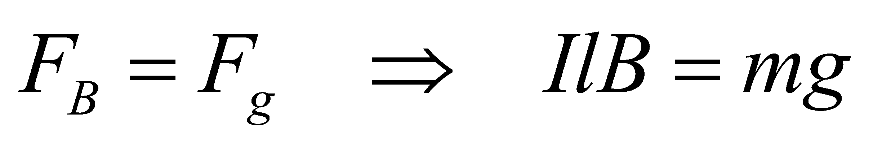

since the wire is perpendicular to the field.

**Evaluate**The equation above implies that the field strength is

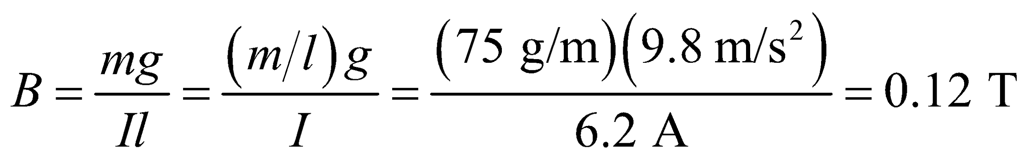

**Assess** This field strength is much greater than the typical value of 0.01 T produced by a bar magnet.

**Section 26.5 Origin of the Magnetic Field**

**29.** **Interpret** For this problem, we are given the current carried by a wire that forms a loop. Given the magnetic field strength at the loop center, we are to find the radius of the loop.

**Develop** This problem is dealt with in Example 26.3, so apply that result (Equation 16.9) here with *x* = 0 (since we are in the plane of the loop).

**Evaluate** Solving Equation 26.9 (with *x* = 0) for the loop radius *a* gives

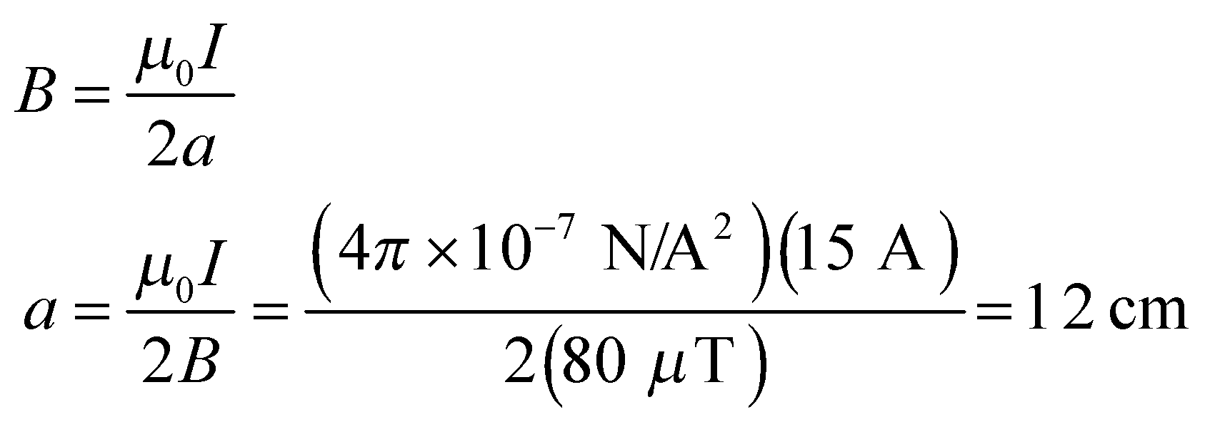

**Assess** The current in the loop is very high (15 A!) yet the magnetic field it produces is quite small (~ 1 G).

**30. Interpret** This problem involves finding the magnetic field on the axis of a current-carrying loop.

**Develop** As shown in Example 26.4, the magnetic field at a point *P* on the axis of a circular loop of radius *a* carrying current *I* is (Equation 26.9):

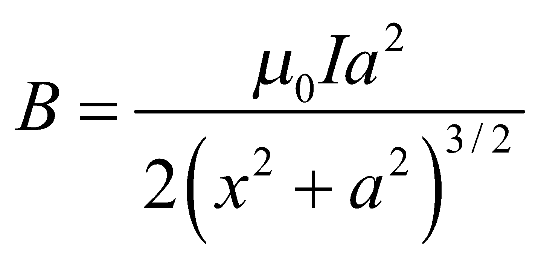

**Evaluate (a)** At the center *x* = 0 so the field strength is

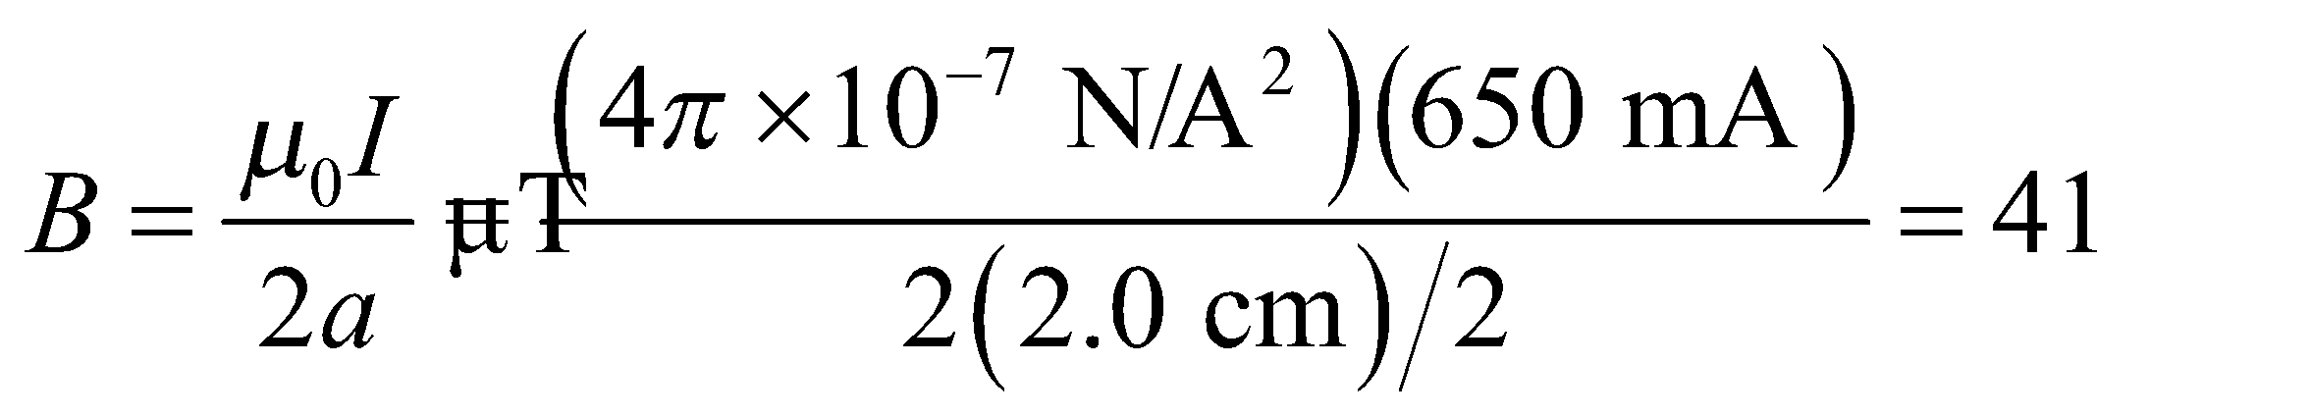

**(b)** At *x* = 20 cm on the axis, we have

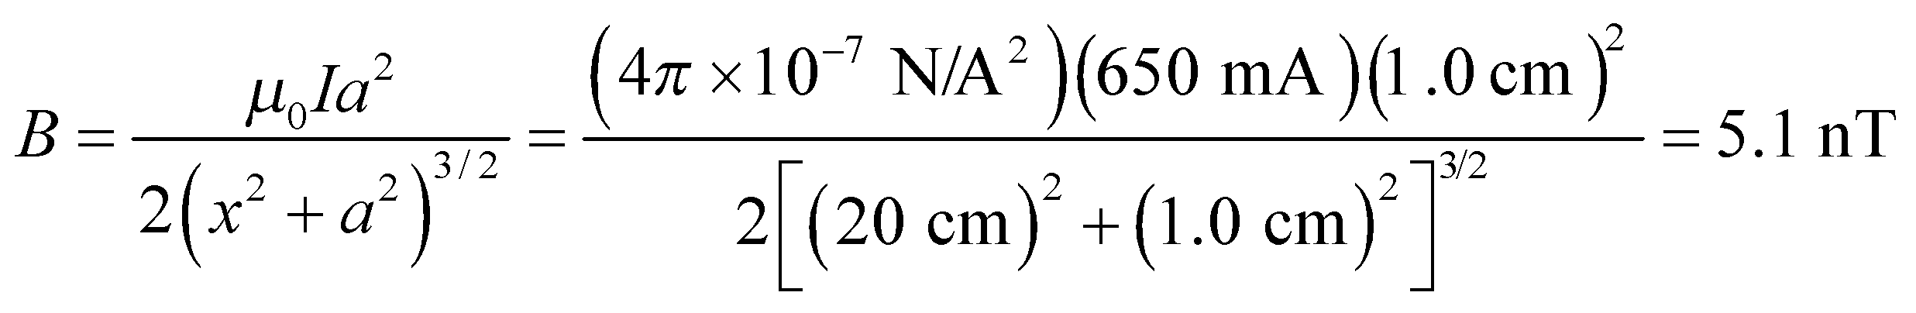

**Assess** The direction of the field is along the axis. The field strength is greatest at the center of the loop since this point is closest to the current.

**31.** **Interpret** This problem is similar to the preceding one, except that we consider here the effect of not one, but several current-carrying loops that are positioned very close together on the same axis. We are given the current in each loop and the radius and are to find the magnetic field strength at the center of the loops.

**Develop** Using the principle of superposition, the total magnetic field at the center of the loops will be the sum of the magnetic field from each loop. The number n of loops involved is *n* =*L*/(2*πa*) where *L* = 2.2 m and 2*a* = 5.0 cm. From Problem 29, we see that the magnetic field due to a single loop at the center of the loops is *B* =*μ*0*I*/(2*a*).

**Evaluate** The total magnetic field is

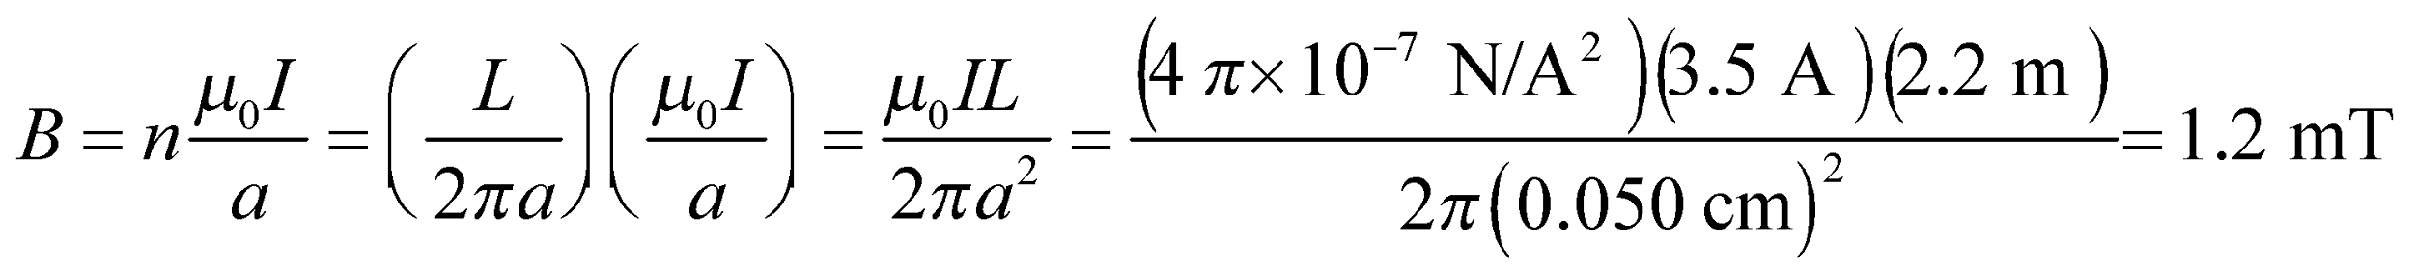

**Assess** For this approximation to be valid, the loop radius must be much, much larger than the separation between the loops.

**32. Interpret** This problem involves finding the magnetic field strength at a given distance from a current-carrying wire.

**Develop** Equation 26.10 of Example 26.4 gives the magnetic field strength a distance *r* from an infinitely long straight wire:

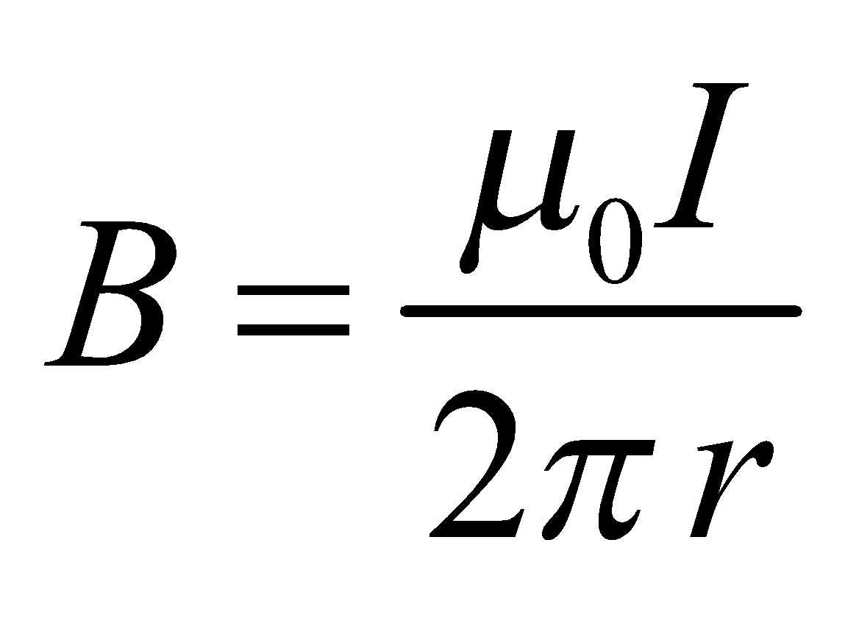

The expression is applicable if *r* is much smaller than the length of the wire.

**Evaluate** Solving the equation above for the current, we find

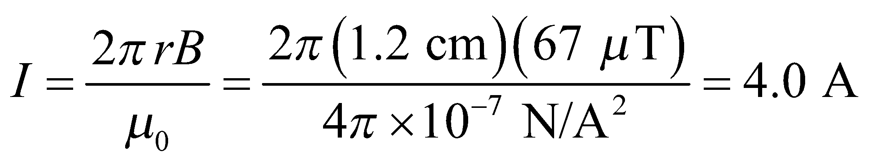

**Assess** The current is proportional to the magnetic field strength. Note that the magnetic field lines are concentric circles, as illustrated in Fig. 26.18.

**33.** **Interpret** This problem involves two long parallel wires separated by 1 cm and carrying the given current (note that the current is in the same direction for both wires). We are to find the force between these wires.

**Develop** Apply Equation 26.11. To find the force per unit length, simply divide through by the length l of the wires:

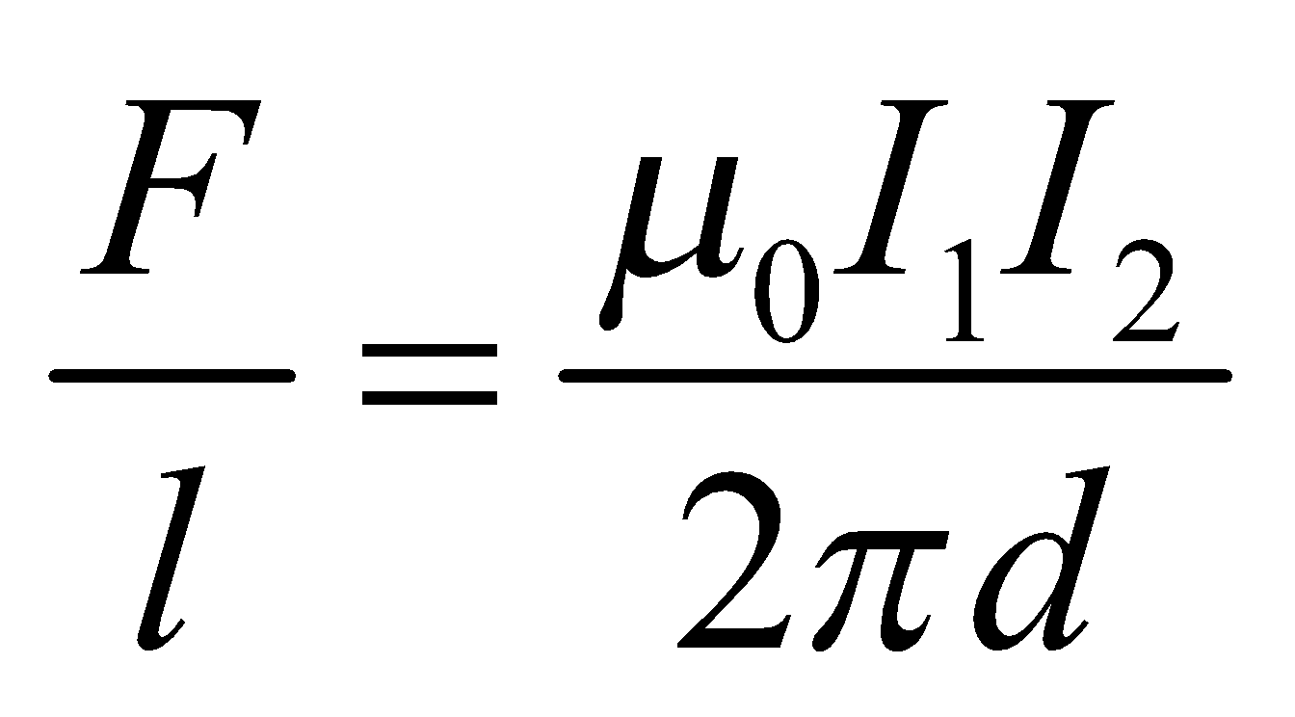

**Evaluate** Inserting the given quantities gives

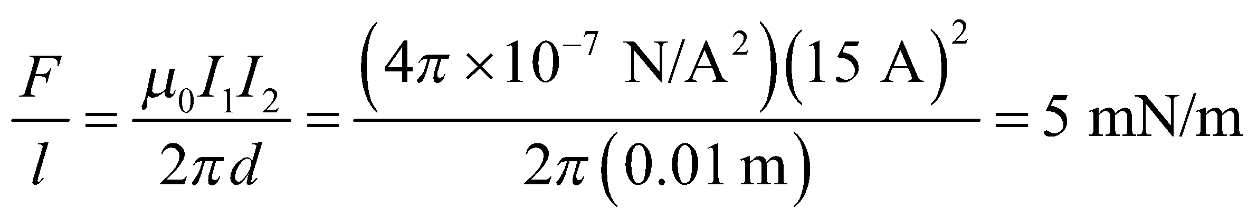

to a single significant figure.

**Assess** If the currents were in the opposite directions, the force would be zero.

**Section 26.6 Magnetic Dipoles**

**34. Interpret** We are to find the magnetic field strength produced by the Earth’s magnetic dipole.

**Develop** Apply Equation 26.12, which gives the magnetic field strength *B* at a distance *x* along the axis of a magnetic dipole moment *μ* as

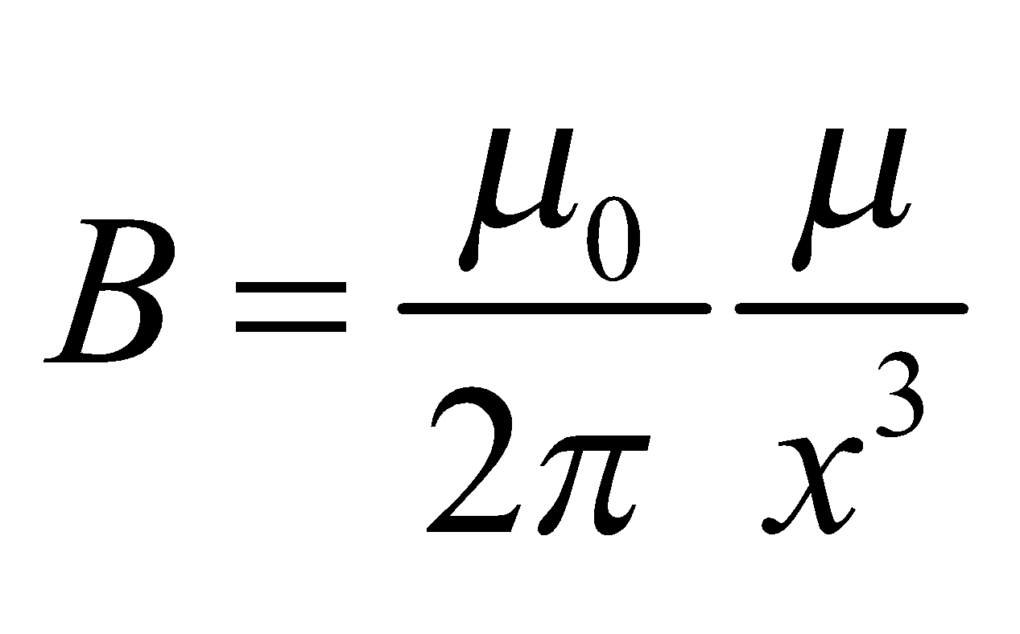

**Evaluate** Substituting the values given, we find the field strength to be

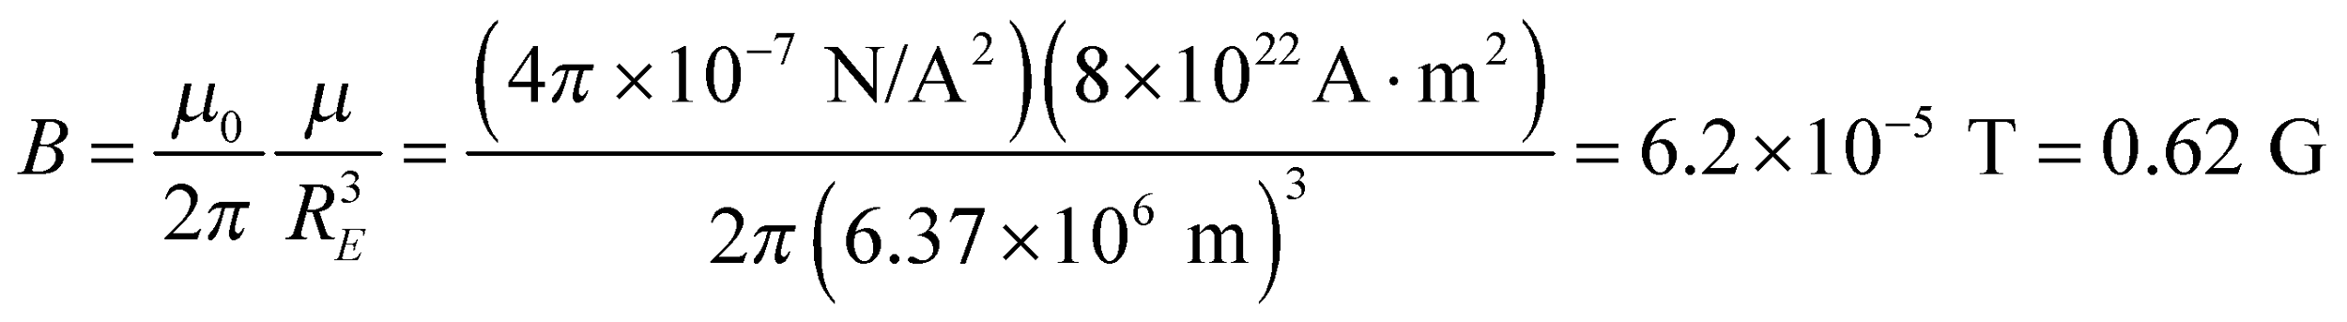

**Assess** The main component of the Earth’s magnetic field is a dipole. The magnetic field near the surface of the Earth is about 0.5 G.

**35.** **Interpret** We are to find the strength of the magnetic dipole moment of the given current loop, and the magnitude of the torque it would experience when placed at 40° in the given magnetic field.

**Develop** To find the magnetic dipole moment, apply Equation 26.13, 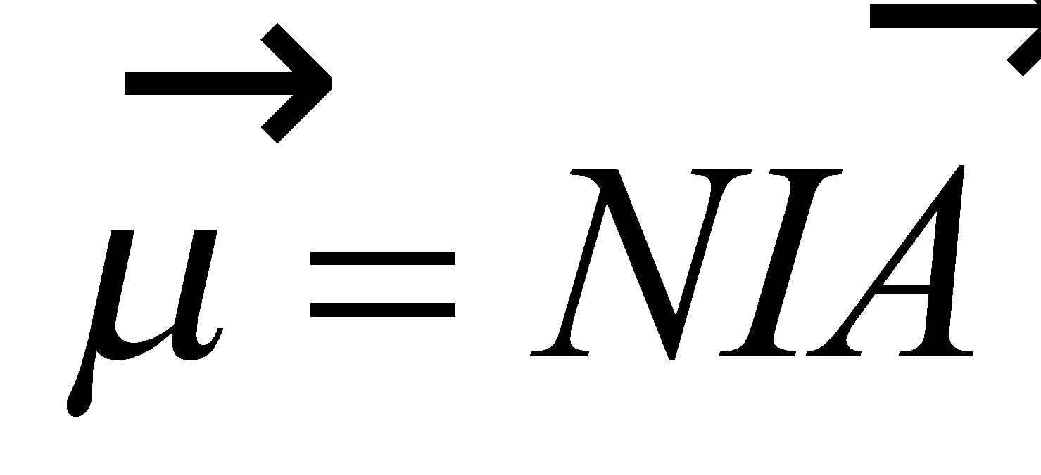, which in scalar form is *μ* = *NIA*. The torque on this loop in a magnetic field B = 1.4 T is given by Equation 26.15.

**Evaluate** (**a**) The strength of the magnetic dipole moment is



(**b**) The torque on the current loop is



**Assess** The maximum torque occurs at *θ* = 90°, as expected.

**36. Interpret** This problem is about an electric motor. We are asked to find the magnetic field strength, given the torque, the current, and the area of the current loop.

**Develop** The maximum torque on a plane circular coil follows from Equations 26.15 (i.e., for *θ* = 90°):

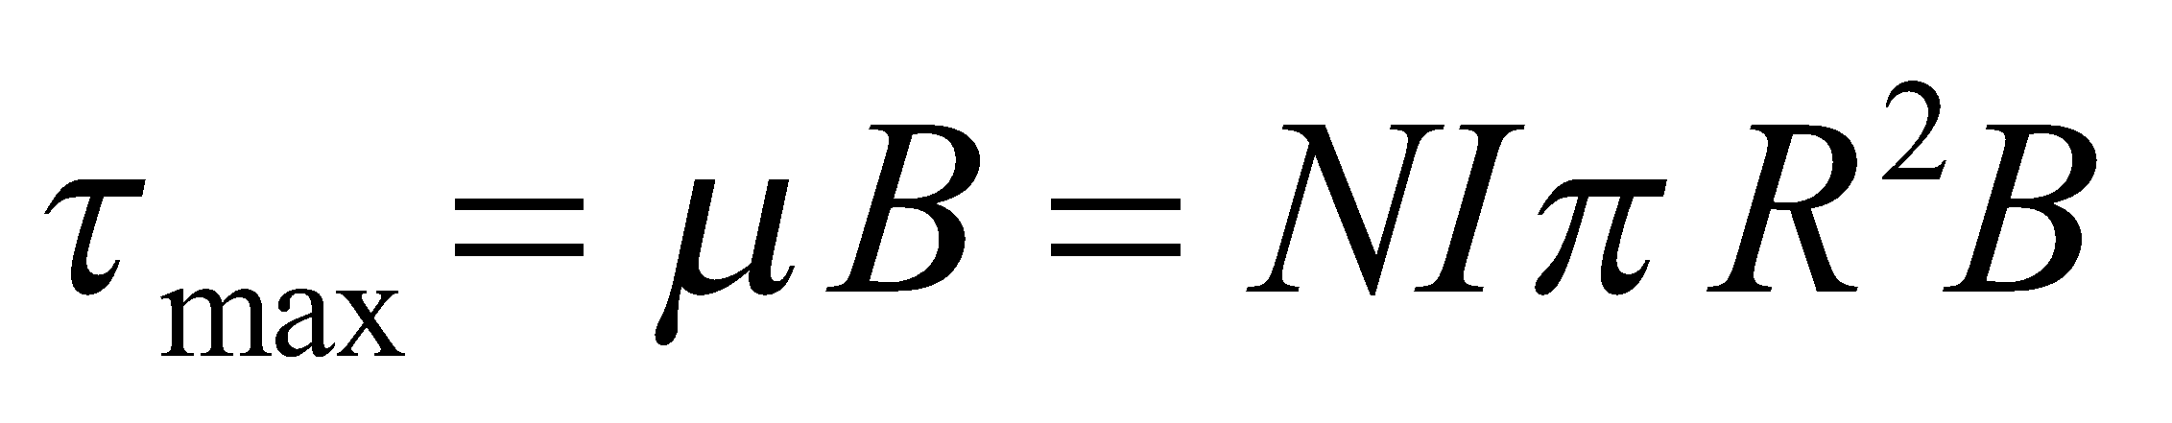

**Evaluate** Solving the expression above for *B* gives

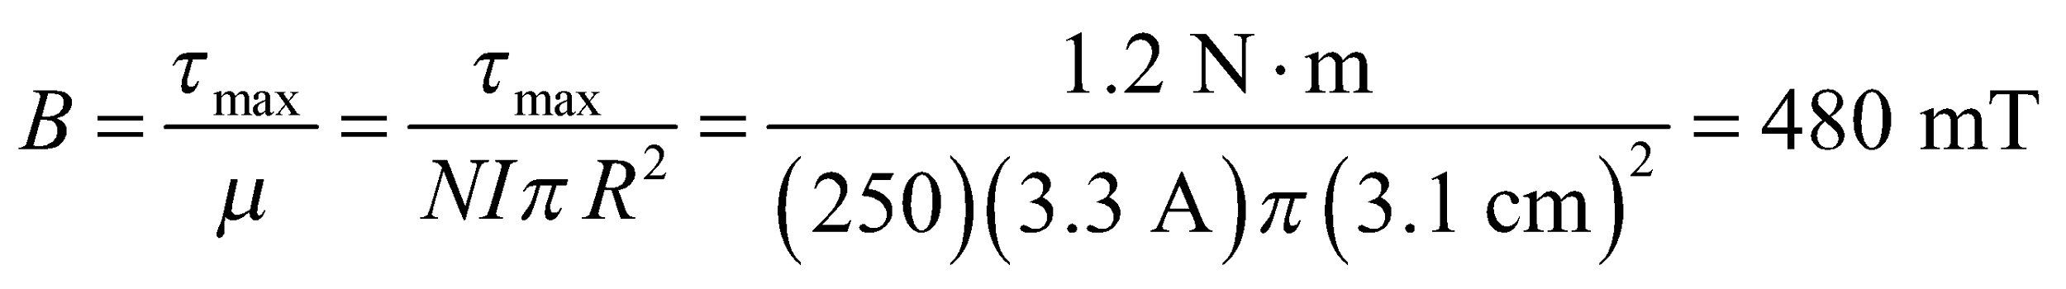

to two significant figures.

**Assess** This field strength is rather high, but it is reasonable for producing the torque needed to rotate the motor.

**Section 26.8 Ampère’s Law**

**37.** **Interpret** This problem involves Ampère’s law for magnetism, which we will use to find the current in a wire given the magnitude of the line integral of the magnetic field.

**Develop** Apply Equation 26.17, where the left-hand side is 8.8 mT.

**Evaluate** Inserting the given quantity for the integral and solving for the current gives

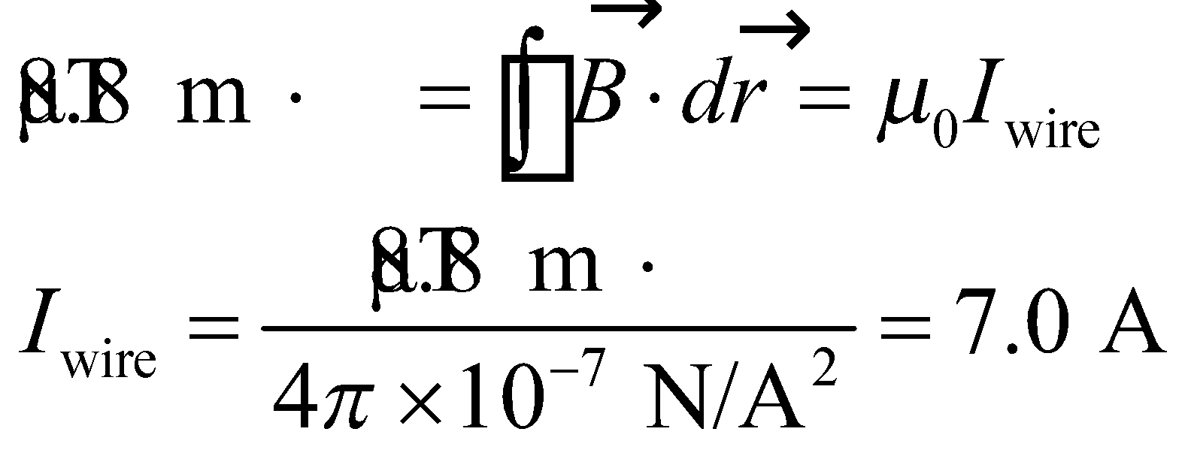

**Assess** The current within the area defined by the line integral is directly proportional to the value of the line integral.

**38. Interpret** This problem involves an application of Ampère’s law, which we can use to find the current enclosed by the loop. The magnetic field is antisymmetric about the horizontal axis through center of the Ampèrian loop, so the contribution to the integral from the top and bottom part of the loop is the same.

**Develop**Applying Ampère’s law (Equation 26.17) to the loop shown in Fig. 26.38 (going clockwise) gives

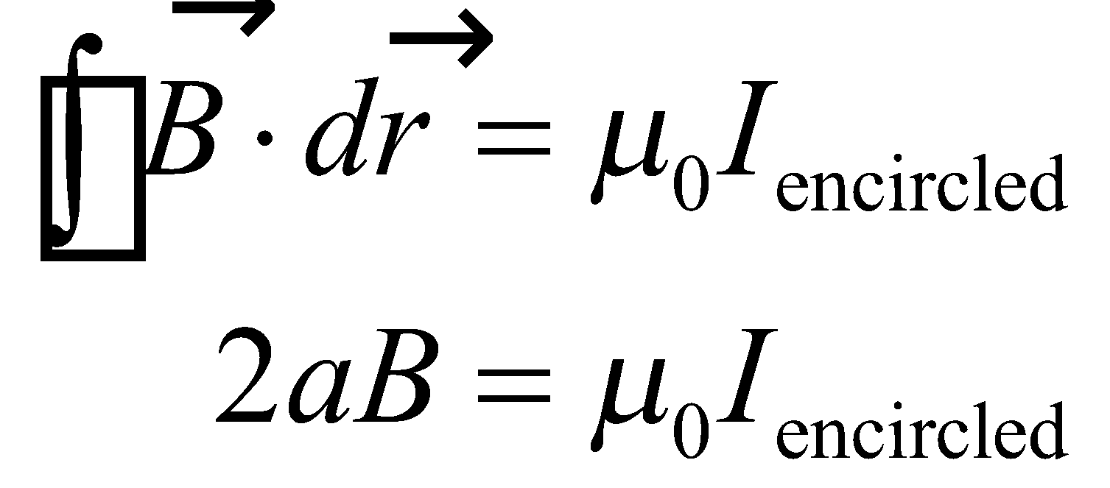

where *a* = 20 cm is the length of the top and bottom of the loop. Note that the vertical sides of the loop give no contribution to the line integral because they are perpendicular to the field.

**Evaluate** Thus, the encircled current is

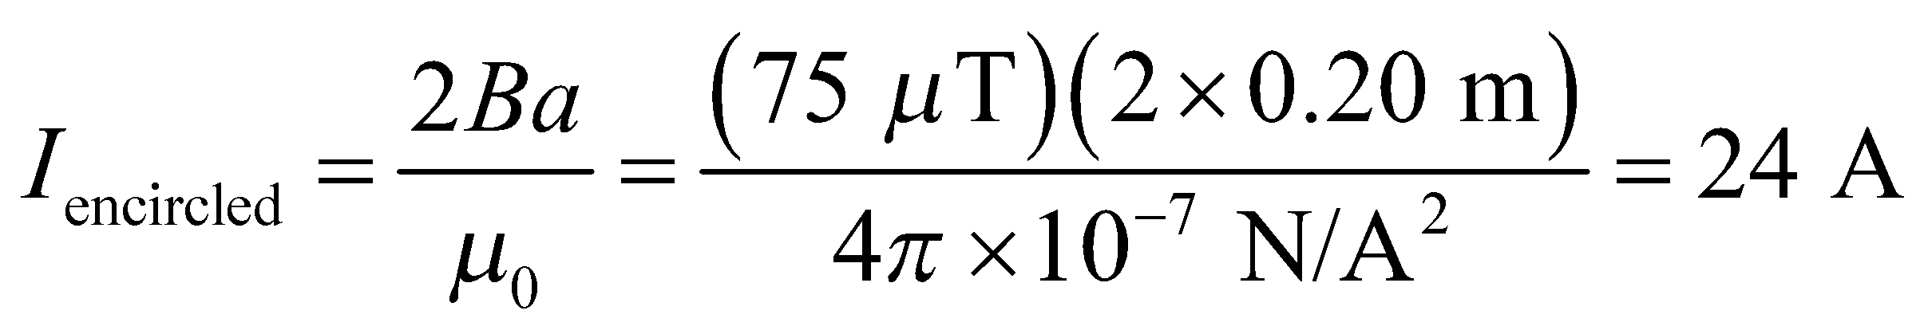

**Assess**As explained in the text, the current flows along the boundary surface between the regions of oppositely directed  positive into the page in Fig. 26.38, for a clockwise circulation around the loop.

**39.** **Interpret** This problem is similar to Example 26.7. We can apply Ampère’s law to find the strength of the magnetic field inside and at the surface of the wire with the given dimensions and carrying the given current.

**Develop** Because the current is uniform within the wire, the fraction of current contained within 1 mm of the wire’s axis is

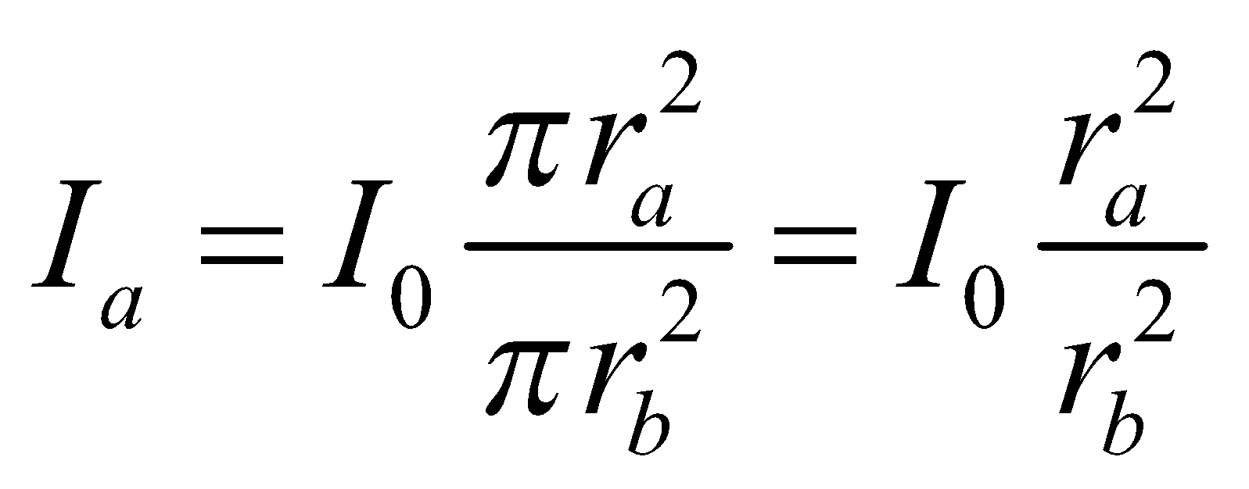

where *r*a = 0.10 mm and *r*b = 1.0 mm. We can insert this into Ampère’s law (Equation 26.17) to find the strength of the magnetic field at *r*a. For part (b), we are to find the magnetic field strength at the surface of the wire (*r*b), so the current enclosed is simply *I*0 = 5.0 A.

**Evaluate** (**a**) The magnetic field strength at 0.10 mm from the wire axis is

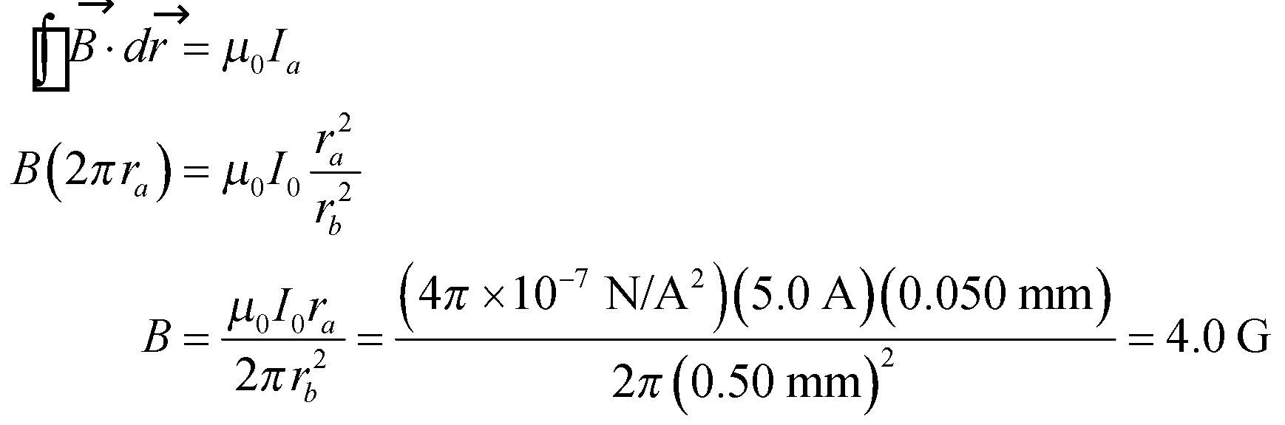

(**b**) At the surface of the wire, Ampere’s law gives

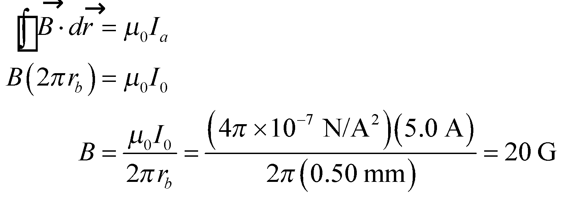

**Assess** Because this problem is the same as Example 26.7, we could have directly applied Equations 26.19 and 26.18 for parts (a) and (b), respectively. The results, of course, are the same.

**40. Interpret** This problem is about the magnetic field of a long current-carrying wire of radius *R*. We want to show that the expression for the current inside the wire (Equation 26.19) reduces to the expression for the current outside the wire (Equation 26.18) at the wire’s surface.

**Develop**Equation 26.18, 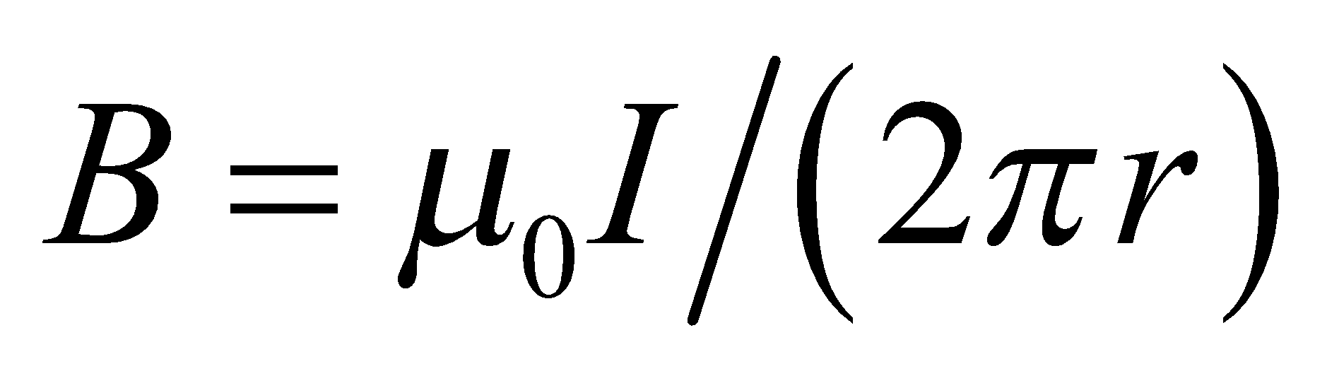 holds for 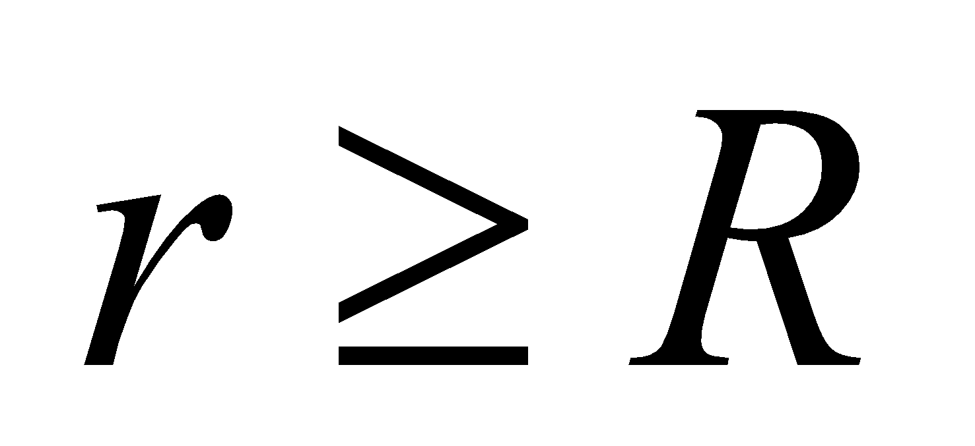 while Equation 26.19, 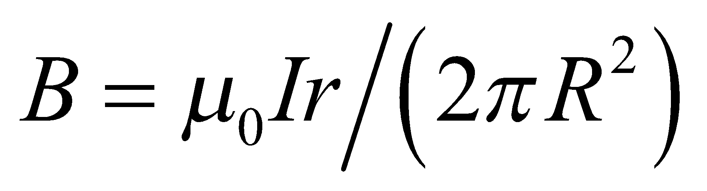 holds for 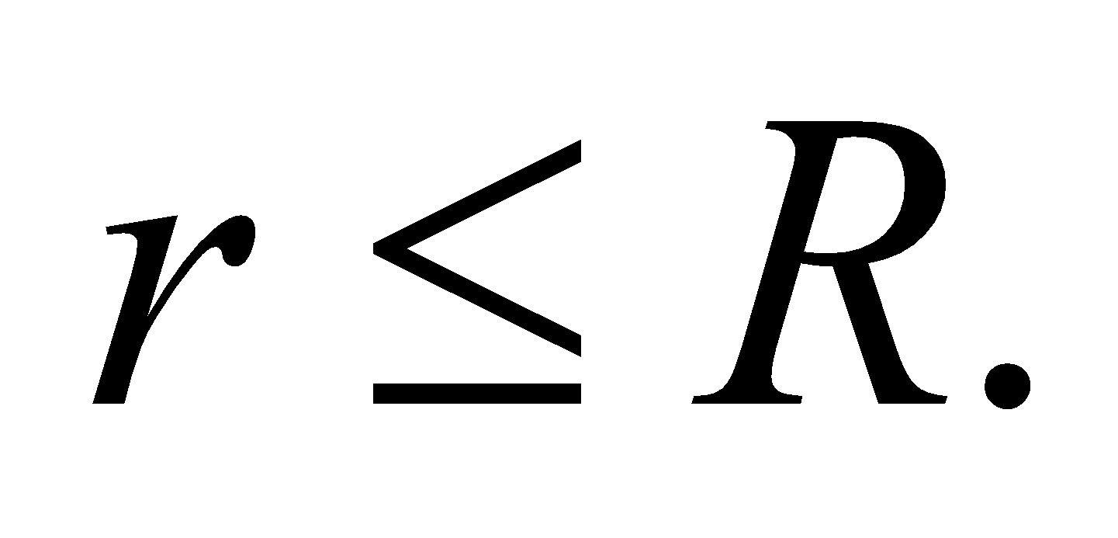 Evaluating both at *r* = *R* will determine if they give the same result at the surface of the wire.

**Evaluate** Inserting *r* = *R* into Equation 26.18 gives 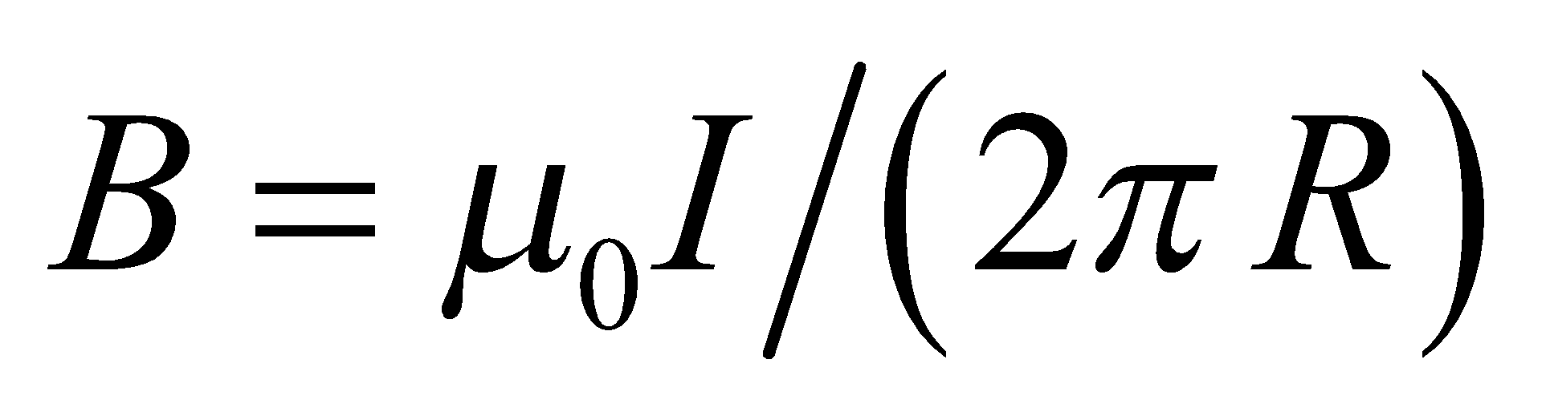. Inserting *r* = *R* into Equation 26.19 gives 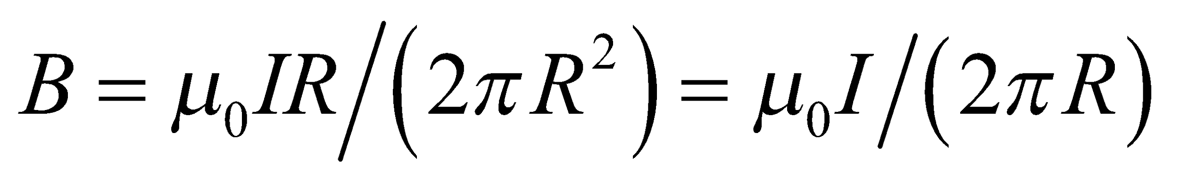, which is the same result as for Equation 26.18.

**Assess** We expect both equations to give the same result for the magnetic field since the encircled current at *r* = *R* is 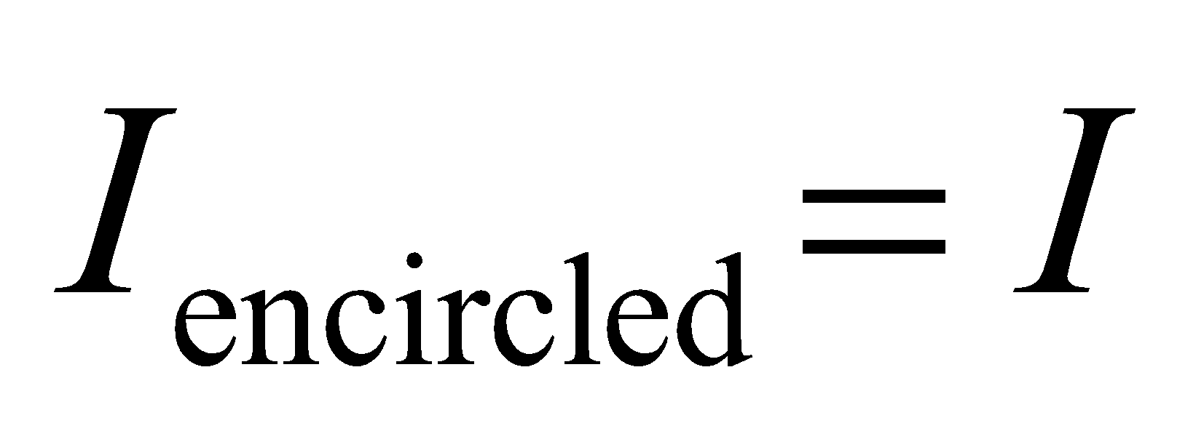 in both cases.

**41.** **Interpret** We are asked to find the magnetic field strength inside a solenoid given the current-loop density and the current.

**Develop** Apply Equation 26.21, which gives the field inside the solenoid (i.e., many radii away from the end of the solenoid).

**Evaluate** Inserting the given quantities gives



**Assess** This is a very strong magnetic field.

**Problems**

**42. Interpret** This problem asks us to find the magnetic force exerted on a moving charged particle. We are given the velocity and magnetic field.

**Develop** The magnetic force on a moving charge can be calculated using Equation 26.1: 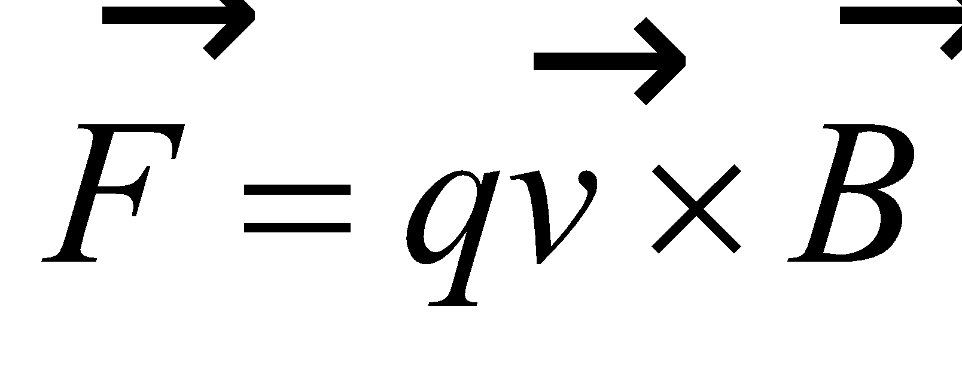, which gives

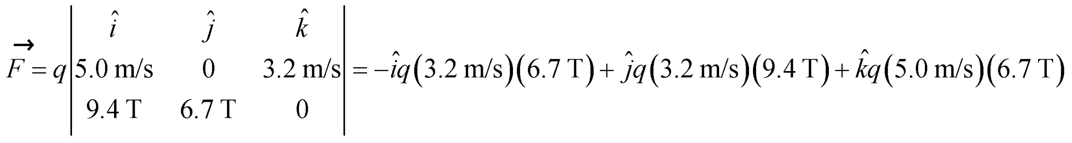

**Evaluate** **(a)** The force is

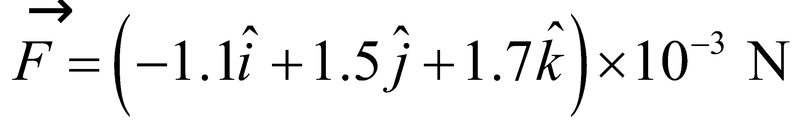

The magnitude and direction can be found from the components, if desired.

**(b)** The dot product between force and velocity is

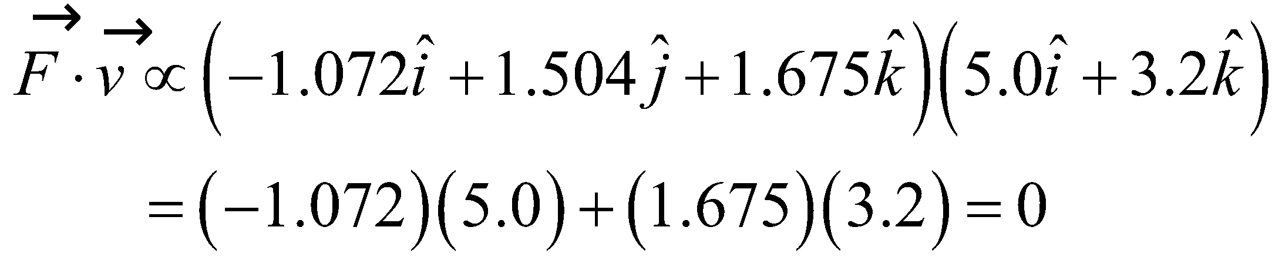

The dot product between force and the magnetic field is

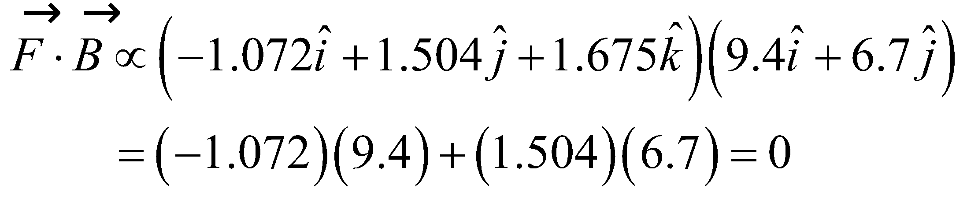

**Assess**The fact that the product 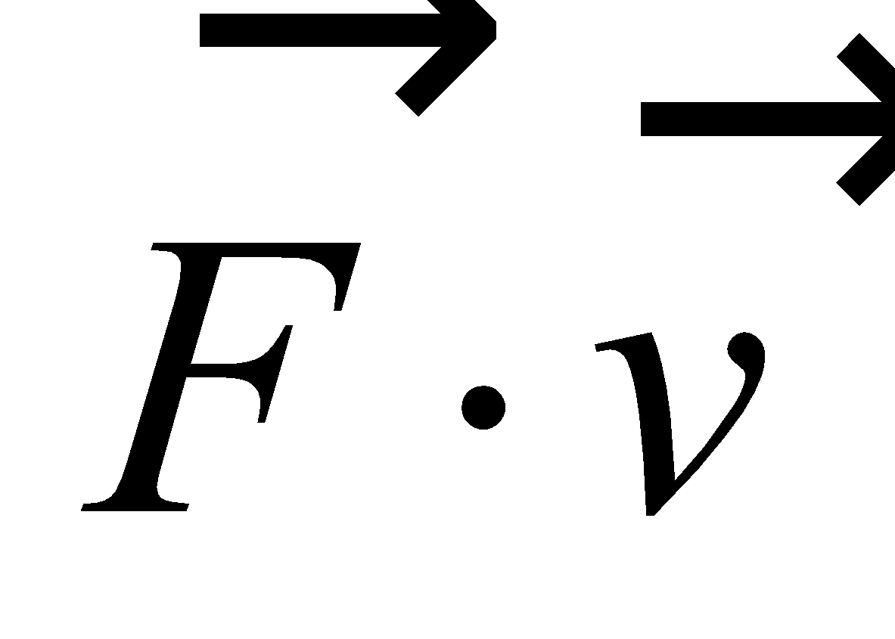 vanishes can also be shown in a general fashion as follows:

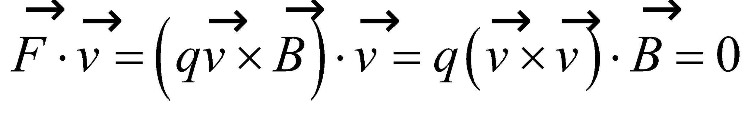

where we have used the vector identity 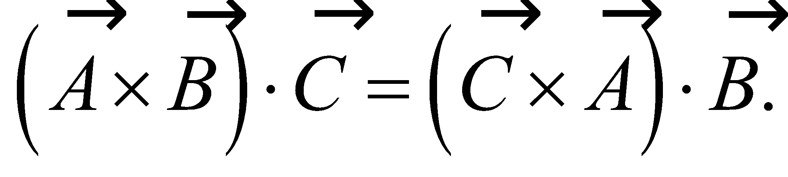

**43.** **Interpret** The problem asks us to estimate Jupiter's magnetic dipole moment given the magnetic field strength at its poles.

**Develop**The magnetic field on the axis of a magnetic dipole far from its center is given by 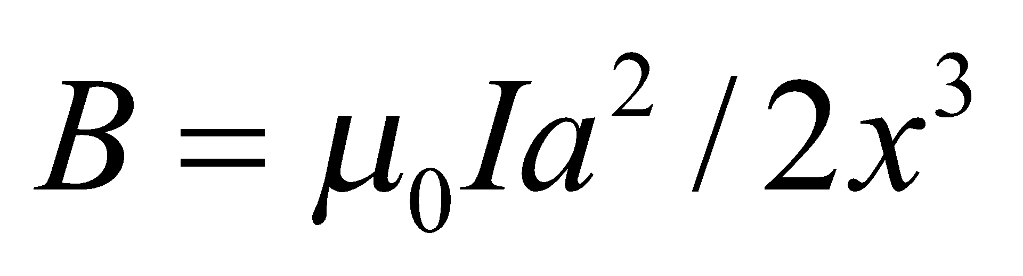(see Equation 26.9). If we substitute 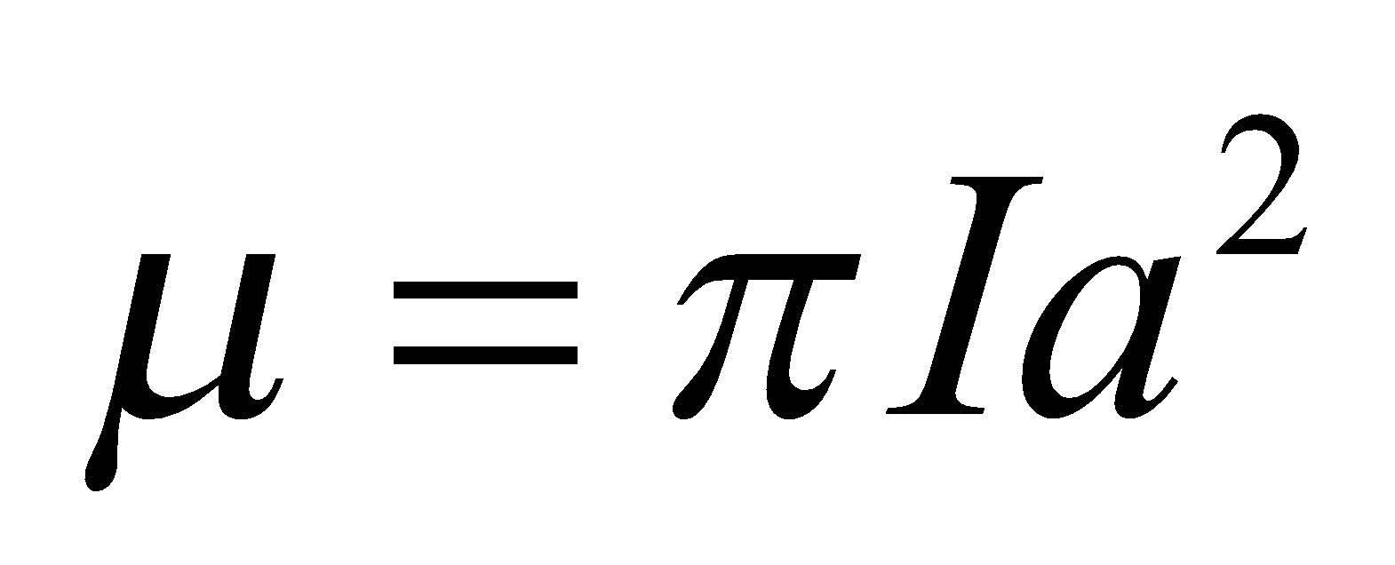for the magnetic dipole moment, 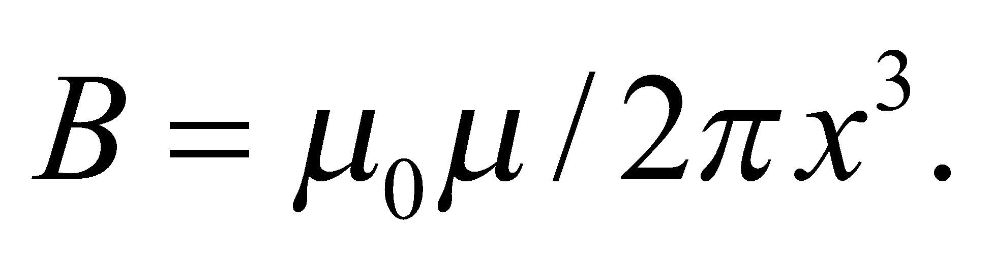

**Evaluate**We can assume that Jupiter's poles are both one radii away from the planet's magnetic dipole: 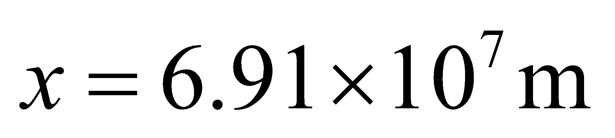 (from Appendix E). Given the field at the poles, the magnetic dipole moment is

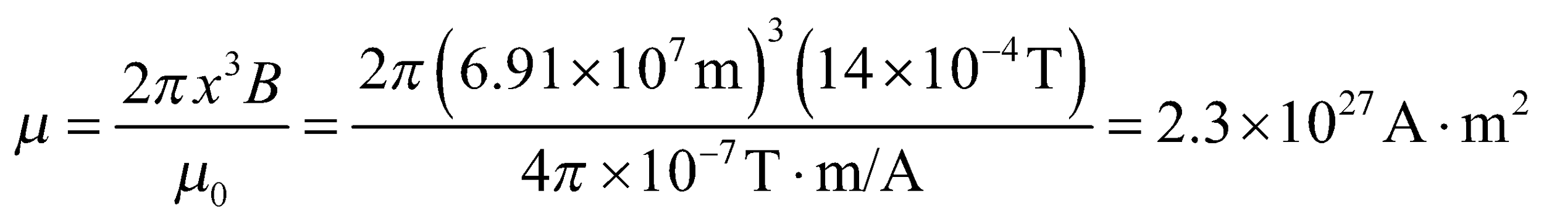

**Assess** This is a huge dipole moment, but we can imagine it would have to be to produce a planet-wide magnetic field. The units are correct, since the magnetic dipole moment is current multiplied by area. Jupiter's magnetic field is believed to arise from currents in metallic hydrogen found deep beneath the planet's surface. If we assume that Jupiter's dipole moment were due to a single giant current loop with a radius half that of the planet, the loop would have to carry a current of 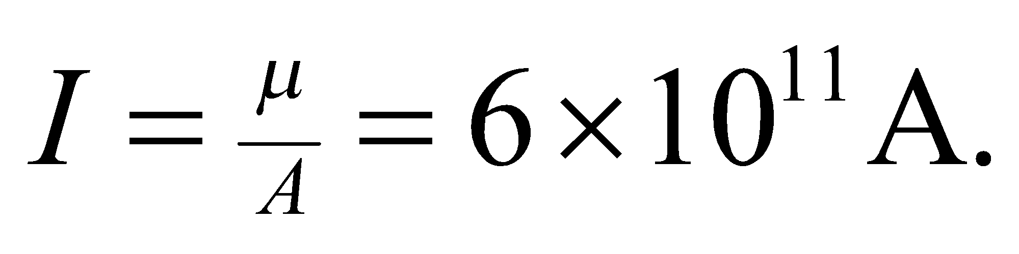

**44.** **Interpret** We are given the force exerted on a first proton of known velocity and the force exerted on a second proton whose velocity direction is given, but not its speed. We are to find the magnetic field vector and the speed of the second proton.

**Develop** Apply Equation 26.1 to generate two scalar equations relating the components of the force to those of the velocity and magnetic field. For the first proton, this gives

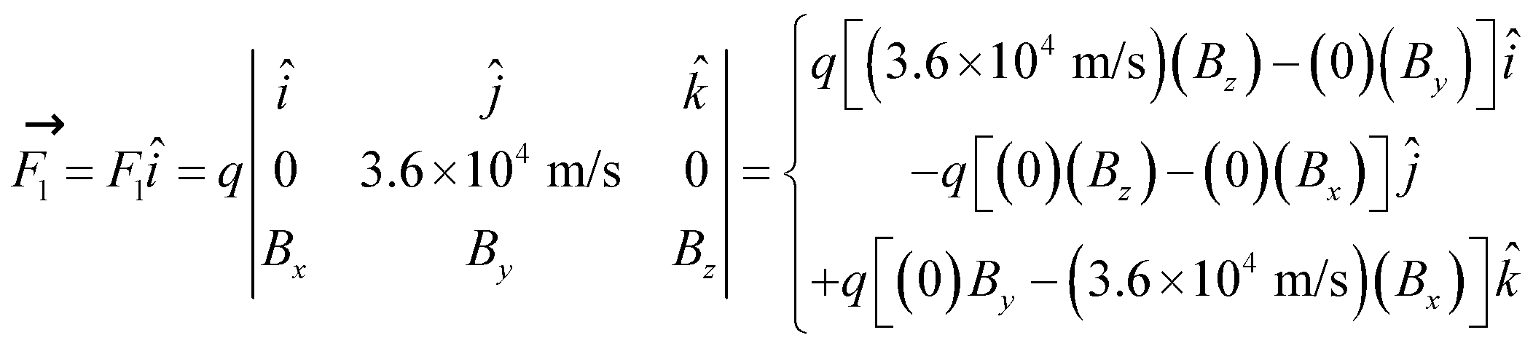

which tells us that *B*x = 0 because *F*1 has no *z* component. For the second proton, Equation 26.1 gives

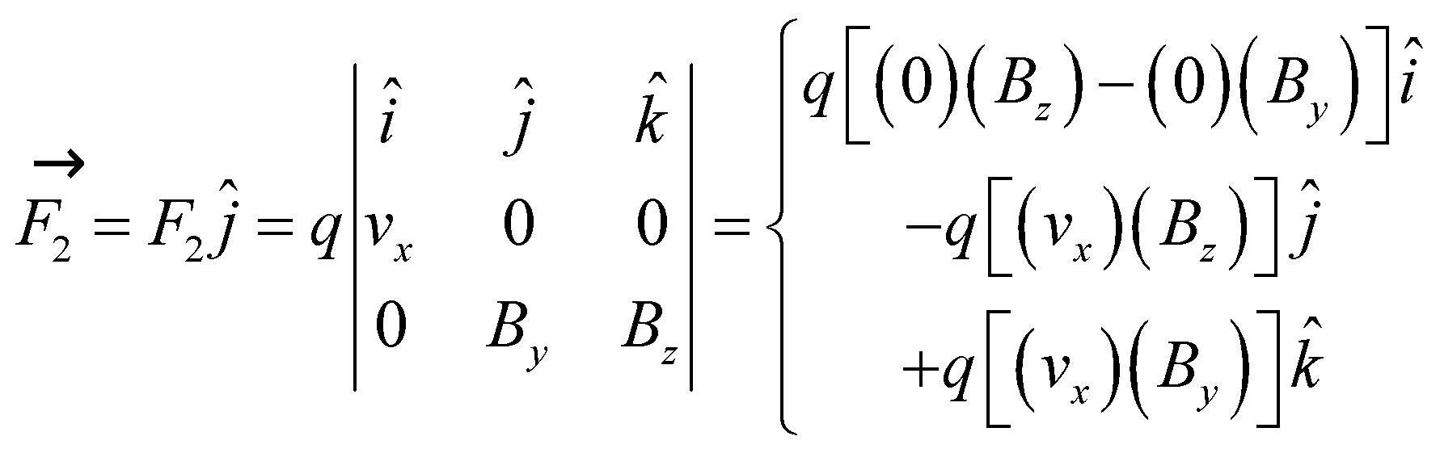

which tells us that *B*y = 0 because the *F*2 has no *z* component. We can equate the vector components to find *B*z and *v*x.

**Evaluate** From the equation for *F*1, the *z* component of the magnetic field is

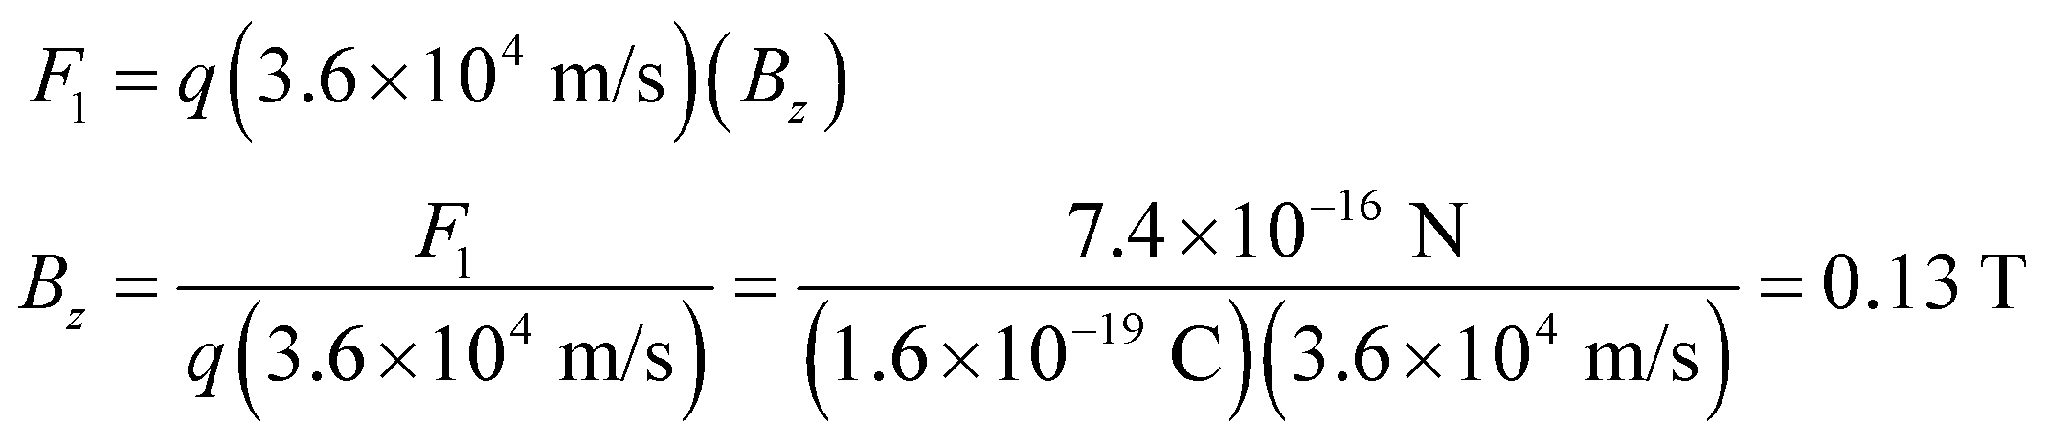

From the equation for *F*2, the speed of the second proton is

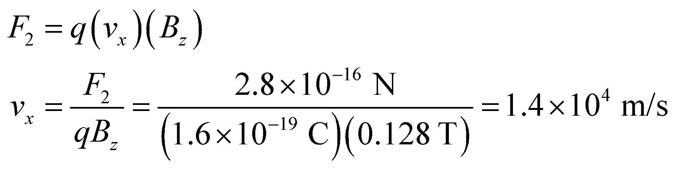

Thus, the magnetic field is 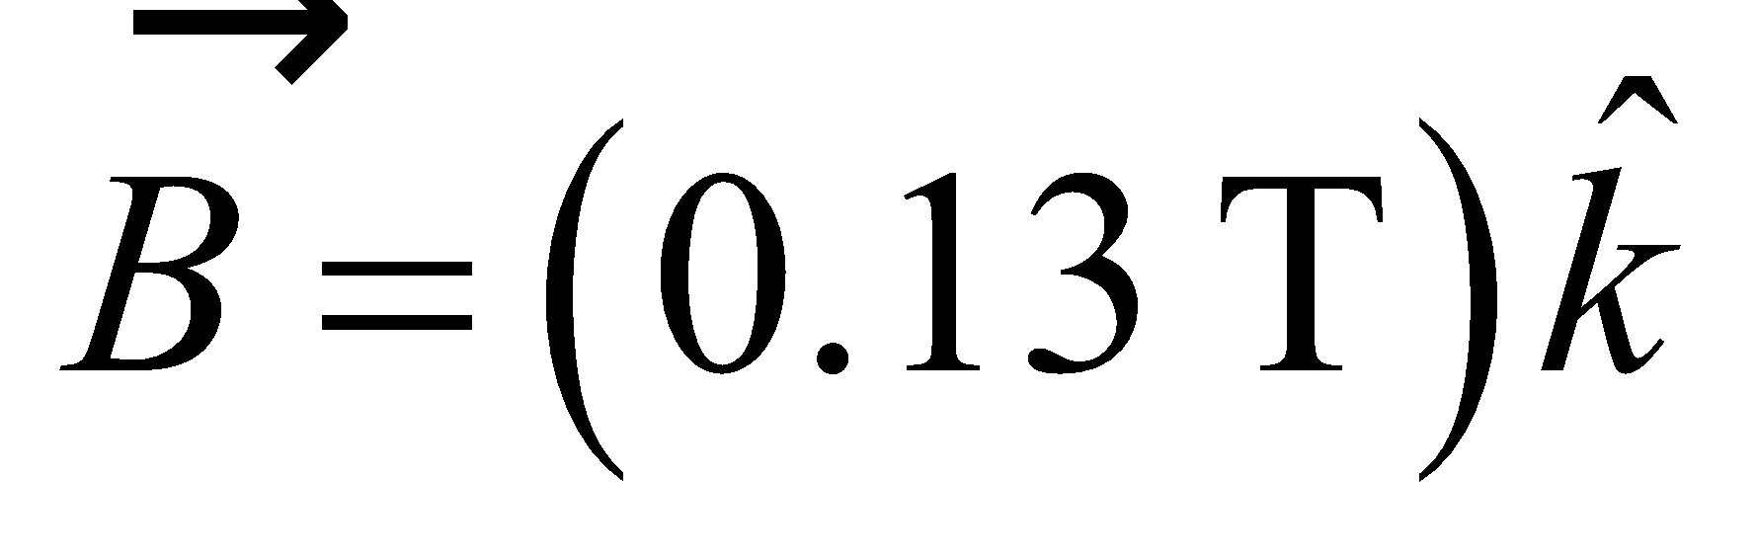 and the velocity of the second proton is 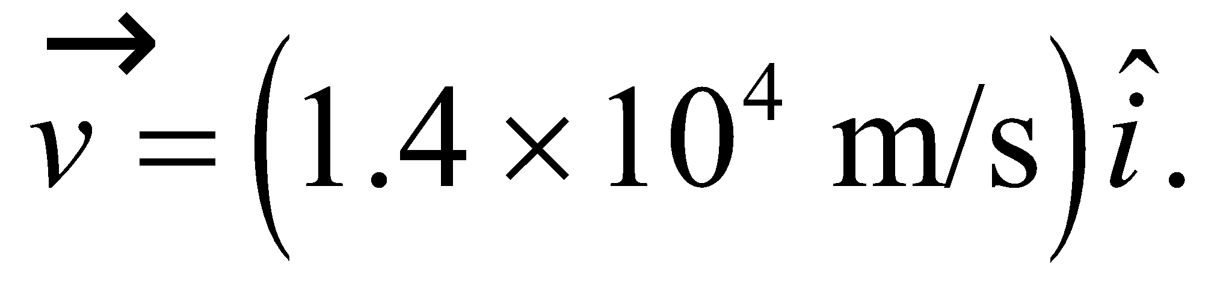

**Assess** As required, the force is perpendicular to the magnetic field and to the velocity in each case.

**45.** **Interpret** We are asked to approximate the amount of current flowing in the Earth's liquid core that would produce the measured magnetic field at the poles. We assume the current is confined to a single loop whose axis passes through the poles.

**Develop**The magnetic field from a single current loop was calculated in Example 26.3 for a point on the loop's axis: 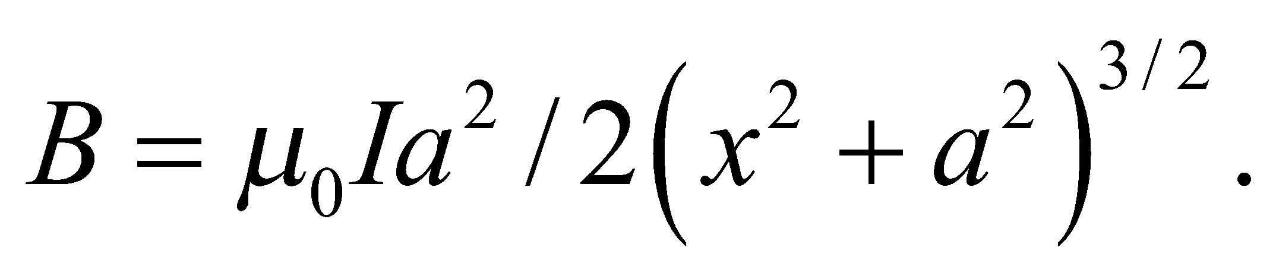 For the given model of the Earth's field, the radius of the loop, 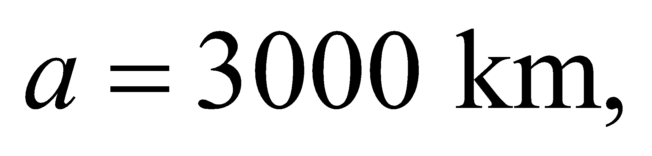is not much smaller than the distance to the north pole: 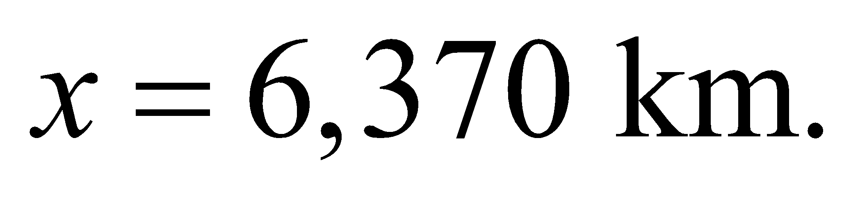

**Evaluate**Solving for the current, we arrive at

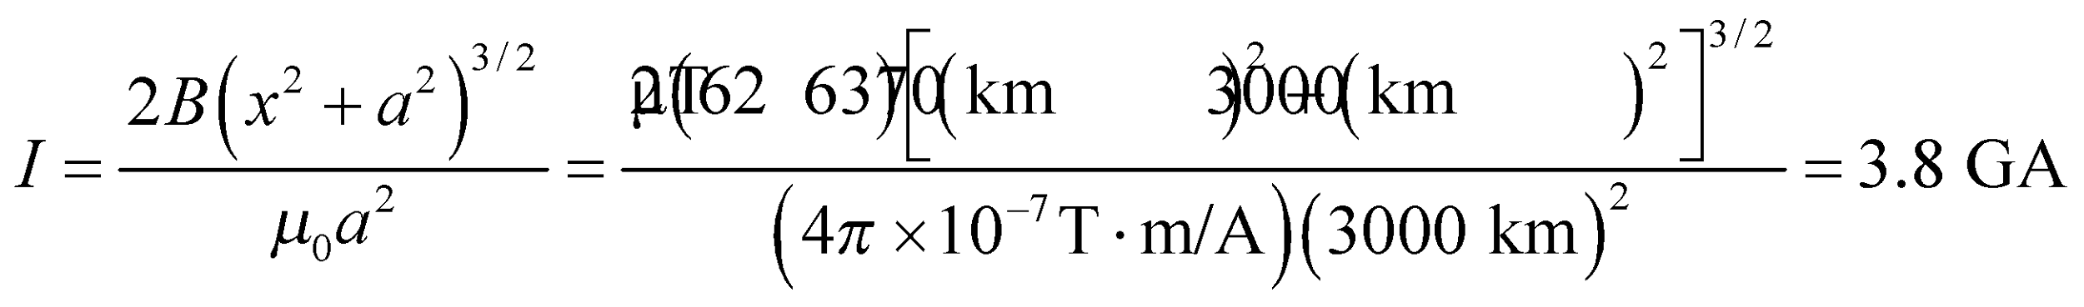

**Assess** A single current loop would generate a dipole magnetic field, but the Earth's field is more complicated than that. It is believed that convection of molten iron in the liquid core creates a dynamo that sustains the planet's magnetic field.

**46.** **Interpret** A beam of electrons will be bent by a magnetic field. We are asked to find the farthest that the beam penetrates into the region defined by the field.

**Develop**Since the beam is perpendicular to the field, it will follow a circular path with radius 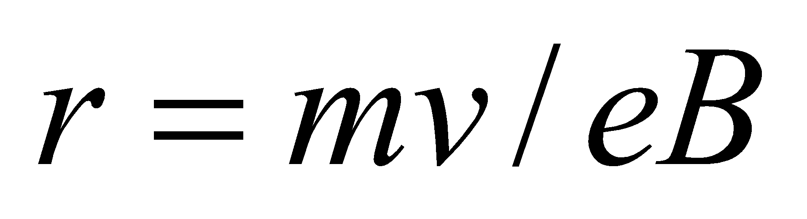 (Equation 26.3). Moreover, since the beam enters perpendicularly the magnetic field region, it will complete a half-circle before exiting in the opposite direction that it entered. Therefore, the farthest that the electrons penetrate is the same as the radius of curvature.

**Evaluate**The penetration distance is

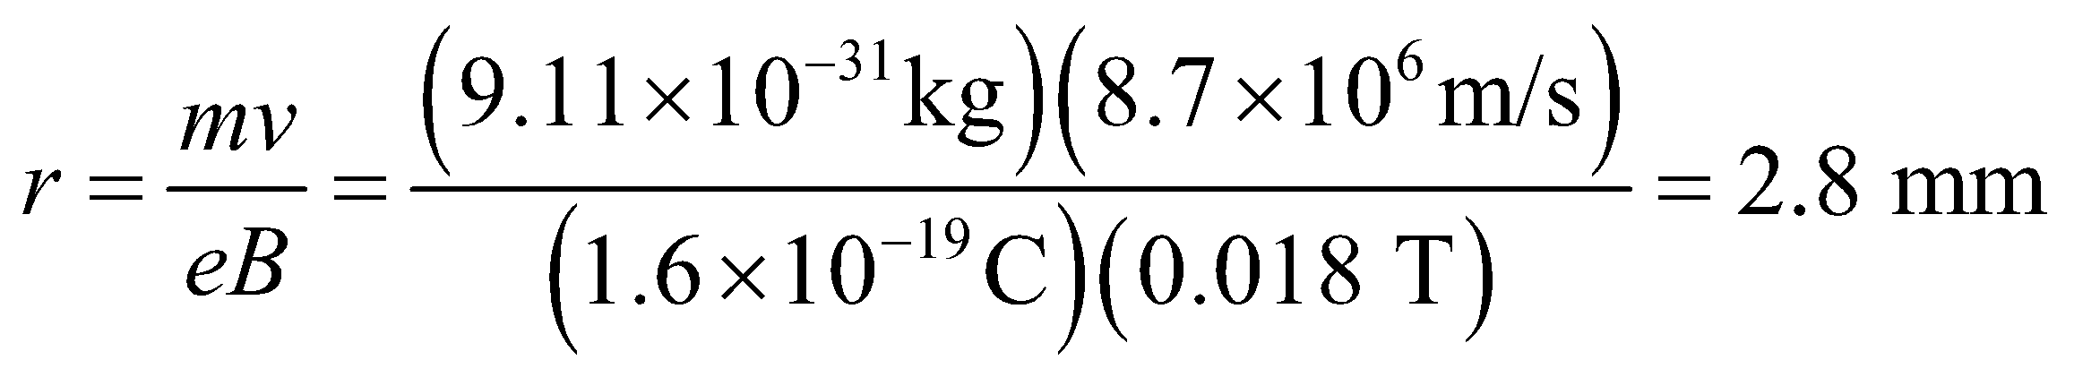

**Assess** The field acts like a mirror, reflecting the electrons back at the same initial speed with a small displacement. We can explore what happens if the beam enters the field region at angle *θ* to the normal of the boundary, see figure below.



In this case, the beam penetrates a distance 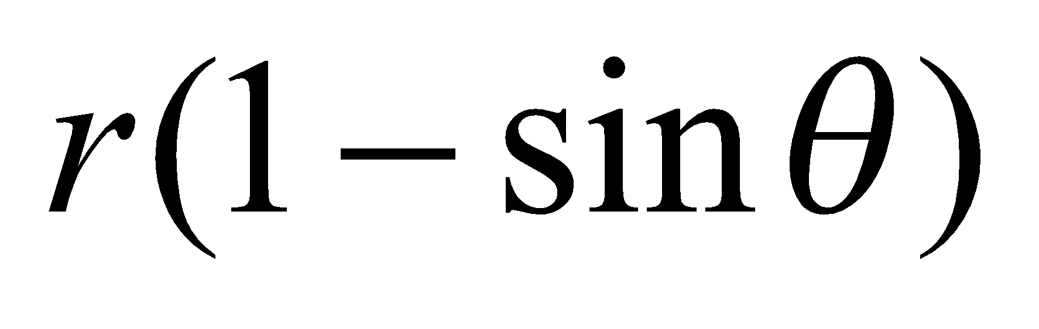into the region and exits at the same angle *θ* on the other side of the normal.

**47. Interpret** This problem is about a charged particle undergoing circular motion in a magnetic field, and we want to express the radius of the orbit in terms of its charge, mass, kinetic energy, and the magnetic field strength.

**Develop** From Equation 26.3, the radius of the circular motion is 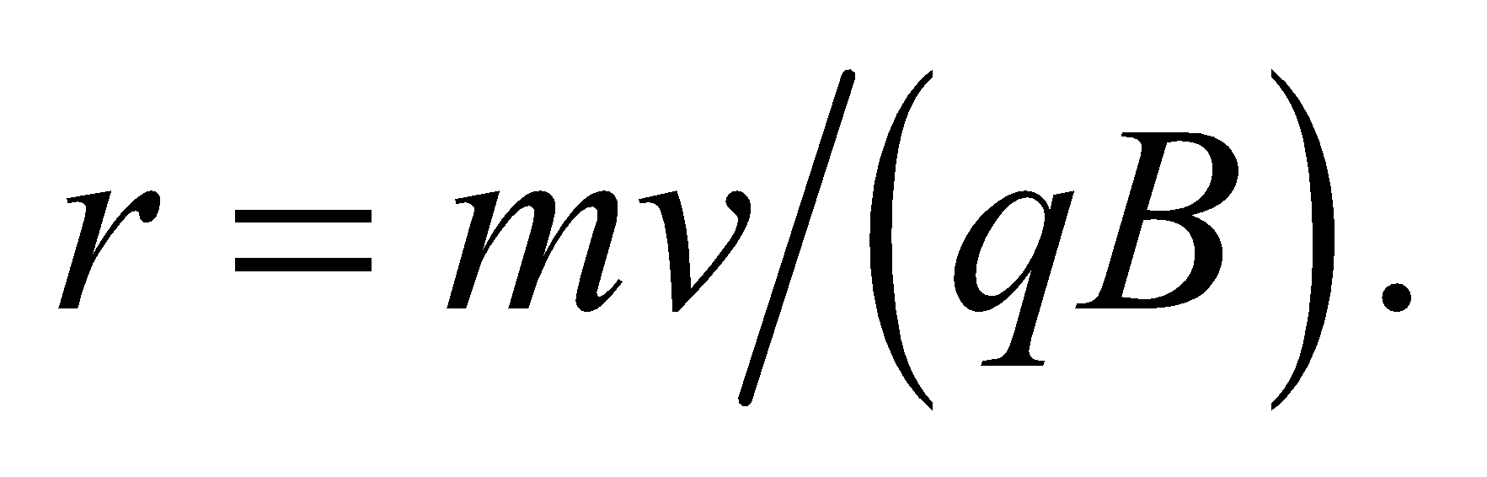 For a non-relativistic particle, 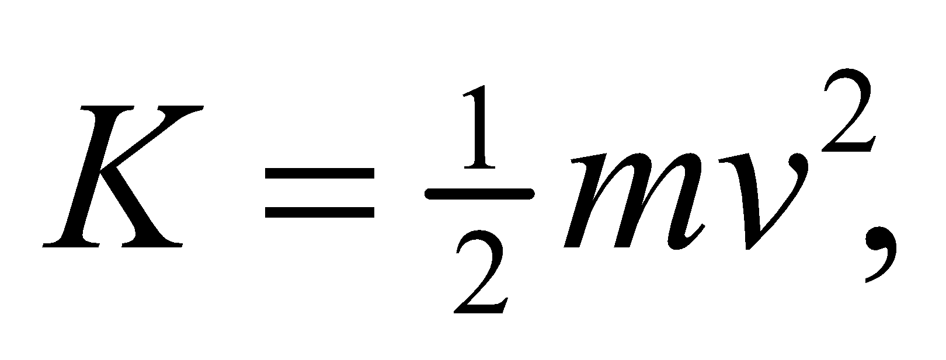 or 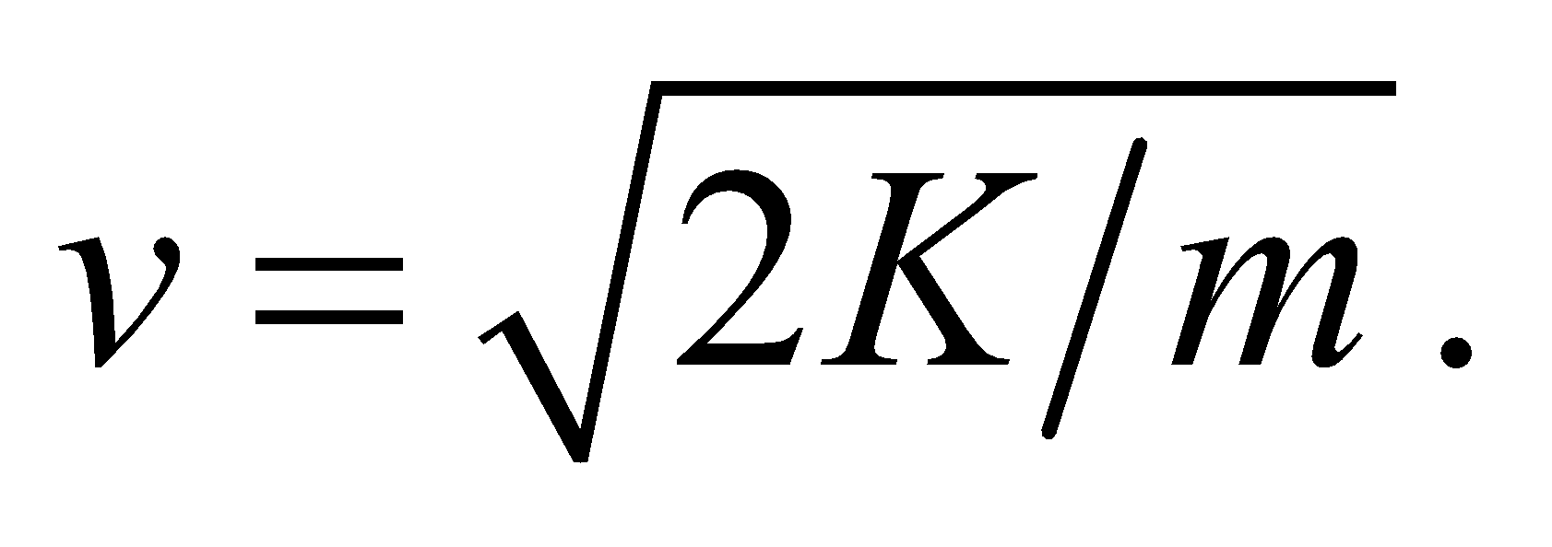

**Evaluate** Therefore, the radius of the orbit is

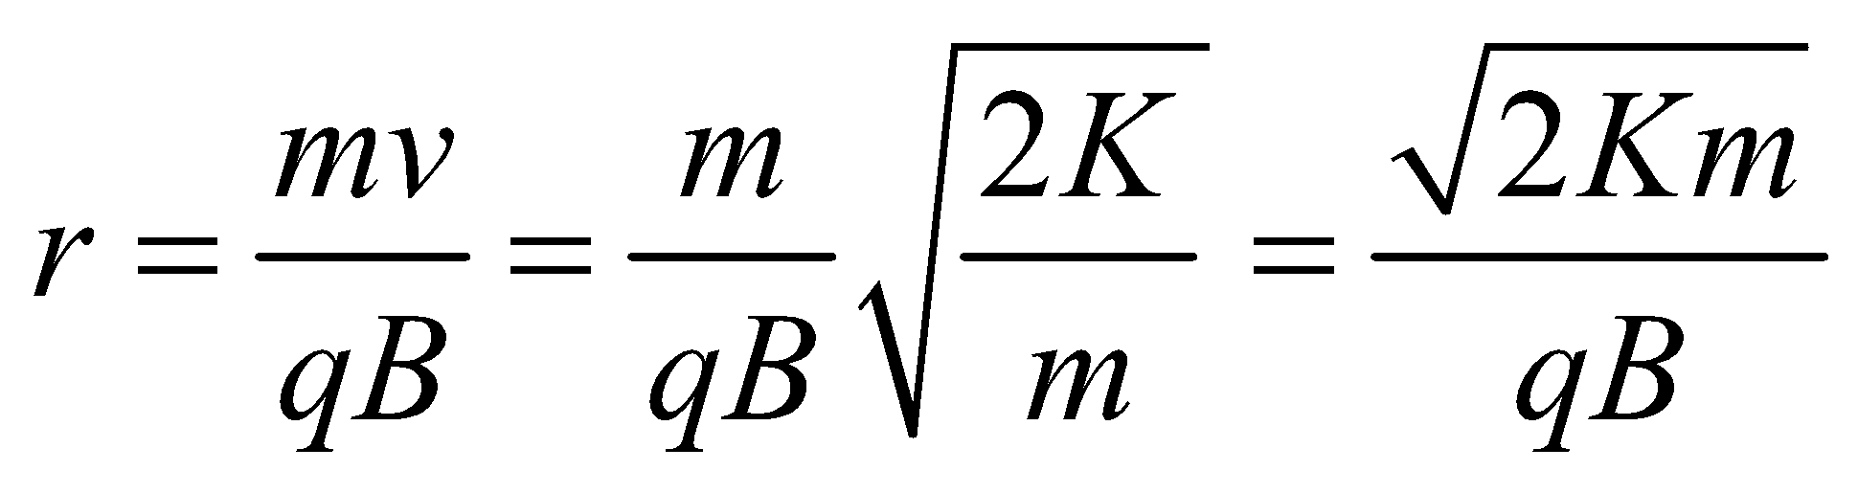

**Assess** Our result indicates that the radius is proportional to 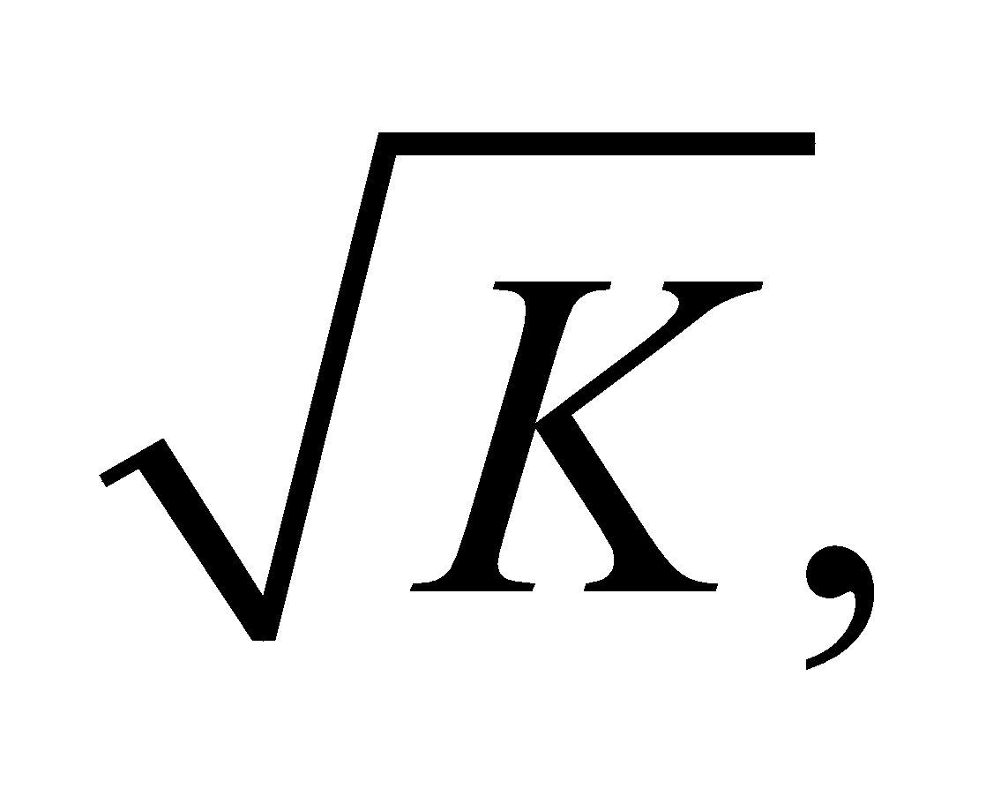 or *v*. Thus, the greater the kinetic energy of the particle, the larger its radius.

**48.** **Interpret** The problem asks us to consider the acceleration of deuterium nuclei in a cyclotron.

**Develop**Particles in a cyclotron get a boost in velocity each time they pass from one dee to the other. The magnetic field holds them in a circular orbit, so they make multiple passes. In order to always be accelerating the particles, the voltage has to be alternated every time they make a half circle of their orbit. In other words, the voltage needs to cycle at the same rate as the particles revolve in the magnetic field, which is just the cyclotron frequenqcy: 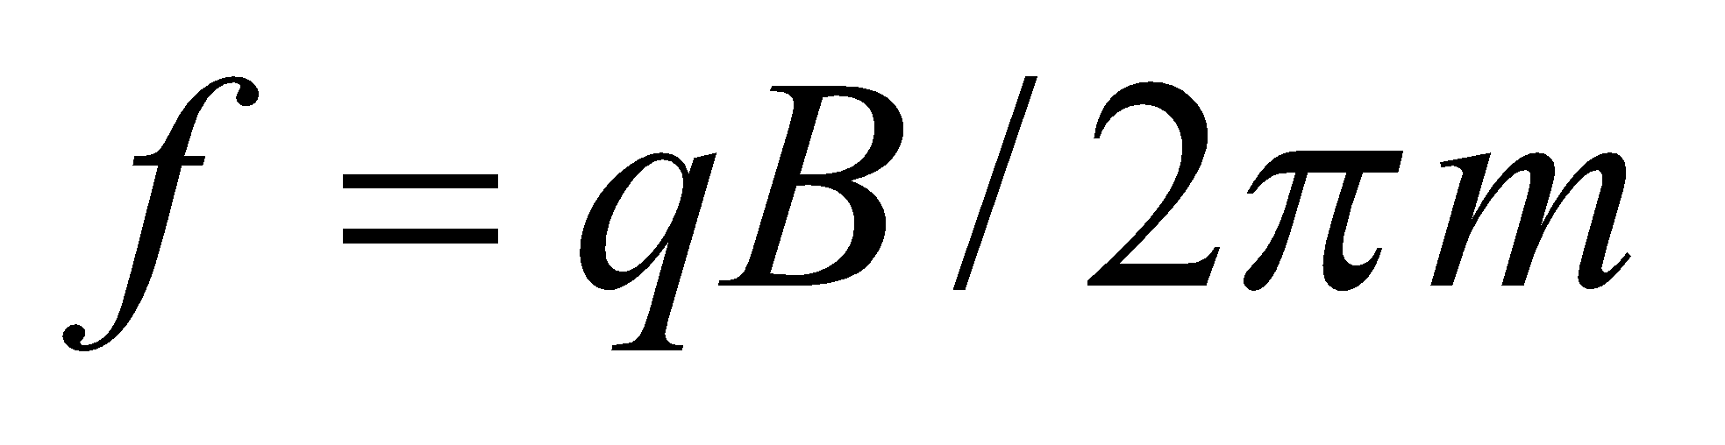 (Equation 26.4). In this case, the particles are deuterium nuclei, which have atomic mass 2 and charge +*e*:

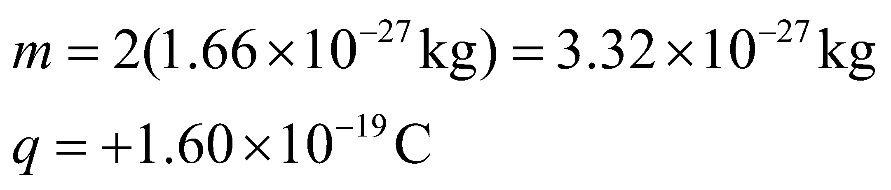

The frequency does not depend on the speed (energy) of the nuclei, but the radius of their orbit does:  (Equation 26.3). The maximum energy is achieved when the nuclei reach the outer rim of the cyclotron. We can figure out how many orbits it takes to reach this maximum by dividing by the kinetic energy gain of each orbit. We'll assume the nuclei have negligible kinetic energy to begin with.

**Evaluate**(a) The frequency at which the voltage should be alternated is:

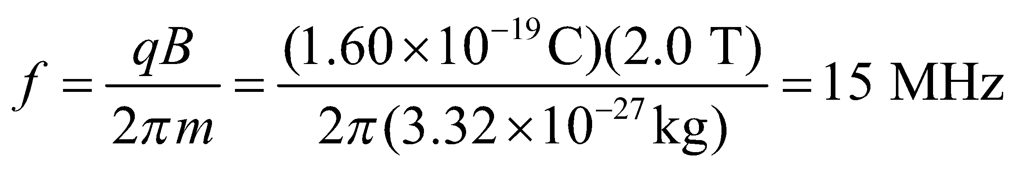

(b) The maximum kinetic energy can be derived from the speed at the cyclotron's radius:

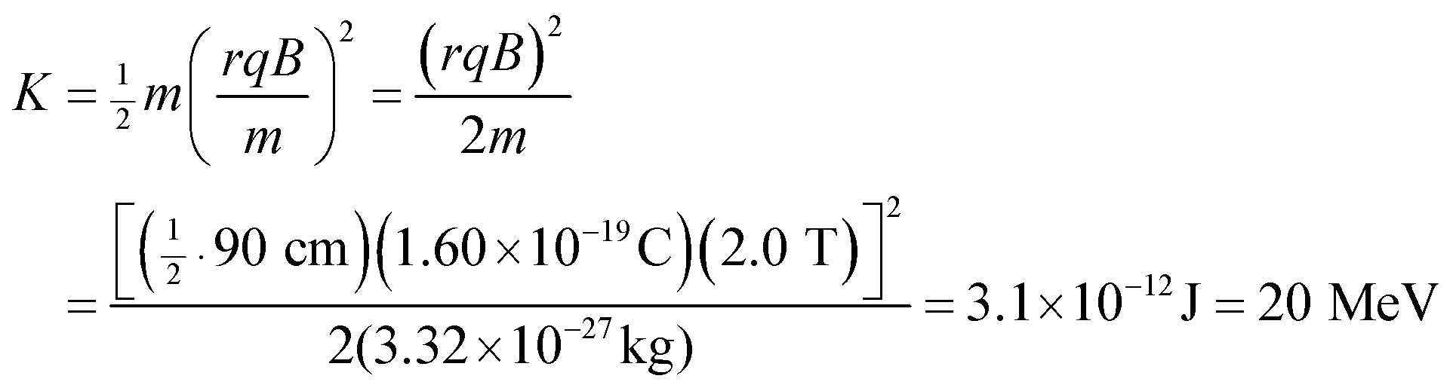

We've written the answer in eV, as this unit is easier to work with for particles.

(c) Each orbit in the cyclotron accounts for two passes across the potential difference between the dees. Therefore, the kinetic energy gain in each orbit is 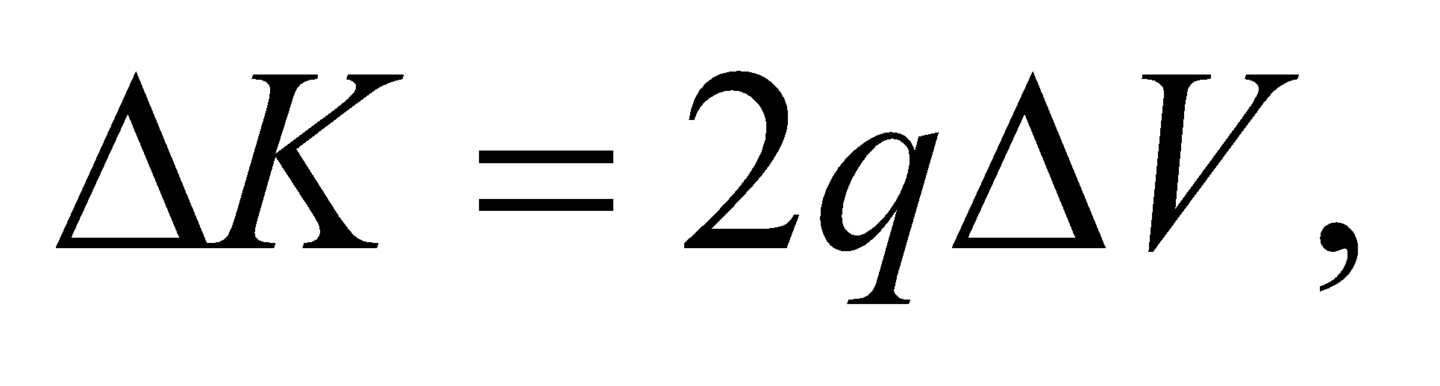 and the number of orbits needed to reach the maximum energy is

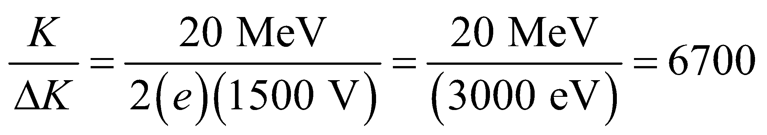

**Assess** Notice how much easier the final calculation was when we were using eV rather than J. At 15 MHz, the deuterium nuclei will reach the maximum energy in less than half a millisecond.

**49. Interpret** In this problem an electron is moving in a magnetic field with a velocity that has both parallel and perpendicular components to the magnetic field. The path is a spiral.

**Develop** The radius depends only on the perpendicular velocity component,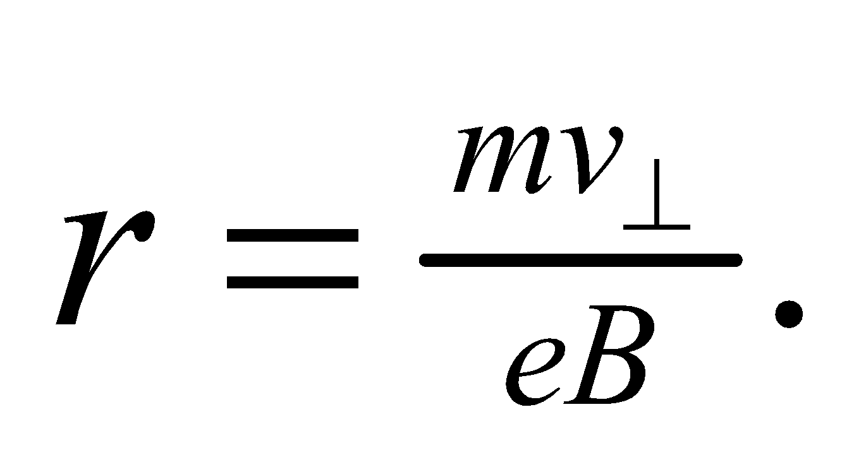On the other hand, the distance moved parallel to the field is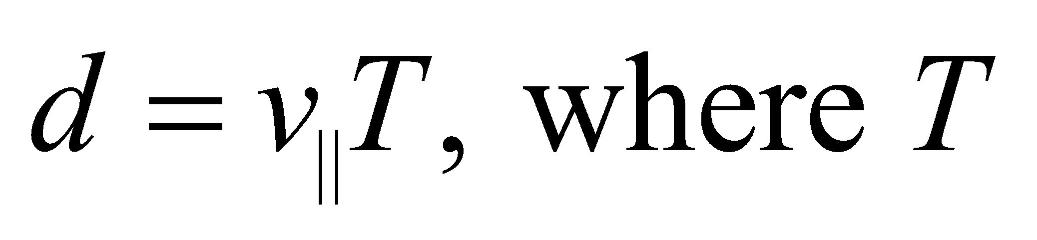is the cyclotron period.

**Evaluate** **(a)** The radius of the spiral path is

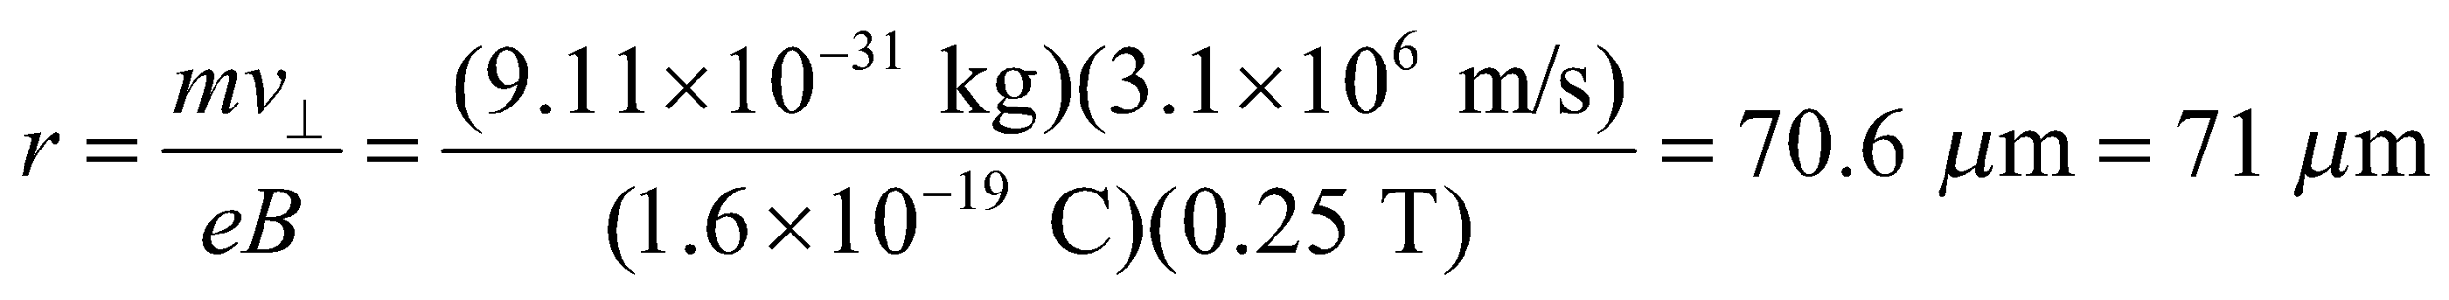

**(b)** Since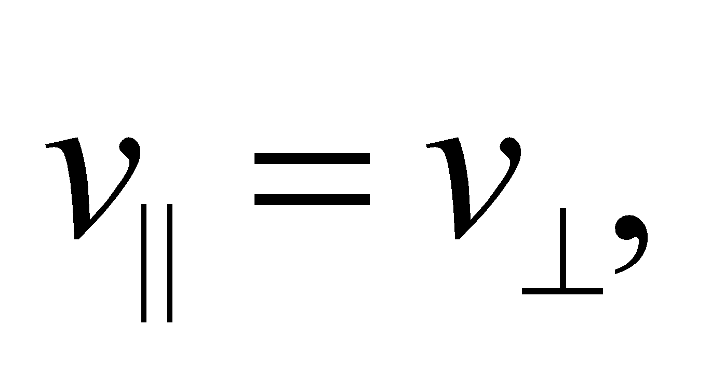the distance moved parallel to the field is

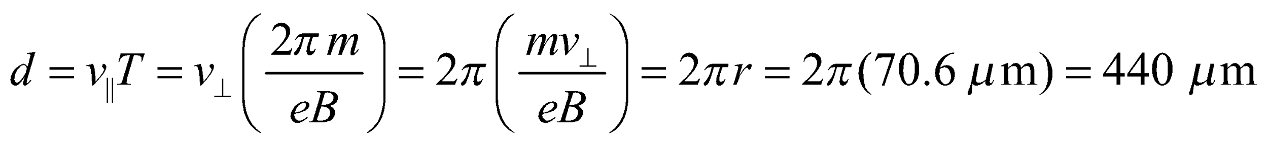

**Assess** Since motion parallel to the field is not affected by the magnetic force, withthe distance traveled in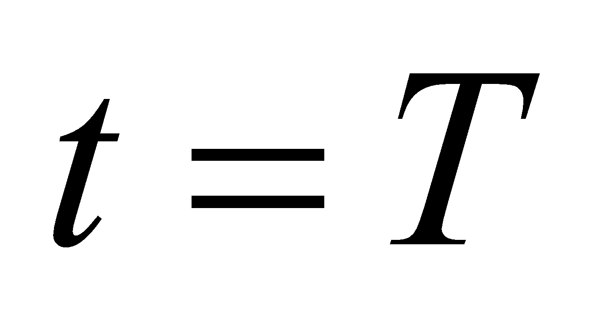along the direction of the field is simply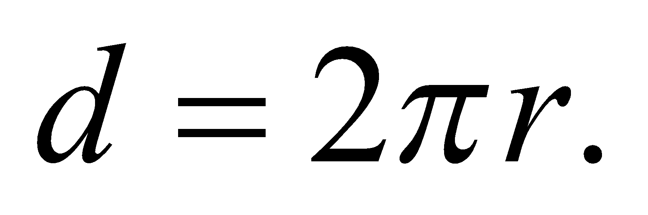

**50.** **Interpret** This problem requires us to find the force exerted on a wire that results from the interaction between the current in the wire and the magnetic field.

**Develop** The current in the wire is given by Ohm’s law (macroscopic version, see Table 24.2) V = IR. Applying Equation 26.5, , we see that the force on the upper and lower section of the circuit cancel (see sketch below), leaving only the force on the vertical section of the circuit.



**Evaluate** Inserting the given quantities into Equation 26.5 we find



**Assess** This problem ignores field-fringing effects that would occur at the edge of the field. However, by symmetry these effects cancel because these effects have the opposite influence on the upper and lower sections of the circuit.

**51.** **Interpret** You're designing a prosthetic ankle that uses an electric motor. You need to find the current necessary to achieve the desired torque.

**Develop**As described in Example 26.5, an electric motor consists of a current loop in a magnetic field. The torque is given by Equation 26.4: 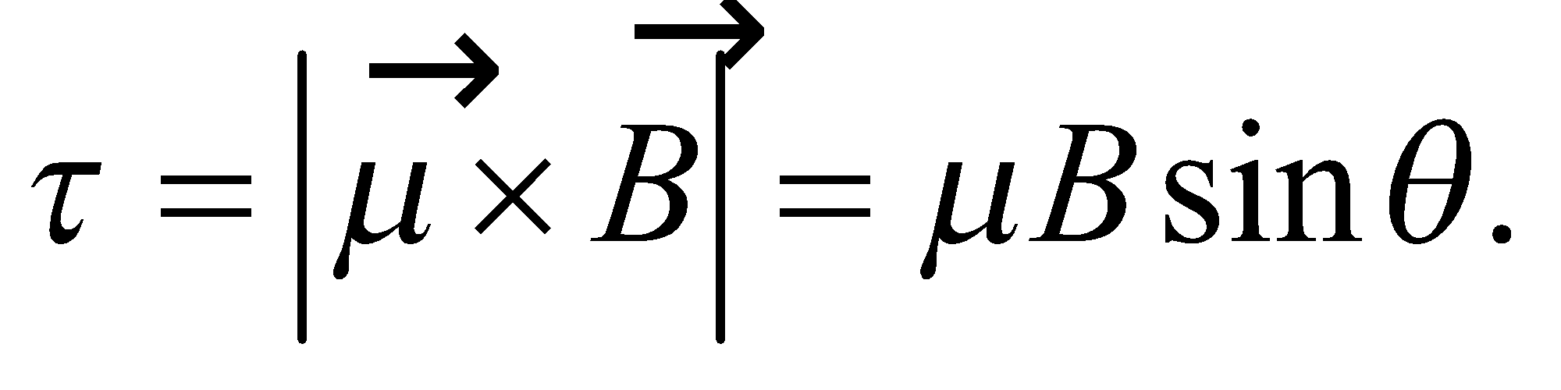 The magnetic dipole moment is equal to 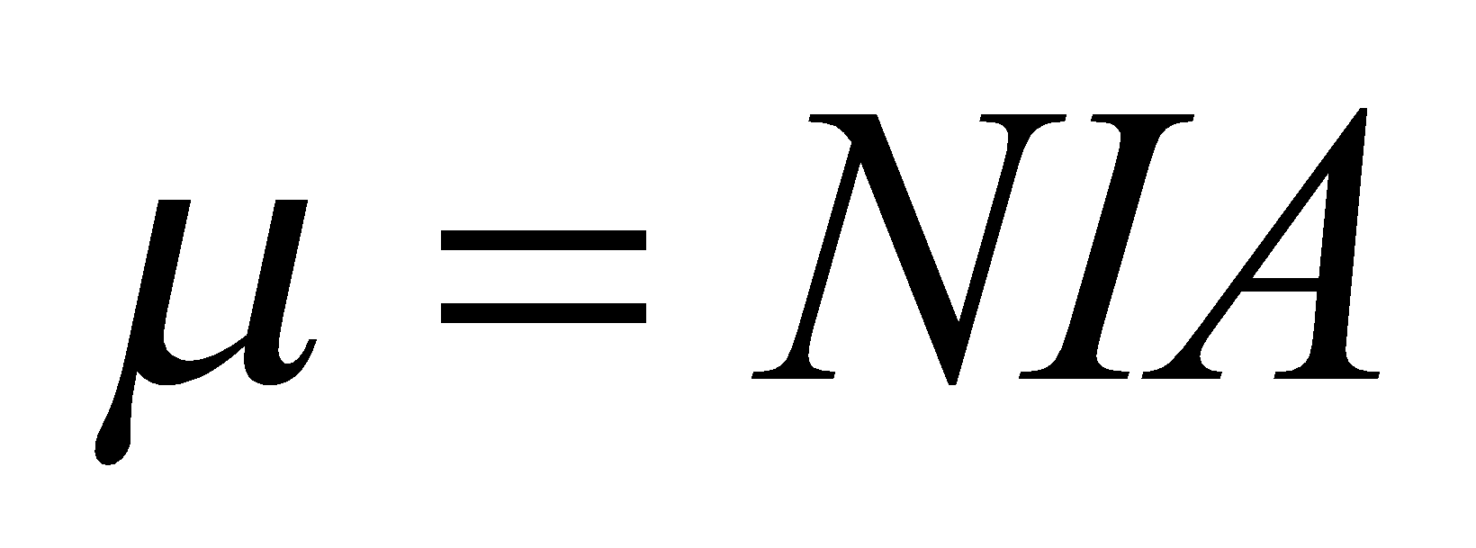 (Equation 26.12).

**Evaluate**The torque is maximum when the magnetic dipole moment is perpendicular to the field 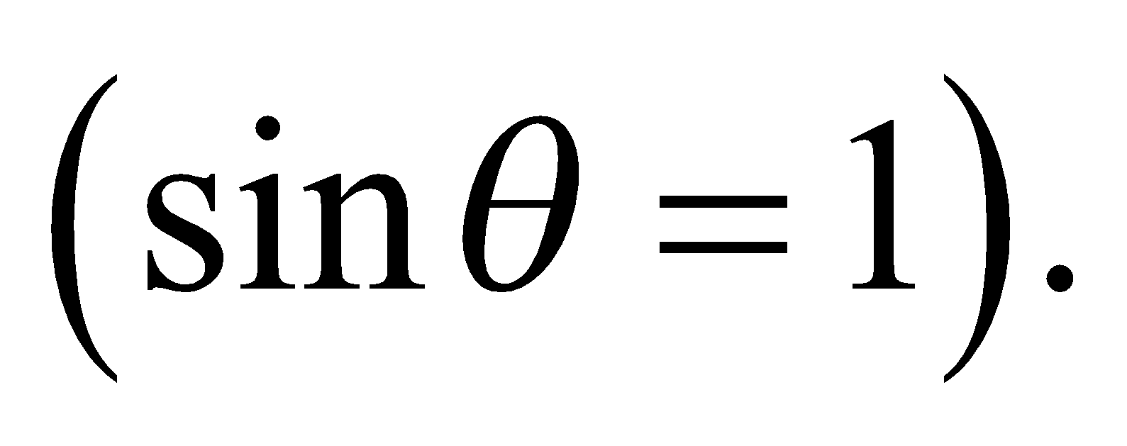 Solving for the current gives

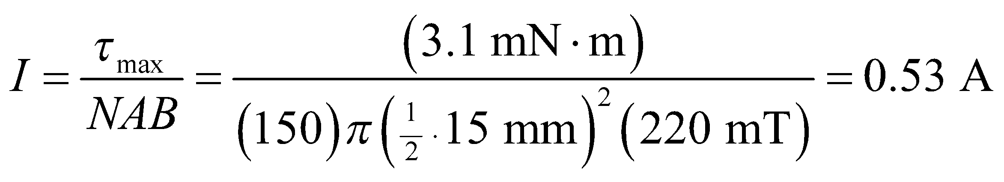

**Assess** Note that the units work out, since 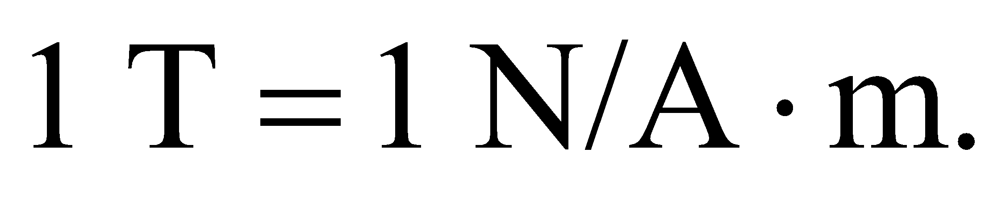The result seems like a reasonable current for this application. But care will be needed to be sure no current leaks out into the surrounding tissue.

**52. Interpret** We are to find the current that’s needed to produce a magnetic force to raise the current-carrying rod against the force of gravity. In addition, we need to specify the direction required for the current.

**Develop**An upward magnetic force on the rod equal (in magnitude) to its weight (= *mg*) is the minimum force necessary to maintain the bar in equilibrium with gravity. The magnetic force is given by Equation 26.5, 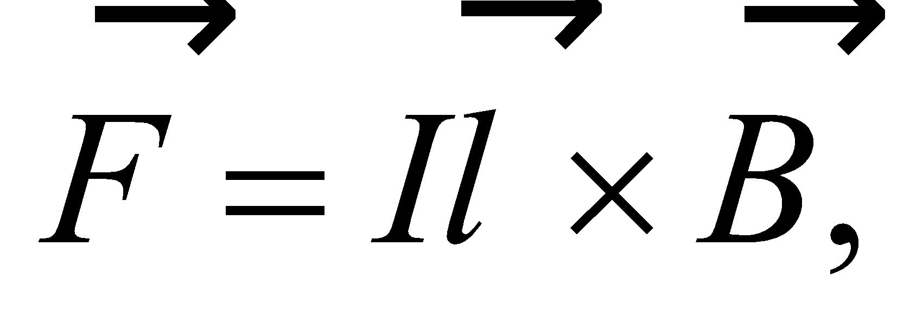 which reduces to 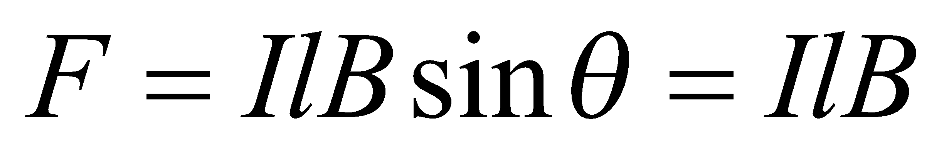 because the rod is perpendicular to the magnetic field (so *θ* = 90°).

**Evaluate** **(a)** The minimum current is obtained by setting 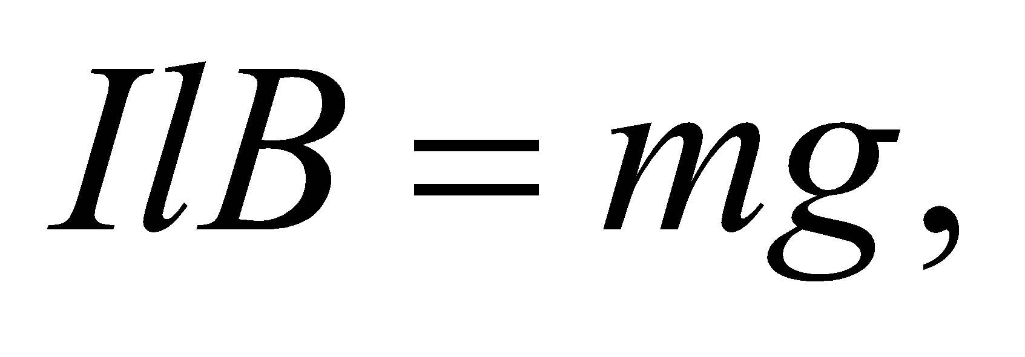 or

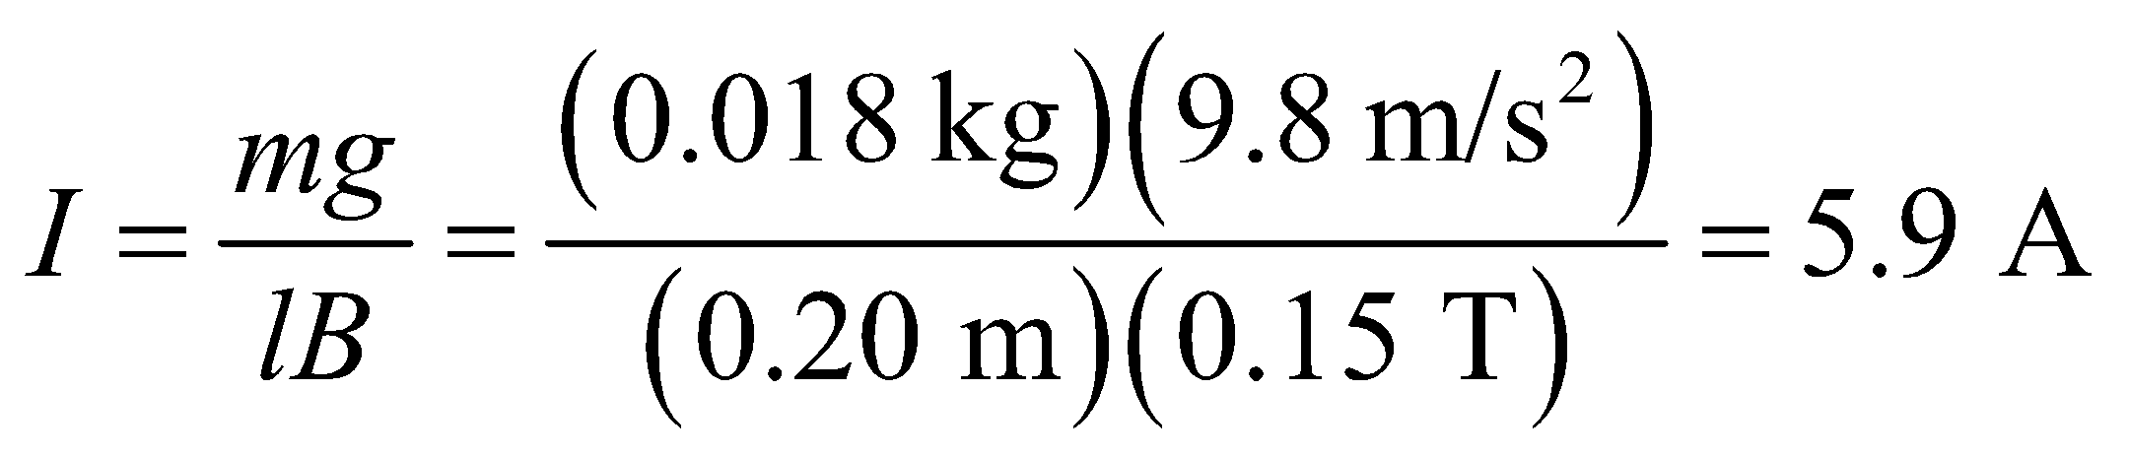

**(b)** Using the right-hand rule, we see that, for the force to be upward, the current must flow from A to B.

**Assess** A current of 5.9 A sounds reasonable. The weight of the rod is about 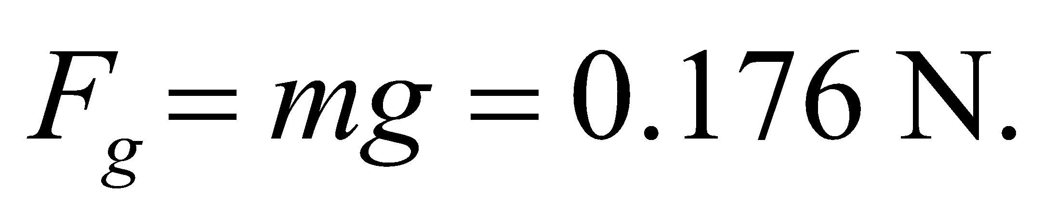 To support the weight with an upward magnetic force, we need a strong enough magnetic field and big enough current such that 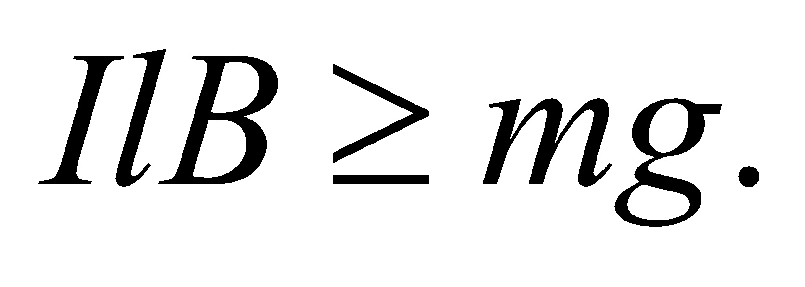

**53.** **Interpret** This problem deals with the Hall effect, which we can use to find the number density of free electrons (i.e., mobile electrons) in copper.

**Develop** The geometry in this problem is the same as that in the discussion leading to Equation 26.6, which shows that the number density n of charge carriers is

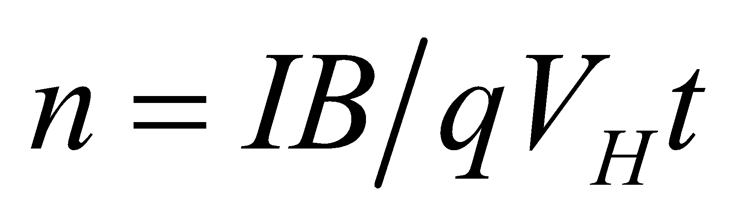

**Evaluate** Inserting the given quantities into this expression gives

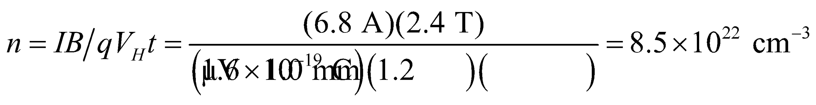

**Assess** This is a typical number density for free electrons in a metal.

**54. Interpret** In this problem the magnetic field exerts a torque on a current-carrying loop, causing the normal of the loop to make an angle with the field. Given this angle, the current, and the loop area, we are to find the magnetic field strength.

**Develop** See the discussion accompanying Figure 26.23. The magnetic torque exerted on a dipole moment 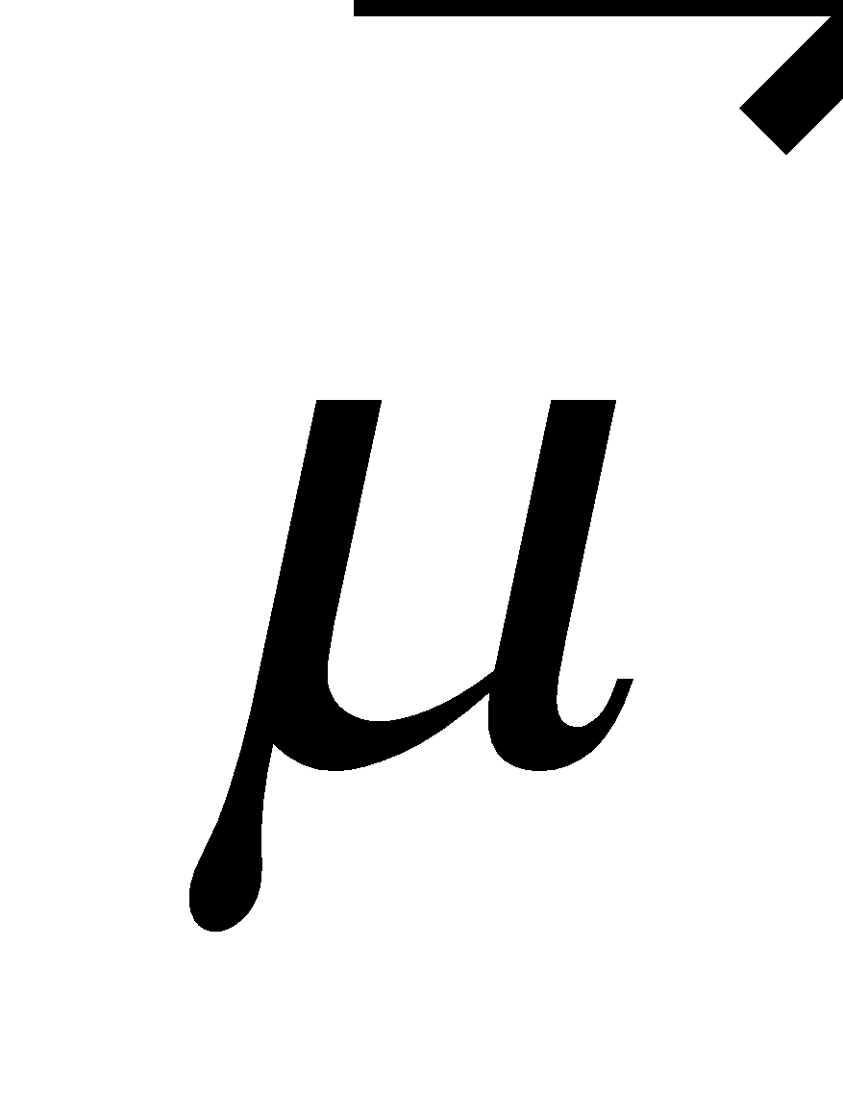 by the magnetic field  is given by Equation 26.15 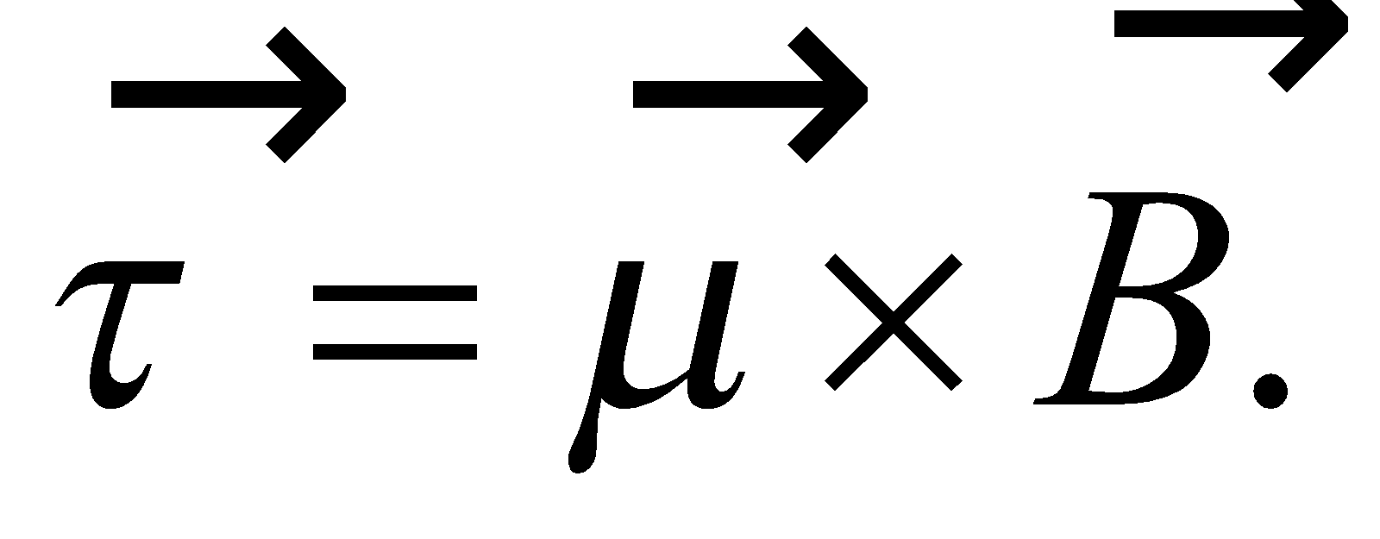 The magnitude of 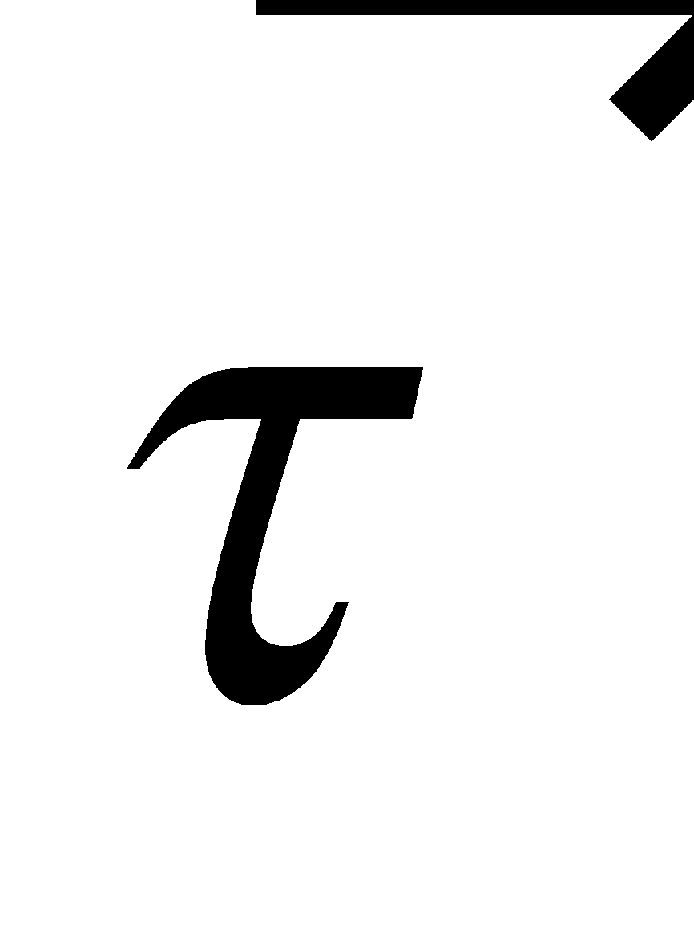 is

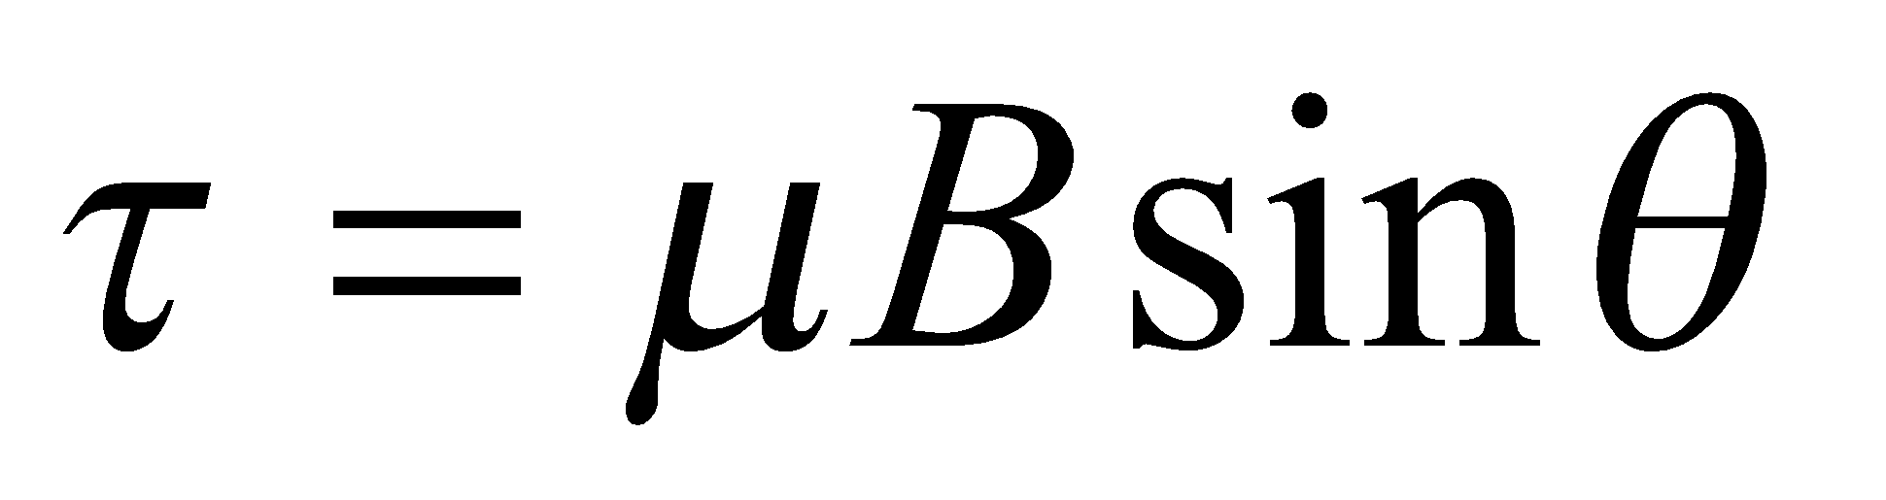

where 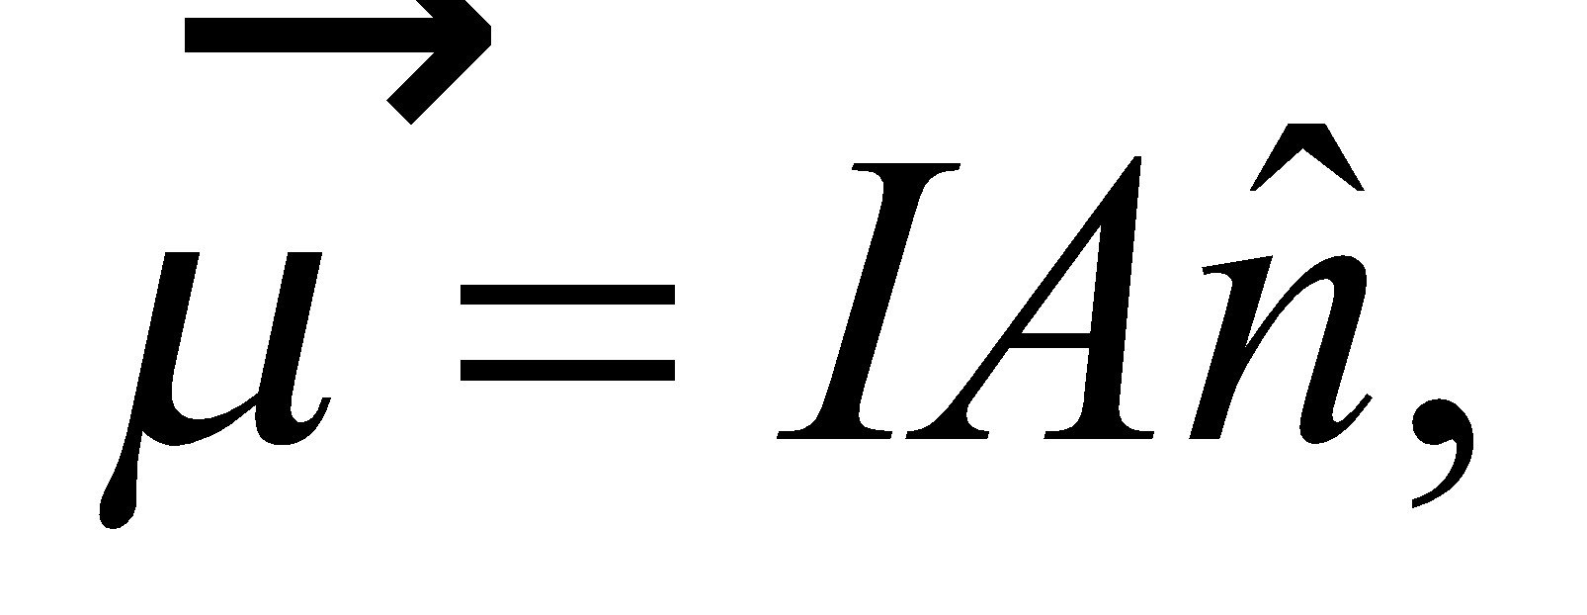 with 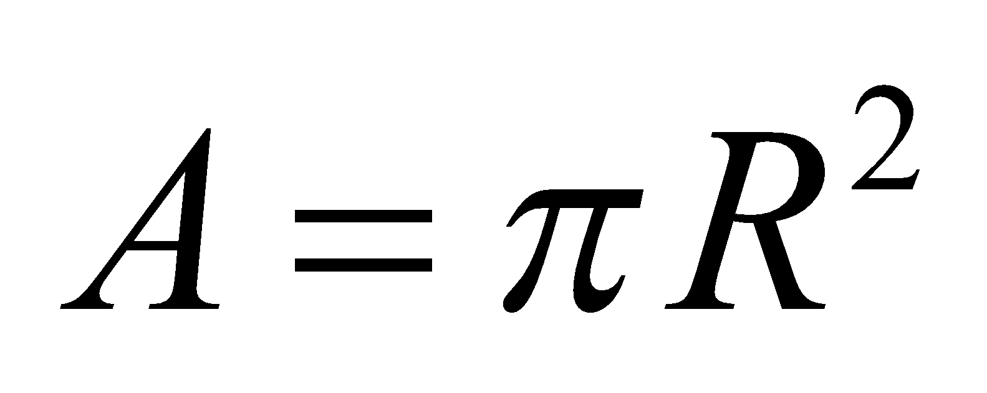 being the area of the loop and 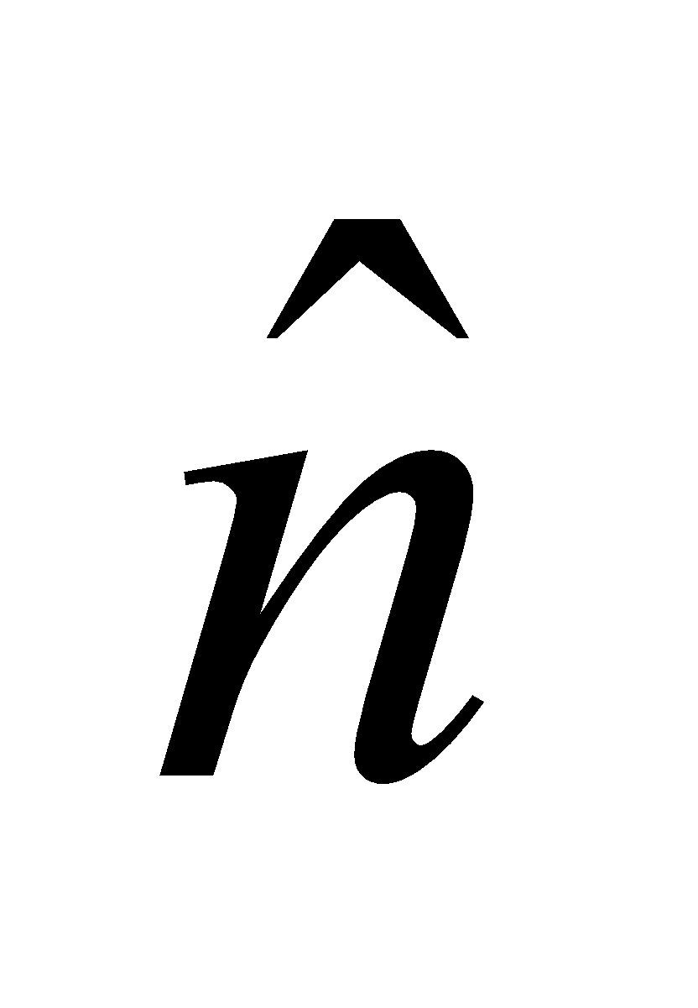 the unit vector in the normal direction of the plane of the loop.

**Evaluate** Substituting the values given in the problem, we find the field strength to be

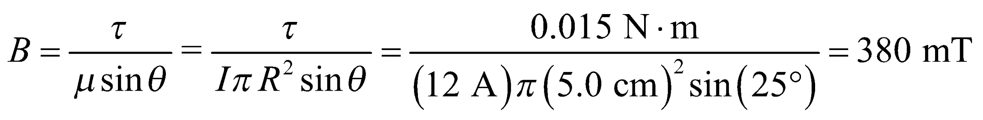

**Assess** The torque tends to align the magnetic dipole moment with the magnetic field. It is at a maximum, 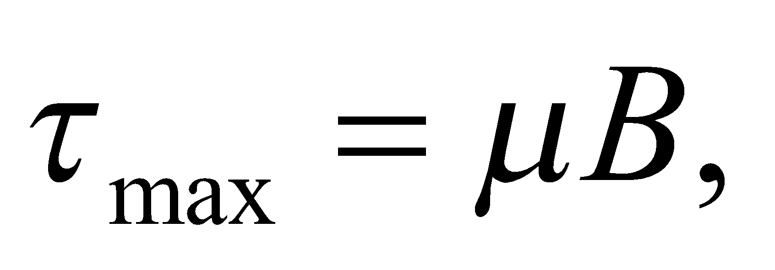 when *θ* = 90°.

**55.** **Interpret** We are to find the magnetic dipole moment of a 100-turn solenoid with the given dimensions and current, and find the maximum torque this coil will experience in a 0.12-T magnetic field.

**Develop** Apply Equation 26.13,



to find the dipole moment. The maximum torque may be found by setting *θ* = 90° in the cross product of Equation 26.15.

**Evaluate** (**a**) The magnetic moment of the coil has magnitude



**(b)** The maximum torque (from Equation 26.14, with sin*θ* = 1) is



**Assess** This is not a very strong motor.

**56.** **Interpret** This problem is about the change in potential energy of a magnetic dipole moment.

**Develop**From Equation 26.15, the potential energy of a magnetic dipole in a magnetic field is 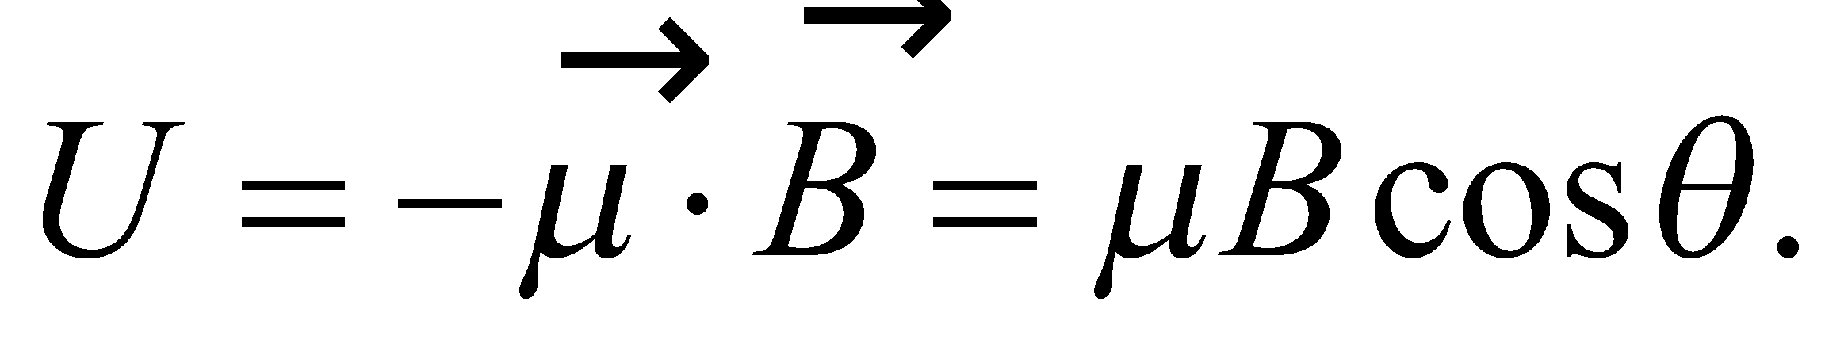 Therefore, the energy required to reverse the orientation of a proton’s magnetic moment from parallel 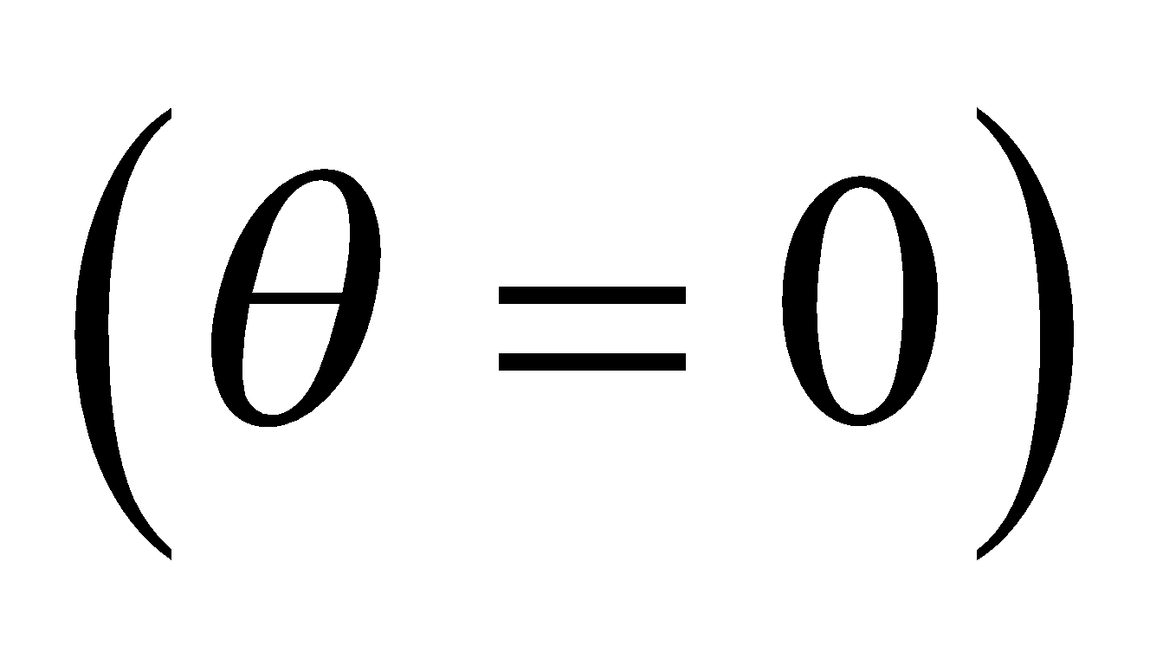 to antiparallel 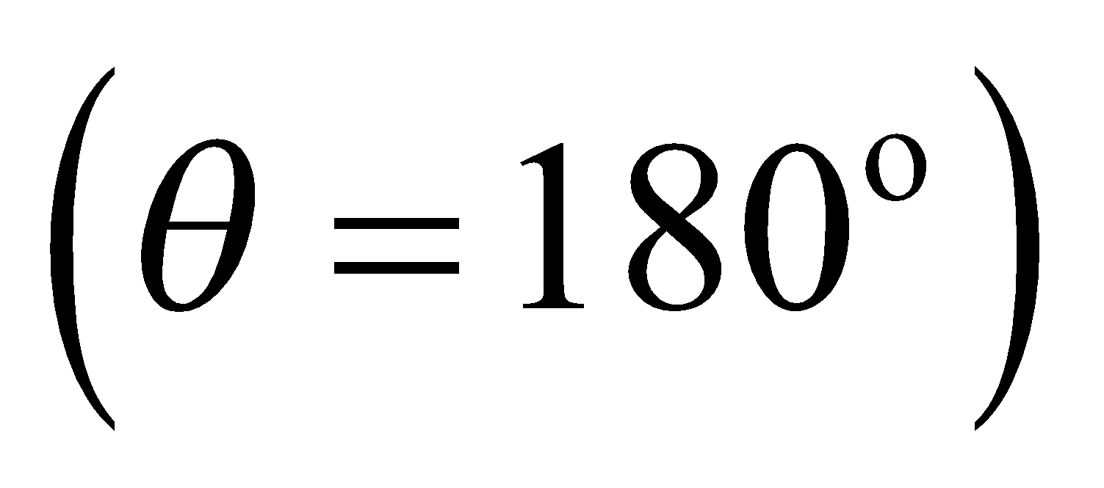 with respect to the applied magnetic field is



where 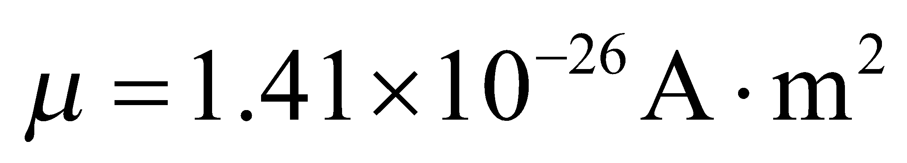 is the magnetic dipole moment of the proton.

**Evaluate**Substituting the values given, we find the energy to be



**Assess** The potential energy of a dipole moment is a minimum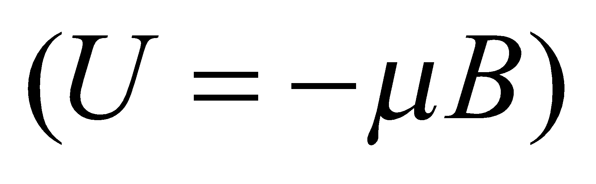when it is parallel to the magnetic field, but a maximum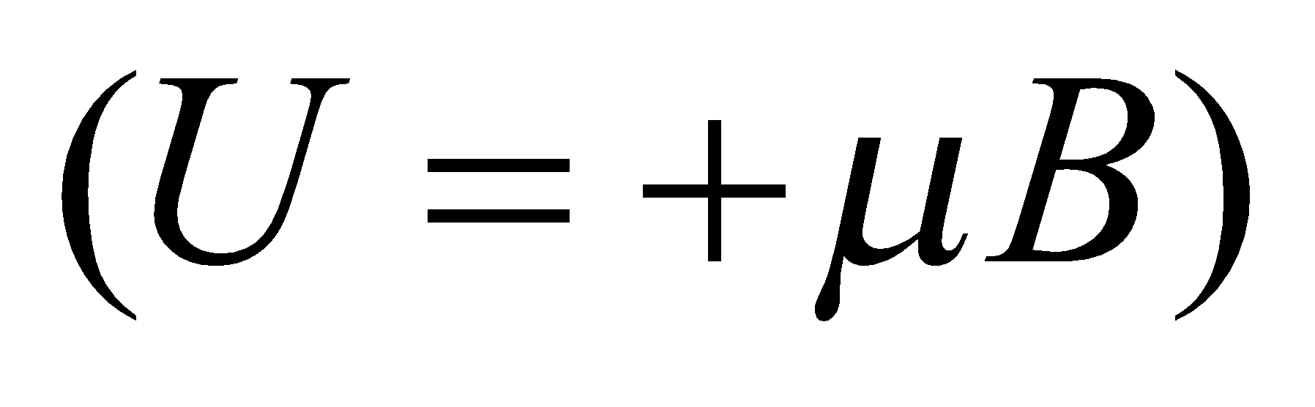when it is antiparallel to the field. Positive work must be done to flip the dipole. In an NMR device, the alignment by the magnetic field of protons and other particles with magnetic dipole moments can be studied by passing radio waves through the sample.

**57. Interpret**  We are to find the force on a quarter-circle of current-carrying wire in a magnetic field. We will use the equation for magnetic force on a wire, which we will express in differential form and then integrate to determine the net force.

**Develop** The force on a section of wire *dl* carrying a current *I* in a magnetic field *B* is

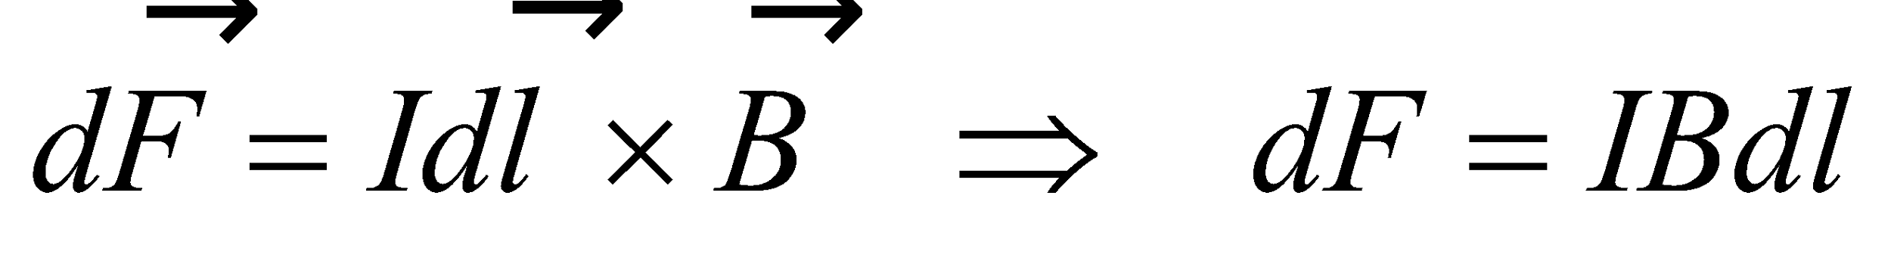

where we have used sin*θ* = 1, because *θ* = 90° for this problem. Using the right-hand rule, we can see from Fig. 26.41 that the force on the wire will be everywhere radially away from the loop center (see figure below). The horizontal component of force on each segment *dl* of the wire is given by 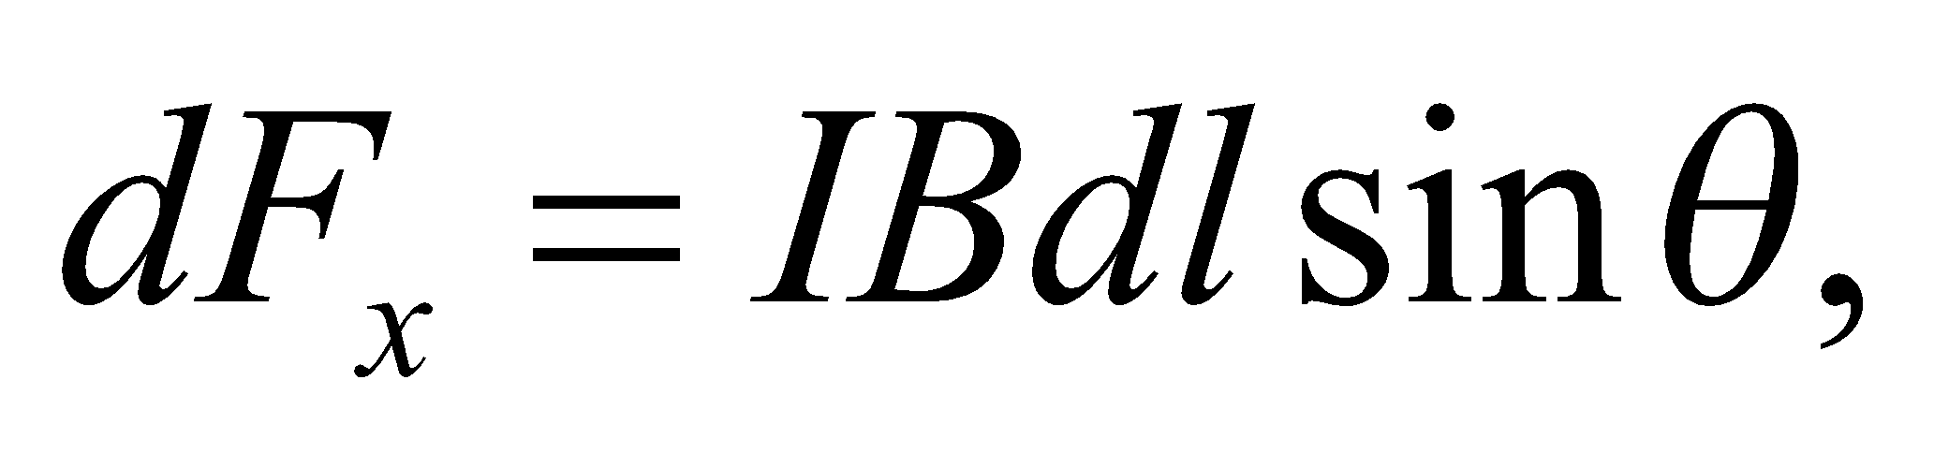 where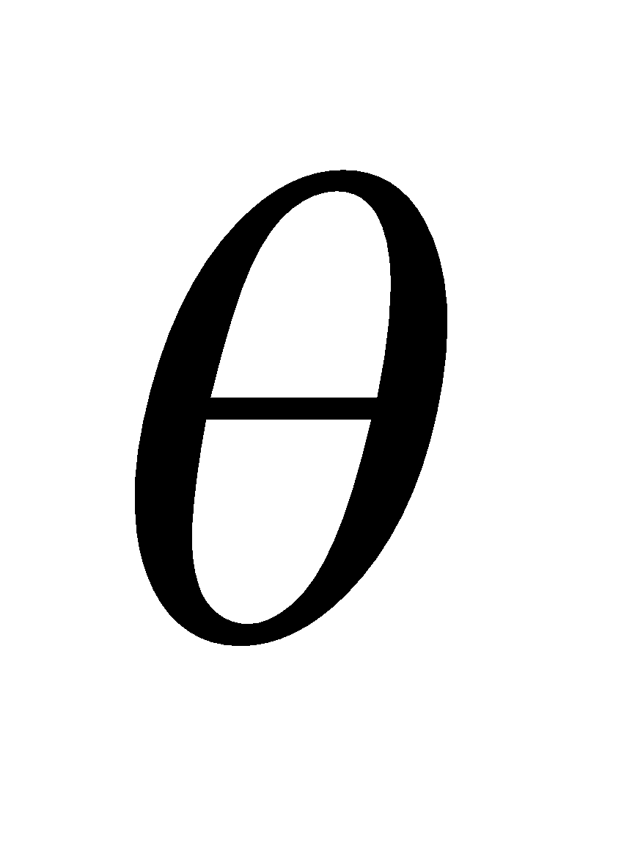is the angle between the vertical and a line between the center of curvature and the wire segment *dl*, as shown in the figure below. The vertical component of the force is 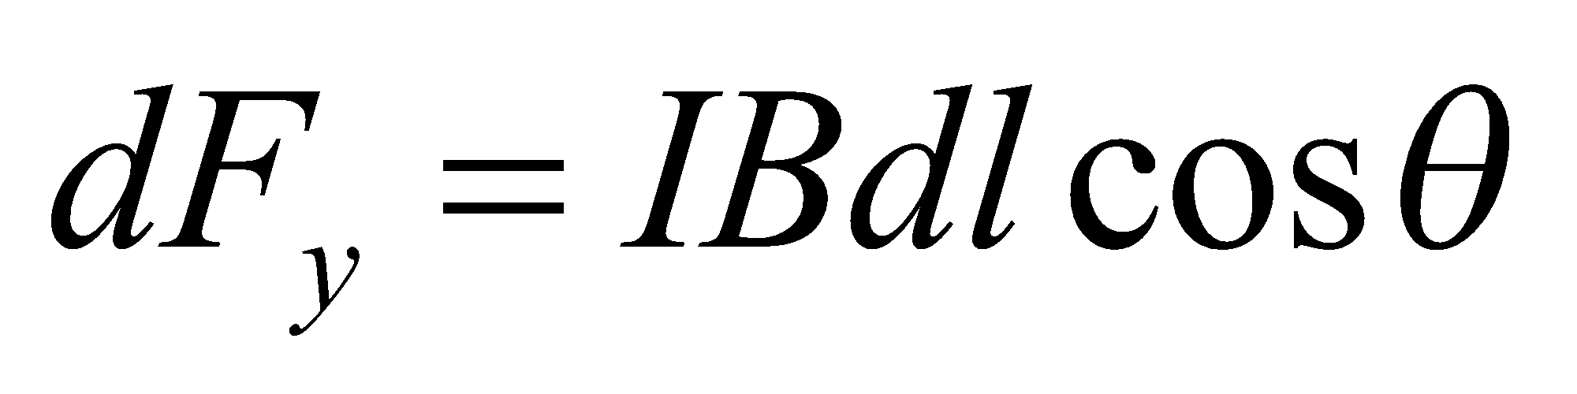. The total horizontal force on the wire is then

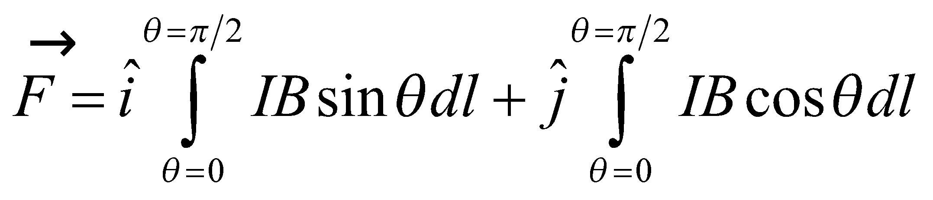

In terms of *θ*, *dl* = *rdθ*. The current and field are constant: *I* = 1.5 A and 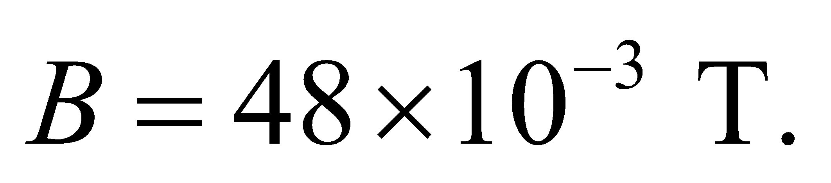 The radius of curvature is 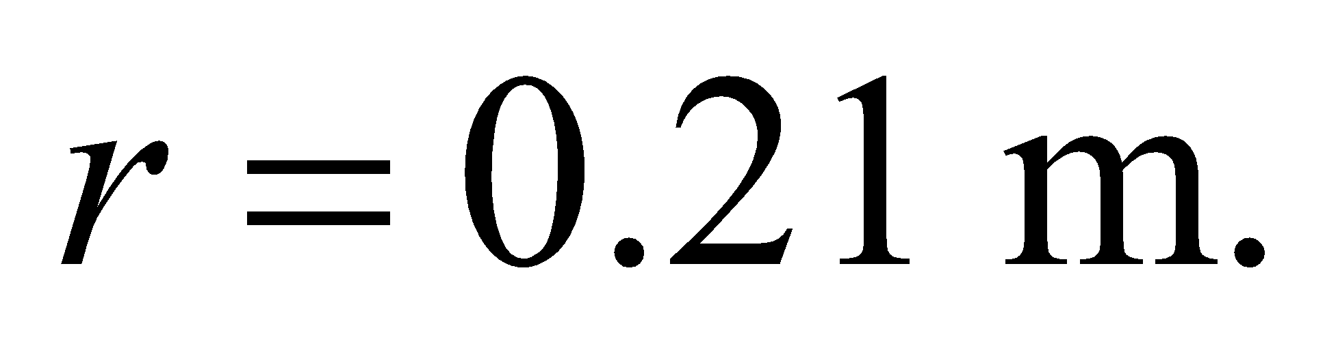



**Evaluate** Evaluating the integral gives

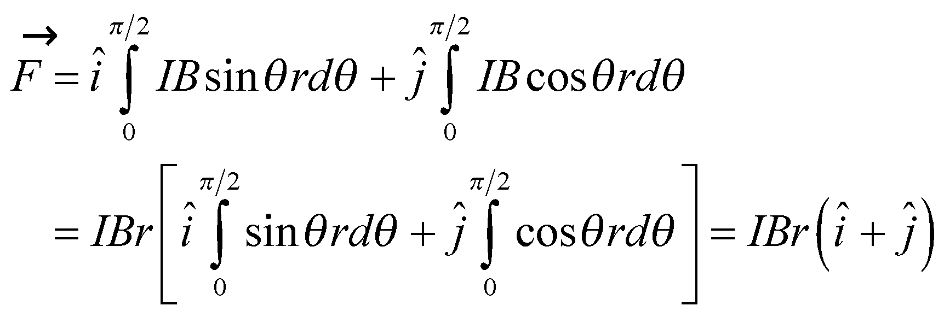

Inserting the values gives



The magnitude is thus 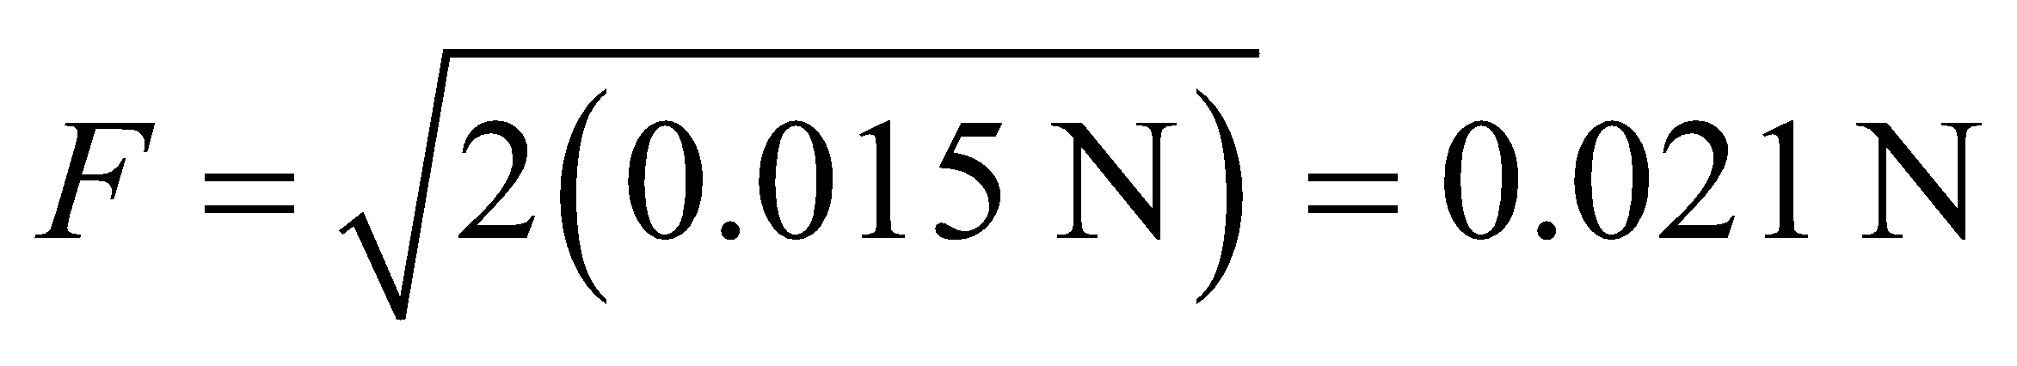 and the direction is 45° above horizontal.

**Assess** The symmetry of the problem makes evaluation of the integral straightforward.

**58.** **Interpret** You need to determine how many turns of a current-carrying wire is needed to have the magnetic field at the center be equal in magnitude to that of the Earth's magnetic field.

**Develop**Equation 26.9 (see Example 26.3) can be modified for *N* turns of wire. Therefore at the center of a flat circular coil  the magnetic field is 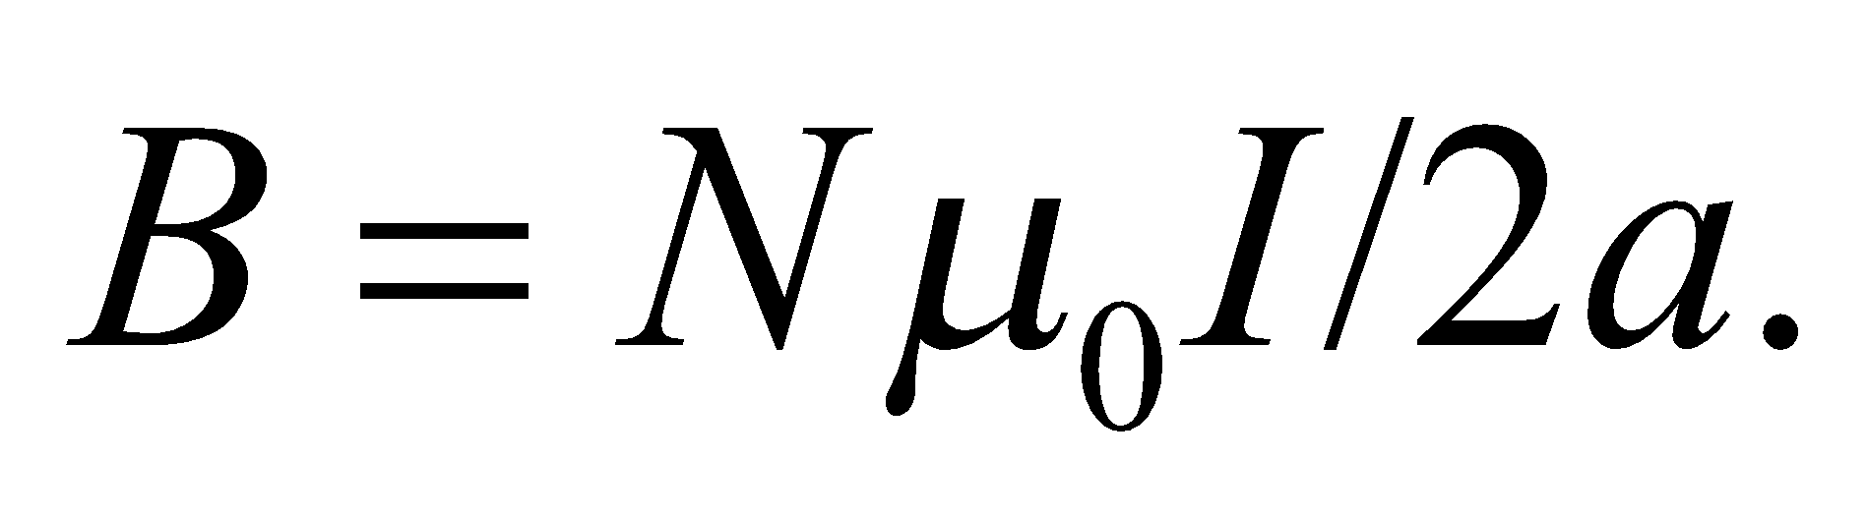The length of wire needed will be *N* multiplied by the loop circumference, 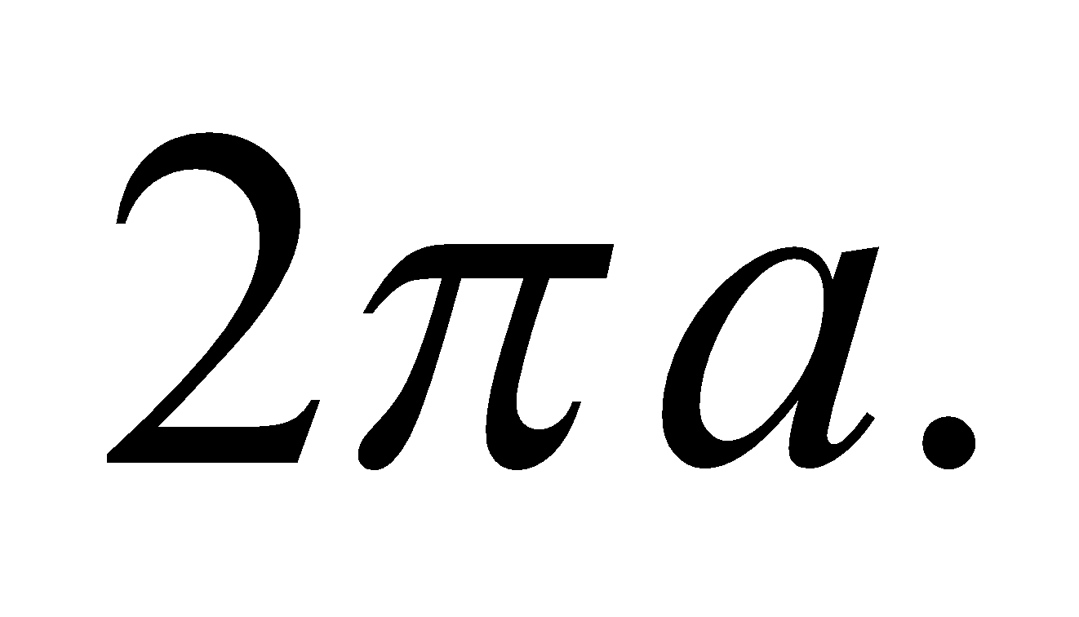

**Evaluate**For each coil that your company is making, the amount of wire you must requisition is

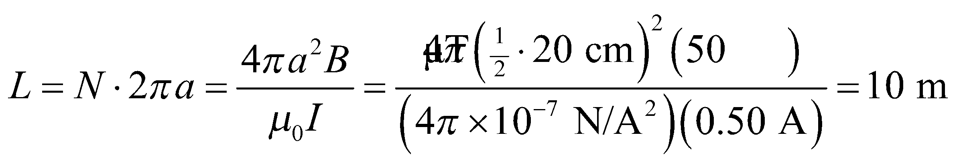

**Assess** Each coil will need 16 turns to cancel out the magnetic field of the Earth.

**59.** **Interpret** This problem involves finding the magnetic field of a wire that is bent into the given geometrical shape and through which flows the given current.

**Develop** The wire may be divided into a straight section and the loop, and the current at the loop center will be the superposition of the magnetic fields from these two components. The magnetic field due to the straight section is

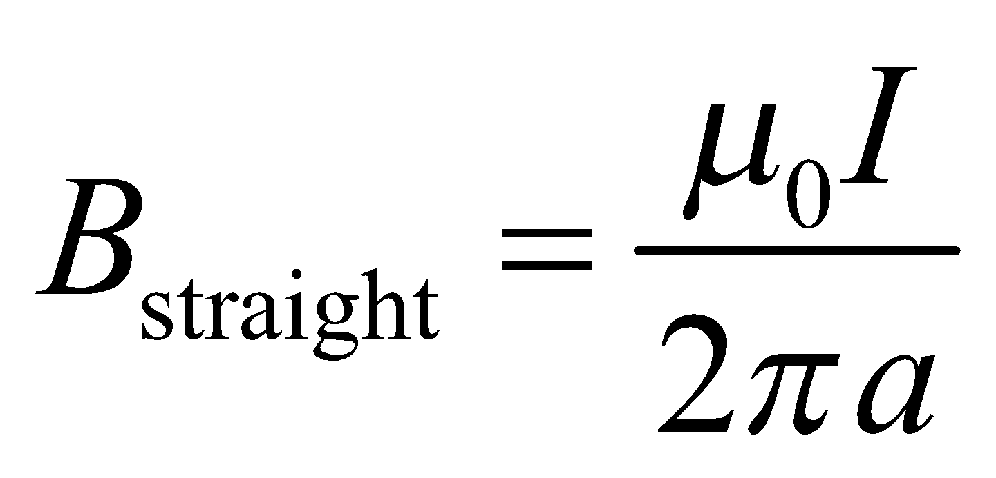

where *a* is the loop radius (see Example 26.4 and Equation 26.10). From Example 26.3, the loop contribution to the magnetic field is

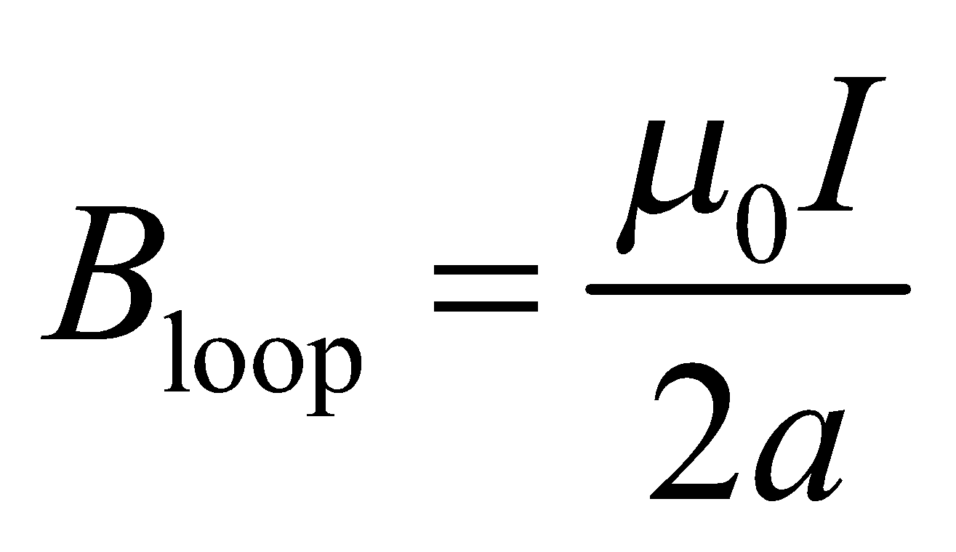

where we have used *x* = 0 in Equation 26.9. Using the right-hand rule, we see that both contributions are out of the page, which we define as the 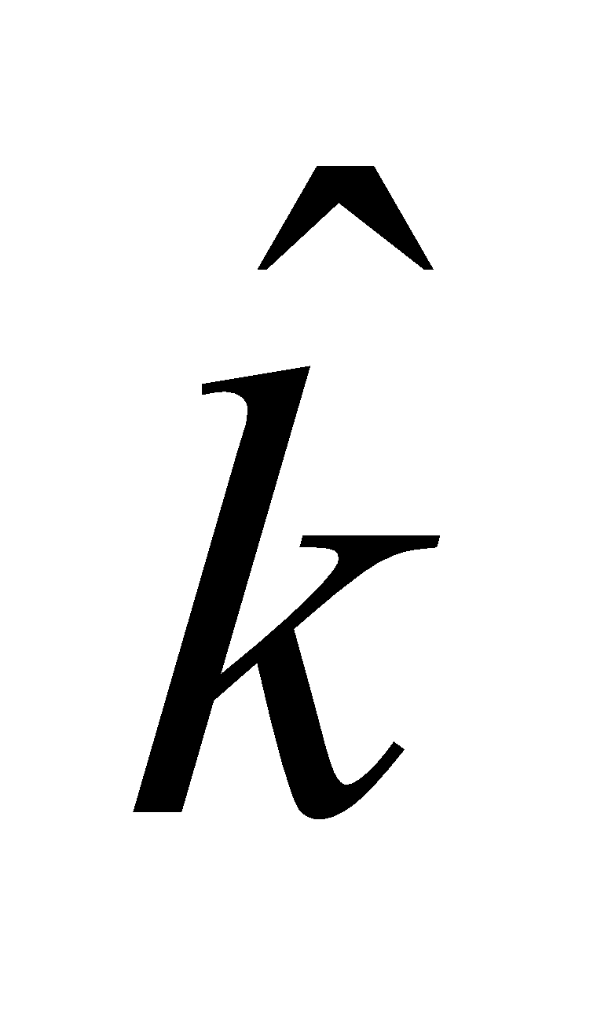 direction.

**Evaluate** Inserting the given quantities and summing the two contributions gives

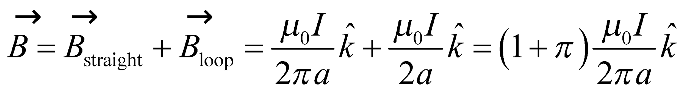

**Assess** The superposition principle greatly simplifies this problem, both analytically and conceptually.

**60.** **Interpret** You want to know what effect a power line overhead will have on your compass reading.

**Develop**The magnetic field induced by the power line has magnitude given by Equation 26.10: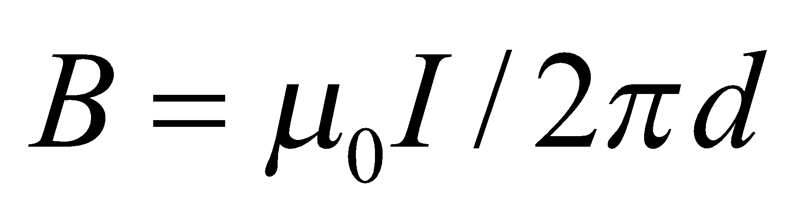, where *d* is the distance from the wire to the ground. If the current is moving northward, then by the right-hand rule the induced magnetic field will point westward at ground level. You can add this magnetic field to the Earth's field to see what effect it will have on your orientation.

**Evaluate**The induced field will have a magnitude of

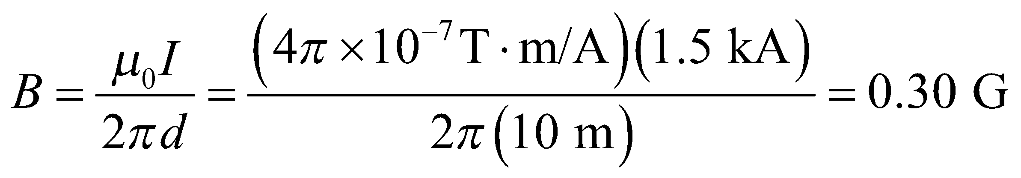

Let's assume that north is in the positive *y*-direction, so that this induced field points in the negative *x*-direction (west). The total field at your location will therefore be

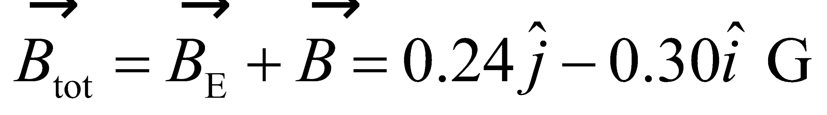

Your compass needle will point at an angle of 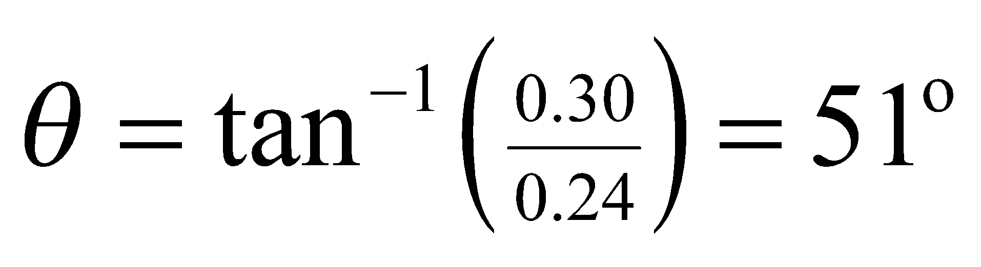 to the west of true north.

**Assess** The lesson is that you shouldn't use a compass to orient yourself when standing near a power line.

**61.** **Interpret** We are to find the magnetic field at the center of a semicircular current-carrying wire by using the Biot–Savart law.

**Develop** Use the coordinate system shown in the figure below. The Biot-Savart law (Equation 26.7) written in a coordinate system with origin at *P*, gives

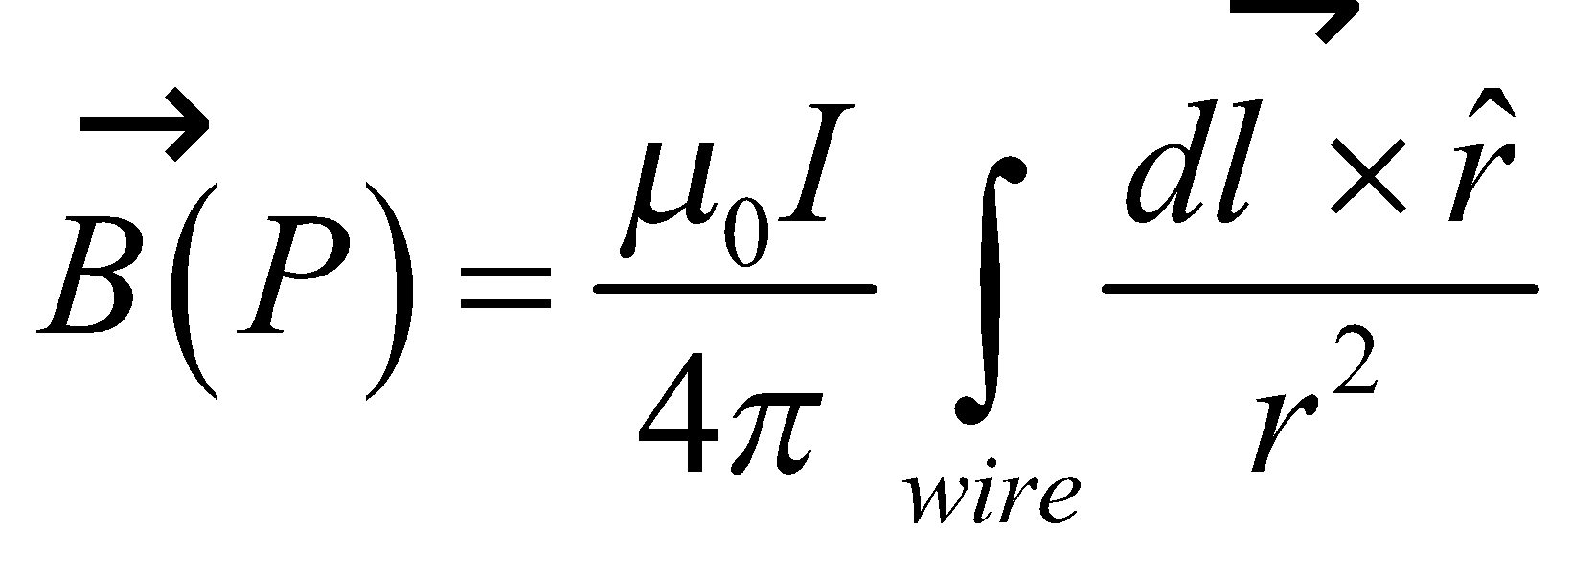

where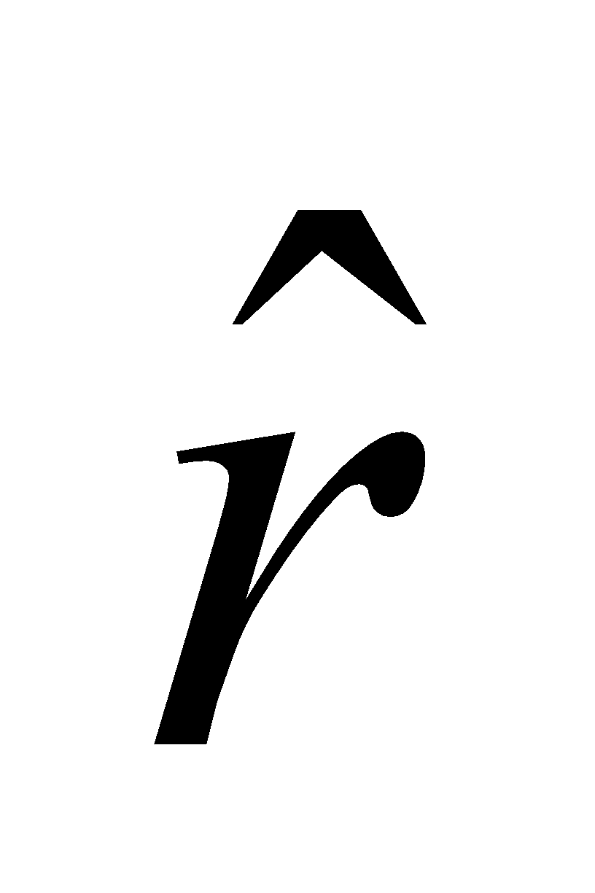is a unit vector from an element 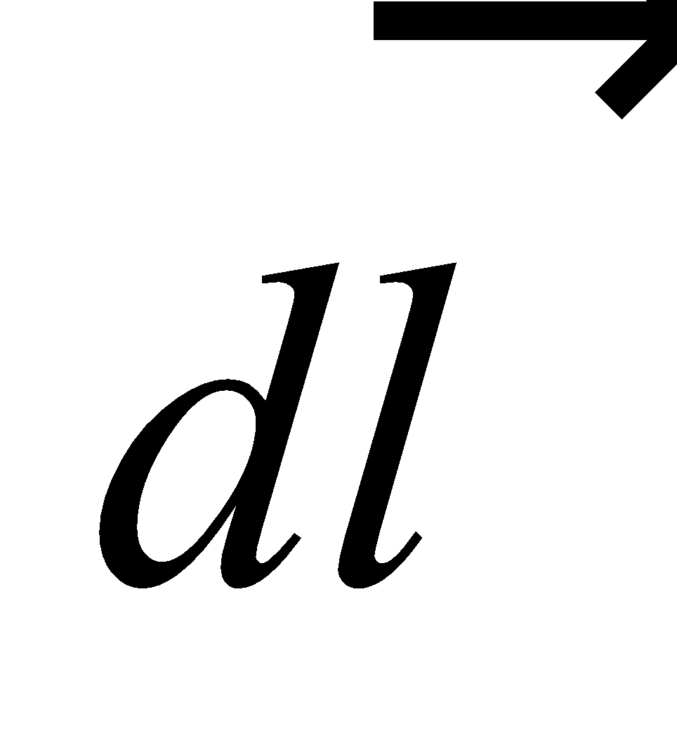 on the wire to the field point *P*. On the straight segments to the left and right of the semicircle,  is parallel to and 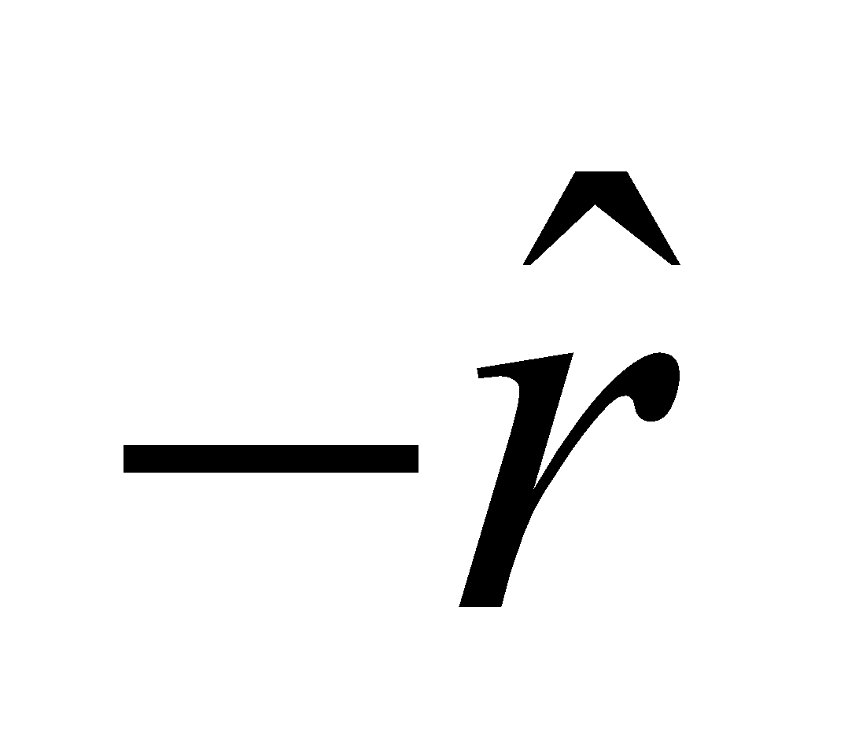, respectively, so 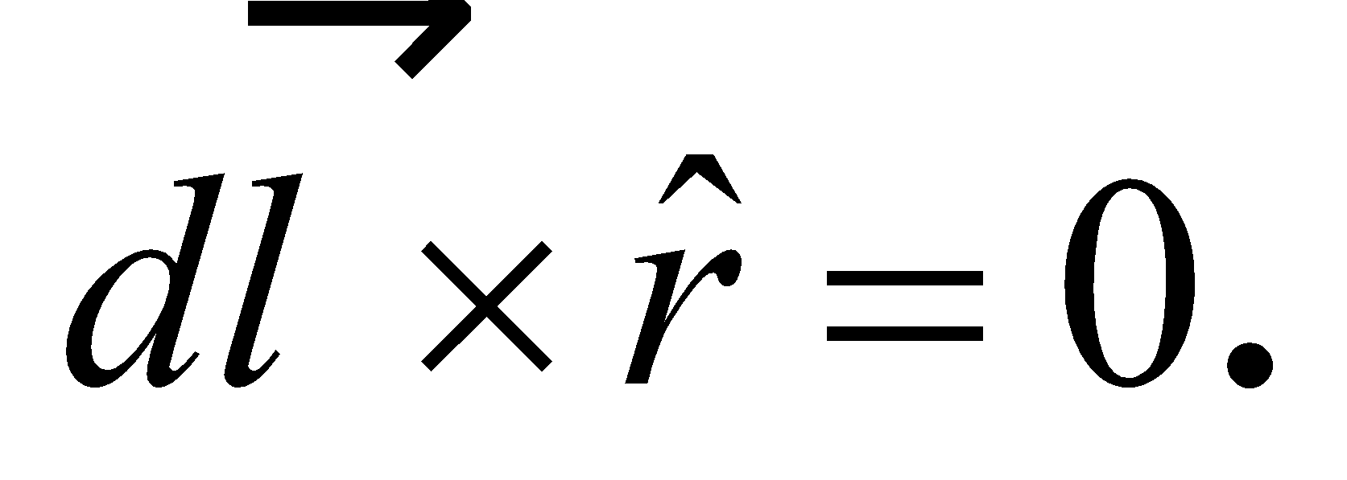 On the semicircle,  is perpendicular to  and the radius is constant at *r* = *a*.

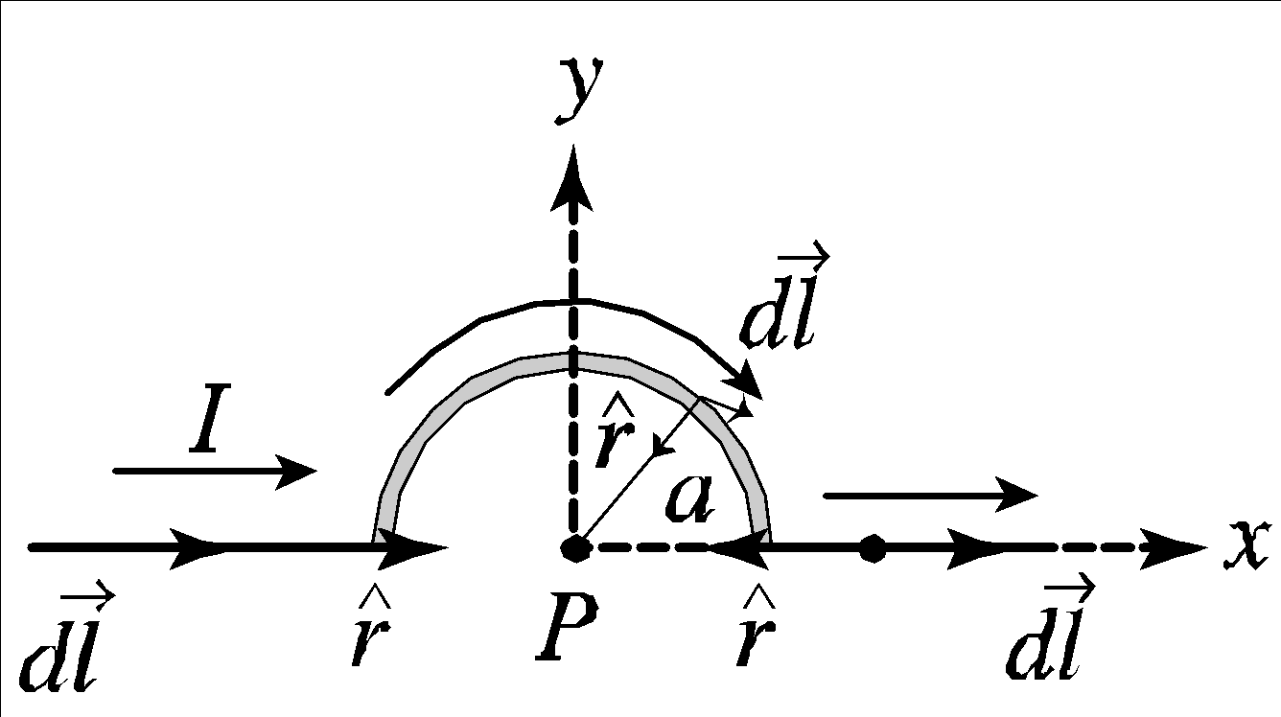

**Evaluate** Evaluating the integral gives

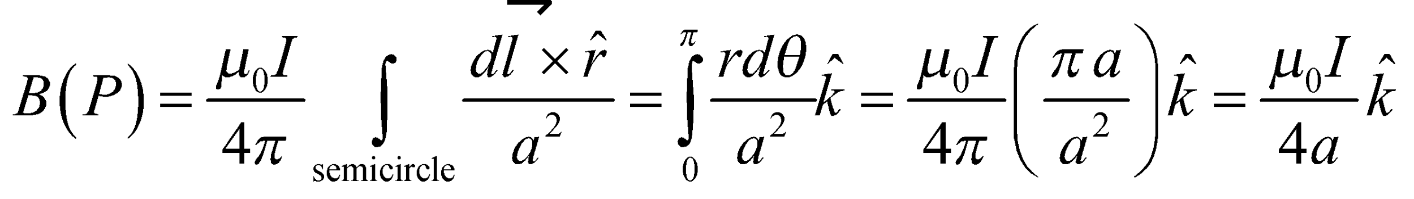

where  is into the page.

**Assess** Notice that  is dimensionless, so the units work out to be (N/A2)(A)/m = N/(A·m) = T.

**62.** **Interpret** We're asked to find an expression for the magnetic force on three parallel wires carrying the same current.

**Develop**Let's first label the wires 1, 2, 3. The force between parallel wires is attractive, with a magnitude given by Equation 26.11: 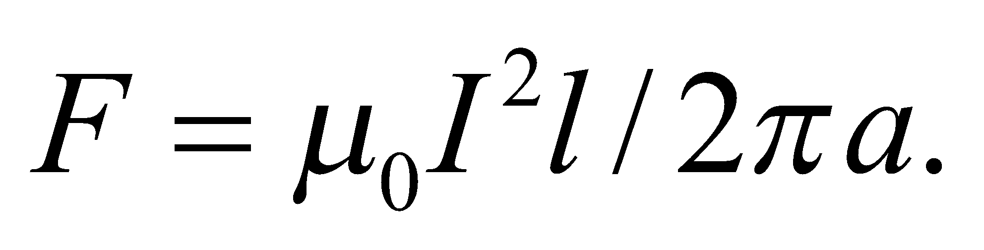 We'll concentrate on wire 1 and the forces exerted on it by wires 2 and 3: 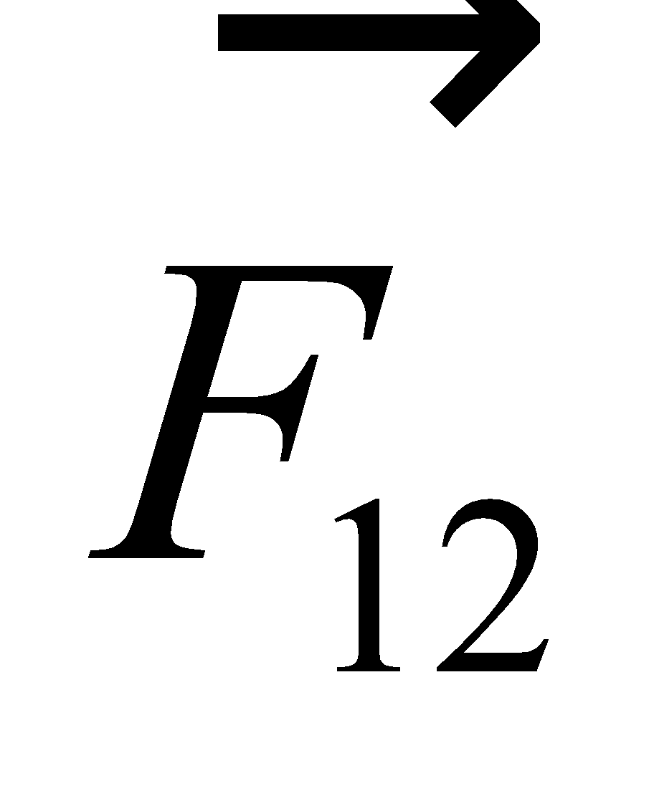 and 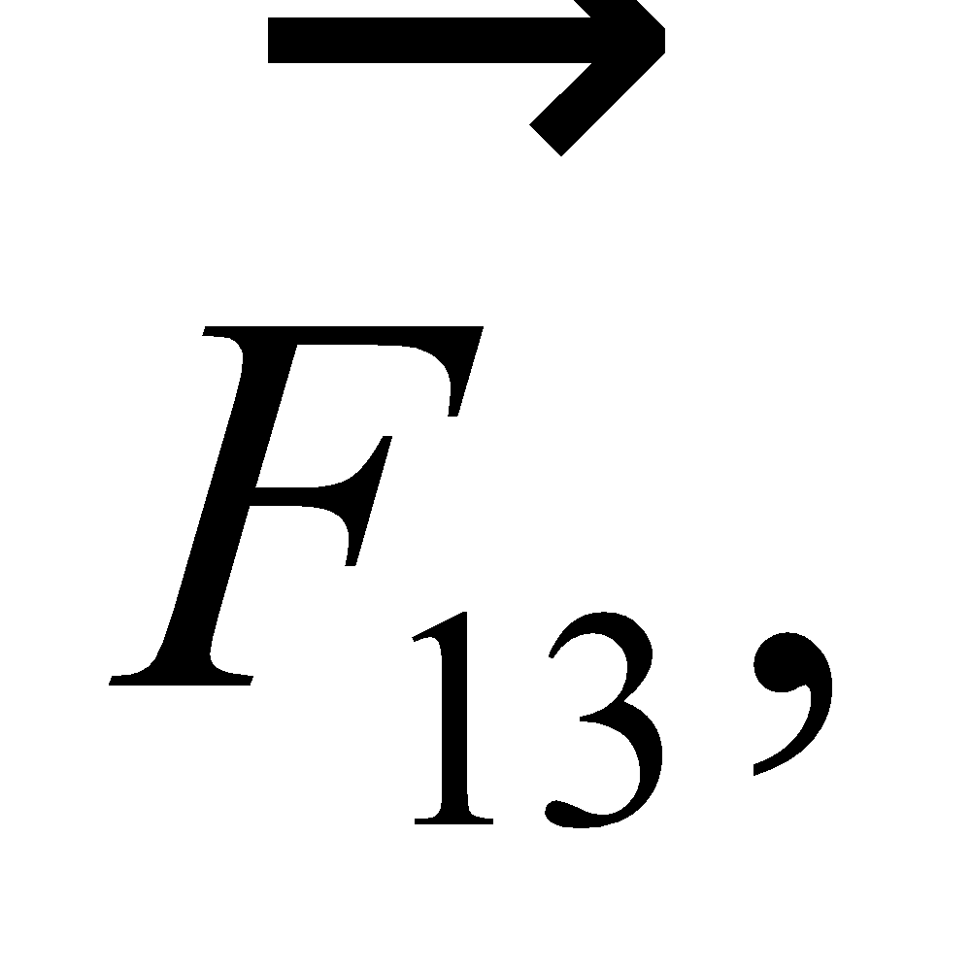respectively. See the figure below.



**Evaluate**From the figure, we can see that the *x*-components of  and 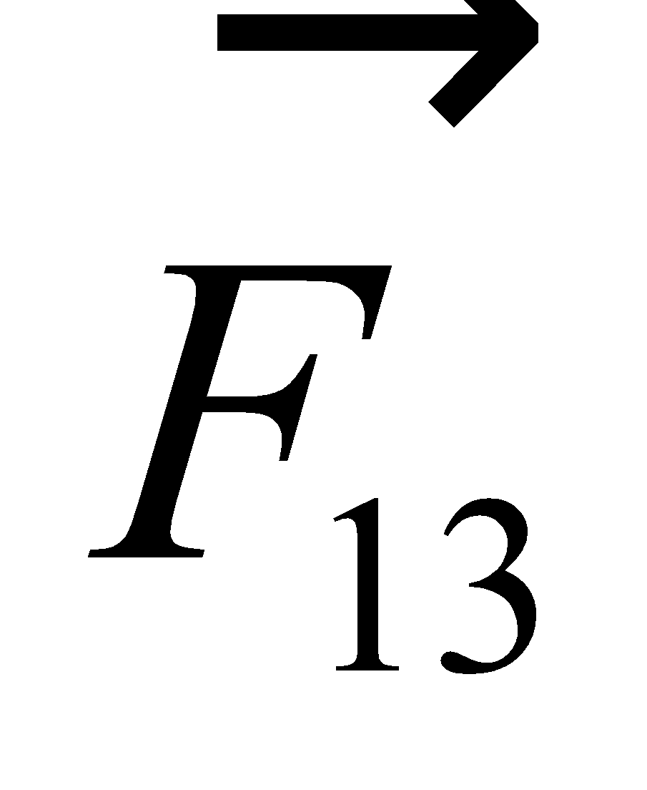 will cancel each other out. We only need to add the *y*-components to find the total force on wire 1:

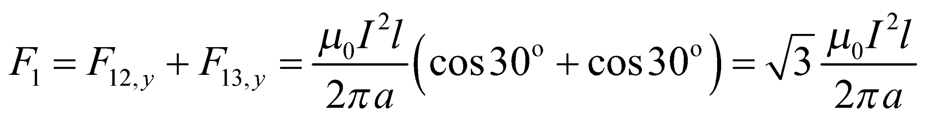

By symmetry, this will be the same force on wires 2 and 3.

**Assess** All of the forces point inward towards the center of the triangle.

**63.** **Interpret** This problem involves finding the force on a wire loop carrying current due to the magnetic field of a nearby straight wire also carrying current.

**Develop** See the figure below. At any given distance from the long, straight wire, the force on a current element in the top segment cancels that on a corresponding element in the bottom. The force on the near side (parallel currents) is attractive, and that on the far side (antiparallel currents) is repulsive. The force is given by Equation 26.5, , where the magnetic field may be found using Equation 26.10, *B* = *μ*0*I*/(2*πy*), where y is the distance from the straight wire.

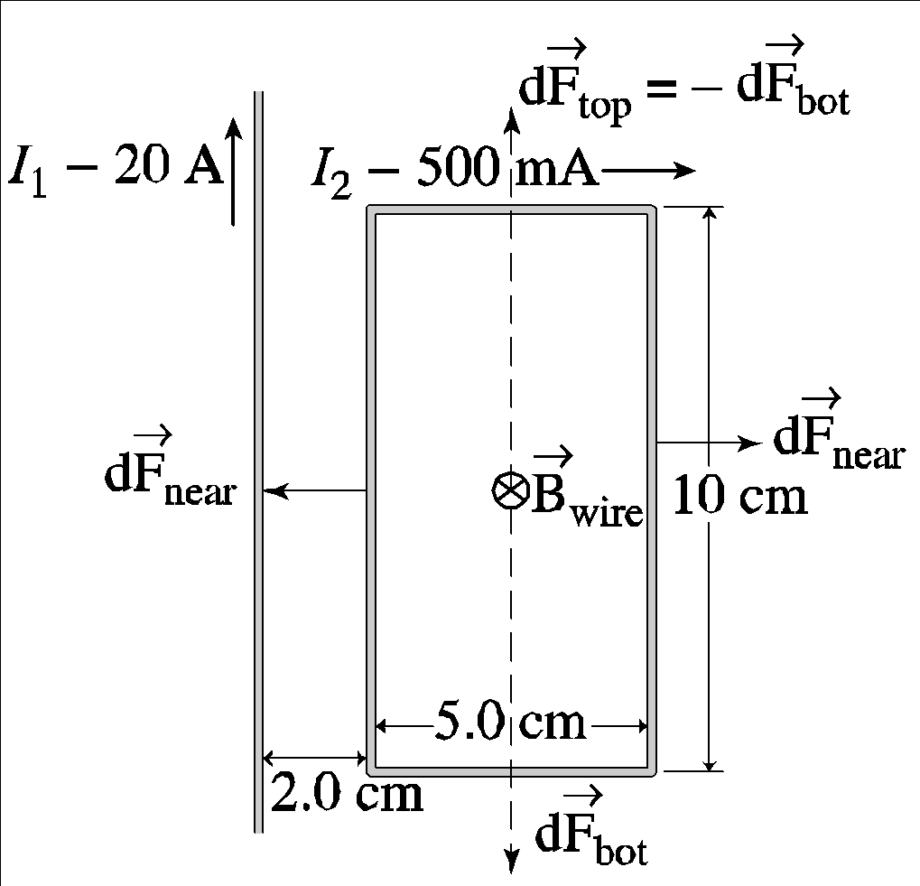

**Evaluate** Performing the sum and inserting the given quantities gives

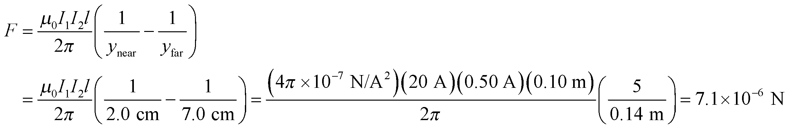

**Assess** Notice that this expression reduces to Equation 26.10 for 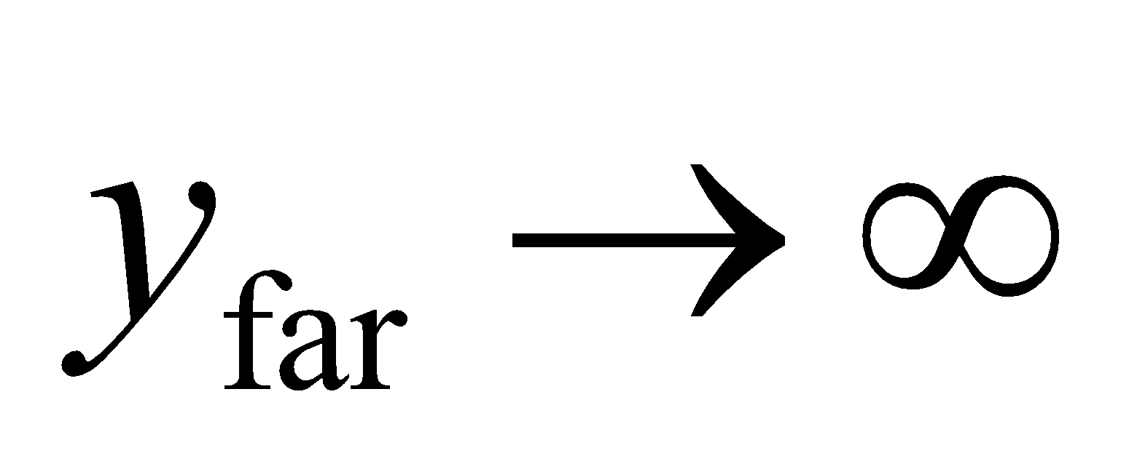, as expected.

**64. Interpret** The system is a long conducting rod having a non-uniform current density. We are interested in the magnetic field strength both inside and outside the rod. The problem involves Ampère’s law.

**Develop** The magnetic field of a long conducting rod is approximately cylindrically symmetric, as discussed in Section 26.8. The magnetic field can be found by using Ampère’s law (Equation 26.17)

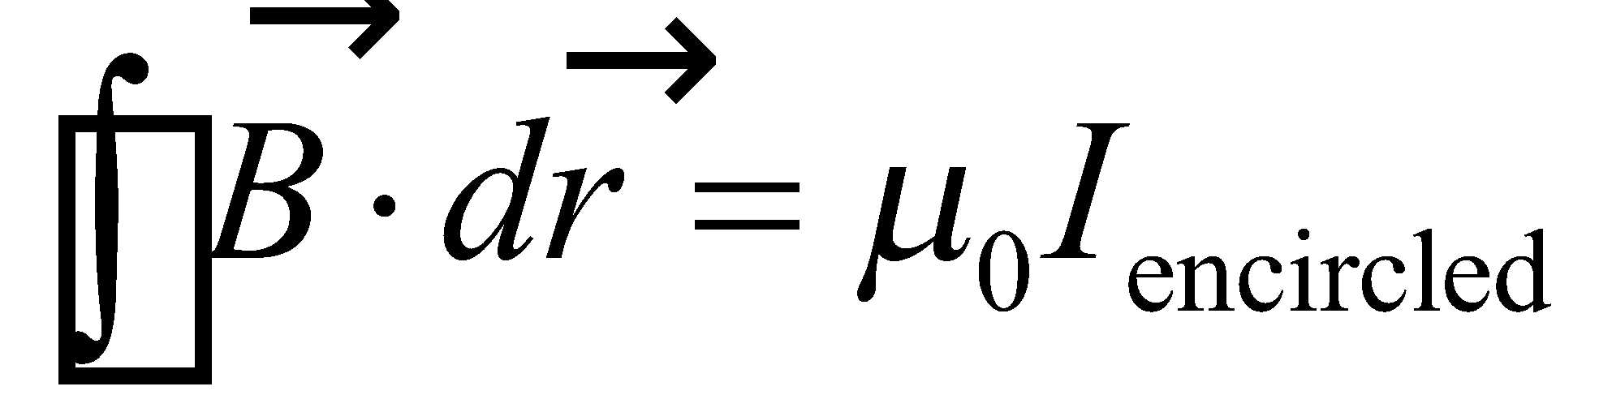

**Evaluate (a)** Inside the rod, Ampère’s law can be used to find the field, as in Example 26.8, by integrating the current density over a smaller cross-sectional area that corresponds to 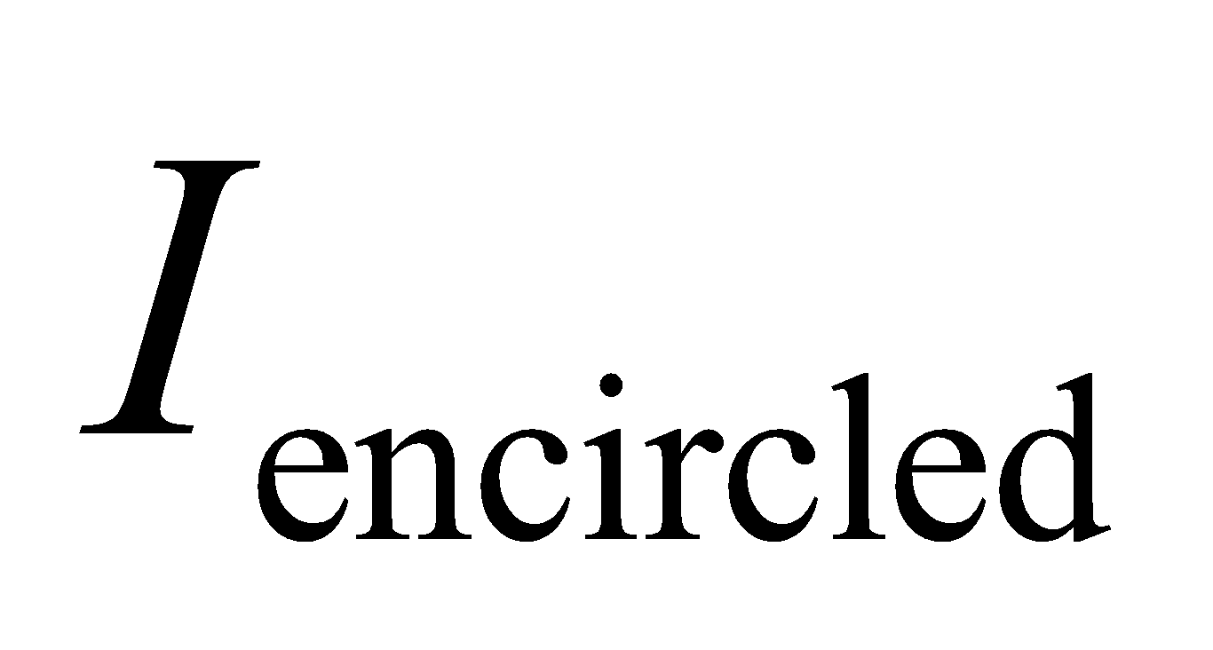 for an amperian loop with  Then,

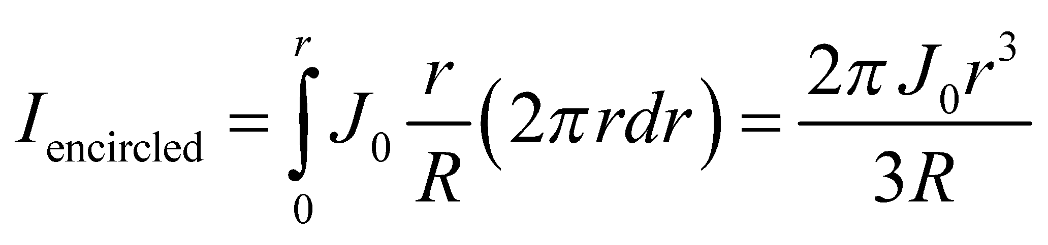

Here, area elements were chosen to be circular rings of radius *r*, thickness *dr*, and area 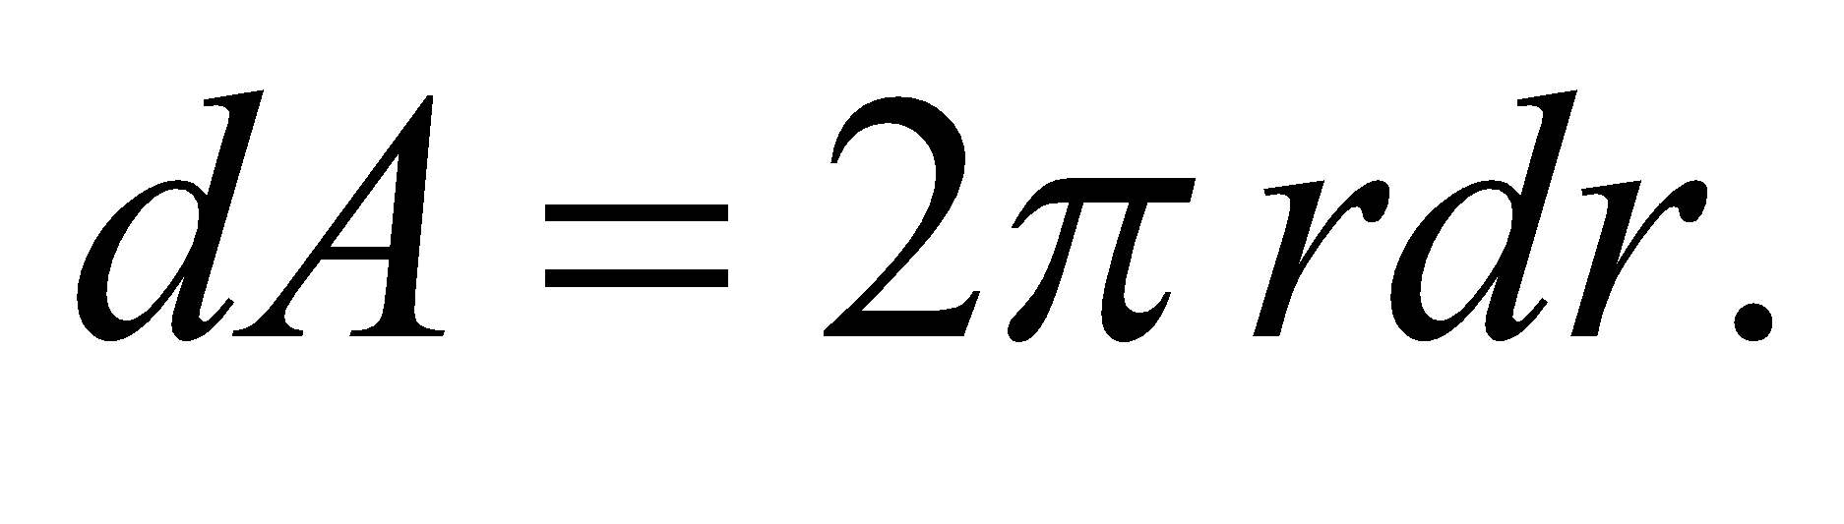 Ampère’s law thus gives 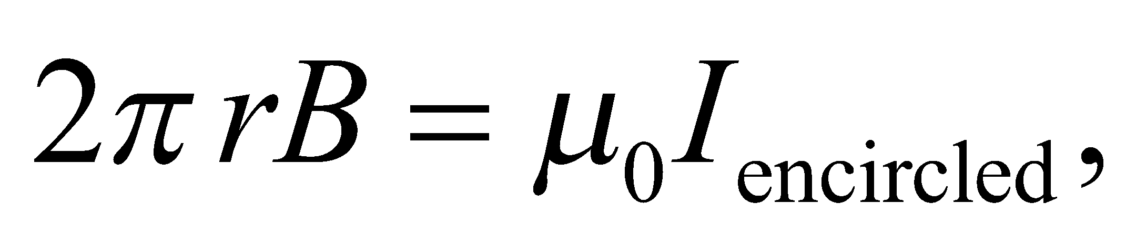 or

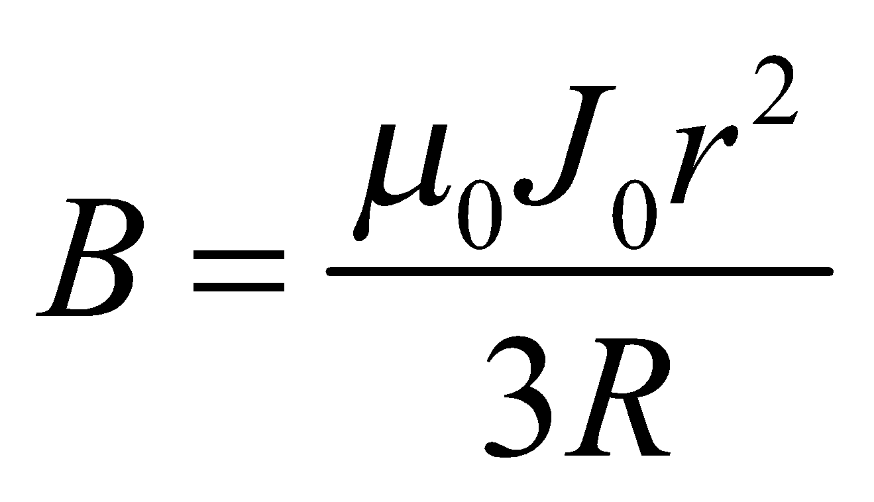

for 

**(b)** The field outside 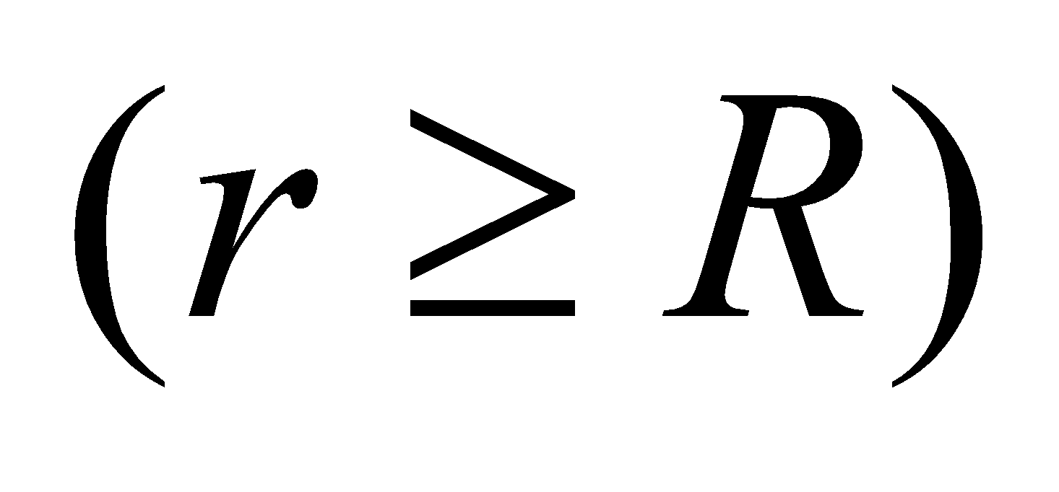 is given by Equation 26.17, and has direction circling the rod according to the right-hand rule. The total current can be related to the current density by integrating over the cross-sectional area of the rod:

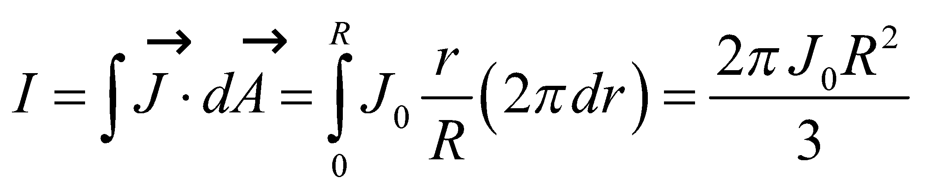

The magnetic field outside the wire is then

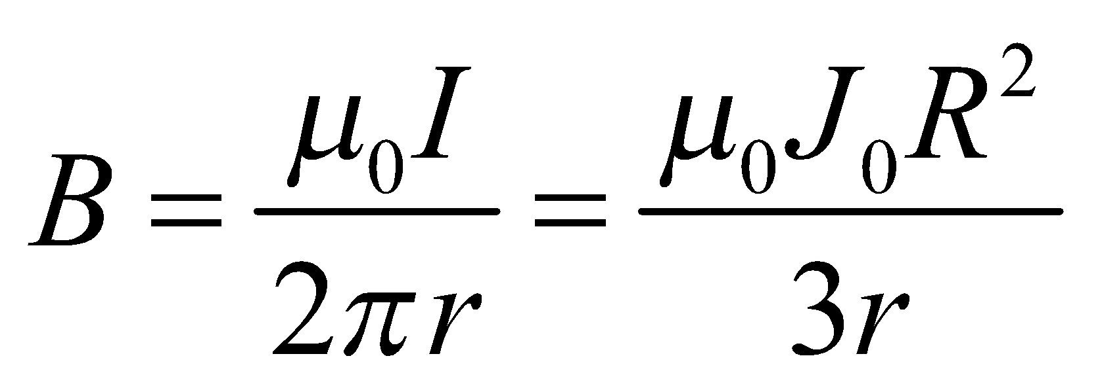

for 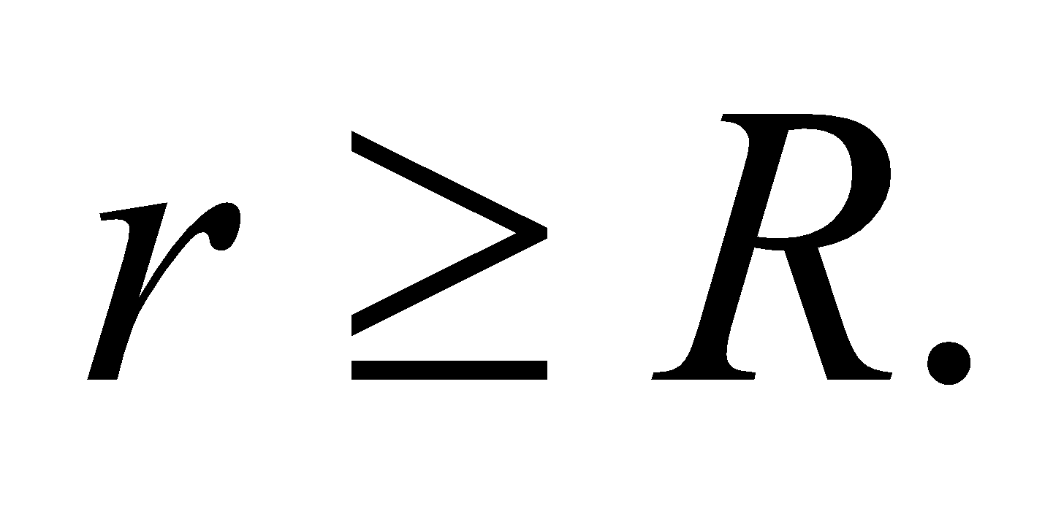

**Assess** The magnetic field increases as *r*2 inside the rod, but decreases as 1/*r* outside the rod. At *r* = *R*, both expressions give the same result: 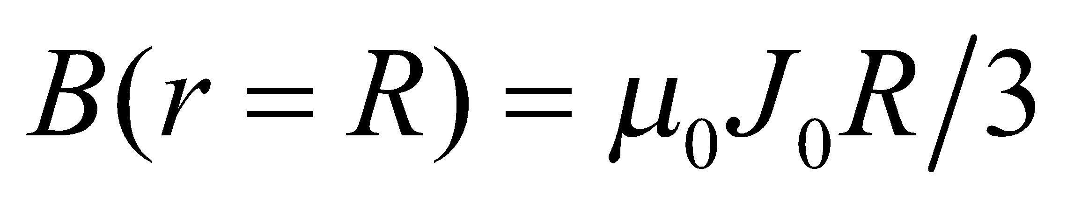.

**65.** **Interpret** This problem involves Ampère’s law, which we can use to find the magnetic field inside and outside a conducting pipe that carries current.

**Develop** Apply Ampère’s law, Equation 26.17 to both situations. Inside the pipe, there is no current enclosed by the Ampèrian loop. Outside the pipe, the current enclosed is I.

**Evaluate** (**a**) Because there is no current enclosed inside the pipe, the magnetic field is zero (*B* = 0) inside the pipe.

(**b**) Outside the pipe, the field is cylindrically symmetric (provided we are far, compared to the pipe radius, from the pipe ends), so Ampères law gives

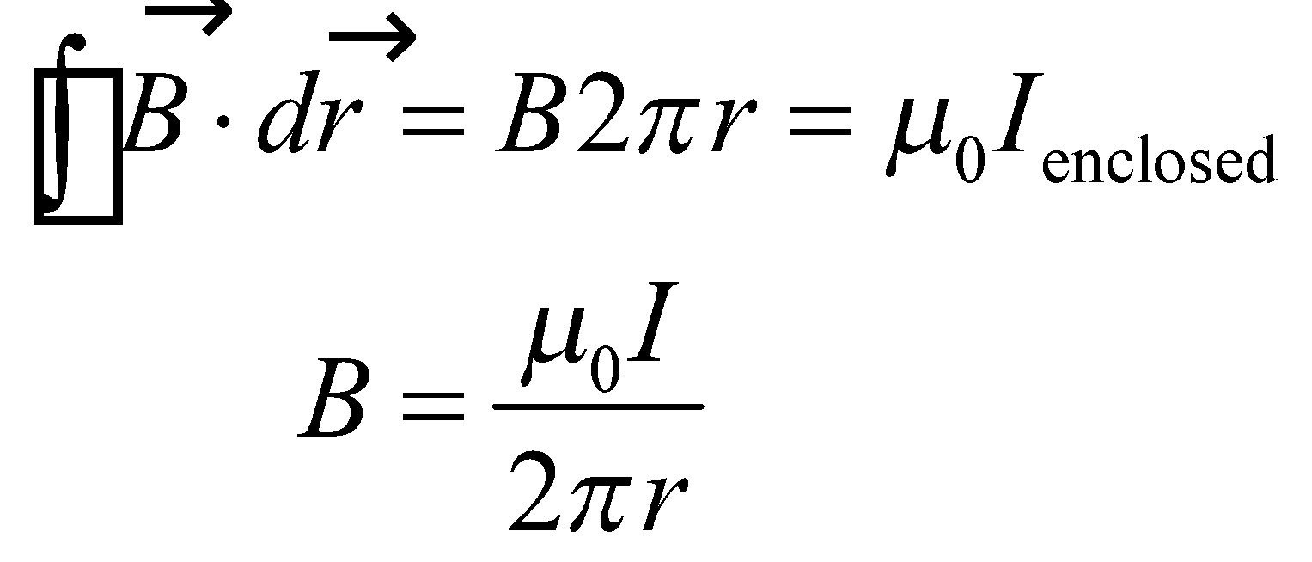

**Assess** The field outside a hollow pipe is just like that outside a wire (see Example 26.7).

**66.** **Interpret** This problem involves Ampère’s law, which we can use to find the magnetic field surrounding a coaxial cable that carries equal but opposite currents on its inner and outer conductors.

**Develop** For the magnetic field inside the inner conductor, the problem is exactly the same as Example 26.7, so we can apply Equation 26.19. Outside the outer conductor, the total current is zero, so the magnetic field is zero by Ampère’s law (Equation 26.17). Between the two conductors, we can use the result from Example 26.7 for the field outside a wire.

**Evaluate** (a) From Example 26.17, the field inside the wire is 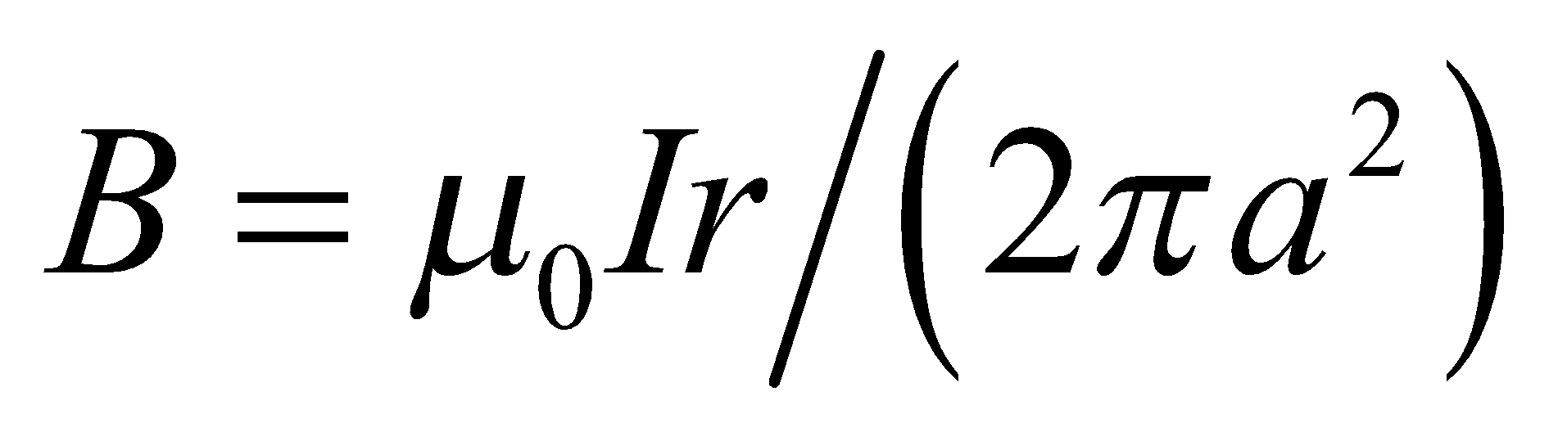.

(b) Between the inner and outer conductors, the field is .

(c) Outside the coaxial cable, the magnetic field is zero (*B* = 0).

**Assess** Inside the outer conductors, the field is

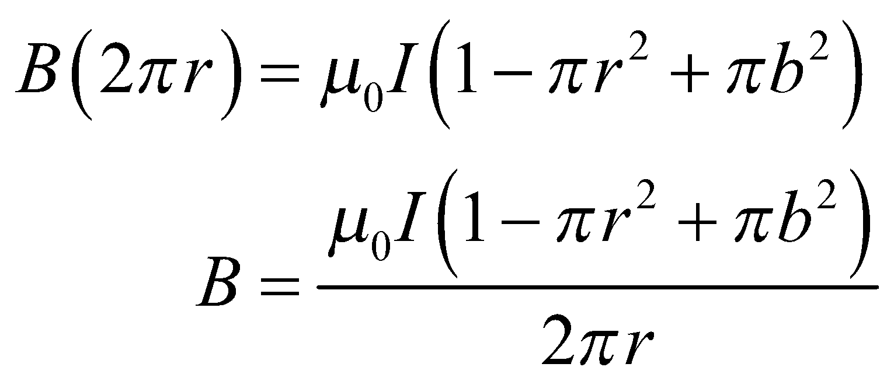

**67. Interpret** This problem deals with the magnetic field of a current-carrying solenoid. We are interested in the number of turns the solenoid has and the power it dissipates.

**Develop** A length-diameter ratio of 10 to 1 is large enough for Equation 26.20, 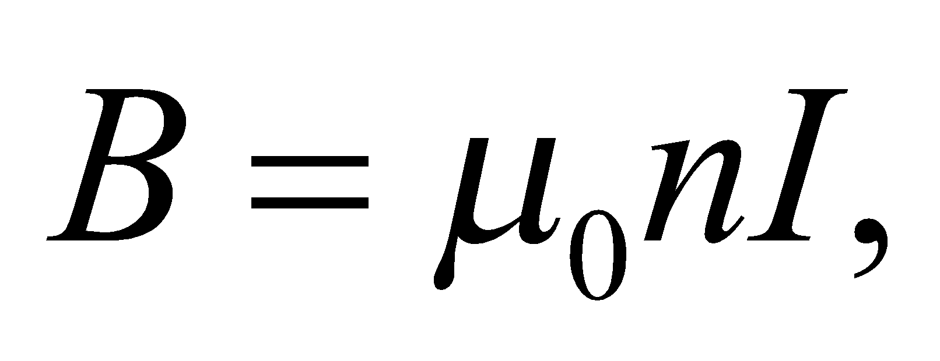 to be a good approximation to the field near the solenoid’s center. This is the equation we shall use to calculate the number of turns. On the other hand, the power the solenoid dissipates is given by Equation 2.4.8a,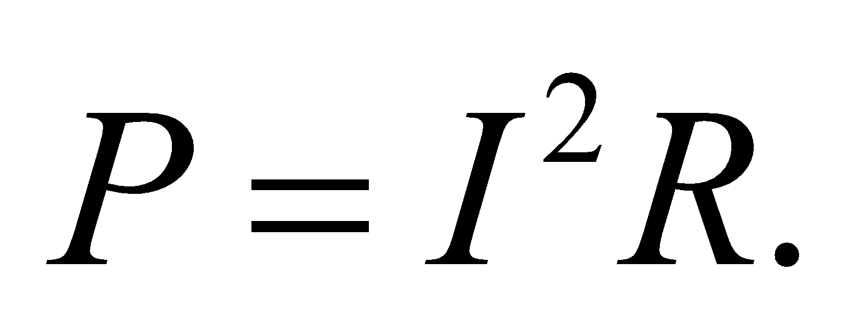

**Evaluate** **(a)** Using Equation 26.21, we find the number of turns per unit length to be

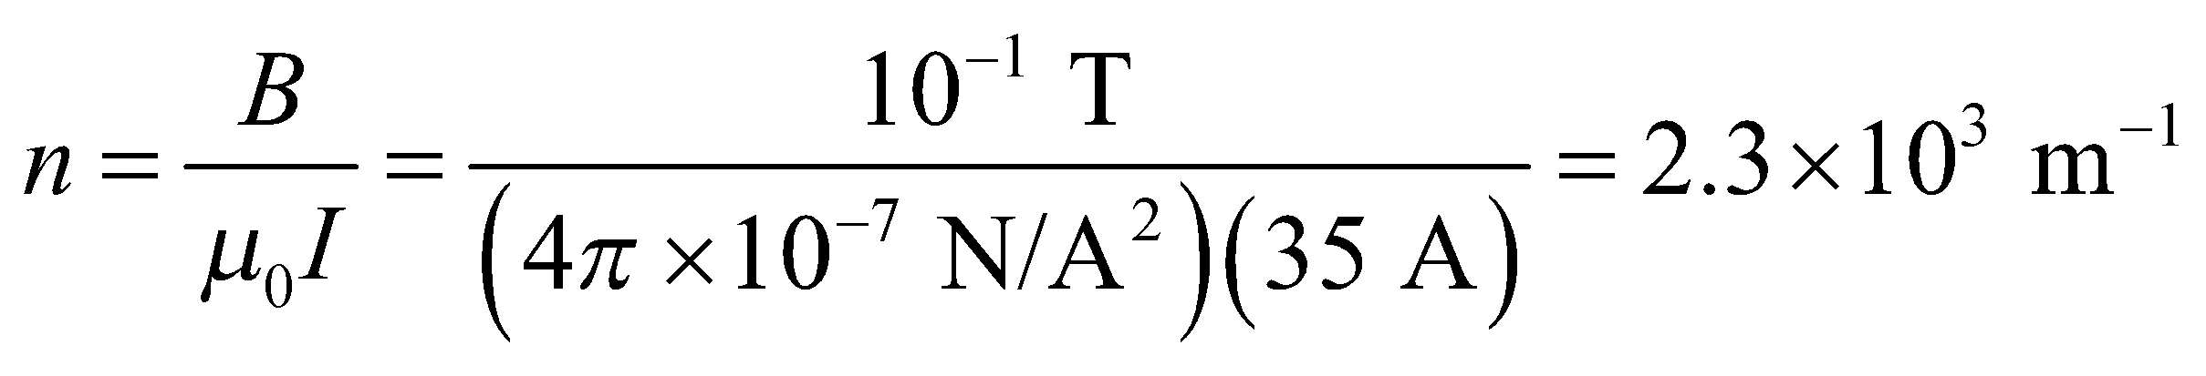

This implies that the total number of turns is 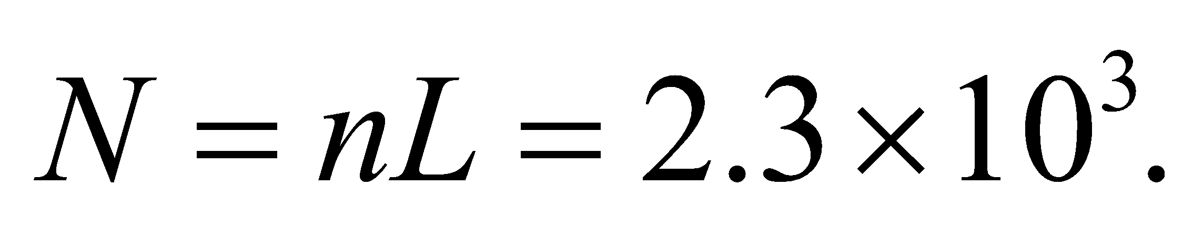

**(b)** A direct current is used in the solenoid, so the power dissipated (Joule heat) is

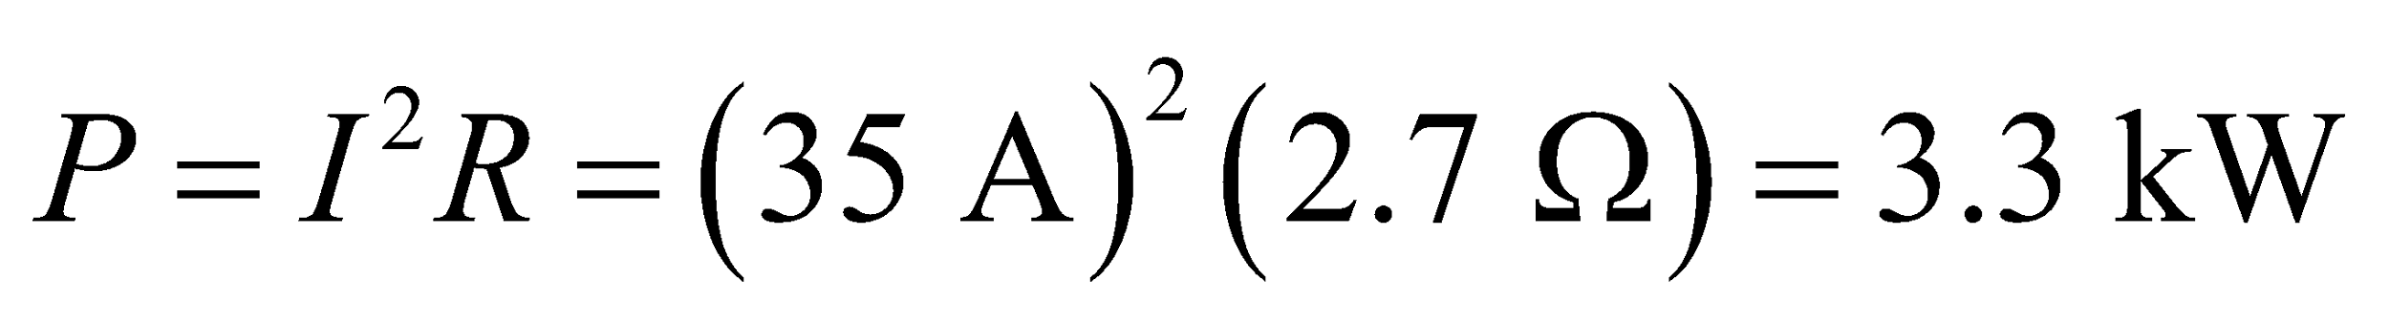

**Assess** That’s a lot of turns in one meter. The solenoid is very tightly wound to produce such a strong field at its center.

**68.** **Interpret** This problem involves finding the magnetic field for two different wire configurations, given the current and the geometrical parameters.

**Develop** Apply Equation 26.21, *B* = *μ*0*nI*, to find the magnetic field inside the solenoid. The maximum loop density is one loop per wire diameter, or *n* = 1/*d* = 2000 m−1. The magnetic field at the center of a flat,

circular current loop can be found from Equation 26.9, 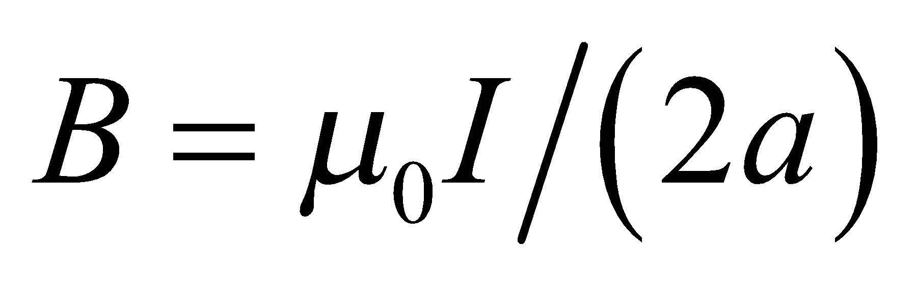, where 2*πa* = 10 m, or *a* = (10 m)/(2*π*).

**Evaluate** (**a**) Inserting the given quantities gives the magnetic field B at the solenoid center as



(**b**) The magnetic field at the center of the loop is

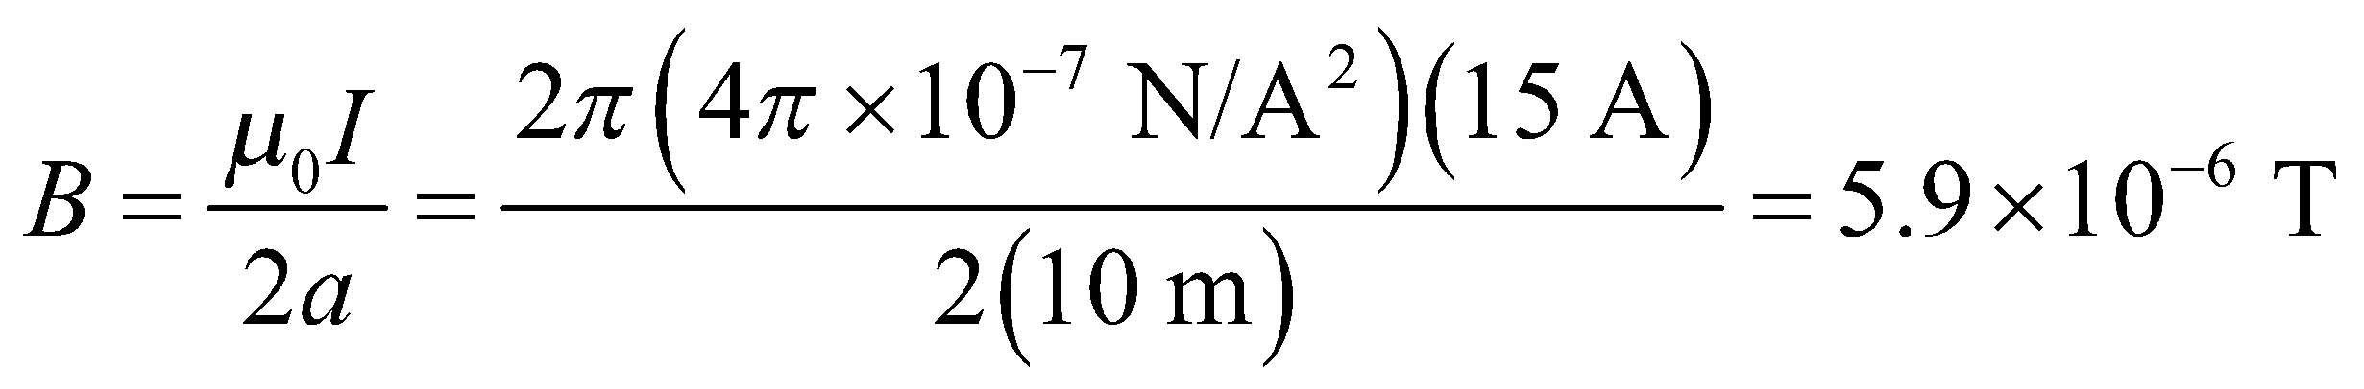

**Assess** To verify that the use of Equation 26.21 is justified, we should verify that the solenoid length is much, much greater than its radius. The length of the solenoid is

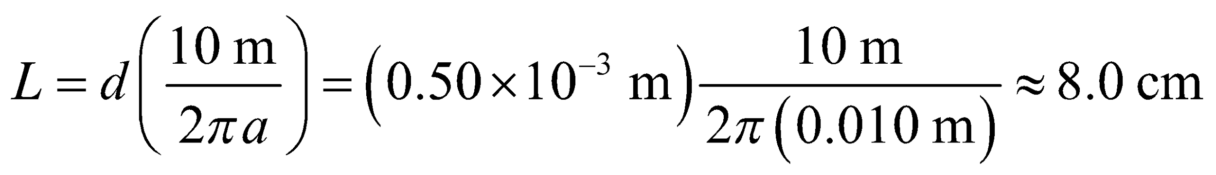

which is essentially an order of magnitude larger than the solenoid diameter (anything over a factor of three is about an order of magnitude, see the scale of a log10 plot). Thus, the use of Equation 26.21 is justified. Notice also that the magnetic field in the solenoid is 4 orders of magnitude larger than at the center of a single loop.

**69. Interpret** In this problem we are asked to derive to expression for the magnetic field of a solenoid by treating it as being made up of a large number of current loops.

**Develop**Consider a small length of solenoid, *dx*, to be like a coil of radius *R* and current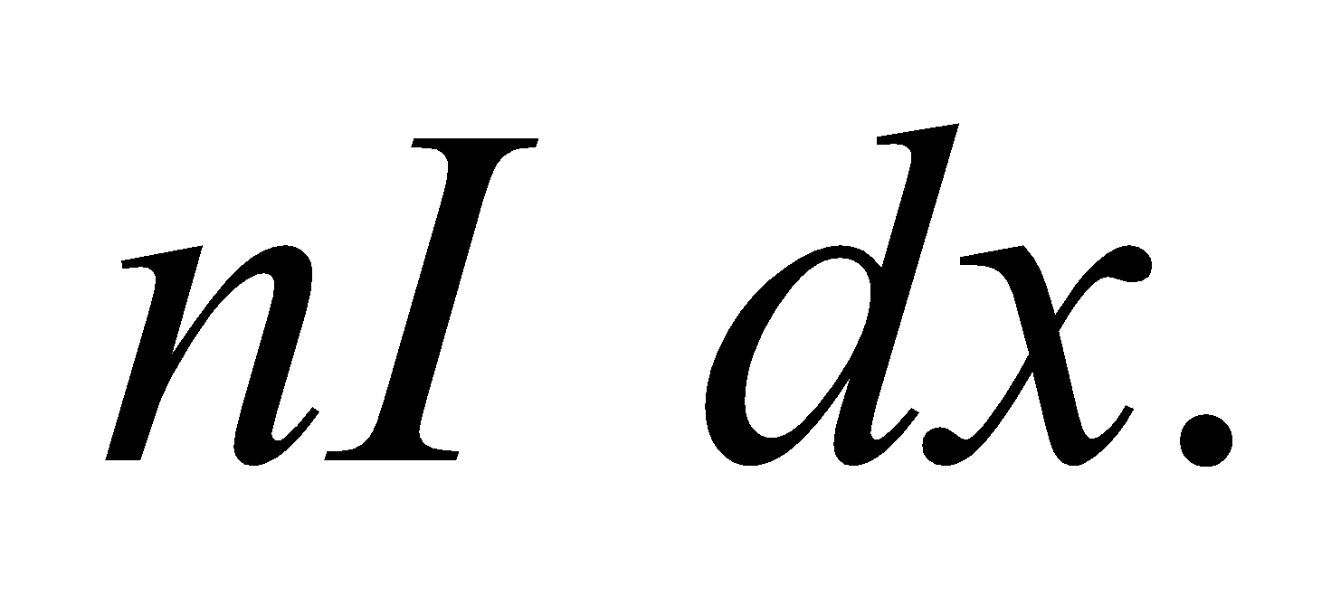Using Equation 26.9, the axial field is

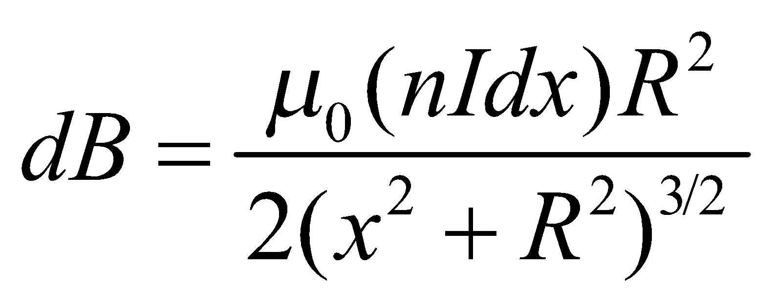

with direction along the axis according to the right-hand rule. For a very long solenoid, we can integrate this from

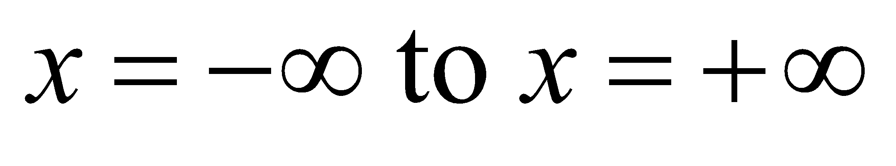to find the total field.

**Evaluate** Integrating over *dx* from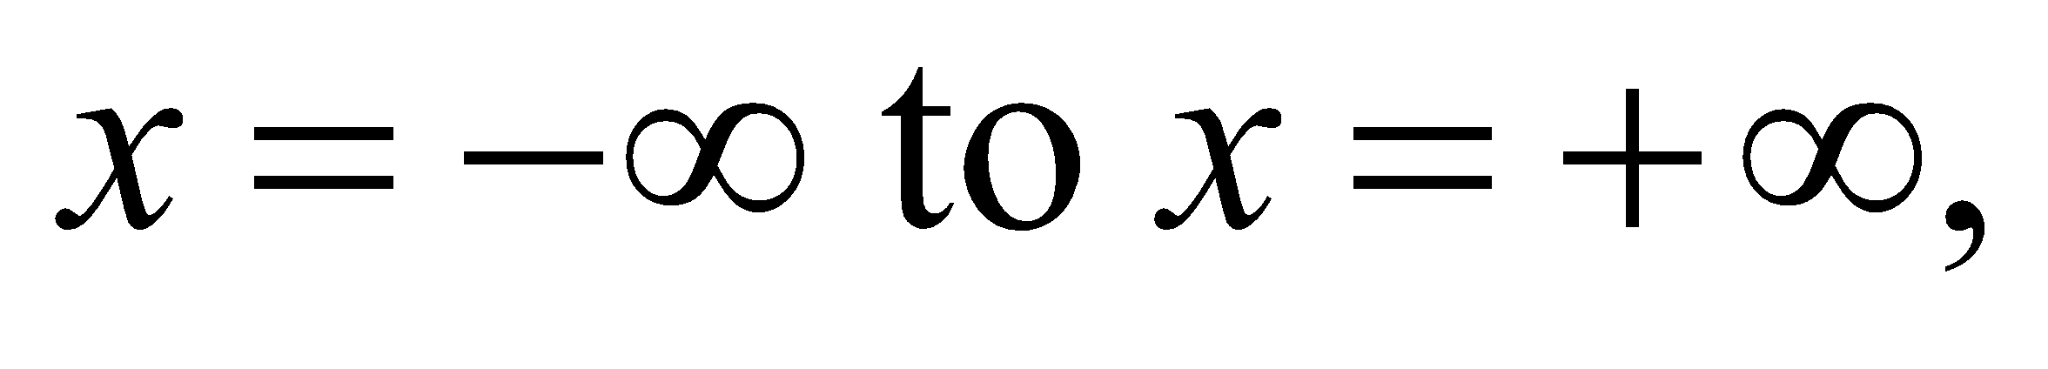we find the magnetic field to be

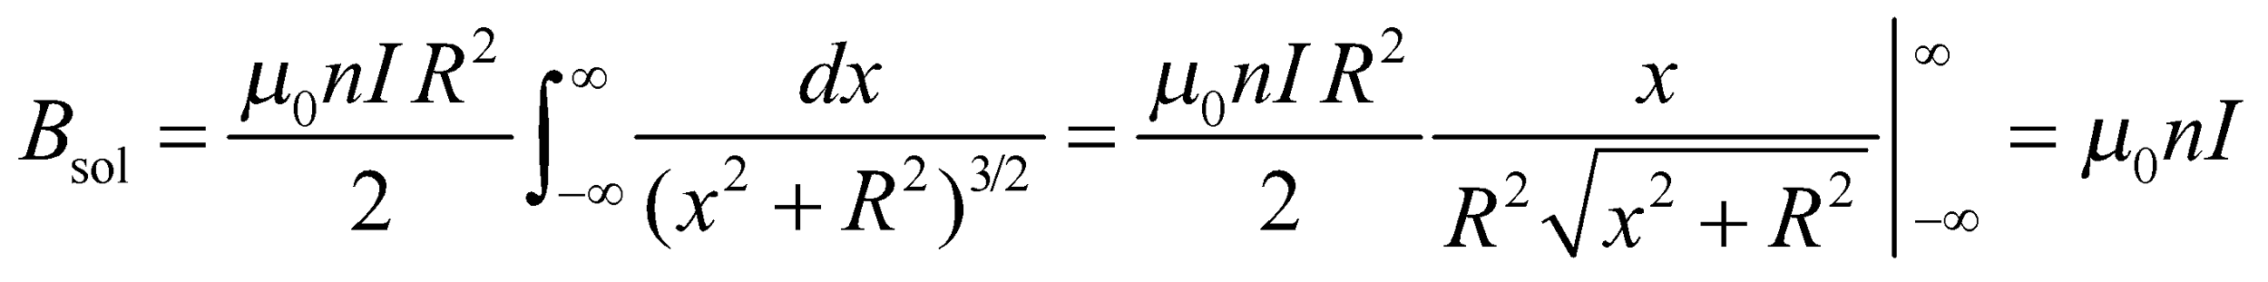

This is the expression given in Equation 26.20.

**Assess** For a finite solenoid, a similar integral gives the field at any point on the axis only, for example, at the center of a solenoid of length *L*,

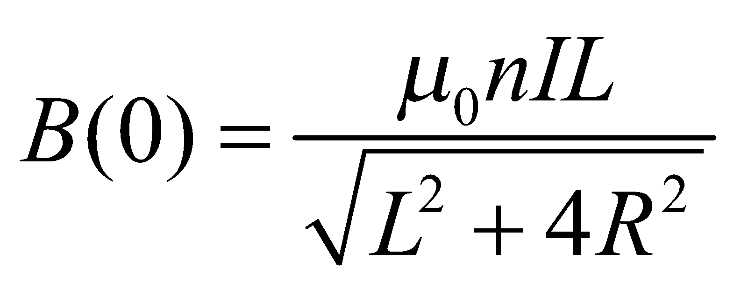

**70.** **Interpret** This problem involves finding the distance from a lightening strike, which we will model as a long, straight wire, at which the magnetic field strength is the same magnitude as the magnetic field of the Earth.

**Develop** Solve Equation 26.10 of Example 26.4 for the distance *y*.

**Evaluate** Inserting the given quantities, we find

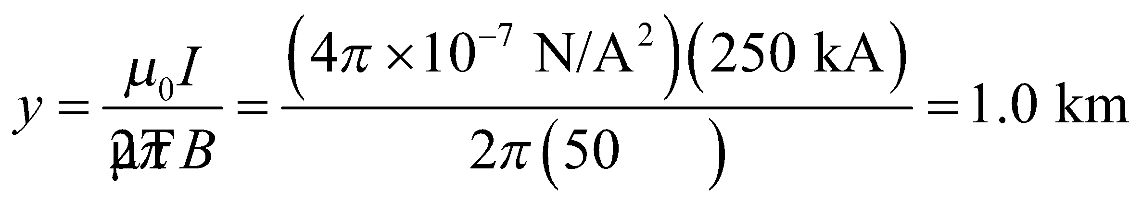

**Assess** This seems like a reasonable distance.

**71.** **Interpret** This problem is about the magnetic field of a coaxial cable. Ampère’s law can be applied since the current distribution has line symmetry.

**Develop**For a long, straight cable, the magnetic field can be found from Ampère’s law. The field lines are cylindrically symmetric and form closed loops, hence they must be concentric circles. If we choose Ampèrian loops that correspond to these concentric circles, then  will be constant and parallel to 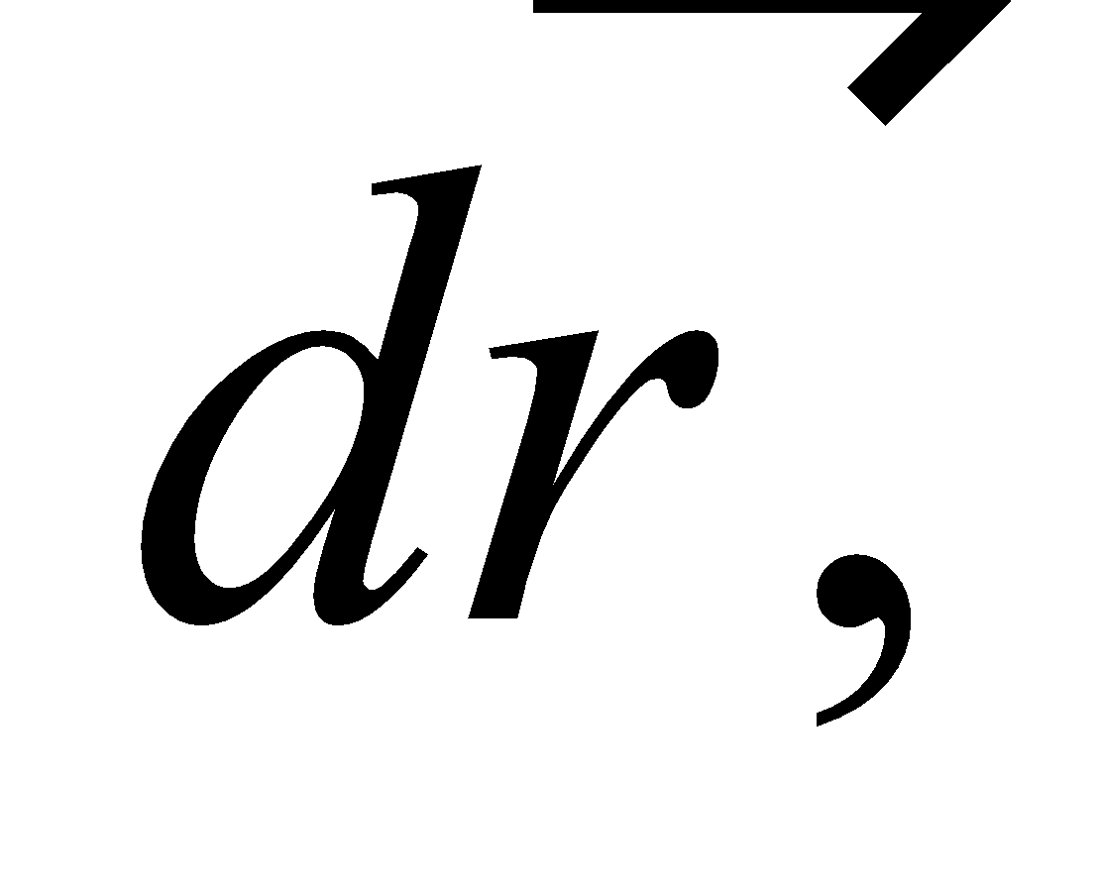 and Equation 26.16 reduces to

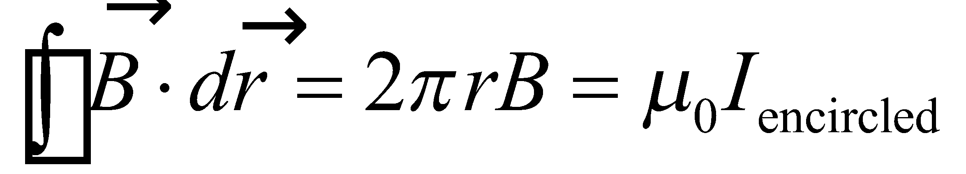

We will look at the field at different radii. As for the geometry of the coaxial cable, let 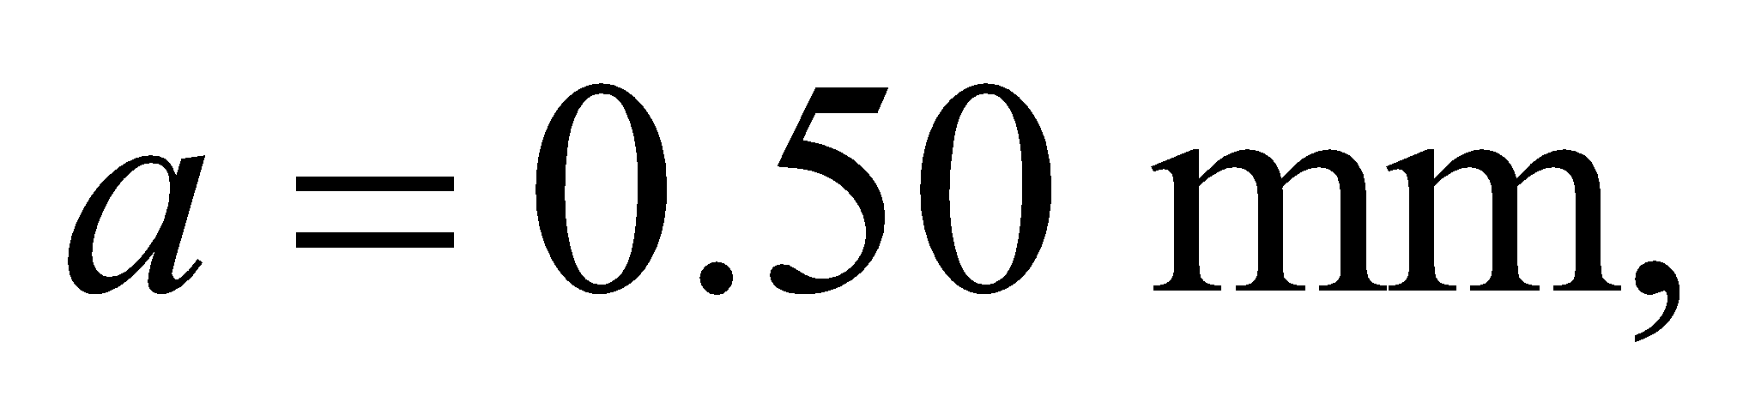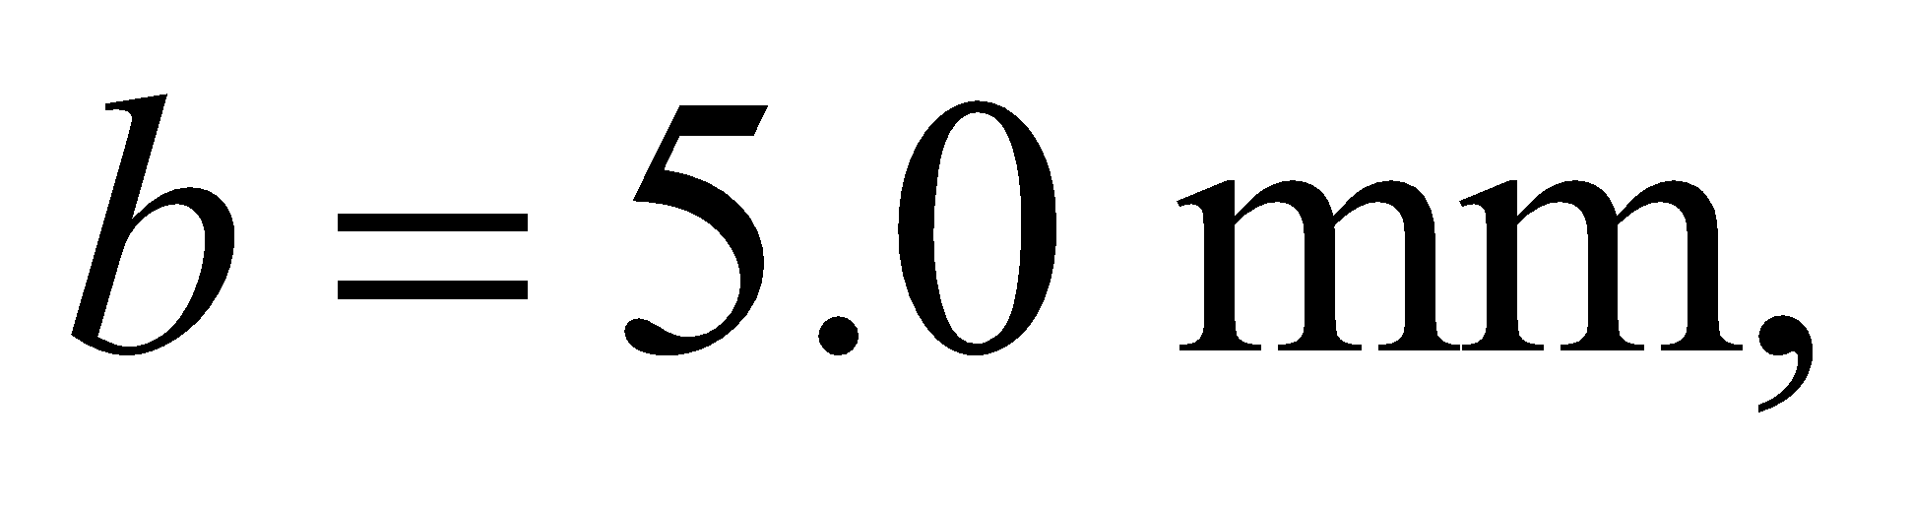and 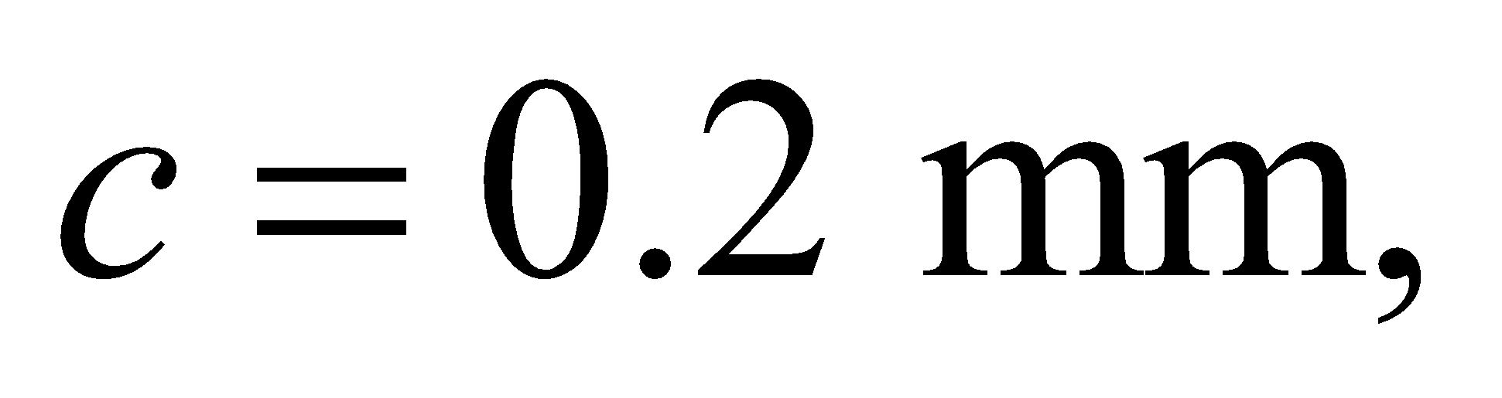in correspondence with Figure 26.46.

**Evaluate**(a) For 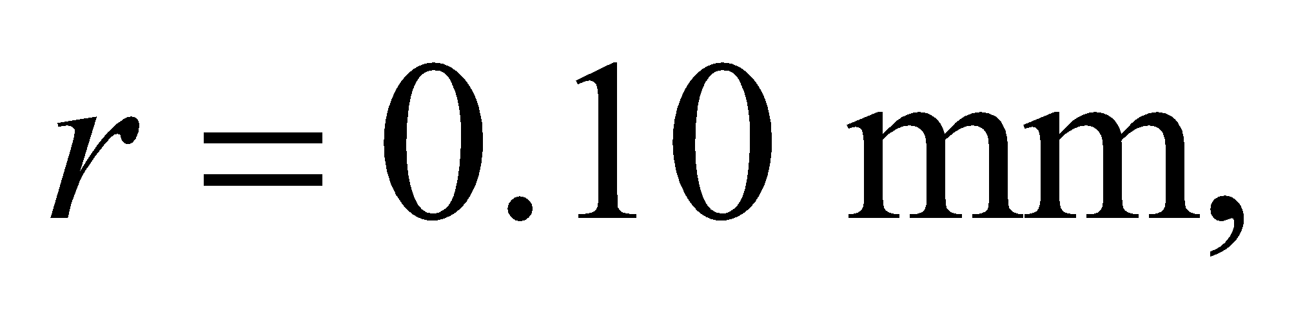this is within the radius, *a*, of the inner conductor. We will assume the current is uniformly distributed over the cross-section of the conductor, so the encircled current will be

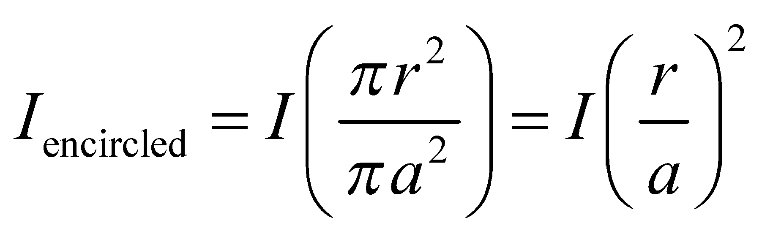

Plugging this into Ampère's law gives a field magnitude of

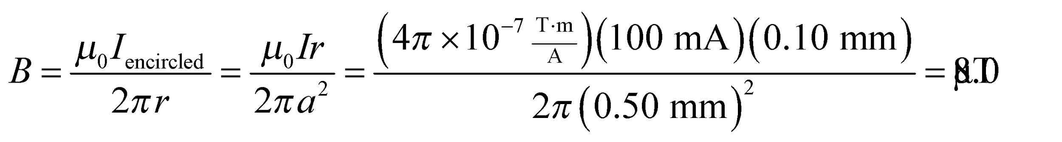

(b) For 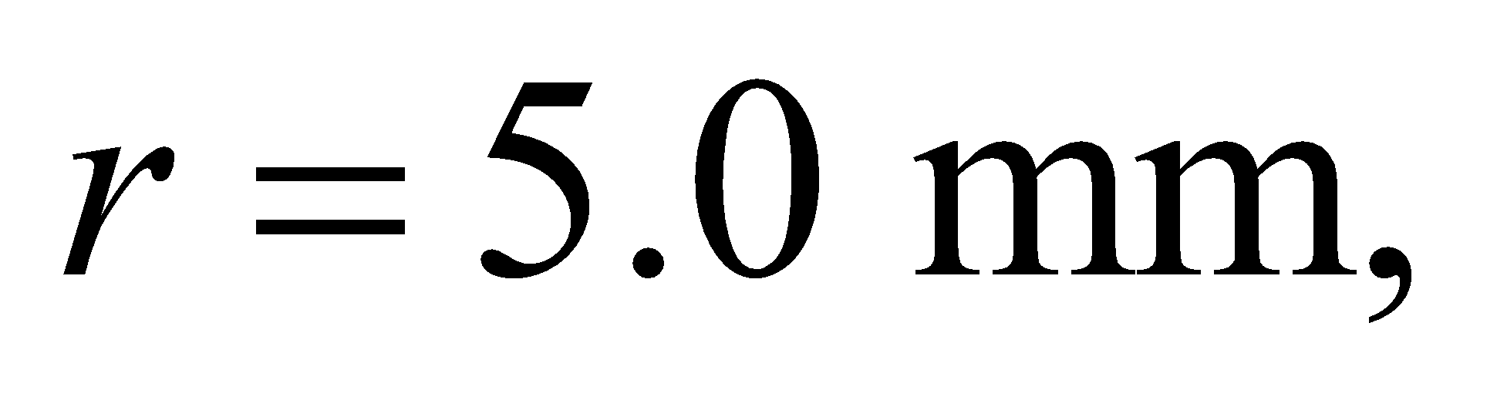this is right at the inner radius, *b*, of the outer conductor, so the encircled current is just the current, *I*, flowing in the inner conductor. The magnetic field here is

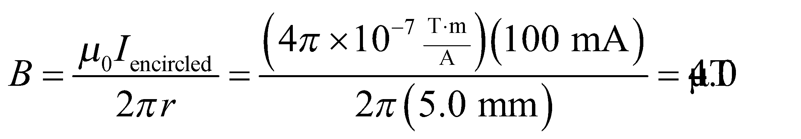

(c) For 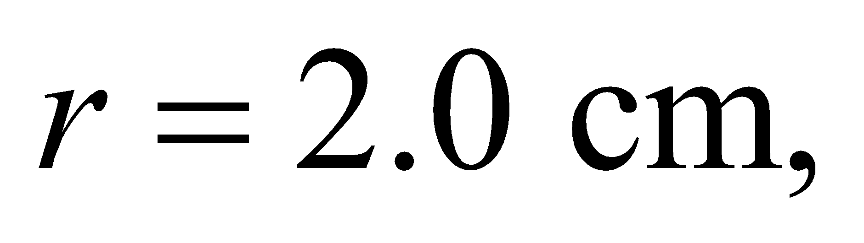this is beyond the outer radius, 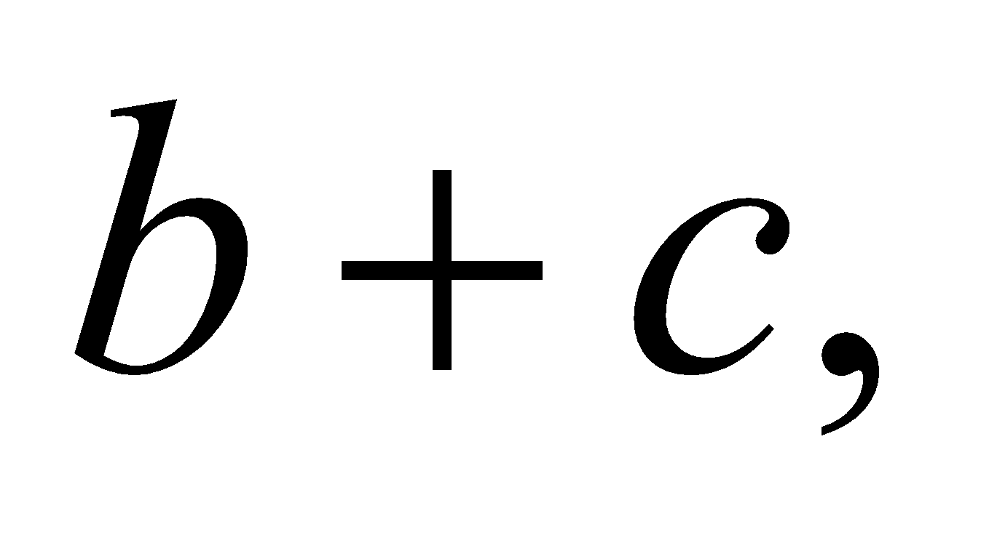of the outer conductor, so the encircled current includes the two opposite flowing currents 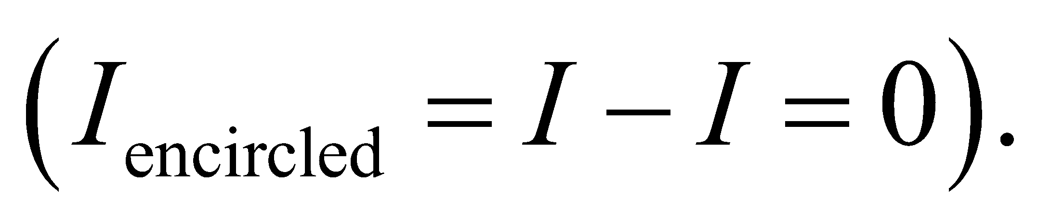 Thus, the magnetic field here is zero.

**Assess** This shows that the magnetic field increases linearly with radius 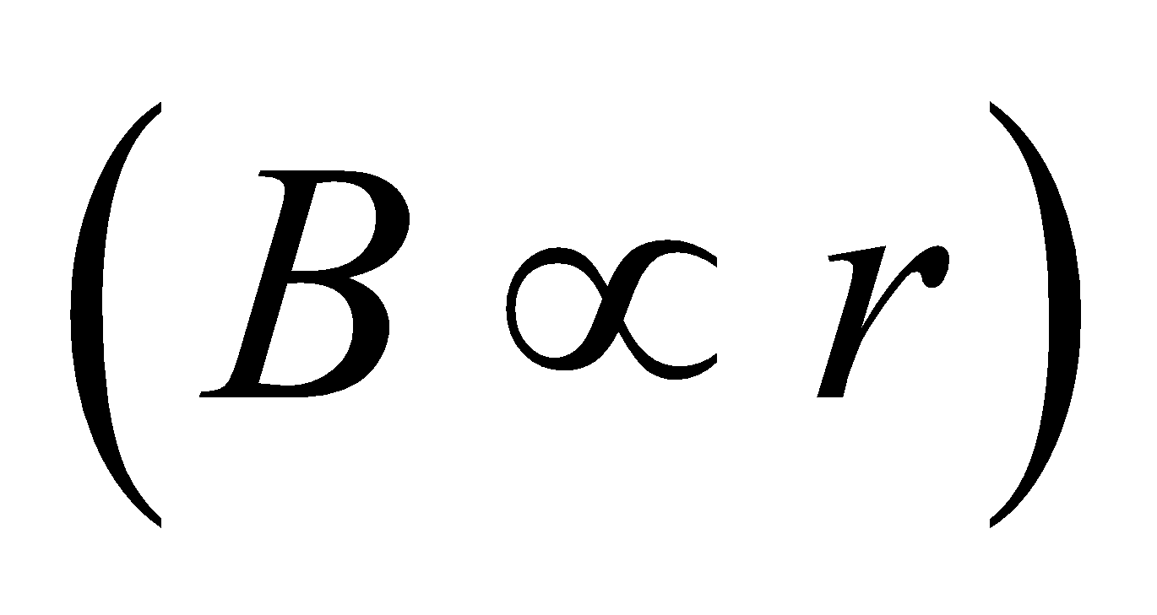 inside the inner conductor until it reaches its maximum at 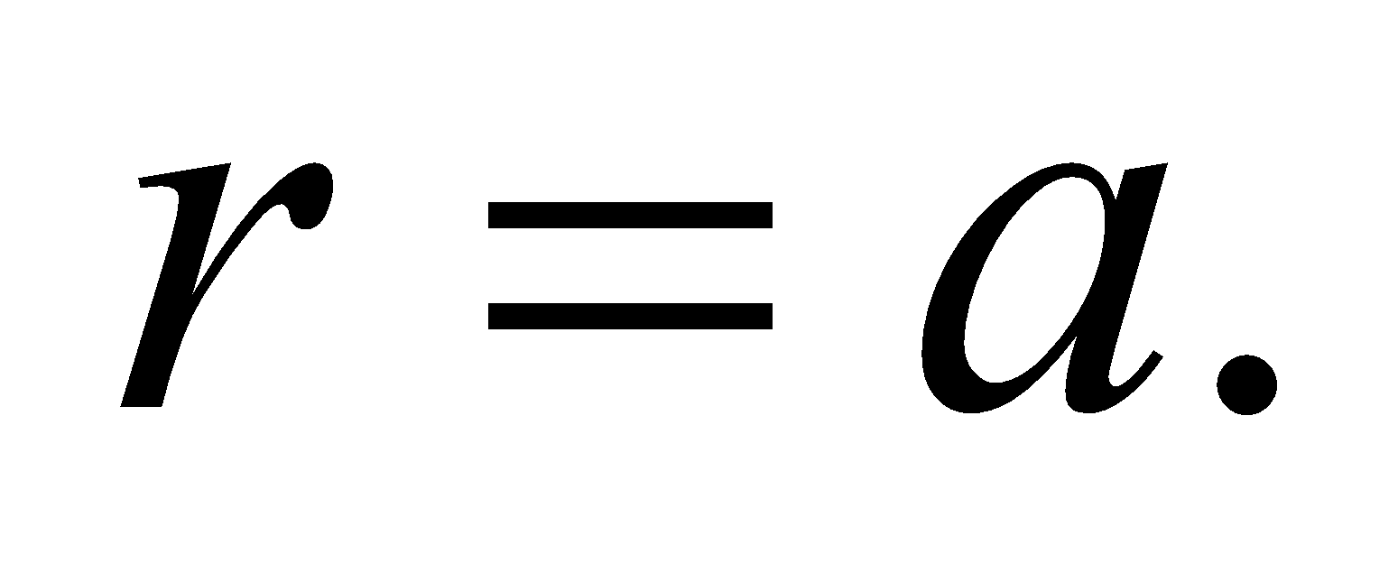 In between the conductors, the field decreases with radius as 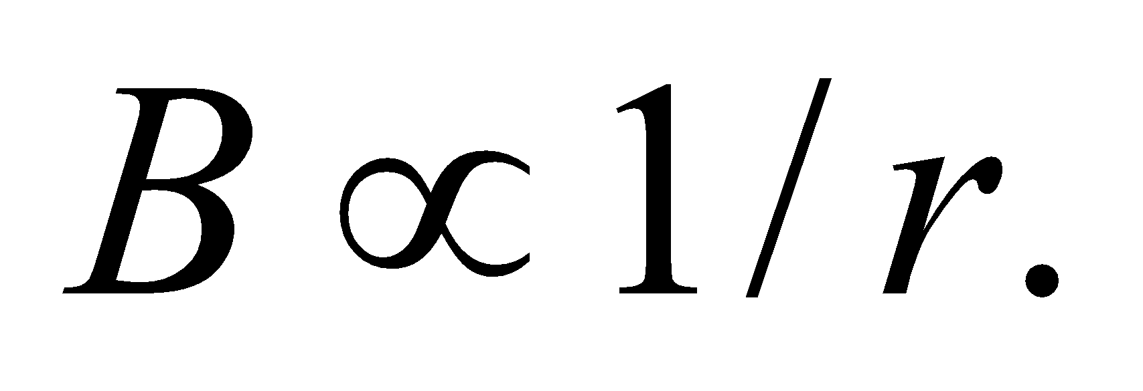 Inside the outer conductor, the field will decrease to zero according to:

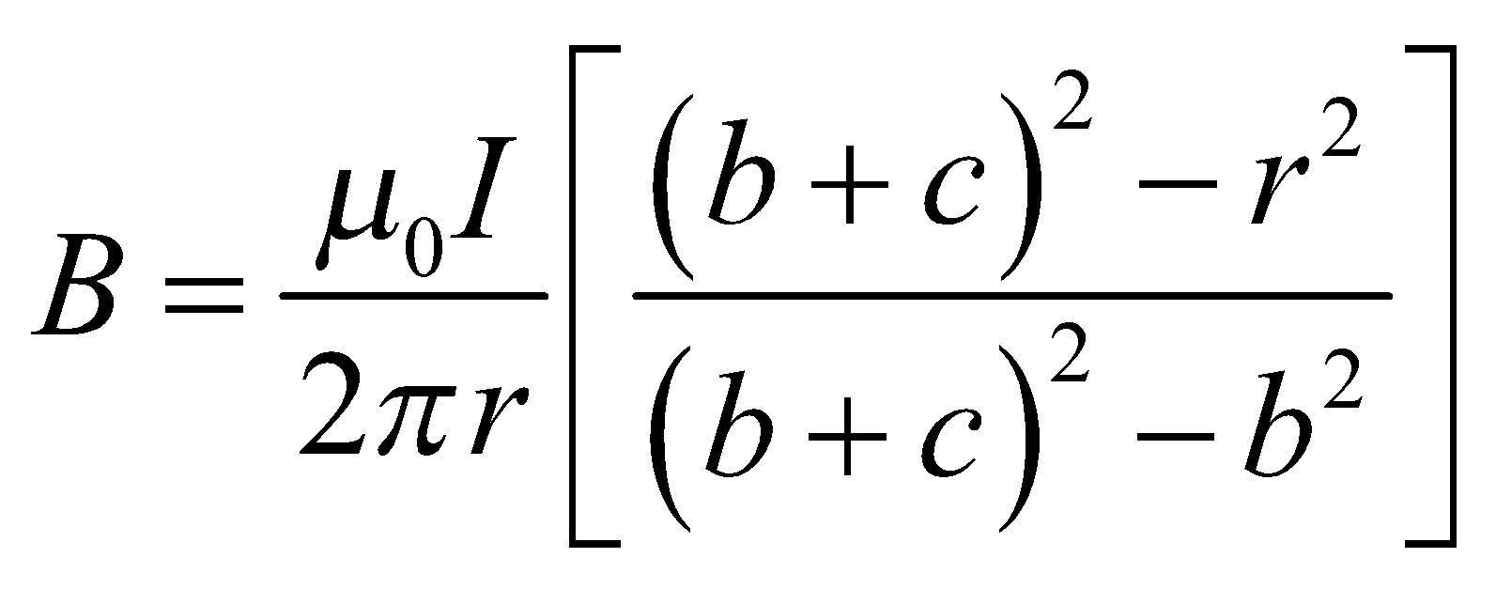

At 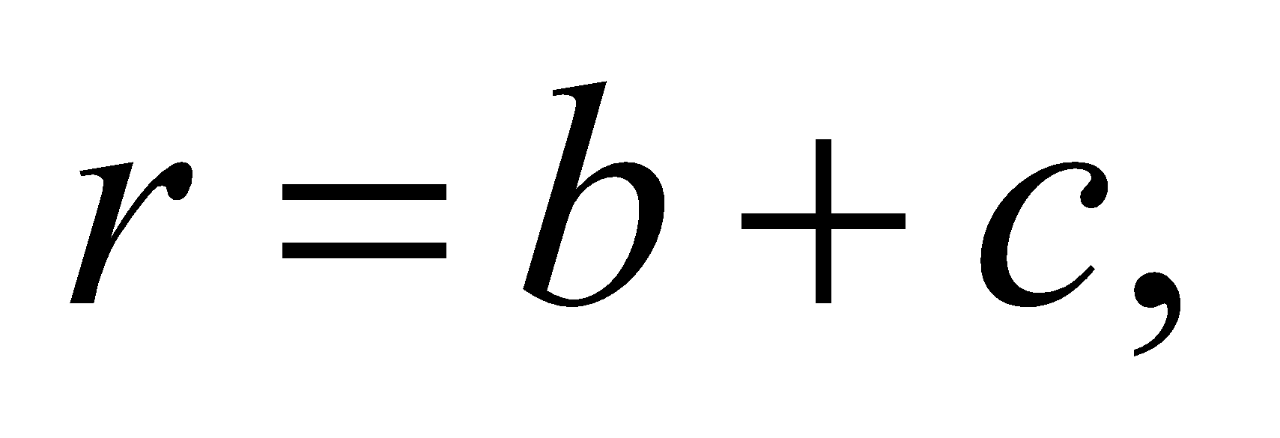this gives 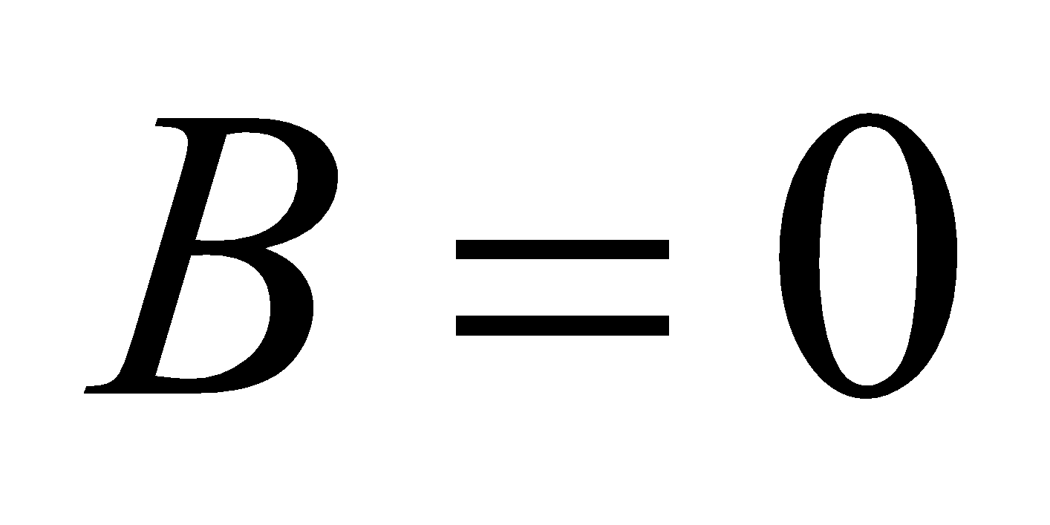 as we would expect.

**72.** **Interpret** We are to find the magnetic field at various points around a loop that carries current. By making the appropriate assumptions, we can directly apply the different formulas from Chapter 26, alleviating us from the need to derive new expressions.

**Develop** For part (a), we are to find the magnetic field 1.0 mm from a 15-cm-radius wire. At this distance, the wire may be considered to be straight (because 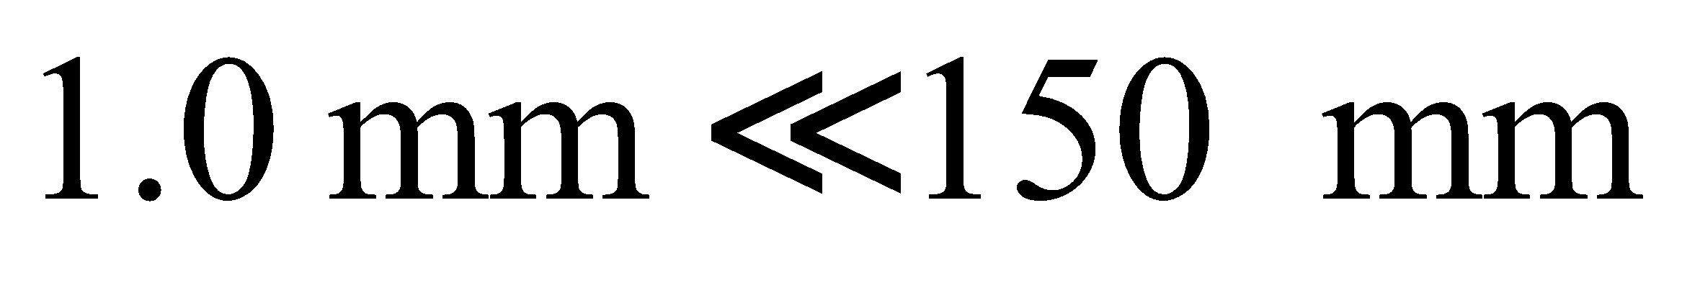), so we can apply Equation 26.10. For part (b), we can apply Equation 26.9 with 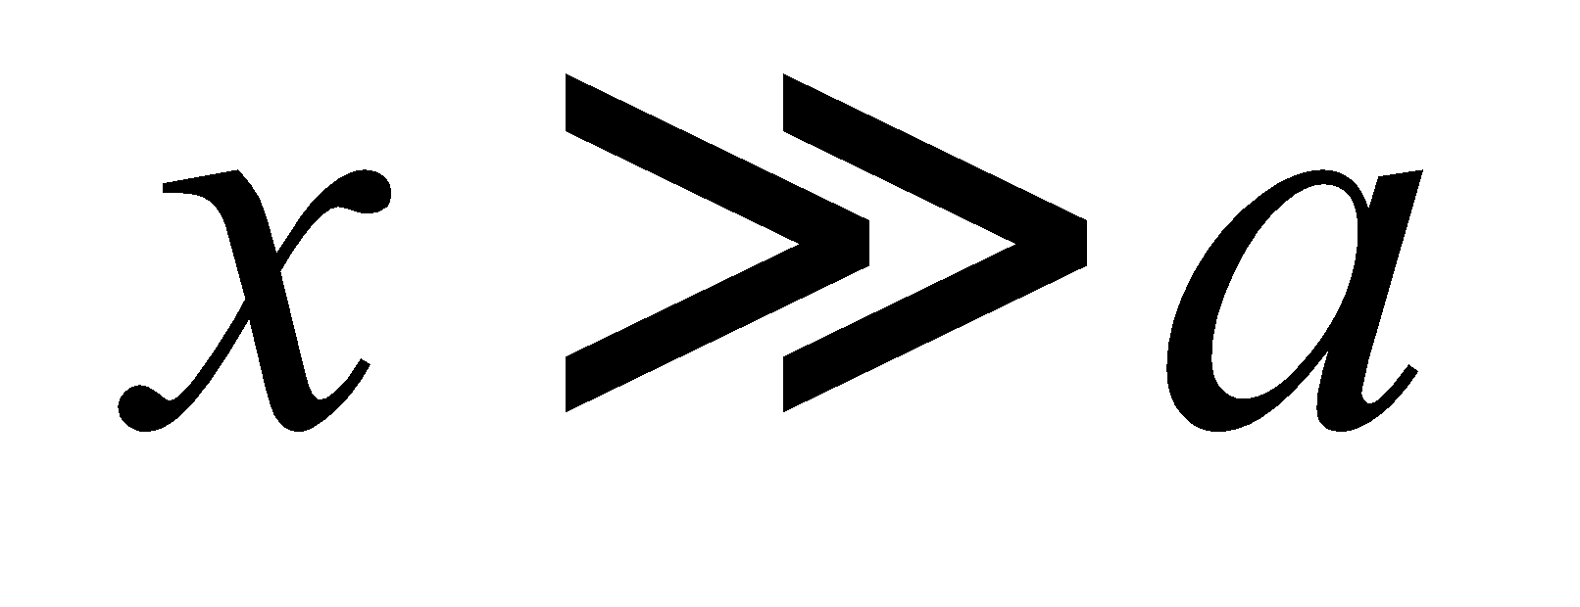, which gives

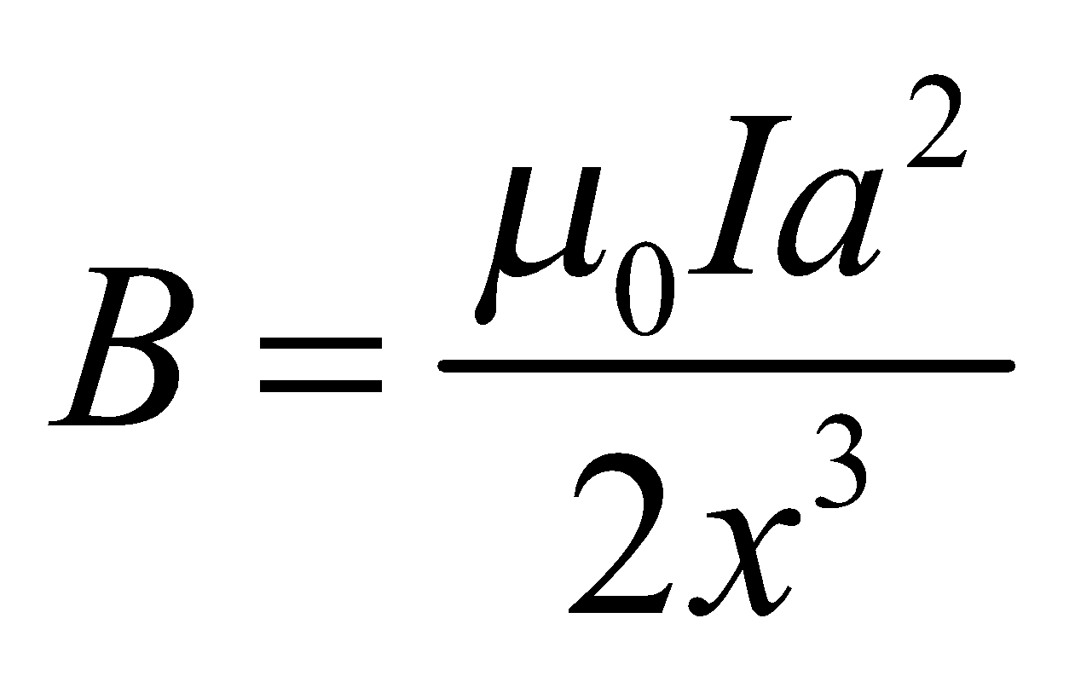

**Evaluate** (**a**) Inserting the given quantities, we find a magnetic field to be

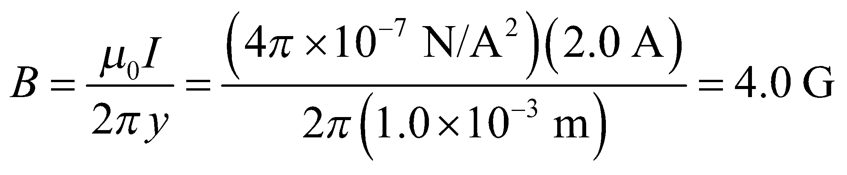

(**b**) The magnetic field 3 m from the loop, on its axis, is

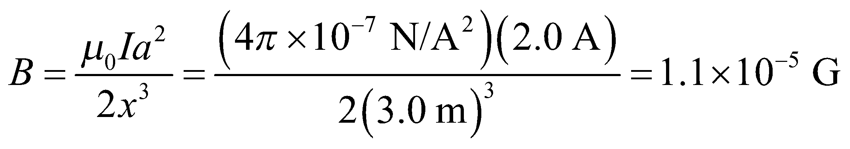

**Assess** The field is much weaker at 3 m from the loop than at 1 mm, as expected.

**73. Interpret** This problem is about the magnetic field of a current-carrying conducting bar. Symmetry holds approximately in certain limits.

**Develop** Very near the conductor, but far from any edge, the field is like that due to a large current sheet.  
On the other hand, very far from the conductor, the field is like that due to a long, straight wire.

**Evaluate** **(a)** Approximating the bar by a large current sheet with 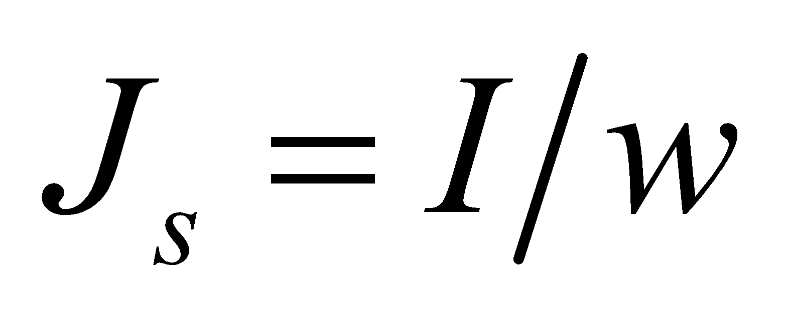, Equation 26.19 gives

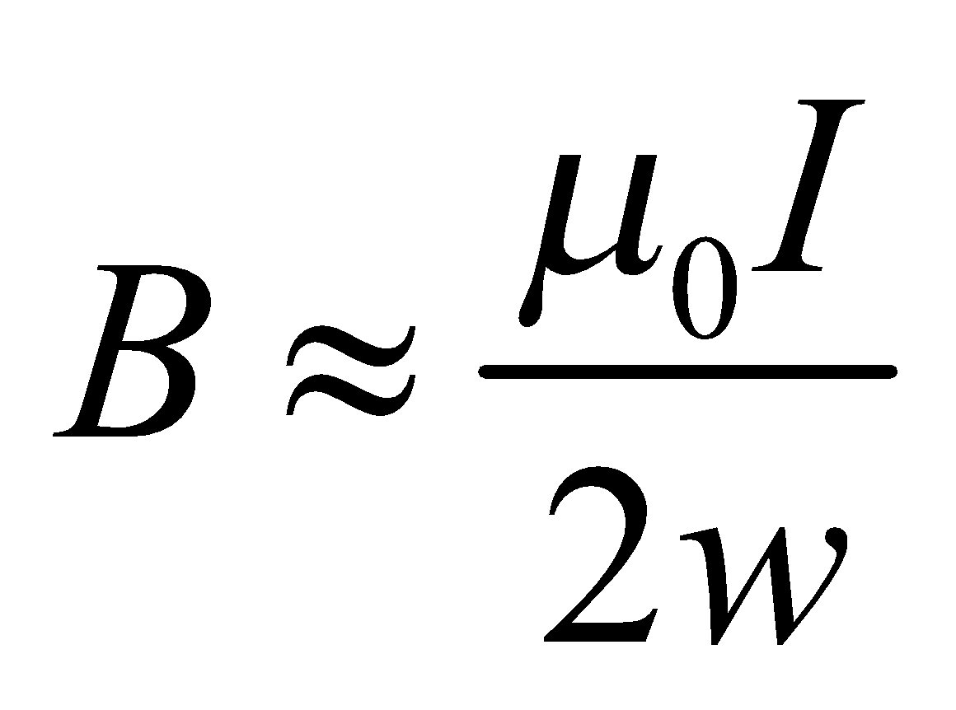

**(b)** Approximating the bar by a long, straight wire. Equation 26.17 gives

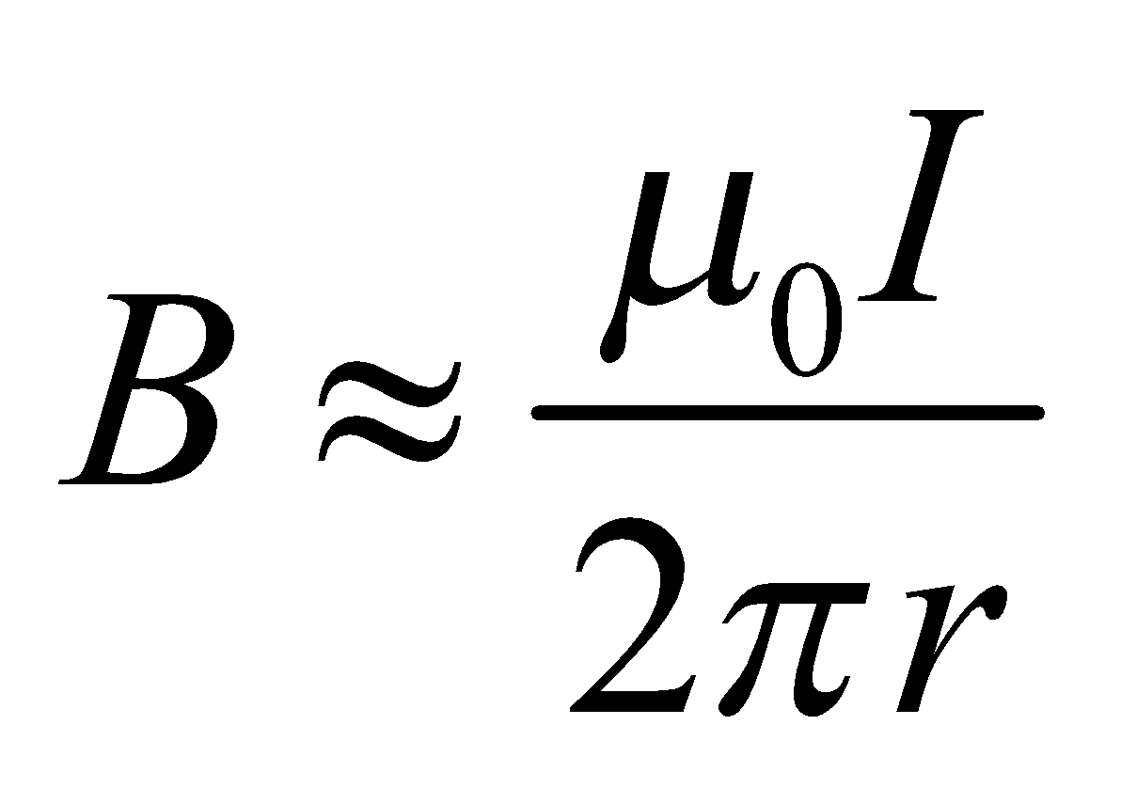

**Assess** The conductor exhibits different approximate symmetries, depending on where the field point is chosen.

**74.** **Interpret** For this problem, we are to find the magnetic field inside and outside a hollow pipe around which current circulates (see sketch below).

**Develop** The current distribution is similar to a solenoid, where the number of turns per unit length and the current in each turn are related to the total current in the pipe by 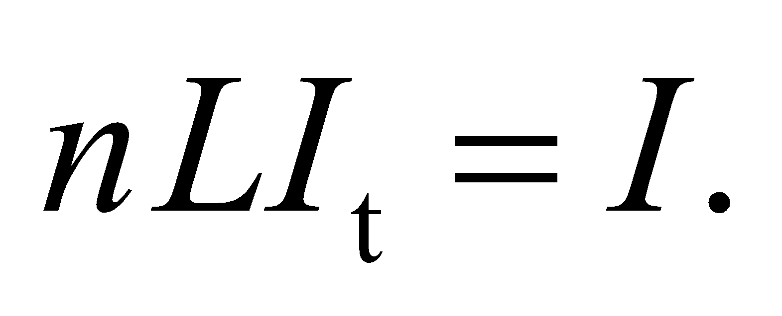 Therefore (see Section 26.8), the field is approximately that of an infinite solenoid.

**Evaluate** (**a**) Inside the pipe, the magnetic field is

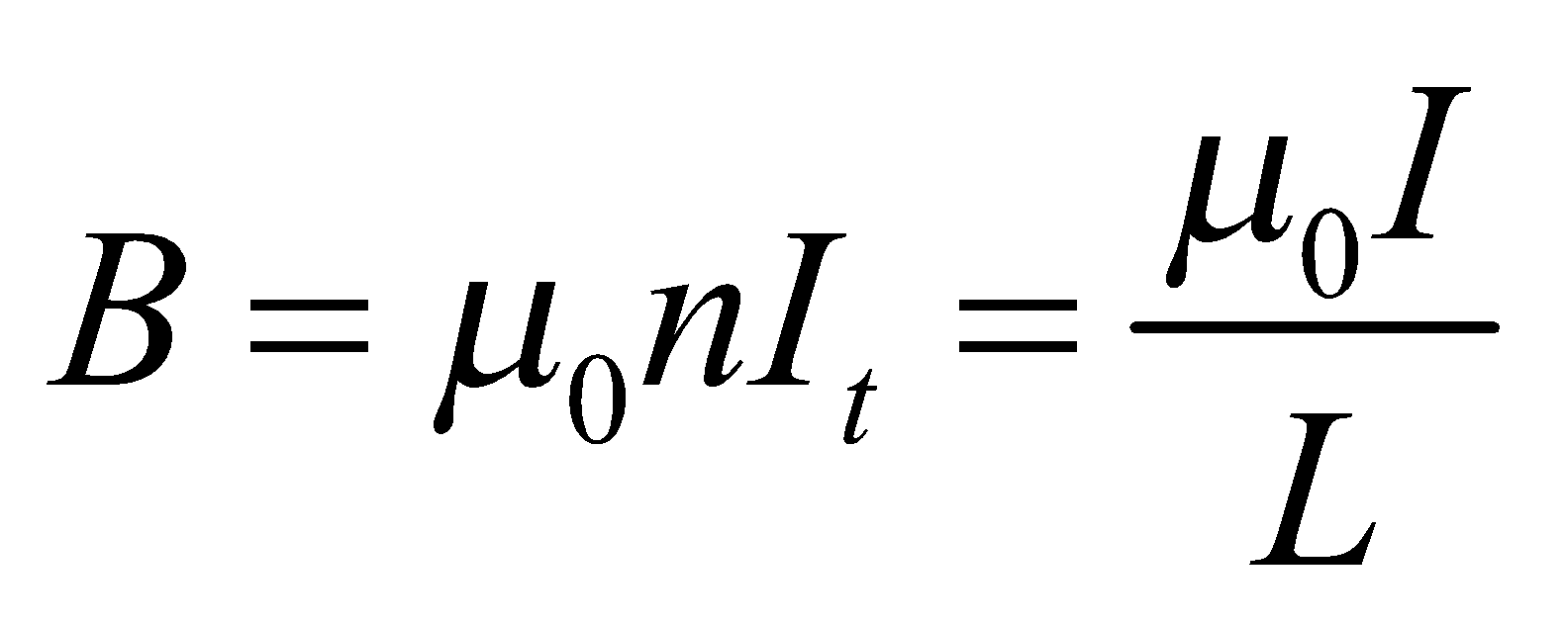

(**b**) Outside the pipe, the current is zero because *I*enclosed = 0 for an Ampèrian loop whose plane is perpendicular to the cylinder axis.

**Assess** If we let 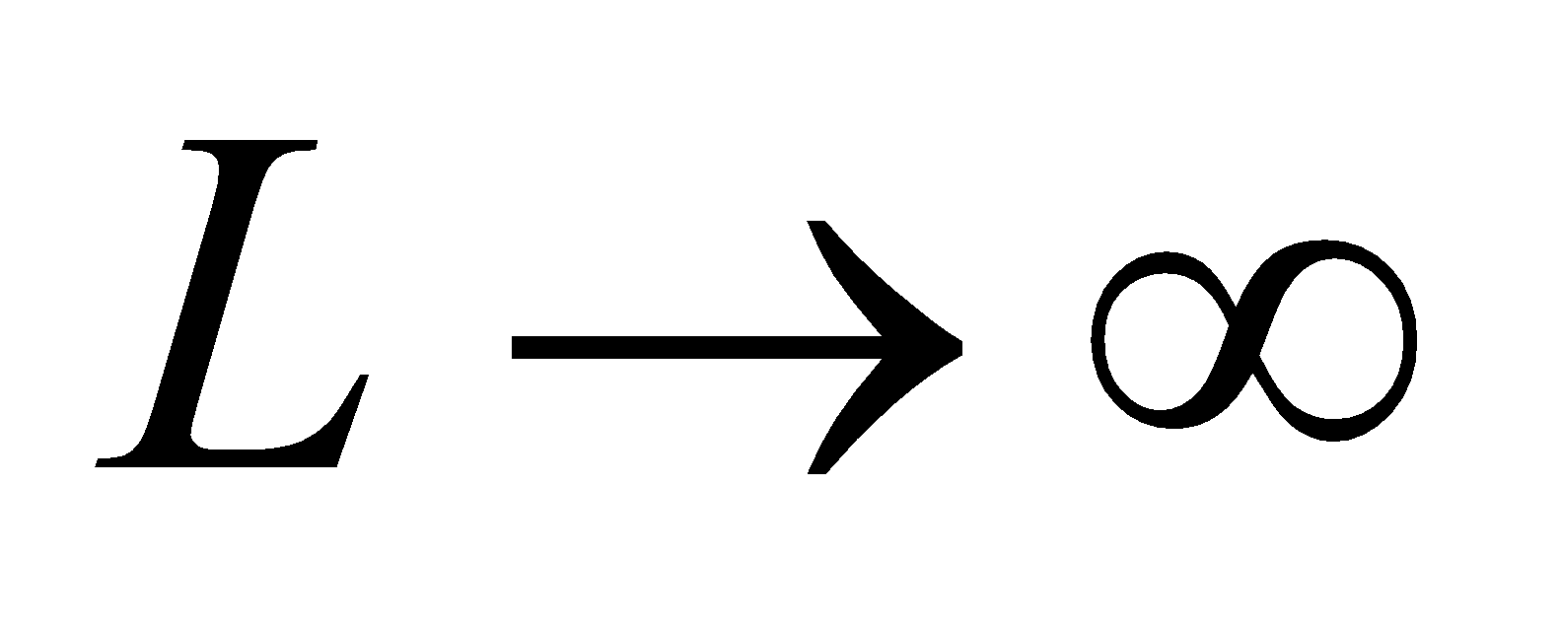, this is a perfect solenoid (note that *I* has to tend to infinity also!).

**75. Interpret** The system is a solid conducting wire having a non-uniform current density. We are interested in the magnetic field strength both inside and outside the wire. This problem involves Ampère’s law.

**Develop** The total current in the wire can be obtained by integrating the current density over the cross sectional area (see sketch below). The magnetic field of a long conducting wire is approximately cylindrically symmetric, as discussed in Section 26.8. The magnetic field can be found by using Ampère’s law:





**Evaluate** **(a)** Using thin rings as the area elements with 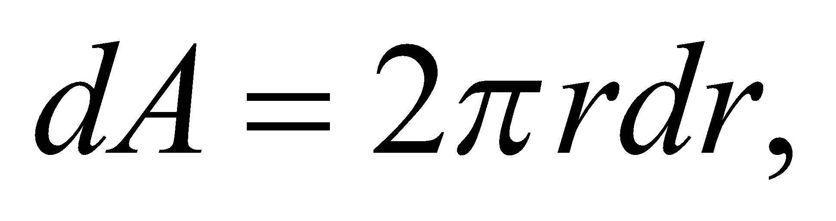 the total current in the wire (*z* axis out of the page) is

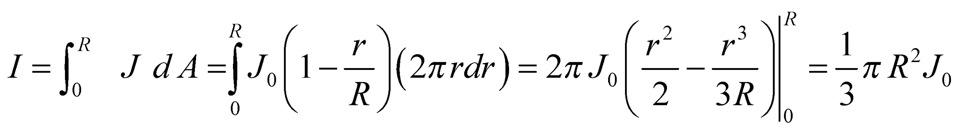

**(b)** A concentric Ampèrian loop outside the wire encircles the total current, so Ampère’s law gives

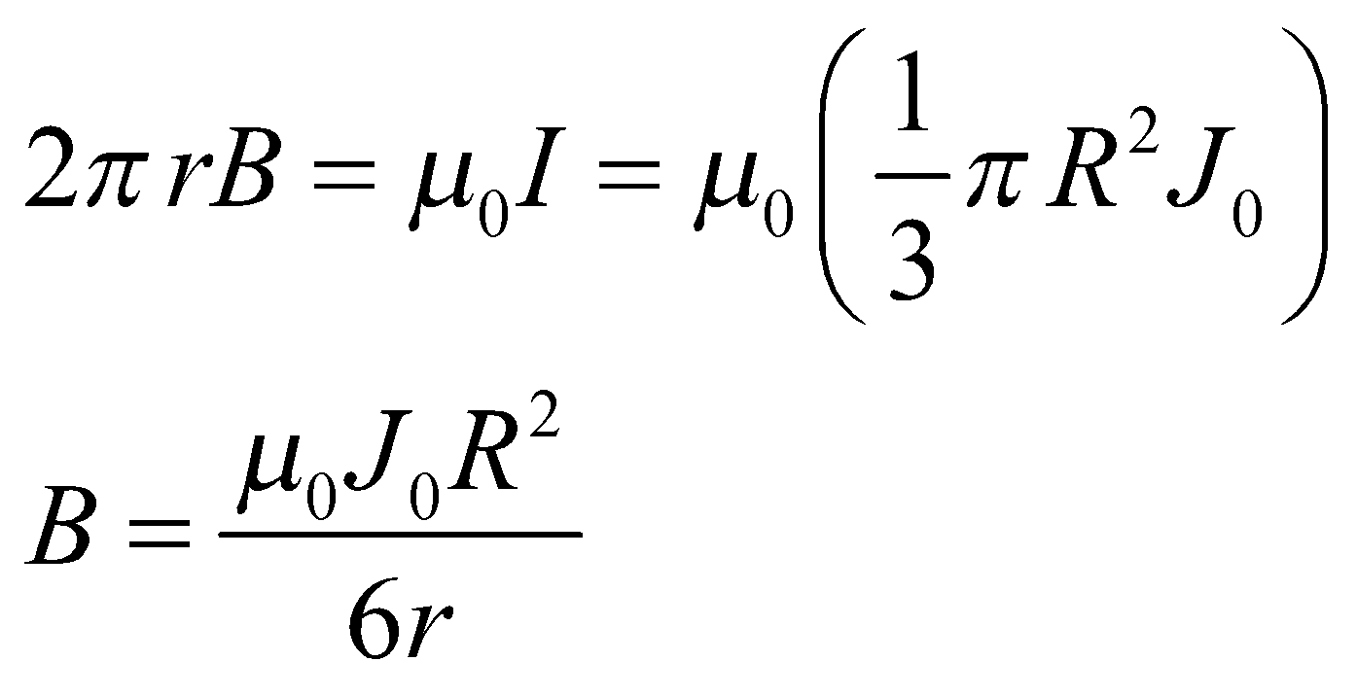

**(c)** Inside the wire, Ampère’s law gives 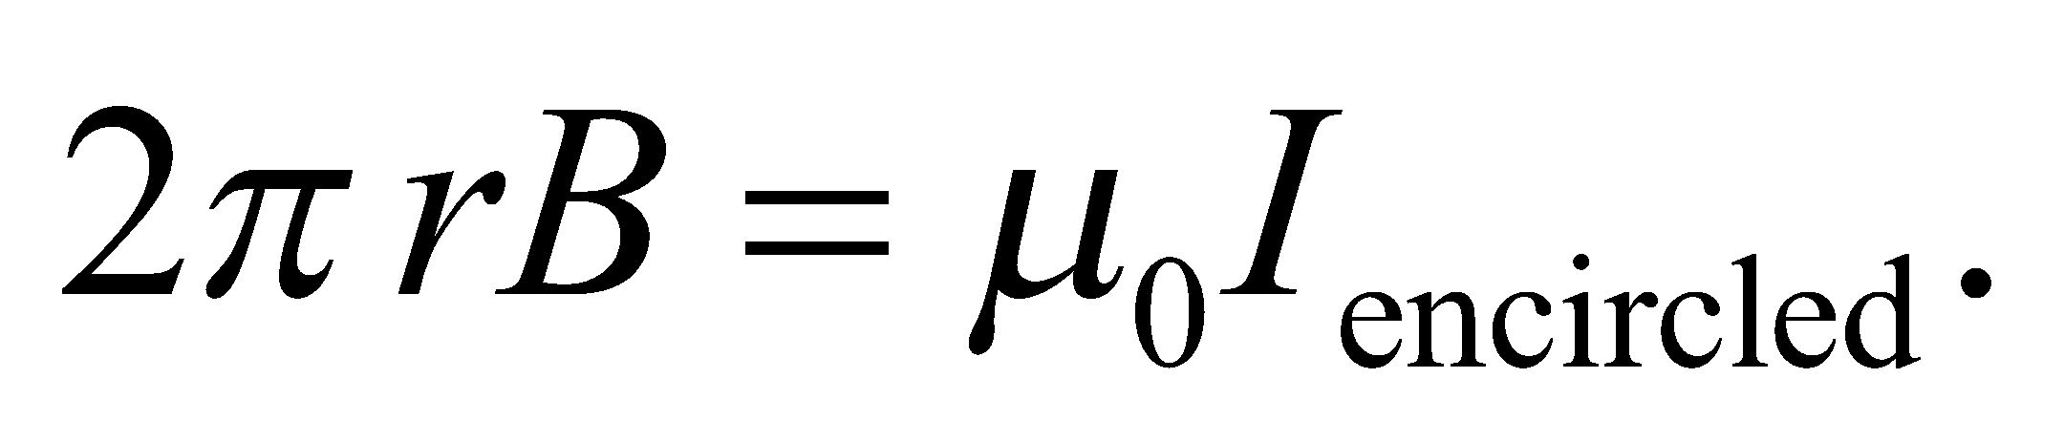 The calculation in part **(a)** shows that within a loop of radius *r* < *R*,

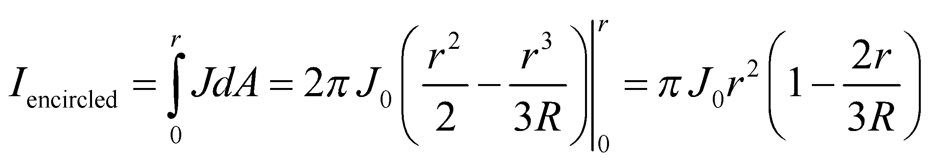

Therefore,

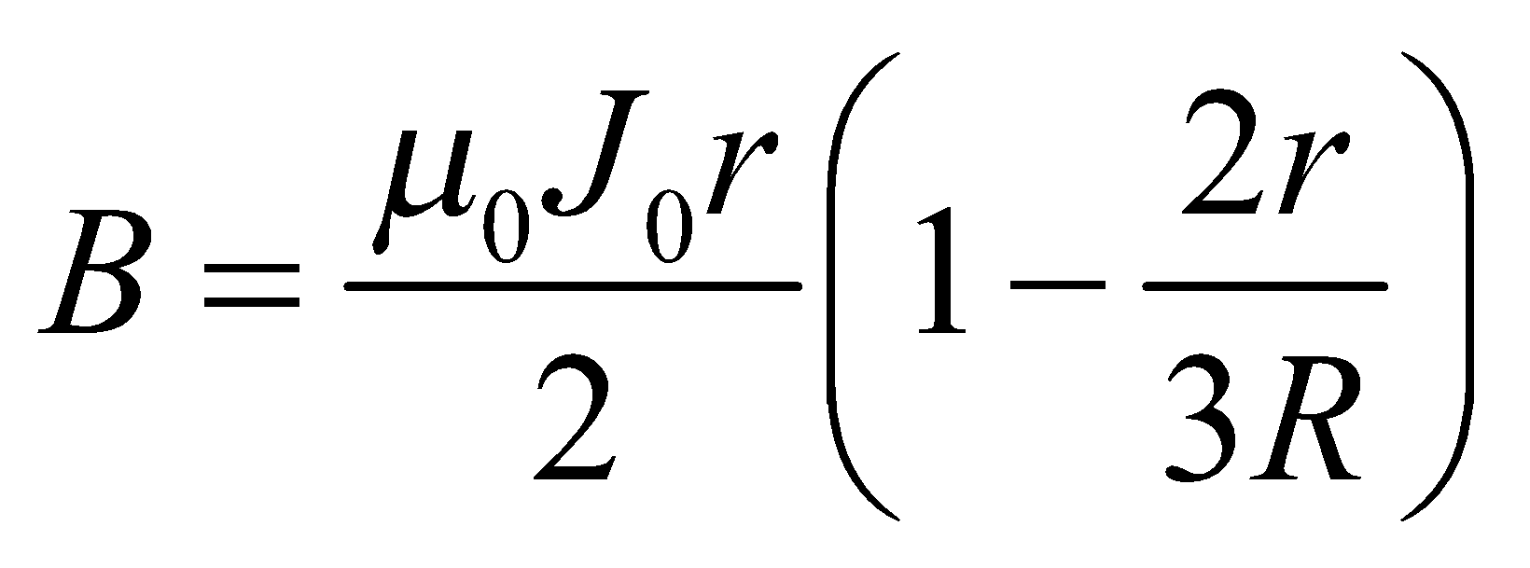

**Assess** At *r* = *R* both equations give 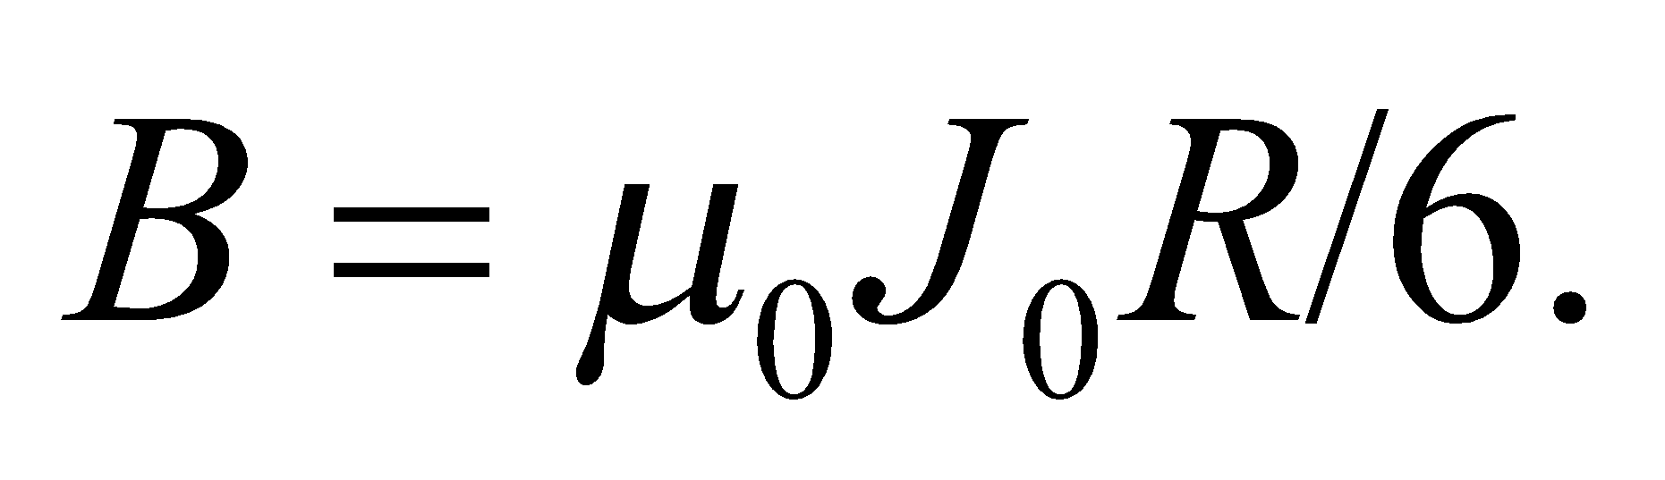 The form is the same as that shown in Equation 26.17.

**76.** **Interpret** Given a rotating disk of uniform charge density, we are to find the magnetic field at the disk’s center.

**Develop** The disk may be considered to be composed of rings of radius *r*, thickness *dr*, and charge 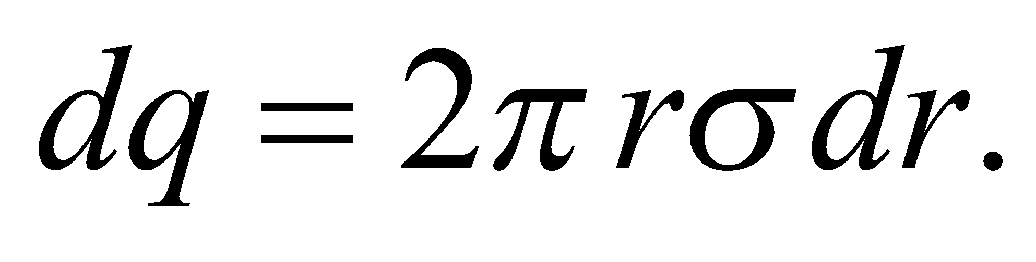 Each ring represents a circular current loop, 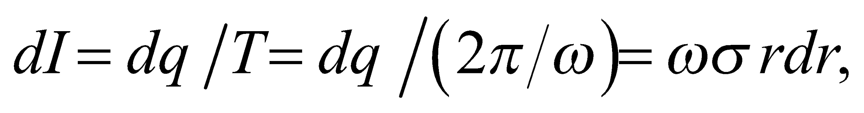 which produces a magnetic field strength 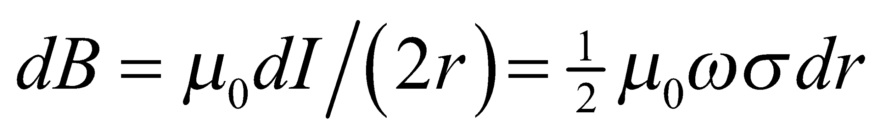 at the center of the disk, directed out of the page, as sketched below for positive charge density.



**Evaluate** Performing the integration gives

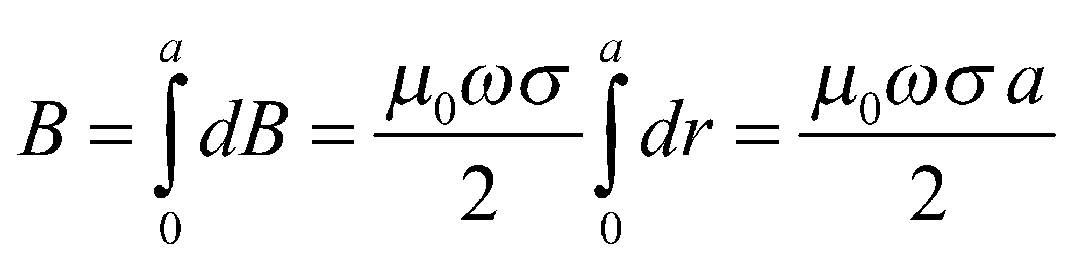

**Assess** This is the same as for a loop with radius *a* and with current *I* = *ωσa*2.

**77.** **Interpret** You're designing a system to orient a satellite using the torque that the Earth's magnetic field will induce on a current loop. You want the maximum torque possible, but you are limited to a fixed length of wire.

**Develop**Let's assume that the loops are circular. The torque on such a loop is given by Equations 26.14 and 26.12:

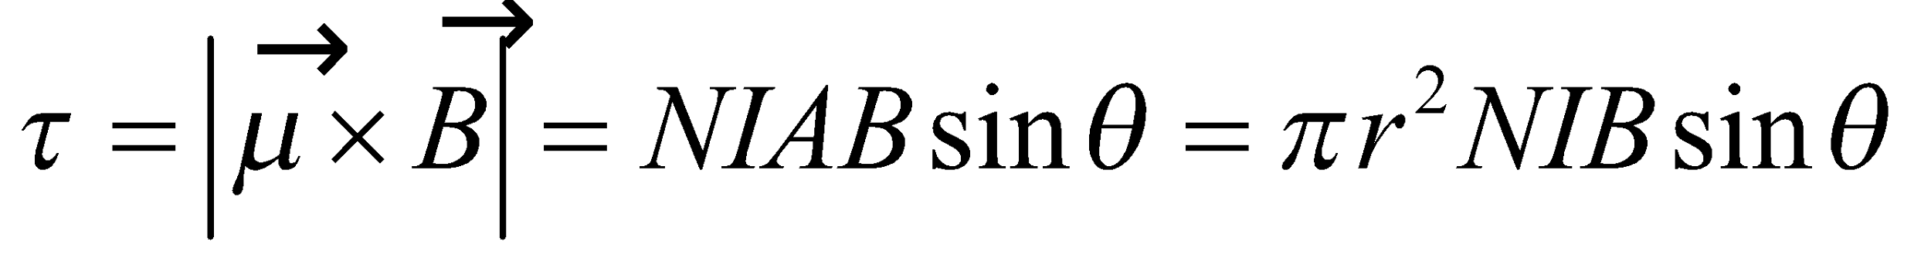

The current will be specified by the satellite's power supply. The magnetic field is that of the Earth's and the angle *θ* is dependent on the satellite's orientation. What you need to determine is whether one turn 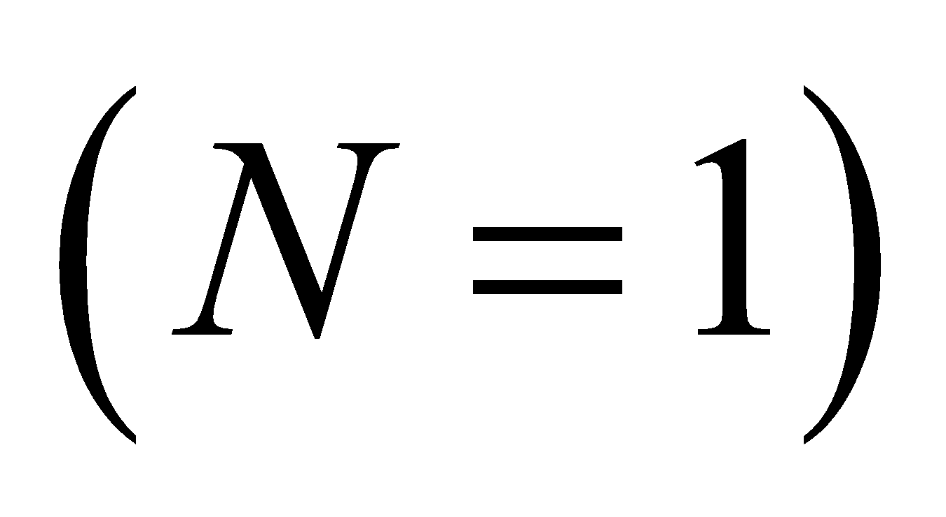or many turns will give more torque, given that the total length of wire is set.

**Evaluate**The wire length is related to the size and number of loops by: 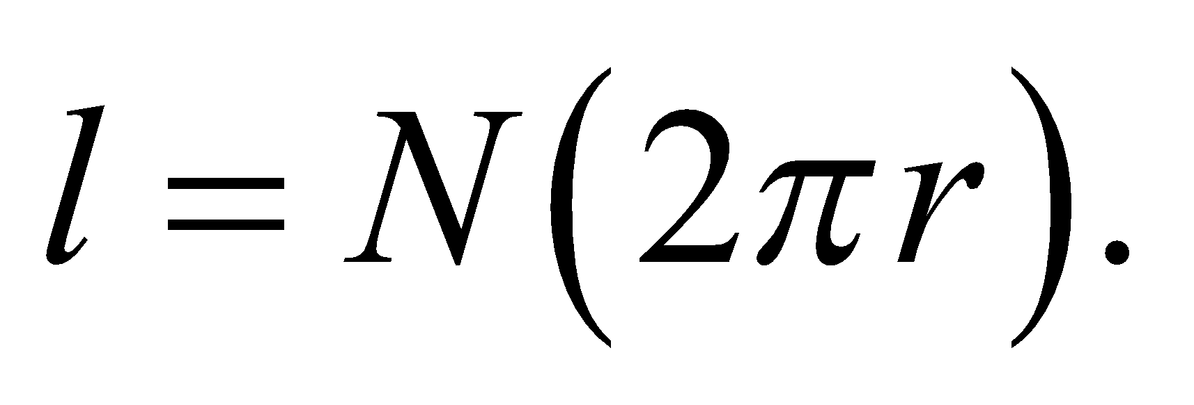 Using this to eliminate *r* from the torque equation gives:

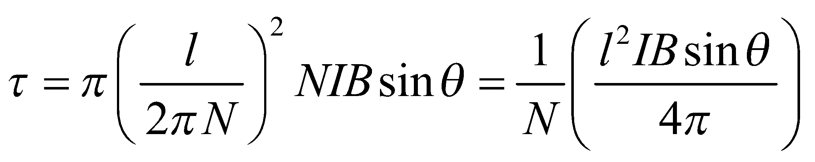

Since 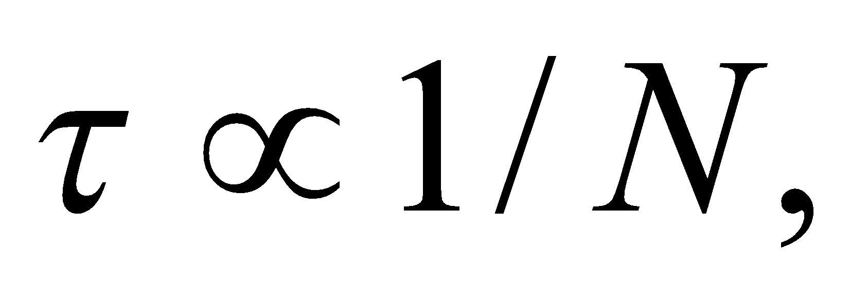you'd get more torque from a single turn loop.

**Assess** Although you gain by having more turns, you're losing more from reducing the area of the loop.

**78. Interpret**This problem involves a current-carrying bar that is maintained in equilibrium by the forces of gravity and the magnetic force. At equilibrium, the two forces cancel exactly.

**Develop**If the height *h* is small compared to the length of the rods, we can use Equation 26.11 for the repulsive magnetic force between the horizontal rods (upward on the top rod)

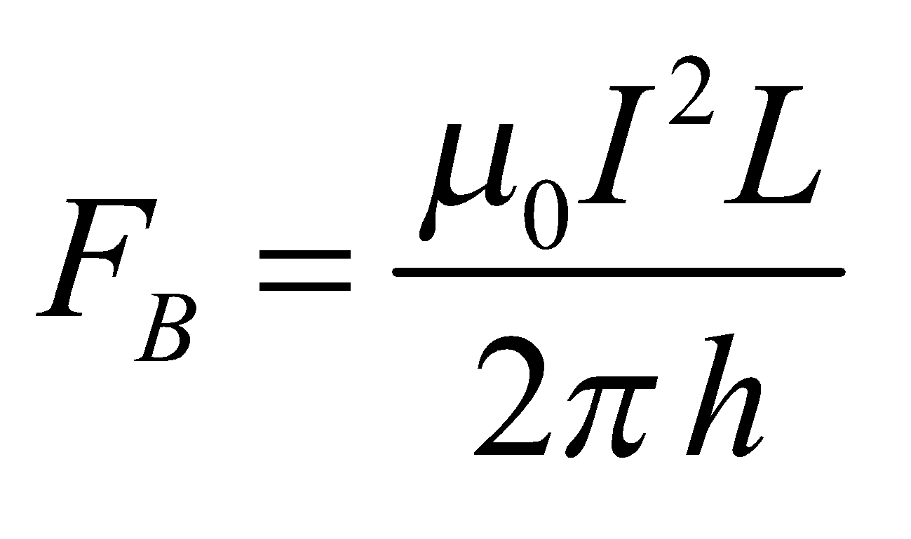

The rod is in equilibrium when this equals its weight, 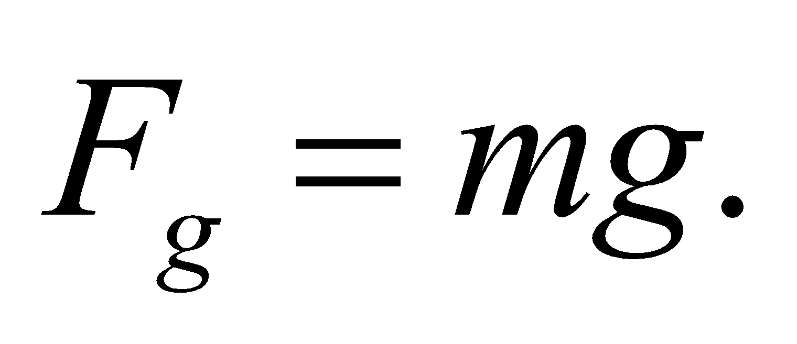

**Evaluate**The equilibrium condition 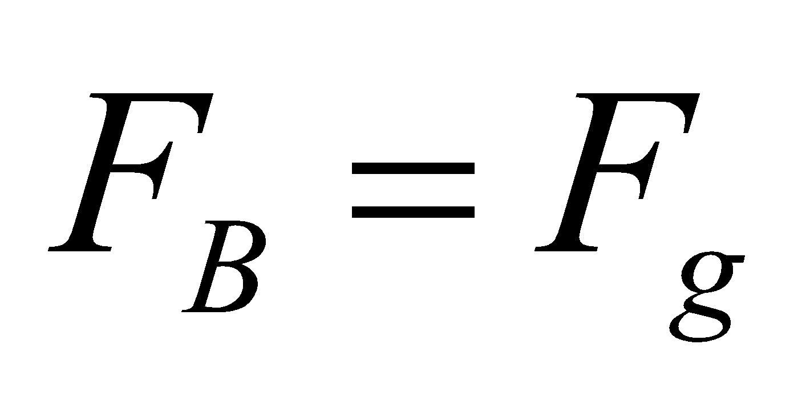 gives

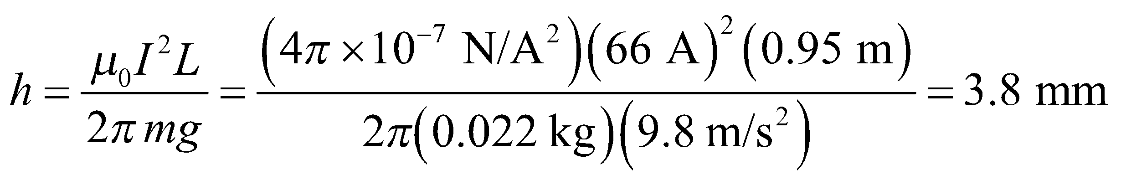

**Assess** The height *h* is indeed small compared to 95 cm, so our assumption is justified.

**79.** **Interpret** We are to find the force per unit length between a thin wire and a parallel ribbon, each of which carry a current I.

**Develop** Use the coordinate system shown in the figure below. The magnitude of the force per unit length on a thin strip of ribbon, of width *dx*, carrying current 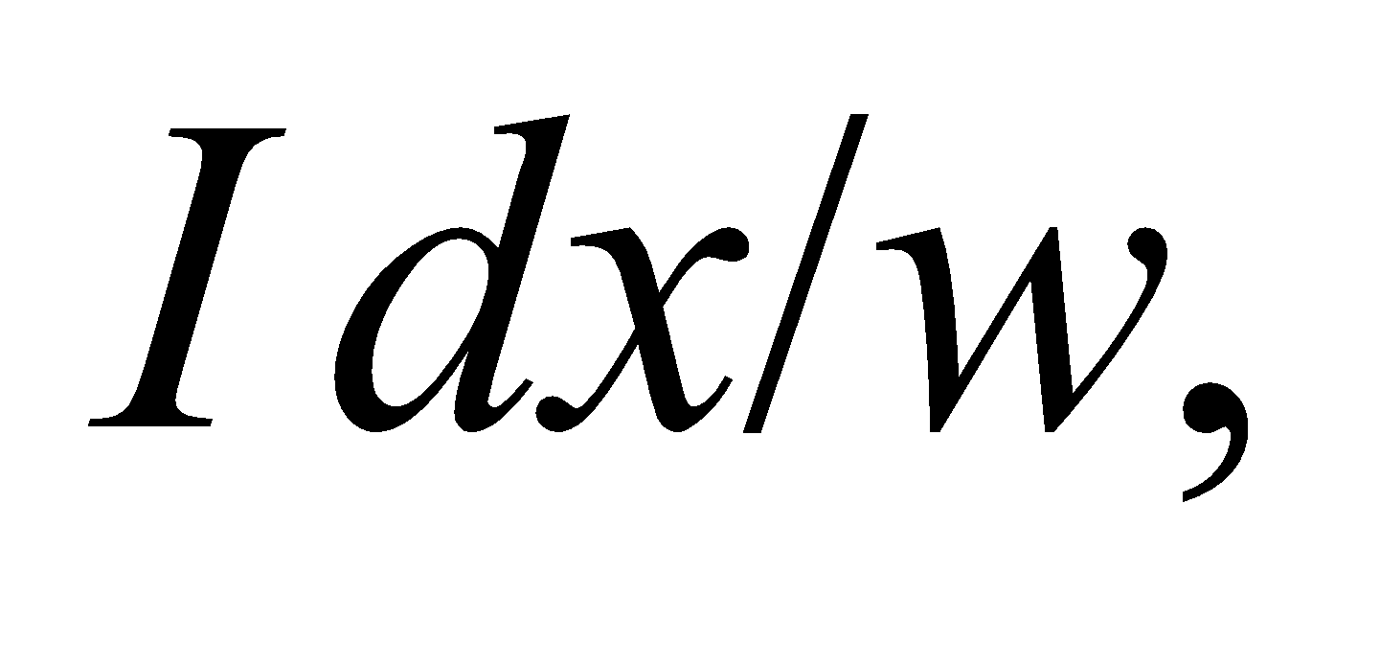 is given by Equation 26.11:

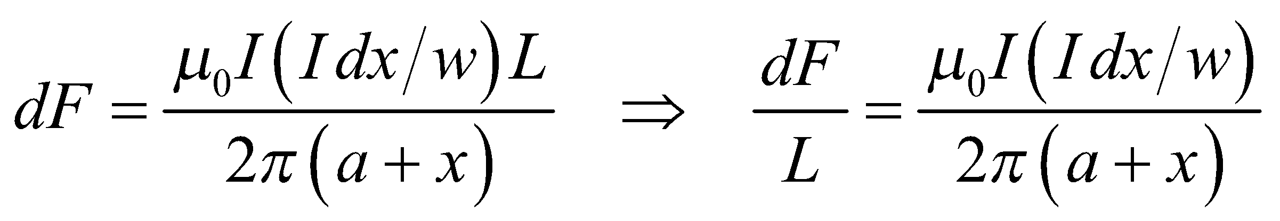

where *x* is the distance from the near edge of the ribbon.

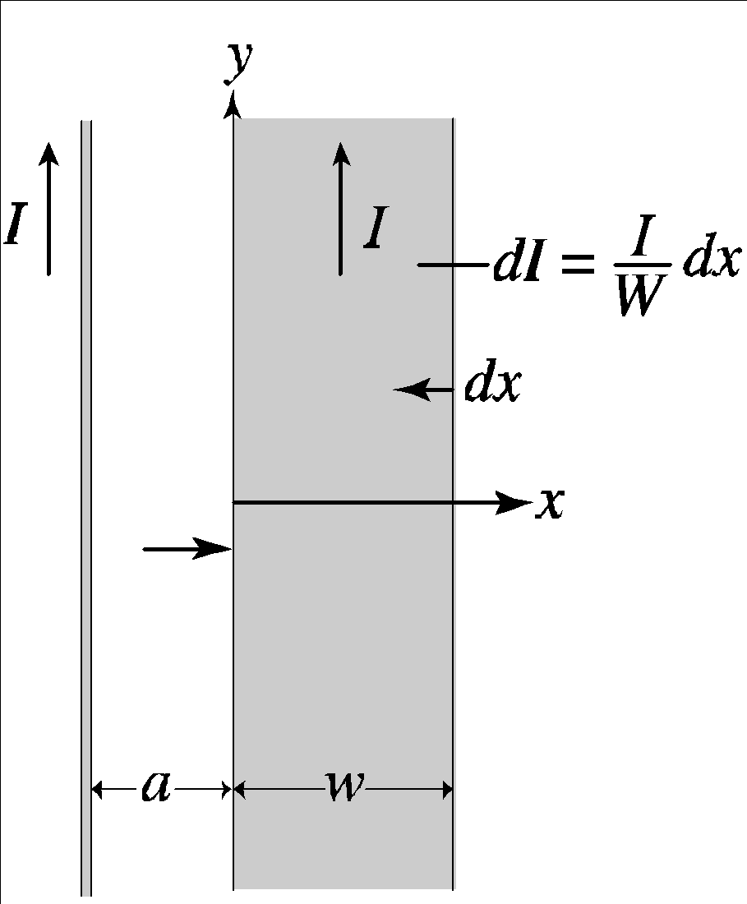

**Evaluate** Integrating the expression above from *x* = 0 to *x* = *w* gives a total force of

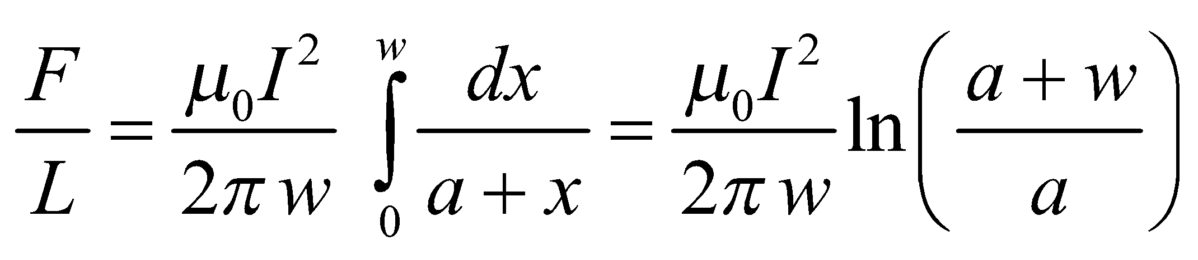

The force is attractive since the currents are parallel.

**Assess** Note that this expression reduces to Equation 26.11 for *w* = 0 [using ln(1 + *ε*) = *ε* + …].

**80.** **Interpret** We're looking for an expression for the magnetic field at the center of a square loop.

**Develop**In Example 26.4, the Biot-Savart law was used to find the field from an infinite wire. In this case, we have four wires of finite length, but much of the math will be the same. Let's assume the current moves around the loop in a counterclockwise direction, as shown in the figure below. By the right-hand rule, the magnetic field contributions from each of the four wires will all point out of the page. By symmetry, all the contributions are also equal in magnitude, so the total magnetic field will just be 4 times the field from one of the wire segments.



**Evaluate**The only difference in the magnetic field of a finite wire from that of an infinite wire is the limits of the integration. So borrowing from Example 26.4, the magnetic field at a distance of 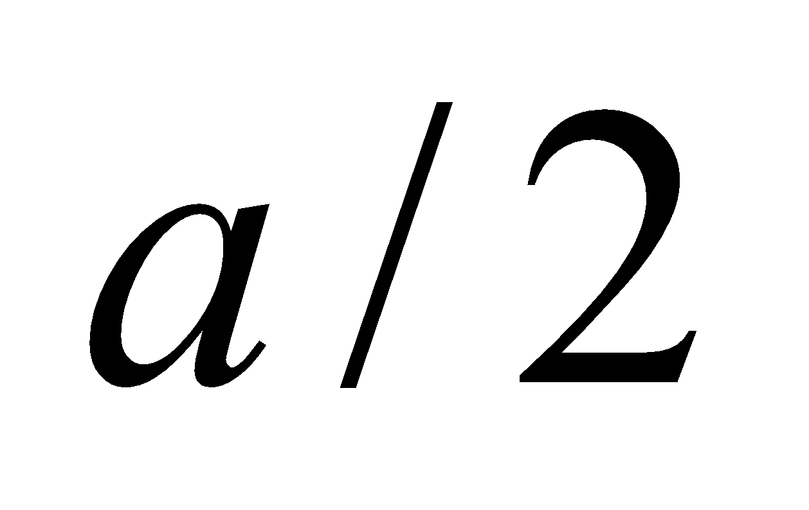 from a wire that extends from 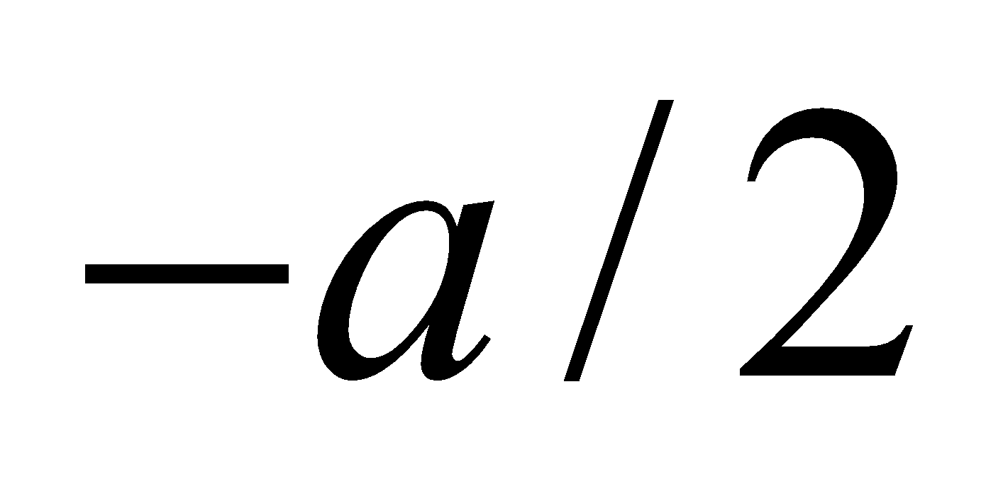 to  is

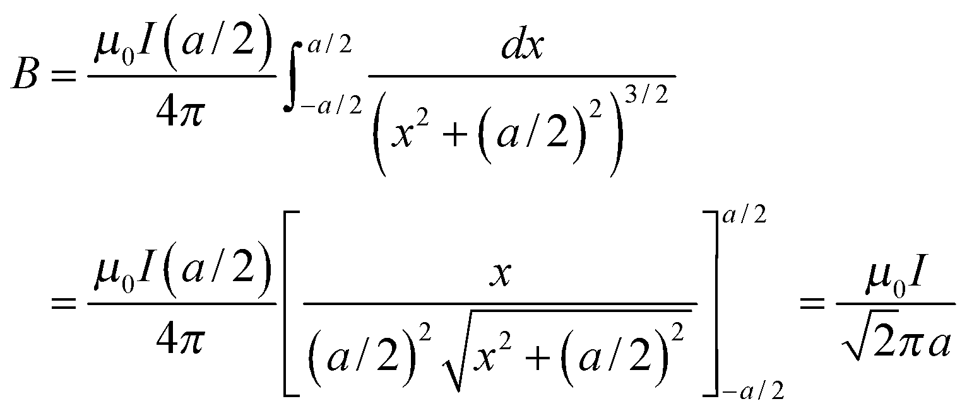

where we have used the integral table in Appendix A. The total field is 4 times this:

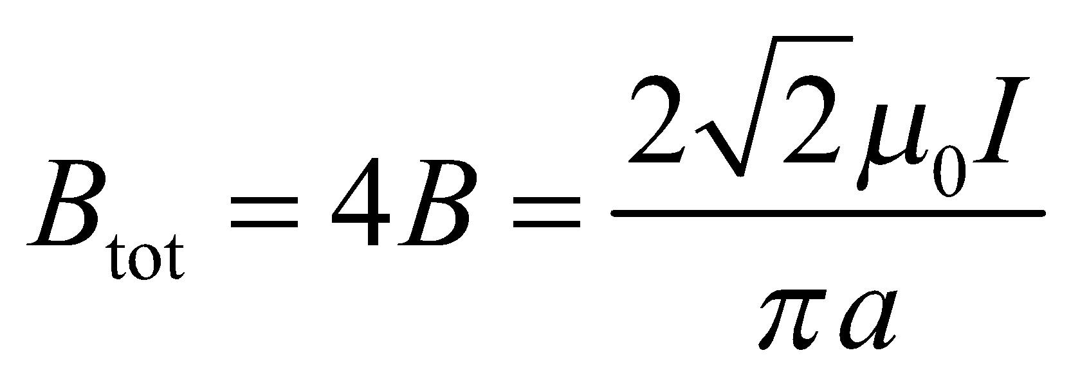

**Assess** Our result for a single wire segment is smaller by a factor of 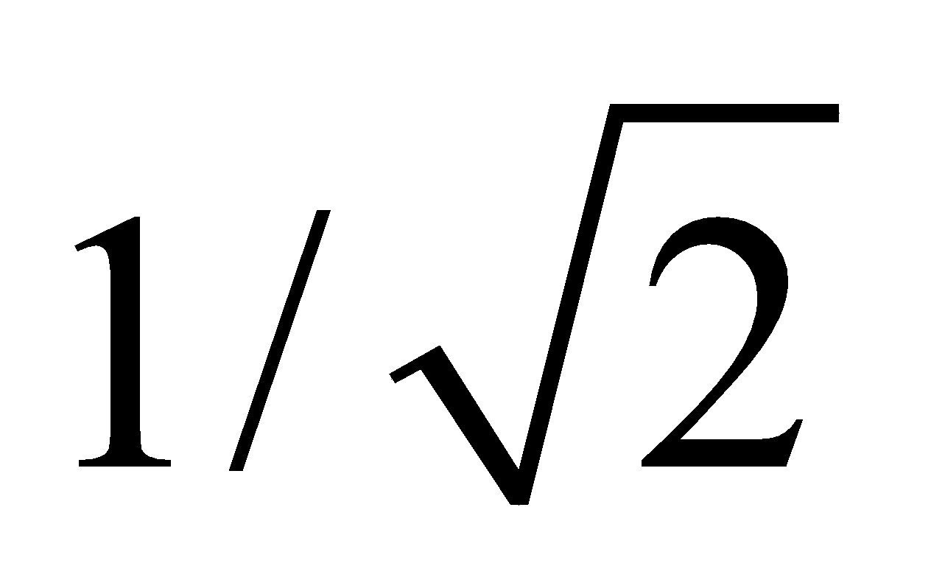 than the magnetic field from an infinite wire at the same given distance. But the sum of the contributions from the 4 wires is in fact larger than that from a single infinite wire. It might also be interesting to compare the magnetic field of a square loop to that of a circular loop with the same area, 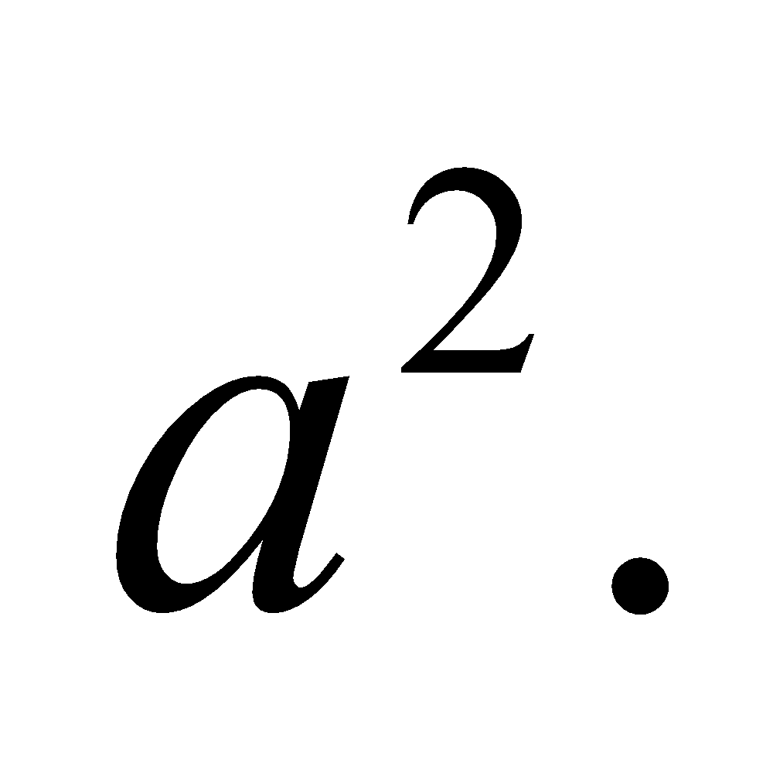 From Equation 26.9, the field at the center of a circular loop with radius 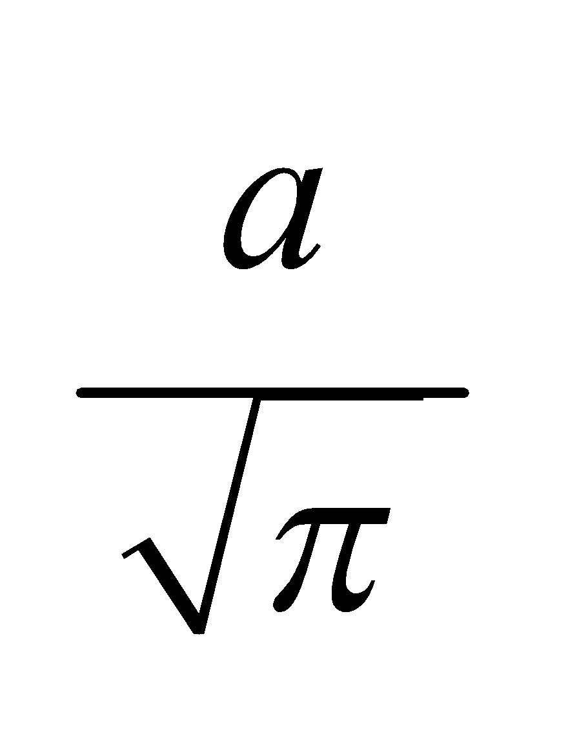 is: 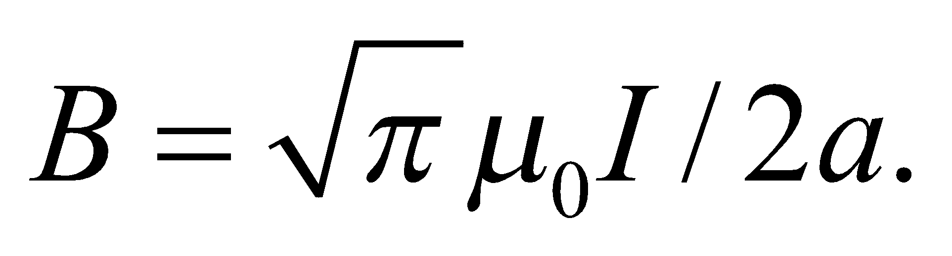 This means the magnetic field at the center of a square loop is roughly 1% bigger than the field at the center of a circular loop.

**81.** **Interpret** We find the magnetic field at the center of a "real" solenoid of finite length, treating the solenoid as a stack of individual coils. We use the formula for the magnetic field due to a single loop, and integrate.

**Develop**As before in Problem 26.69, we can divide up the solenoid into infinitesimal loops with current of 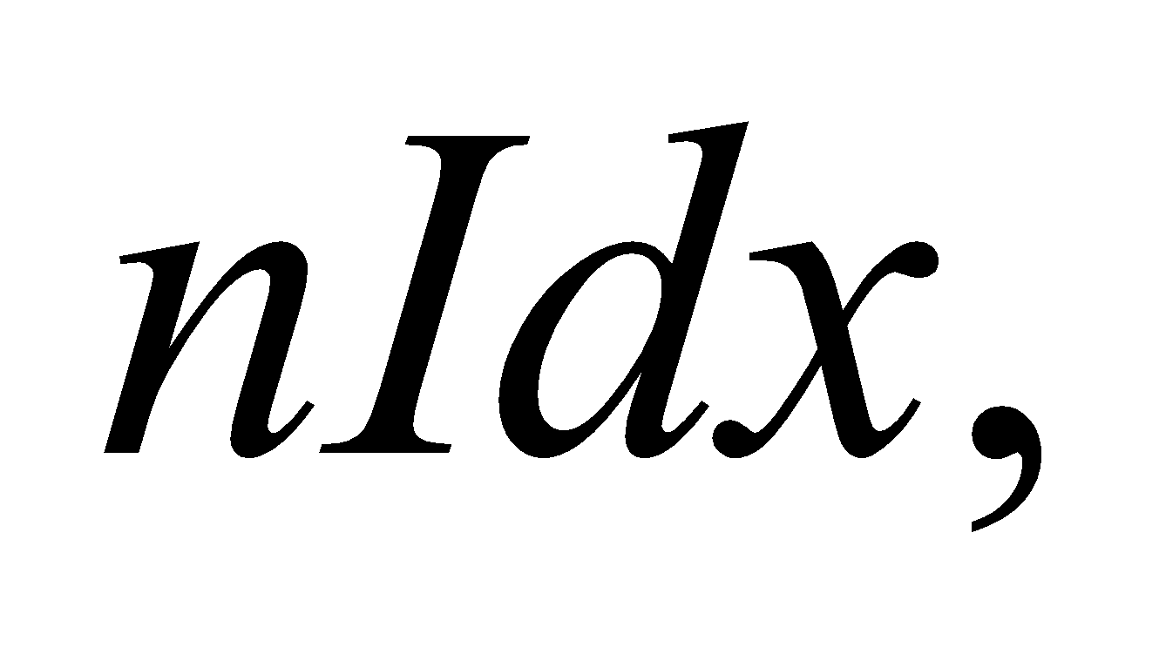where *n* is the number of turns of wire per length. Using Equation 26.9, the axial field from this infinitesimal loop is

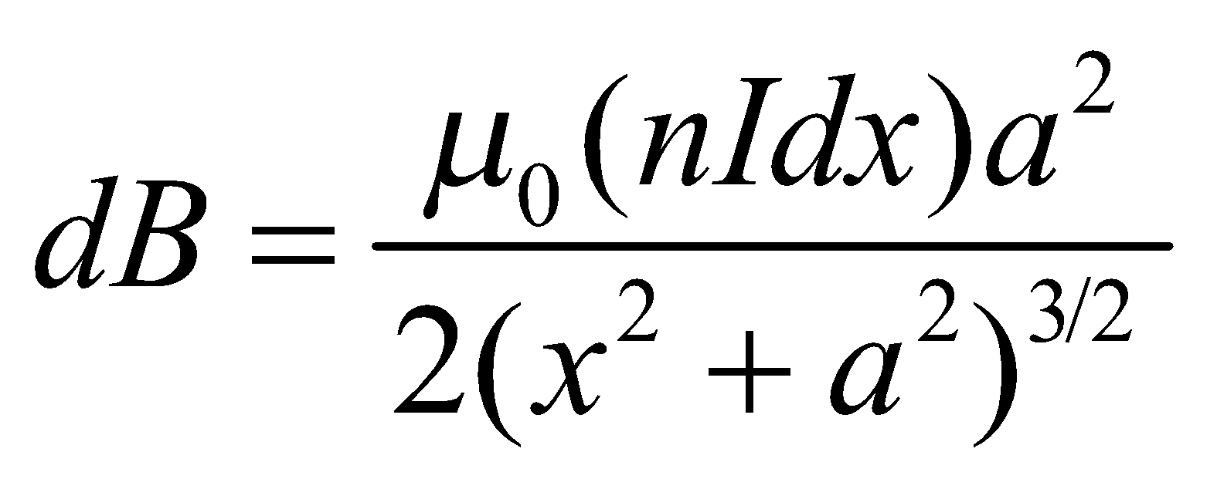

Now instead of integrating *x* from –∞ to ∞, we integrate from –*l*/2 to *l*/2 to obtain the field at the center of the finite length solenoid.

**Evaluate**Performing the integration with help from the tables in Appendix A, we get

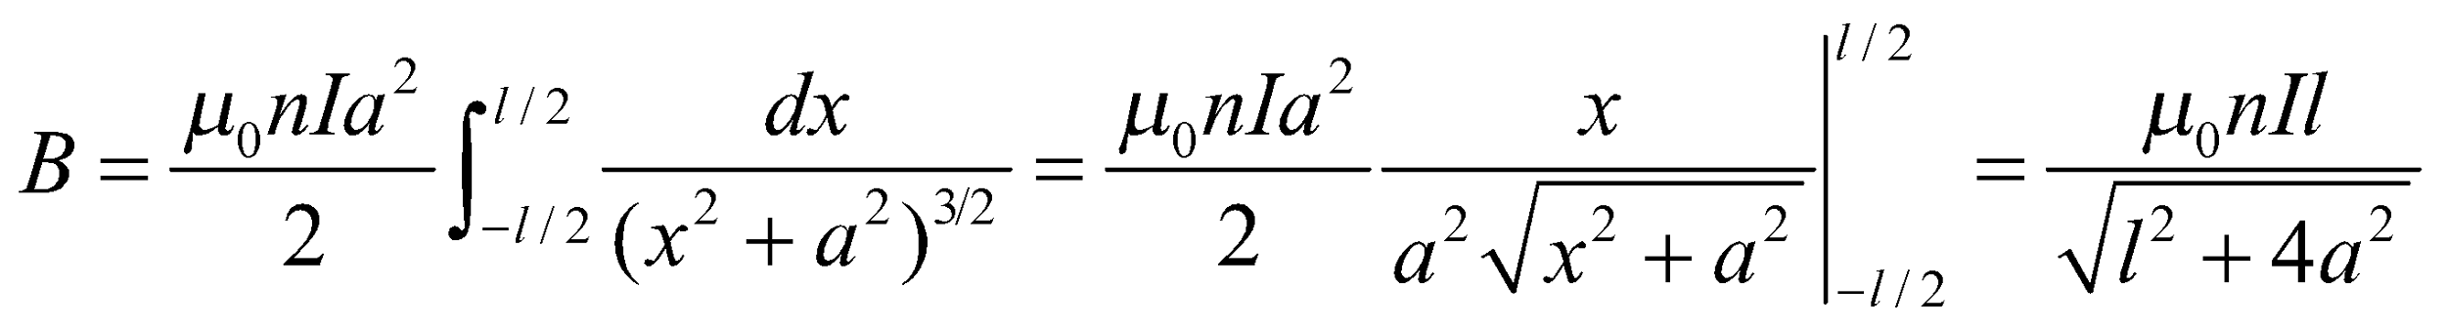

**Assess** We can check this formula by letting 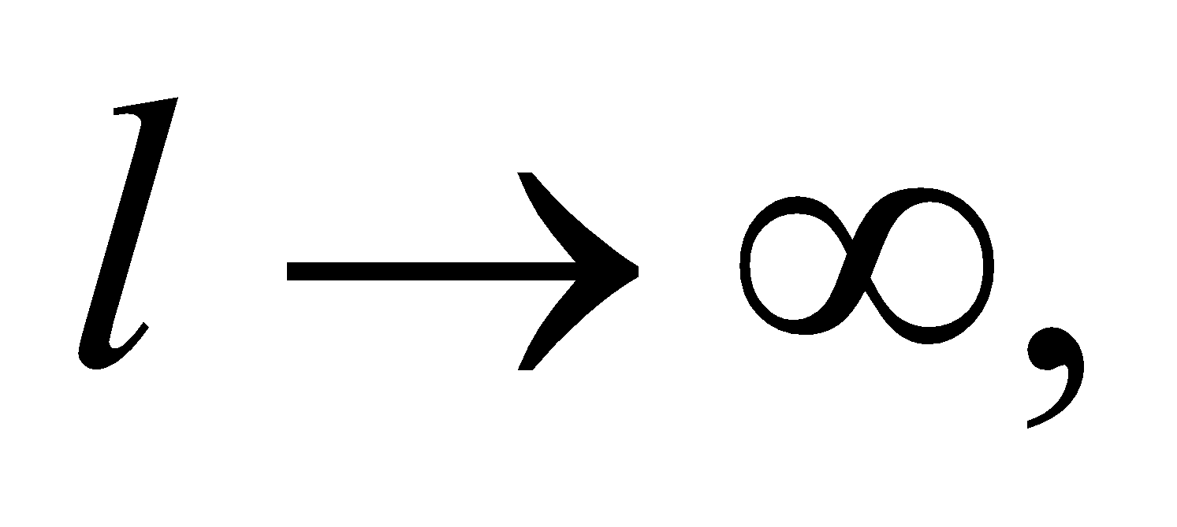 in which case the magnetic field becomes 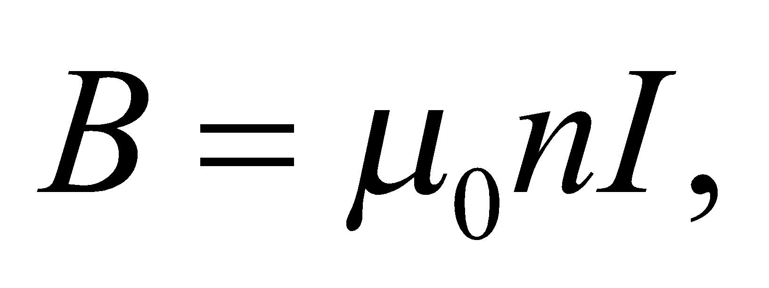 as was already given for an infinite solenoid in Equation 26.21.

**82. Interpret** We are to find the force on a magnetic dipole located on the axis of a current loop by differentiating the potential energy.

**Develop** The potential energy of a dipole in a magnetic field is given by Equation 26.16 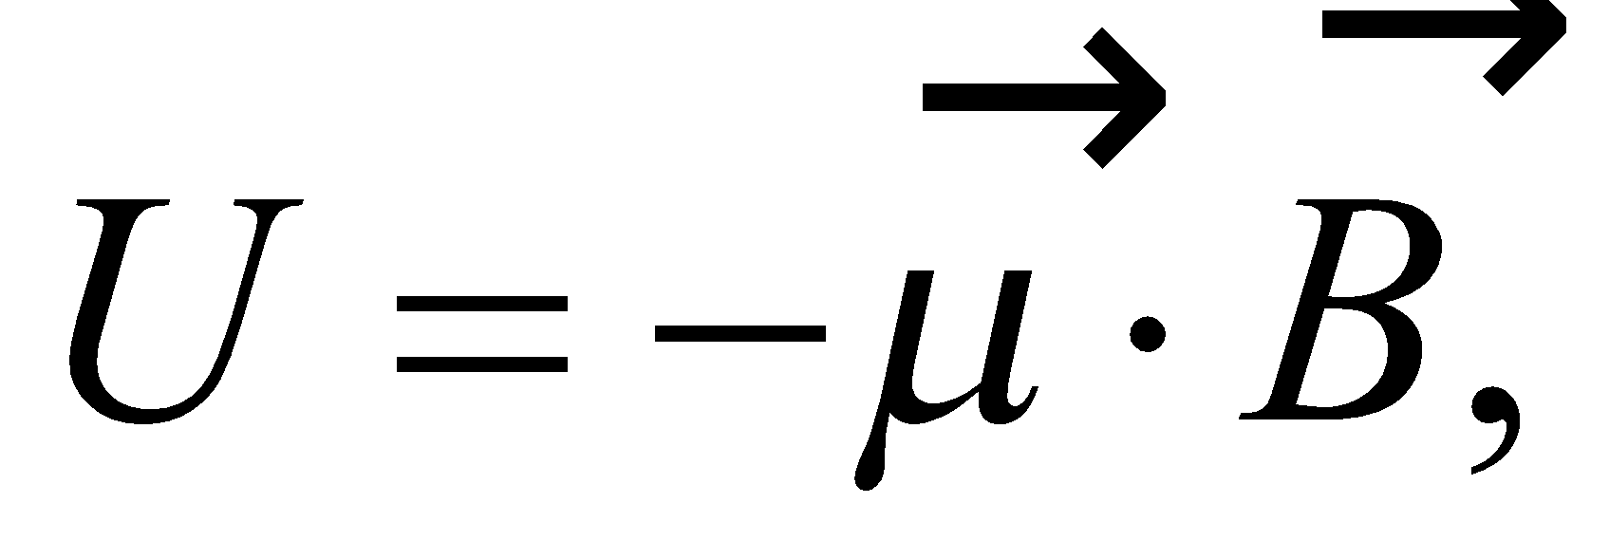 where in this case

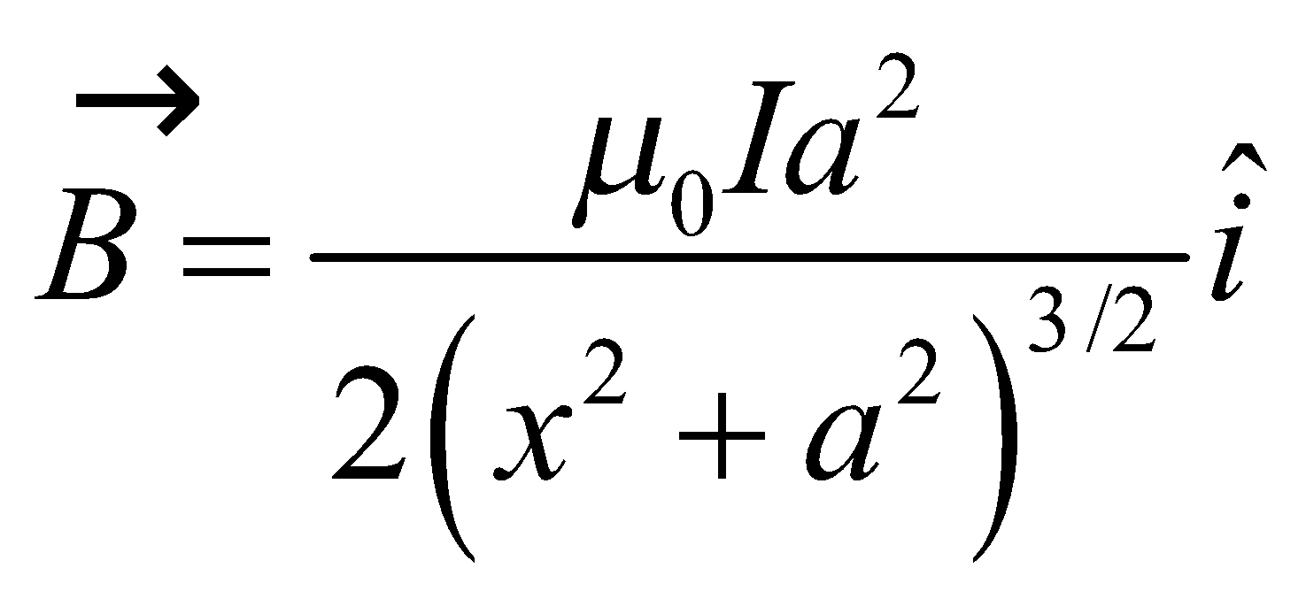

and 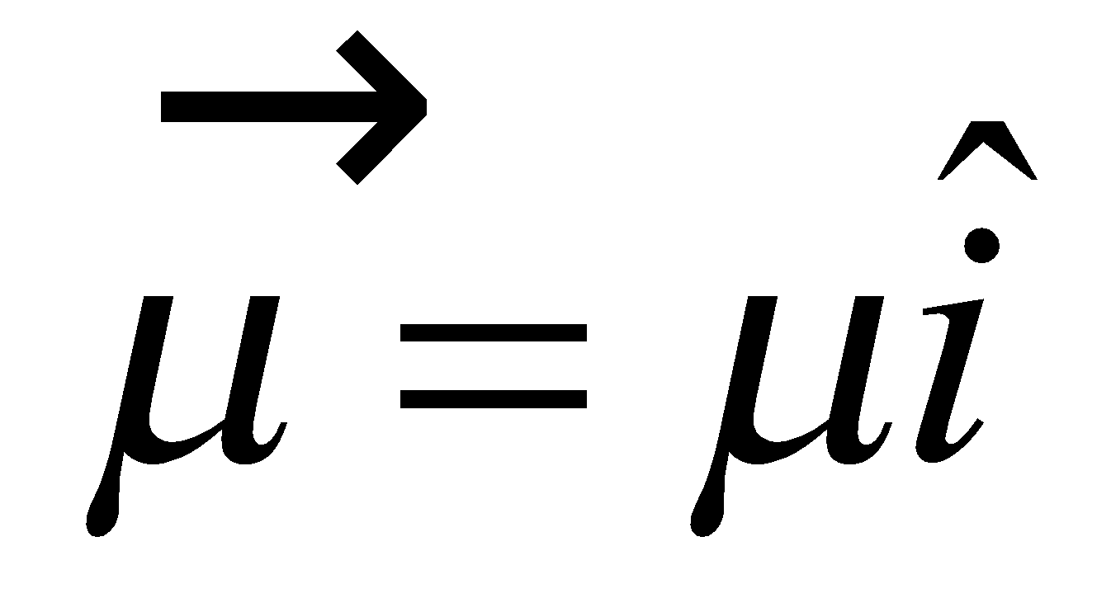. The force is 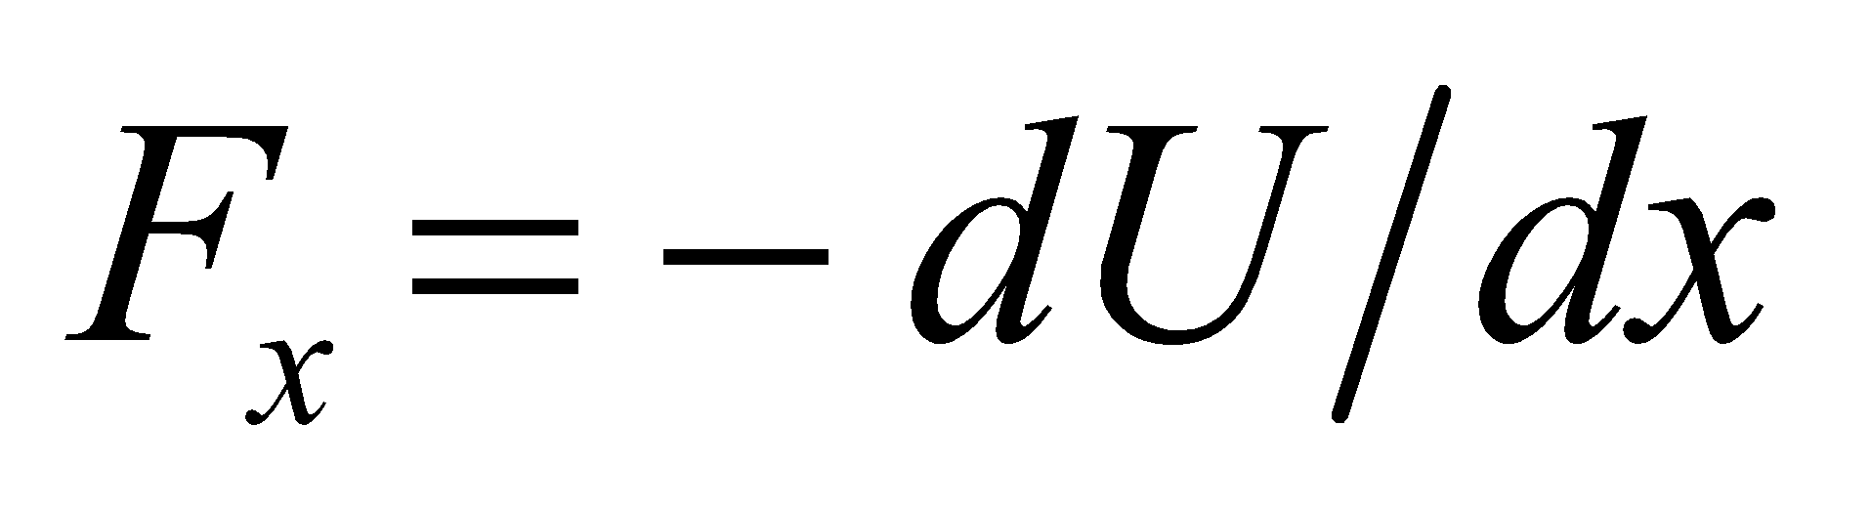.

**Evaluate**

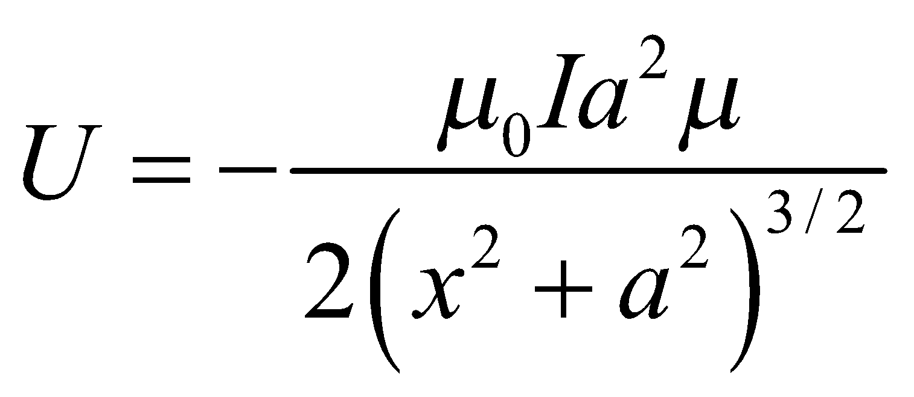

so

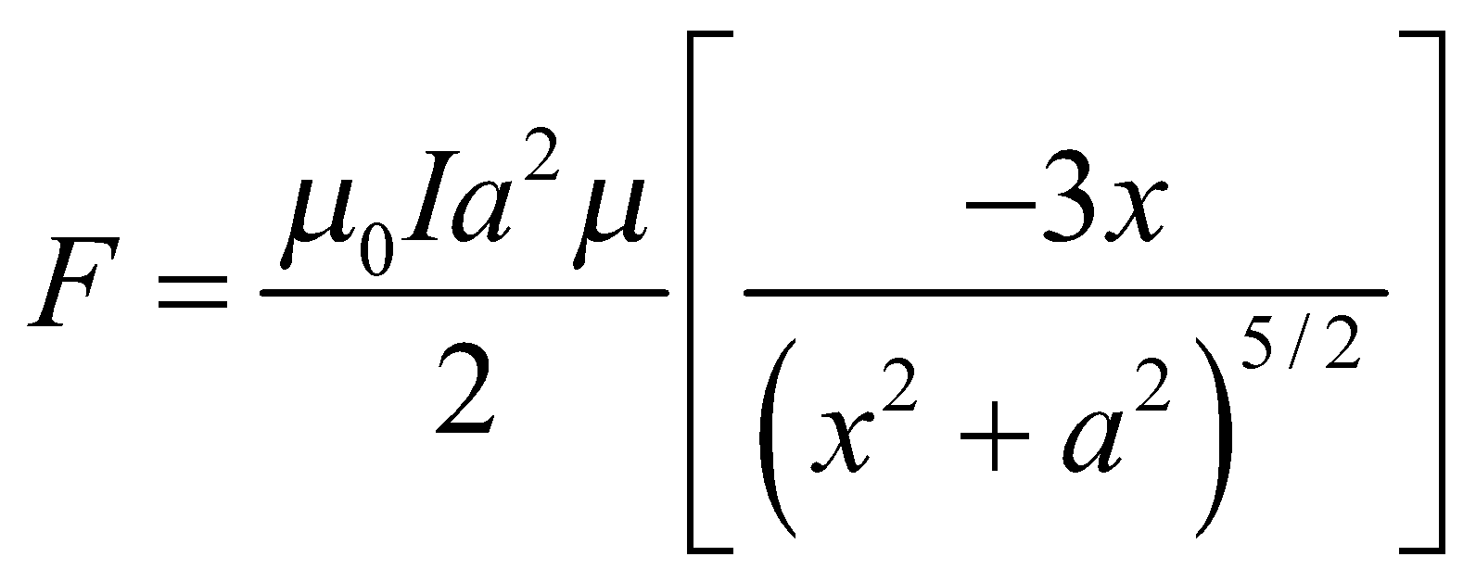

At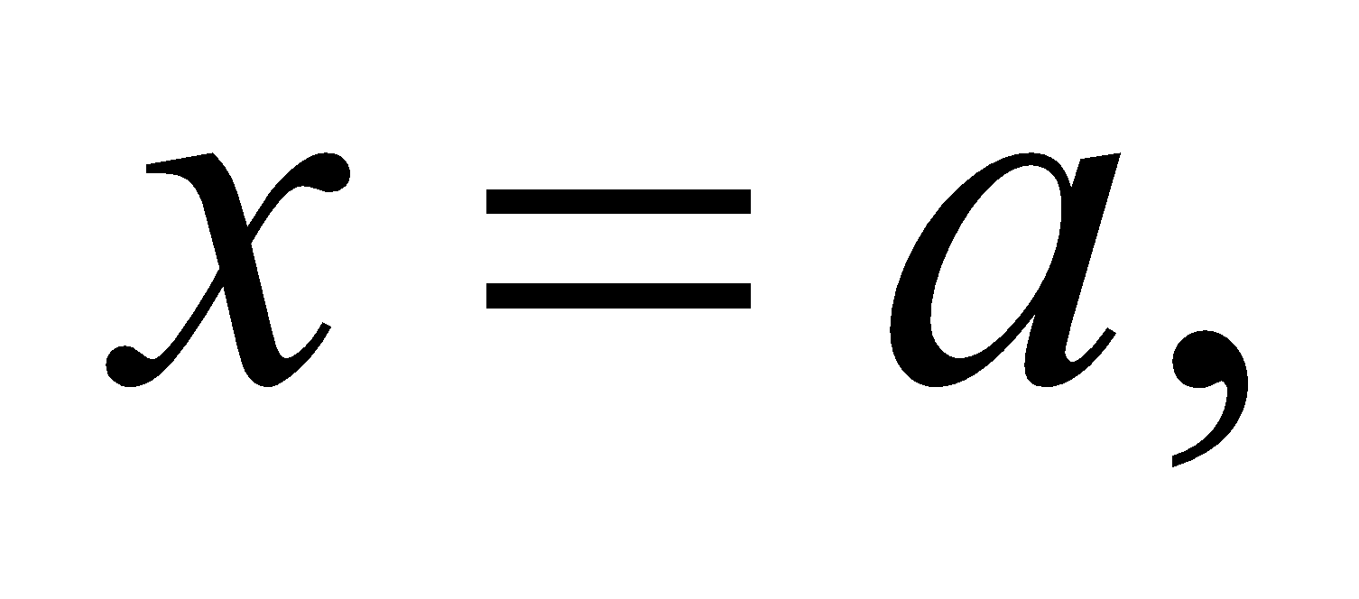

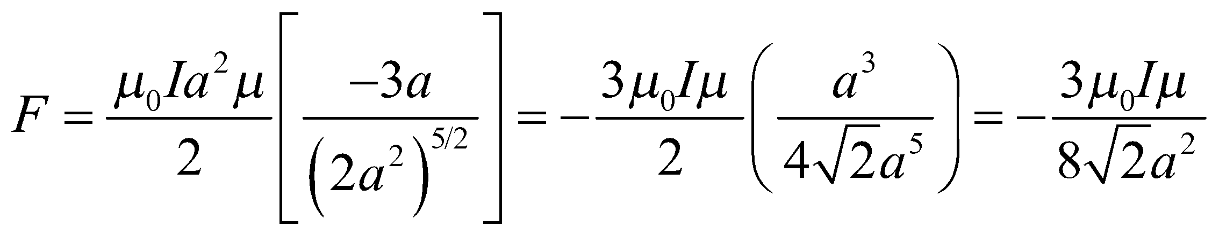

**Assess** This force is opposite the direction of *x*, so it is an attractive force in this case.

**83. Interpret** We need to find the magnetic field necessary to create a certain force on a wire loop. We will model this as a force on a wire in a uniform magnetic field.

**Develop** The force on a wire in a magnetic field is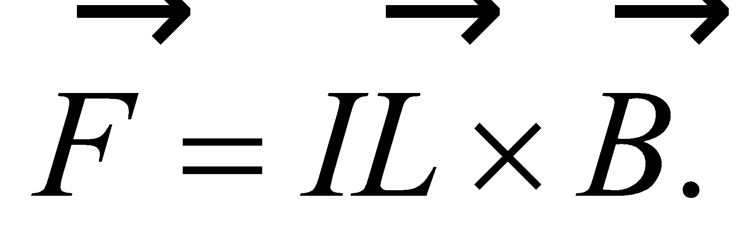We will optimize our speaker design by making

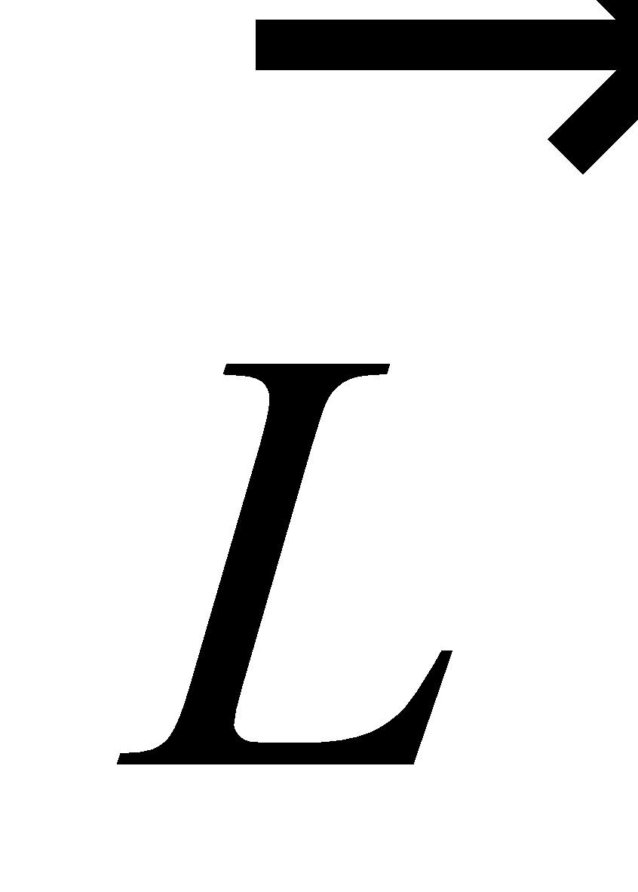andperpendicular, so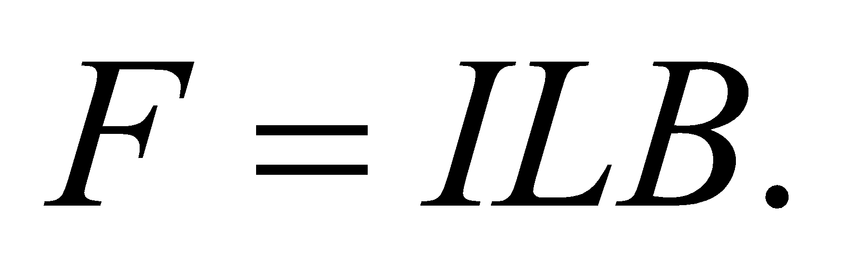From the coil diameter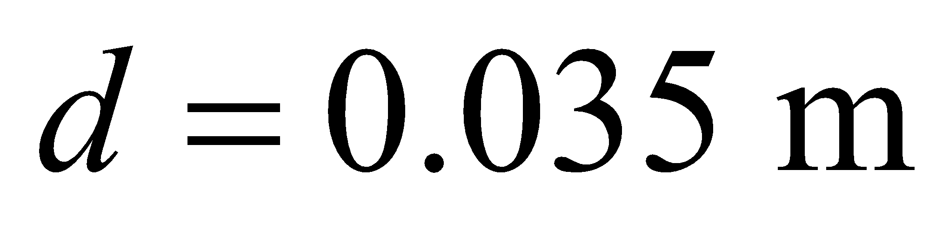and number of turns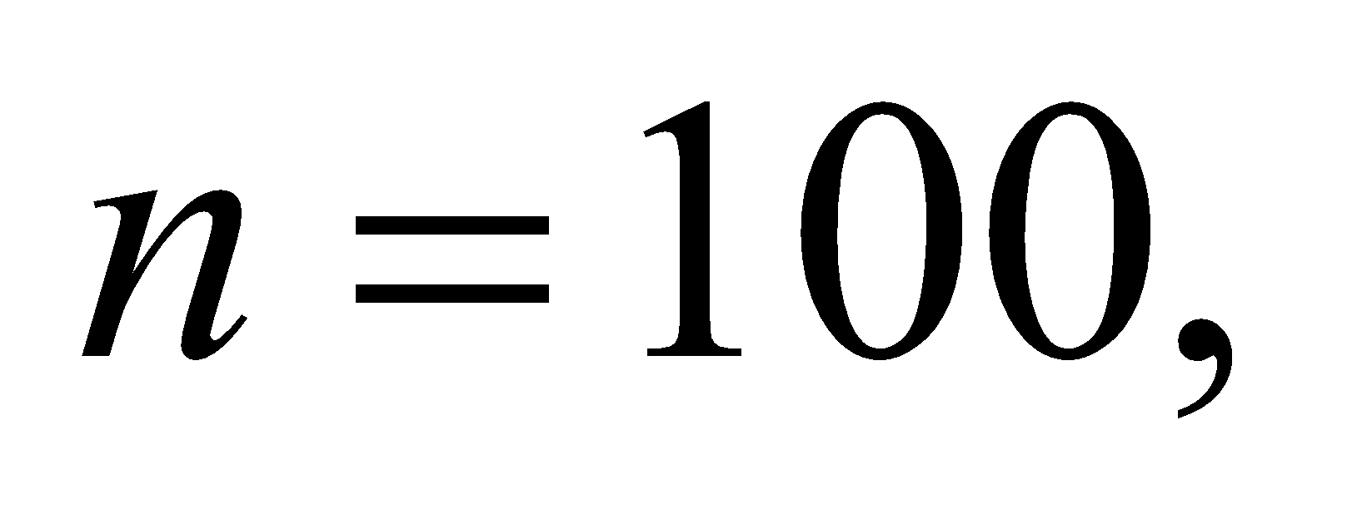we can find

the length of wire *L*. The current in the coil is given as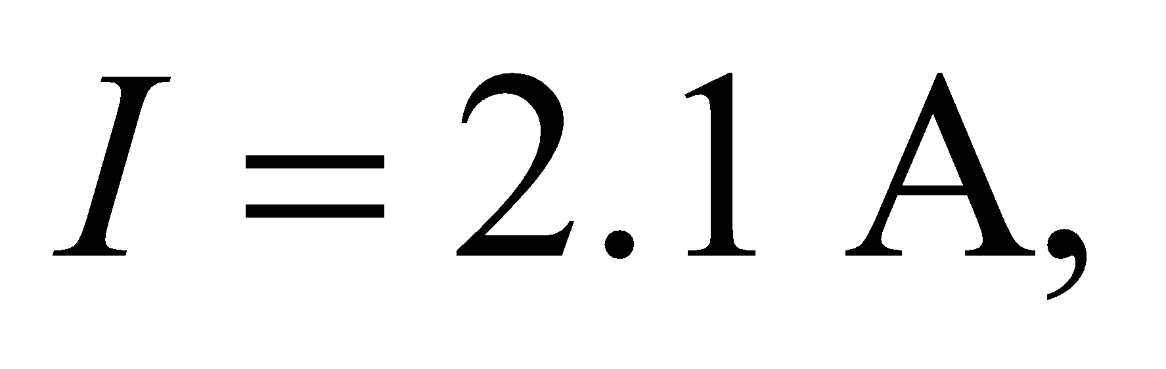and the force is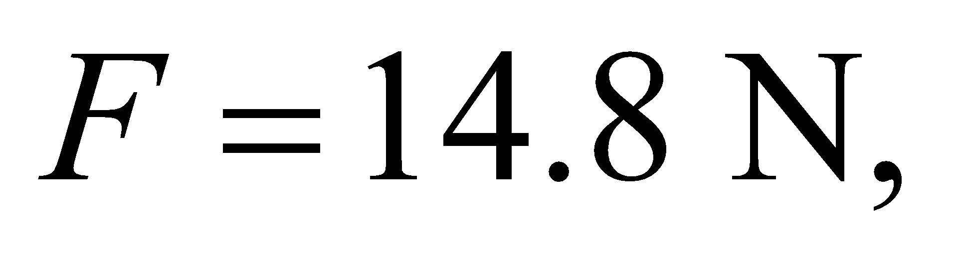so we will simply solve for *B*.

**Evaluate**

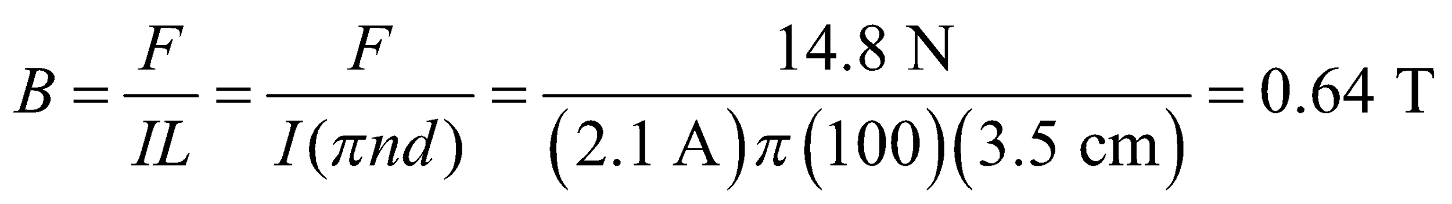

**Assess** This is a fairly high field strength, but reasonable for currently available permanent magnets.

**84.** **Interpret** We're asked to derive the formula for the magnetic field above a current sheet. We won't use Ampère's law, as in Example 26.8, but instead we will integrate over an infinite number of wires.

**Develop**Let's assume the sheet is in the *x*-*y* plane, and the current per unit width, 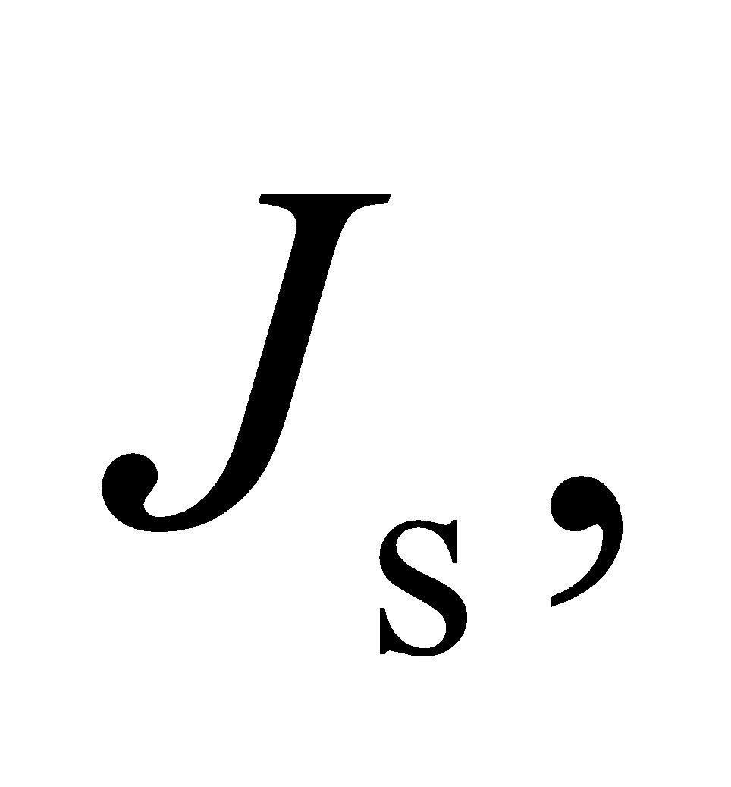 is in the *y*-direction. We consider this sheet current to be made up of an infinite number of line currents with 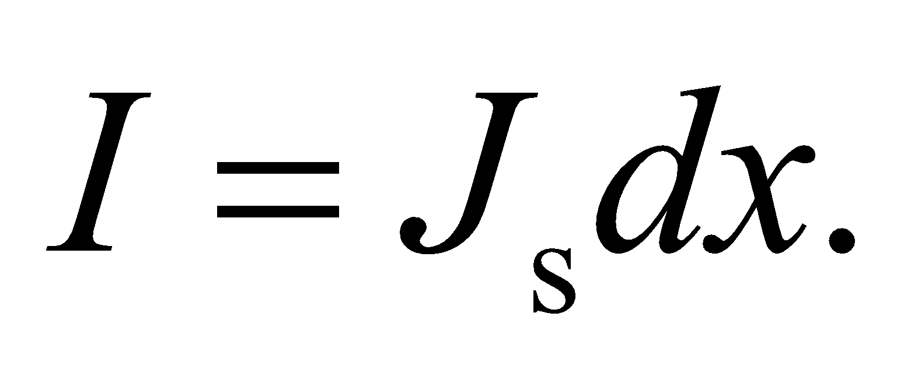 We'll calculate the magnetic field that these line currents produce at a point at 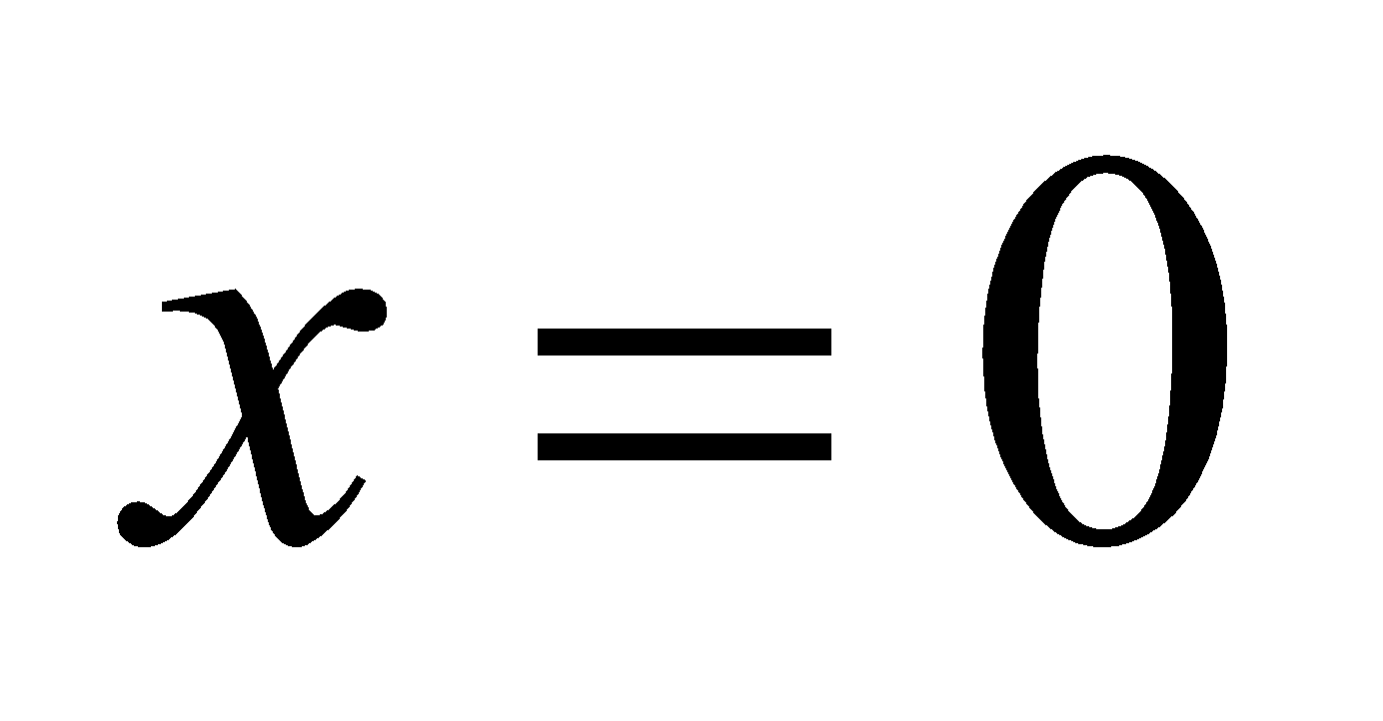 and at a height *z* above the sheet. See the figure below.



From Equation 26.10, each line current will generate a magnetic field at the chosen point that is inversely proportional to the distance:

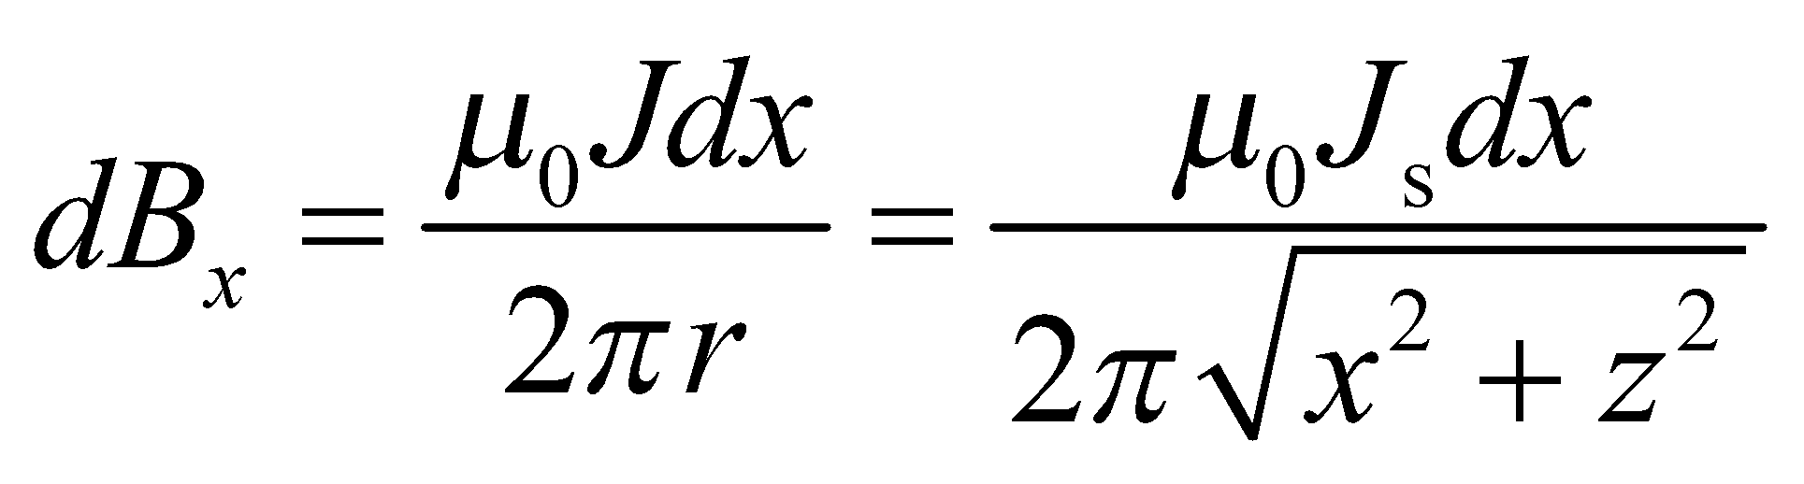

where we use the subscript *x* to denote the location of the line current. It's clear that the field contribution, 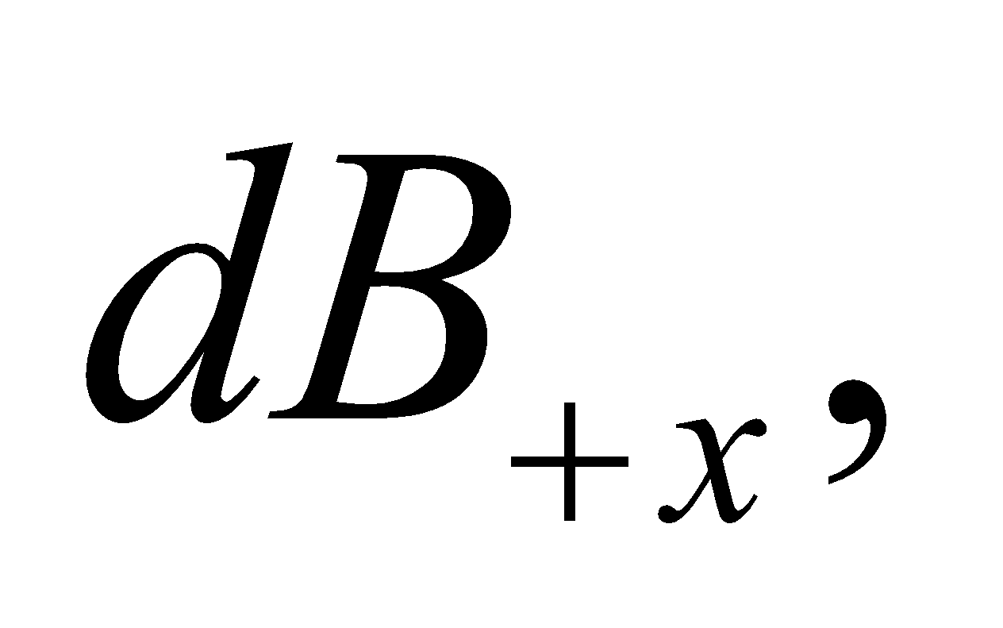from the line current at +*x* will have the same magnitude as the field contribution, 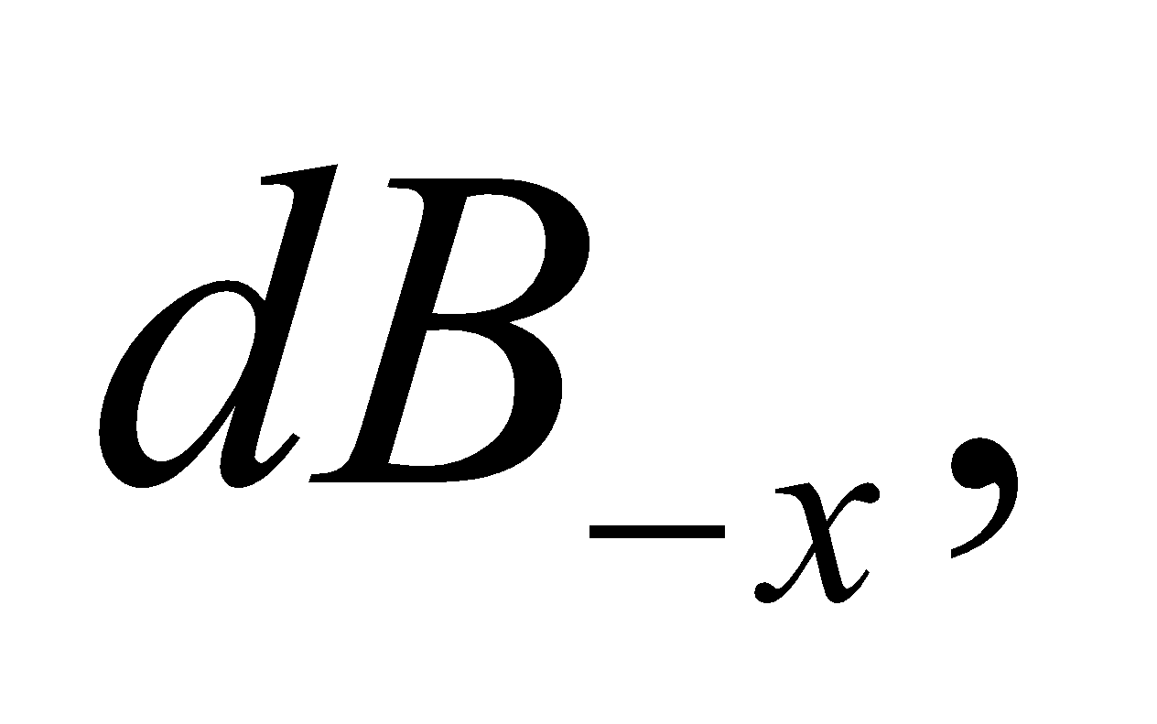from the line current at –*x*. By the symmetry of the situation, the *z*-component of these two fields will cancel out, and we're left with only their *x*-component: 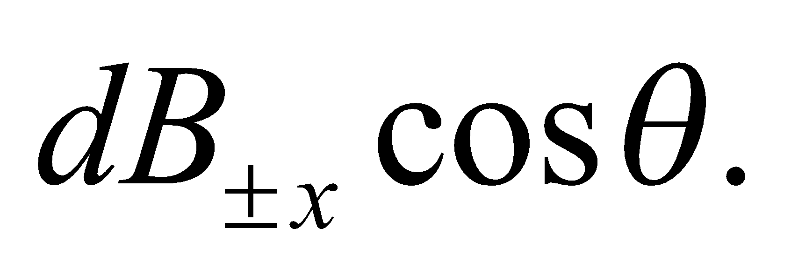 From the figure, we can see that 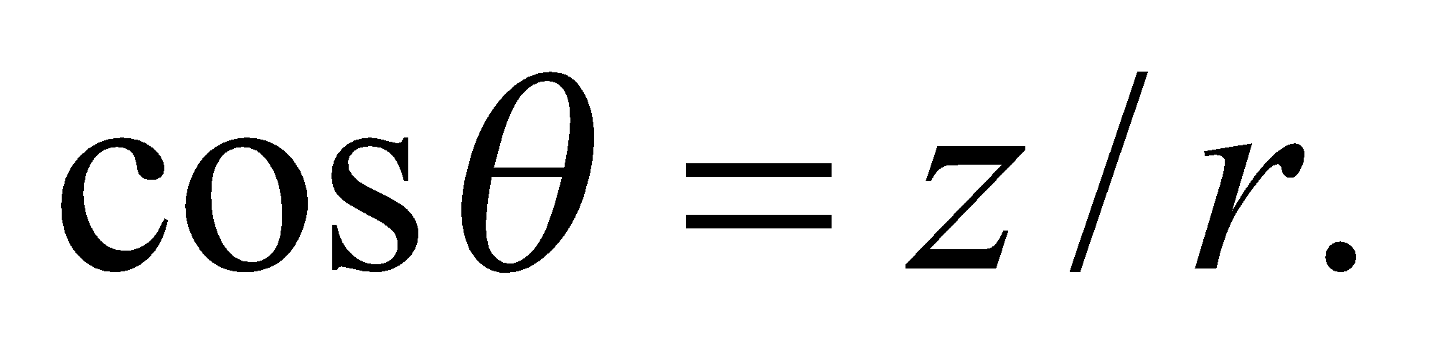 We combine the contribution from the two line currents at +*x* and –*x* into one term:

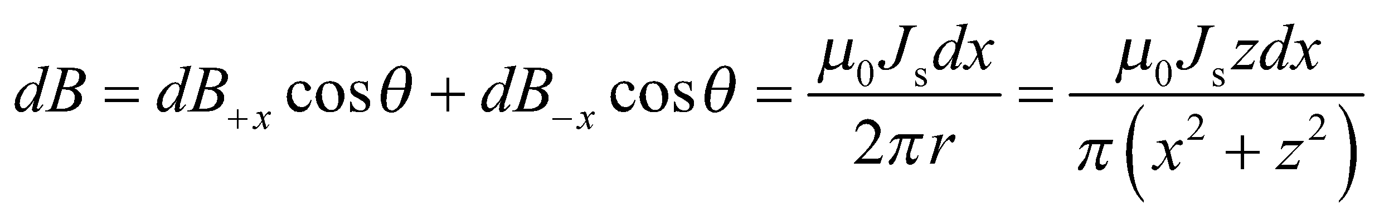

**Evaluate**To find the total field, we integrate *dB* from 0 to ∞:

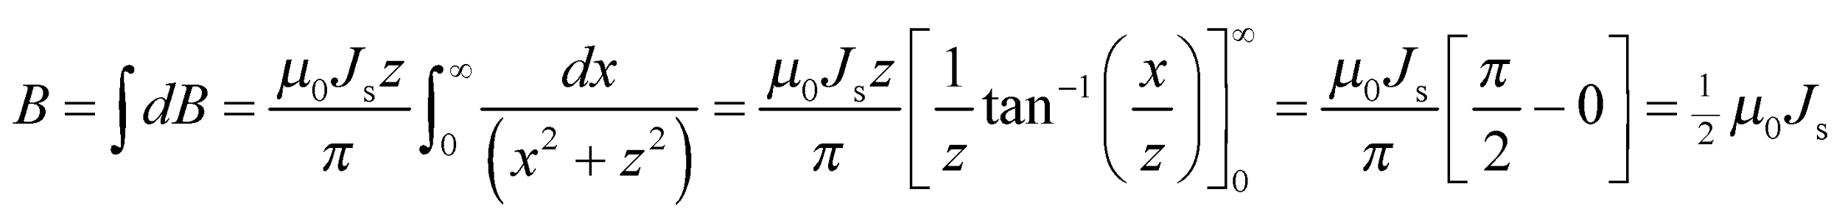

where we have used the integral table in Appendix A, as well as the table of selected values of tan*θ*.

**Assess** Assuming the current in the sheet points out of the paper as in the figure above, the magnetic field will point to the left above the sheet and to the right below the sheet. This all agrees with the derivation in Example 26.8, but notice how much easier this problem is when you use Ampère's law.

**85.** **Interpret** You want to consider the possible effect that magnets used in magnet therapy might have on blood flow.

**Develop**You first have to estimate the typical current in a blood vessel. Each blood vessel carries a small charge, 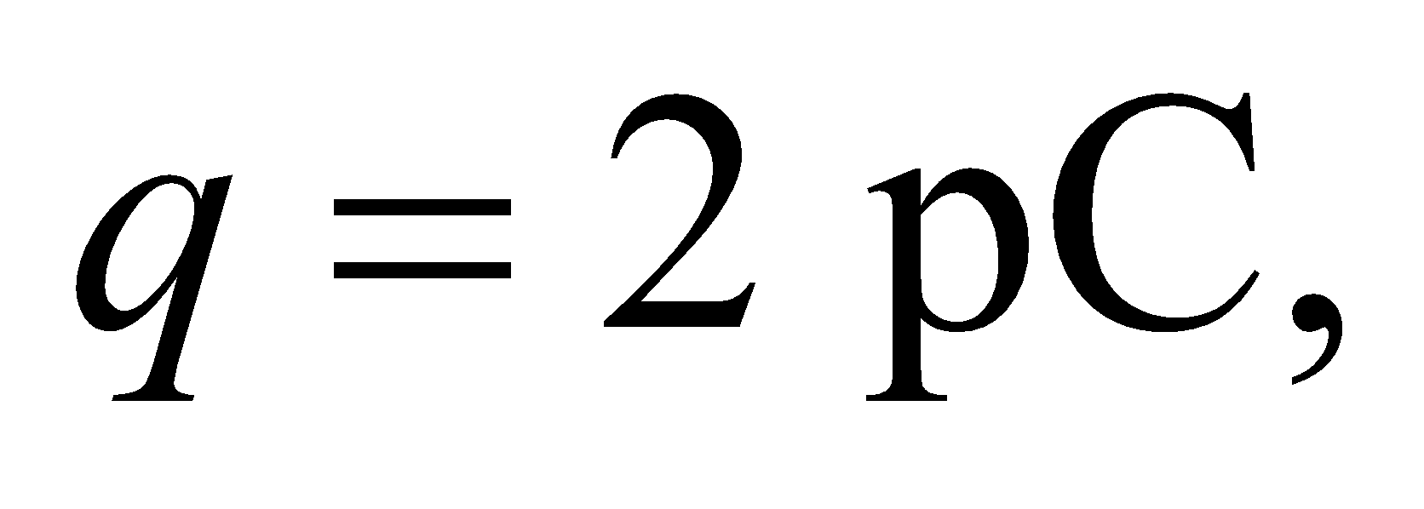 and is moving at a speed of 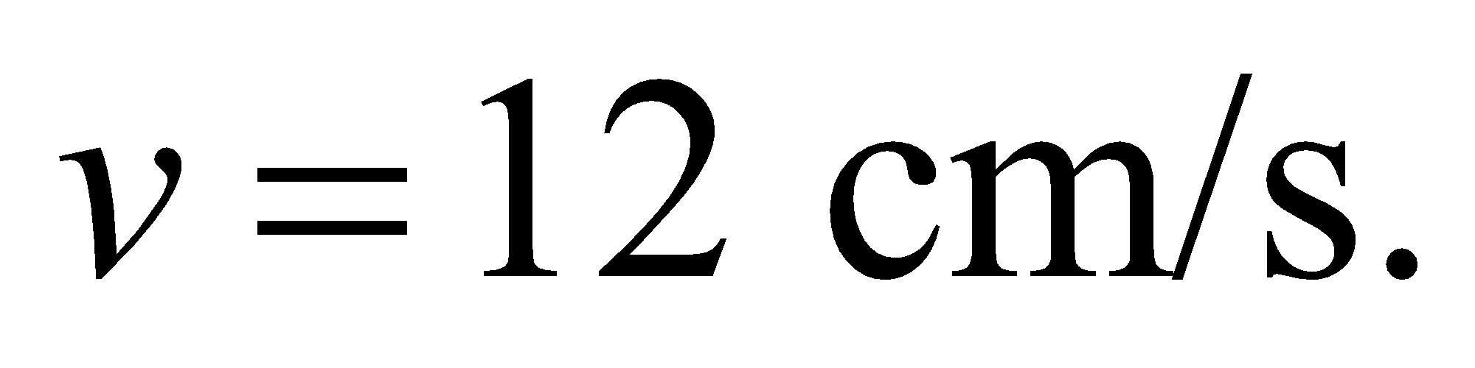 There are roughly 5 billion blood cells per mL moving through a vessel of diameter 3 mm. Plugging these values into Equation 24.2, the current flowing in the vessel is

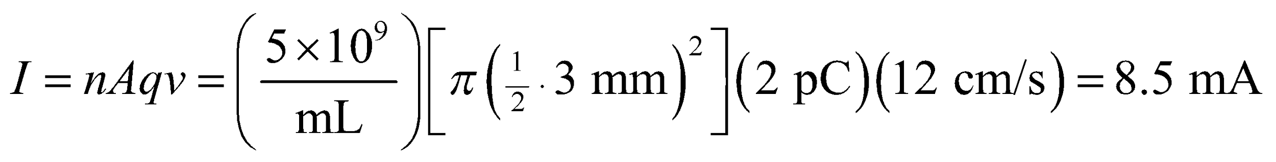

You can compute the Hall effect that a bar magnet would cause inside a current-carrying blood vessel.

**Evaluate**From Equation 26.6, the Hall potential is 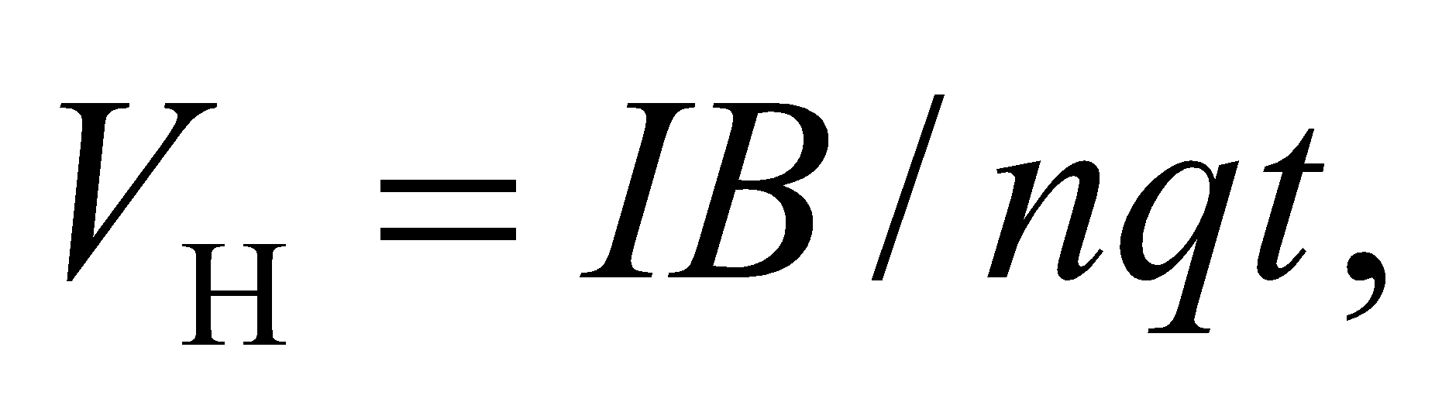where *t* is the thickness of the conducting material. In the case of blood, we can assume *t* is just the diameter of the blood vessel, in which case the Hall potential is

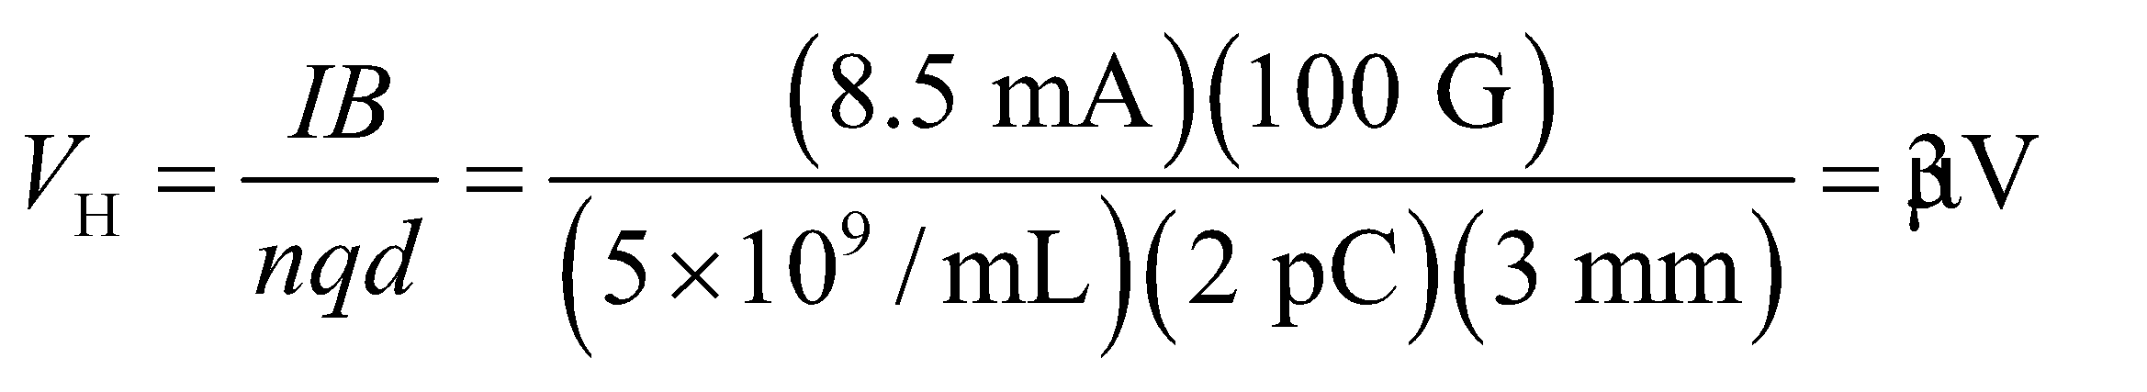

This is roughly 10,000 times smaller than the electric potentials of bioelectric activity.

**Assess** A more straightforward way to calculate the Hall effect would be with 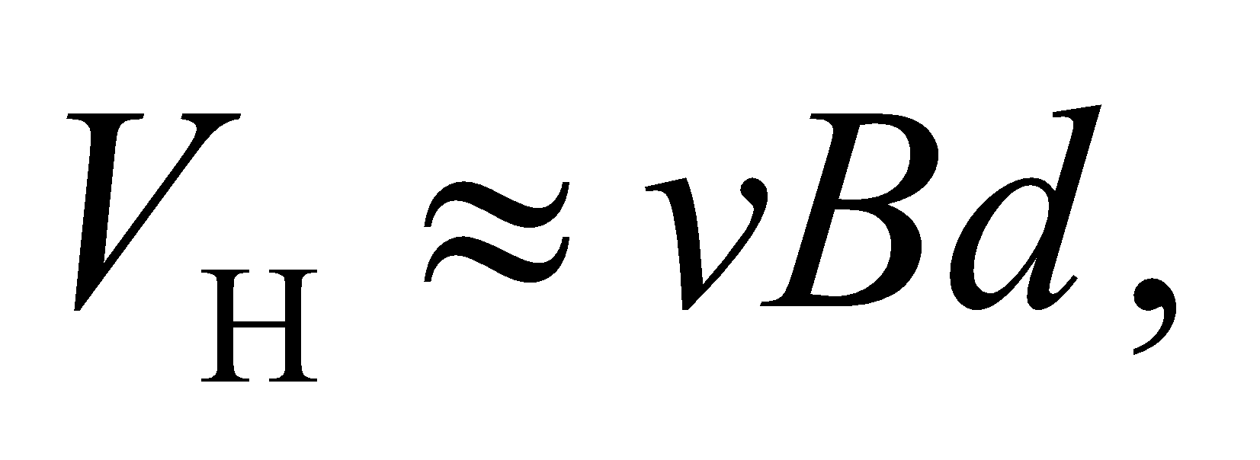which gives roughly the same answer.

**86.** **Interpret** We consider the magnetic field generated by a toroid.

**Develop**The magnetic field is symmetric around the axis of the toroid. We can therefore imagine an Ampèrian loop that is a circle with radius *r* extending from the toroid's axis (as drawn in Figure 26.51b). The magnetic field should be parallel to the tangent of the circle, so by Ampère's law,



**Evaluate**For an Ampèrian loop inside the donut "hole," there is no encircled current, so 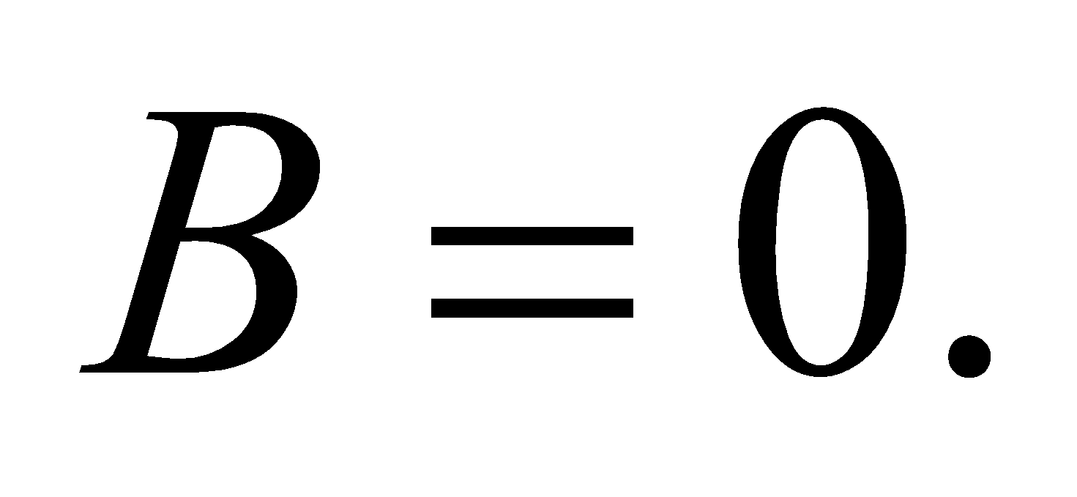 Within the region bounded by the coils, an Ampèrian loop will encircle the wires on the inner half of the toroid. In this case, the encircled current is nonzero, and therefore so is the magnetic field. Lastly, at radii greater than the outer radius of the toroid, the Ampèrian loop will encircle the inner part of the toroid, where the currents flow in one direction, but it will also encircle the outer part of the toroid, where the same currents flow in the opposite direction. Therefore the total current will be zero, and the magnetic field outside the coils will be zero.

The answer is (b).

**Assess** The toroid field is confined to inside the coils just like the infinite solenoid field in Figure 26.34.

**87.** **Interpret** We consider the magnetic field generated by a toroid.

**Develop**As we explained in the previous problem, the magnetic field is symmetric around the axis of the toroid.

**Evaluate**By the right-hand rule, it's clear that the magnetic field lines have to be in the plane of the page. That rules out choices (a) and (b). If the field lines were straight and pointing radially, that would seem to contradict Gauss's law for magnetism, Equation 26.14. One could imagine a sphere centered around where the field was radiating outward. The magnetic flux through this sphere would presumably be non-zero, as if there were a magnetic monopole at the center of the toroid. Ruling out that possibility, we're left with circular field lines, which agrees with the arguments made in the previous problem.

The answer is (d).

**Assess** As described in Figure 26.8, charged particles will spiral around magnetic field lines. Therefore, inside a toroid, charged particles will orbit essentially in a circle as they spiral around the field lines. This is how the million degree fuel in a future fusion reactor will presumably be confined.

**88.** **Interpret** We consider the magnetic field generated by a toroid.

**Develop**From Ampère's law, we know that the magnetic field is proportional to the enclosed current, which in the case of the toroid is proportional to the number of coils: 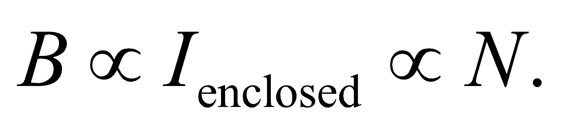

**Evaluate**If the number of turns is doubled, the magnetic field should double as well.

The answer is (a).

**Assess** To increase the magnetic field in a solenoid or toroid, it is often easier to wind more turns in the wire than to increase the current.

**89.** **Interpret** We consider the magnetic field generated by a toroid.

**Develop**To find the field magnitude, we can use the Ampèrian circles that were introduced in Problem 26.86.

**Evaluate**At a given radius, the magnetic field inside the coils will be

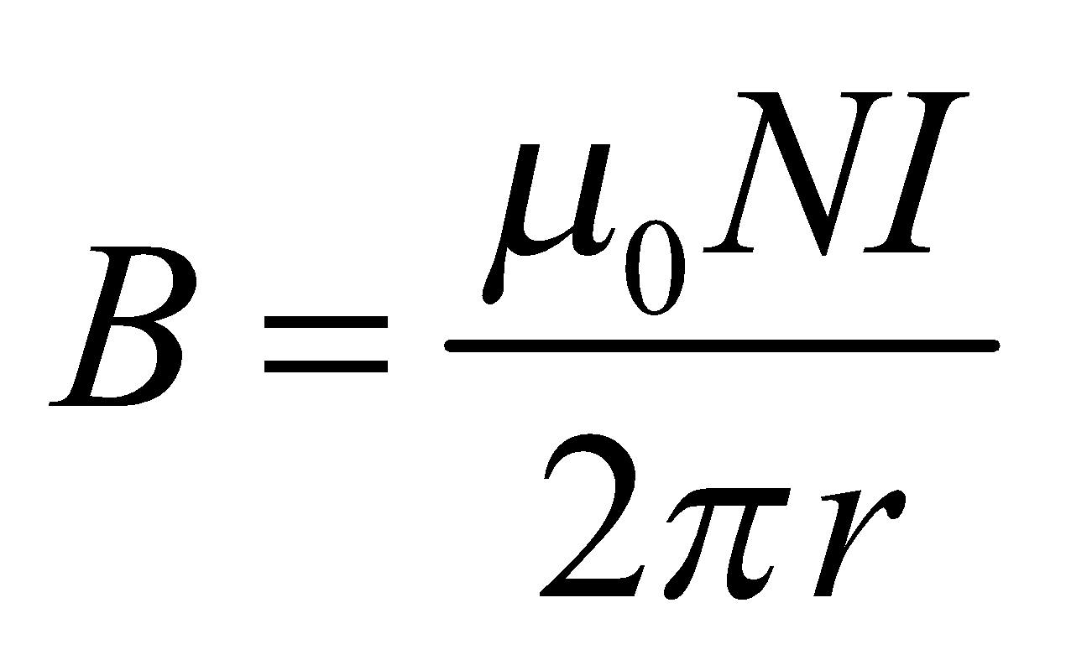

The answer is (d).

**Assess** We see here that the difference between the magnetic field in a solenoid and in a toroid is that in the former the field is uniform (Equation 26.21) but in the latter it is not 